Graphs and Networks

Nik Bear Brown

In this lesson we'll learn the how to implement and analyze graphs and networks in R.

# Additional packages needed

To run the code you may need additional packages.

* If necessary install the followings packages.

install.packages("igraph");

library(igraph)

##   
## Attaching package: 'igraph'

## The following objects are masked from 'package:stats':  
##   
## decompose, spectrum

## The following object is masked from 'package:base':  
##   
## union

dev.off()

## null device   
## 1

# Data

We will be creating graphs with the library(igraph).

# create a undirected unnamed graph  
graph.1 <- make\_graph( c(1,2, 2,3, 3,5, 7,6, 1,8, 2,3, 5,7, 3,6, 3,6, 4,2, 8,8), n=8, directed=F)

# Graphs and Networks

A network is a graph. That is:

* A set of vertices (or nodes) joined by edges.
* Vertices and edges can have properties (feature values).
* Edges can have weights and be directed.

# create a undirected unnamed graph  
graph.1 <- make\_graph( c(1,2, 2,3, 3,5, 7,6, 1,8, 2,3, 5,7, 3,6, 3,6, 4,2, 8,8), n=8, directed=F)  
graph.1

## IGRAPH U--- 8 11 --   
## + edges:  
## [1] 1--2 2--3 3--5 6--7 1--8 2--3 5--7 3--6 3--6 2--4 8--8

plot(graph.1)

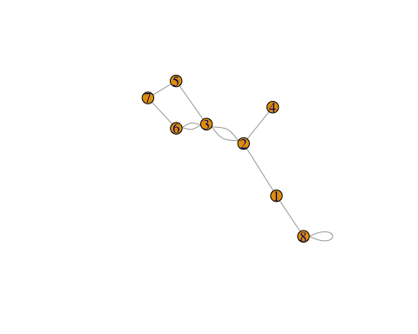

# graph summary  
str(graph.1)

## IGRAPH U--- 8 11 --   
## + edges:  
## [1] 1--2 2--3 3--5 6--7 1--8 2--3 5--7 3--6 3--6 2--4 8--8

# number of vertices  
vcount(graph.1)

## [1] 8

# number of edges  
ecount(graph.1)

## [1] 11

# check if directed, and convert  
is.directed(graph.1)

## [1] FALSE

graph.1 <- as.directed(graph.1) # to convert back, use - as.undirected(graph.1)  
str(graph.1)

## IGRAPH D--- 8 22 --   
## + edges:  
## [1] 1->2 2->3 3->5 6->7 1->8 2->3 5->7 3->6 3->6 2->4 8->8 2->1 3->2 5->3  
## [15] 7->6 8->1 3->2 7->5 6->3 6->3 4->2 8->8

# check for multiple, loop edges and remove them  
is\_simple(graph.1)

## [1] FALSE

which\_multiple(graph.1)

## [1] FALSE FALSE FALSE FALSE FALSE TRUE FALSE FALSE TRUE FALSE FALSE  
## [12] FALSE FALSE FALSE FALSE FALSE TRUE FALSE FALSE TRUE FALSE TRUE

which\_loop(graph.1)

## [1] FALSE FALSE FALSE FALSE FALSE FALSE FALSE FALSE FALSE FALSE TRUE  
## [12] FALSE FALSE FALSE FALSE FALSE FALSE FALSE FALSE FALSE FALSE TRUE

graph.1 <- simplify(graph.1)  
is\_simple(graph.1)

## [1] TRUE

# name vertices using uppercase  
V(graph.1)$name <- toupper(letters[1:8])  
# assign attributes to the graph  
graph.1$name <- "A colorful graph"  
# assign attributes to the graph's vertices  
V(graph.1)$color <- sample(rainbow(8),8,replace=F)  
# assign attributes to the edges  
E(graph.1)$weight <- runif(length(E(graph.1)),.75,5)  
# plot the graph with additional parameters  
# Note: plot=igraph.plot  
plot(graph.1, layout = layout.fruchterman.reingold,   
 main = graph.1$name,  
 vertex.label = V(graph.1)$name,  
 vertex.size = 25,  
 vertex.color= V(graph.1)$color,  
 vertex.frame.color= "white",  
 vertex.label.color = "blue",  
 edge.width=E(graph.1)$weight,   
 edge.color="black")

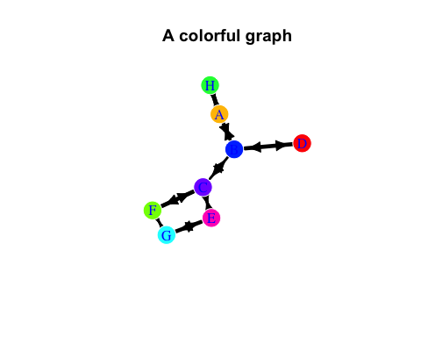

# create a undirected named graph  
graph.2 <- graph.formula(Miley-Justin-Taylor-Miley, Ariana:Taylor-Nicki,   
 Taylor-Iggy)  
plot(graph.2)

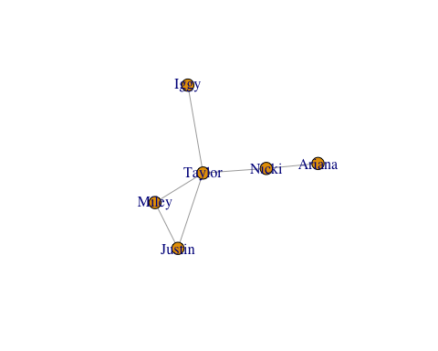

# remove Iggy  
graph.2 <- delete\_vertices(graph.2, match("Iggy", V(graph.2)$name))  
# add two vertices  
graph.2.1 <- add\_vertices(graph.2, 2)  
plot(graph.2.1)

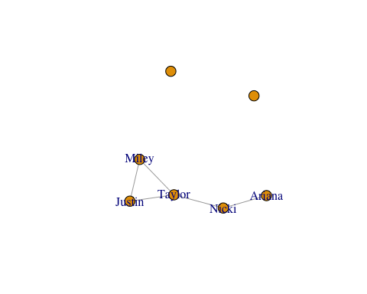

# add two vertices with names  
graph.2.2 <- add\_vertices(graph.2, 2, attr=list(name=c("Iggy", "Jessie")))  
plot(graph.2.2)

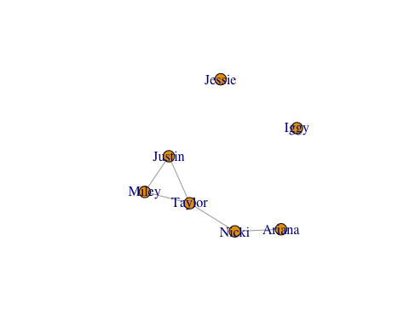

# add edges  
graph.2 <- add\_edges(graph.2.2, match(c("Jessie", "Iggy",  
 "Taylor", "Jessie"), V(graph.2.2)$name ))  
plot(graph.2)

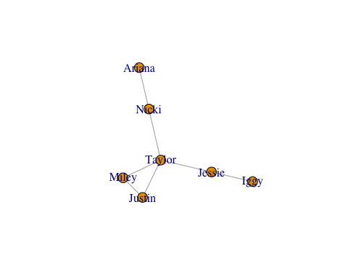

# delete edge  
graph.2 <- delete\_edges(graph.2, match(c("Taylor", "Jessie"), V(graph.2)$name))  
plot(graph.2)

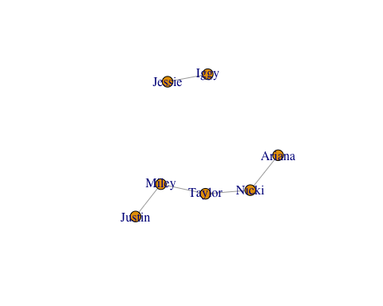

# create a directed named graph  
# the (+) sign signifies the direction of the arrow  
graph.3 <- graph.formula(Miley+-+Justin--+Taylor, Ariana--+Nicki:Iggy--+Jessie)  
plot(graph.3)

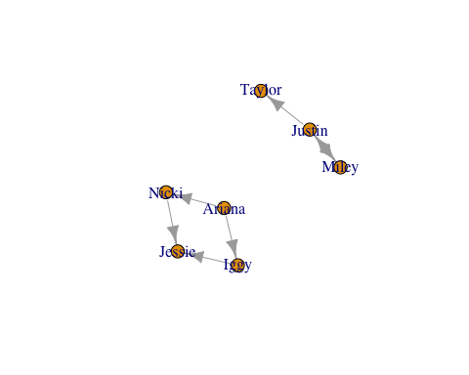

# names of vertices  
V(graph.3)

## + 7/7 vertices, named:  
## [1] Miley Justin Taylor Ariana Nicki Iggy Jessie

# ids of vertices  
as.vector(V(graph.3))

## [1] 1 2 3 4 5 6 7

# sequence of edges  
E(graph.3)

## + 7/7 edges (vertex names):  
## [1] Miley ->Justin Justin->Miley Justin->Taylor Ariana->Nicki   
## [5] Ariana->Iggy Nicki ->Jessie Iggy ->Jessie

# edge from vertex 1 to vertex 2  
E(graph.3, P=c(1,2))

## + 1/7 edge (vertex names):  
## [1] Miley->Justin

# id of the edge from vertex 1 to vertex 2  
as.vector(E(graph.3, P=c(1,2)))

## [1] 1

# all adjacent edges of vertex 4  
E(graph.3)[adj(4)]

## + 2/7 edges (vertex names):  
## [1] Ariana->Nicki Ariana->Iggy

# all adjacent edges of vertices 4 and 1  
E(graph.3)[adj(c(4,1))]

## + 4/7 edges (vertex names):  
## [1] Miley ->Justin Justin->Miley Ariana->Nicki Ariana->Iggy

# all outgoing edges from vertex 2  
E(graph.3)[from(2)]

## + 2/7 edges (vertex names):  
## [1] Justin->Miley Justin->Taylor

# all incoming edges to vertex 7  
E(graph.3)[to(7)]

## + 2/7 edges (vertex names):  
## [1] Nicki->Jessie Iggy ->Jessie

# Bipartite graphs

In graph theory, a [bipartite graph](https://en.wikipedia.org/wiki/Bipartite_graph) is a graph whose vertices can be divided into two disjoint sets and (that is, and are each independent sets) such that every edge connects a vertex in one disjoint set to one in in the other disjoint set. That is, there are only between set and no within set edges.

# create a bipartite graph  
graph.4 <- make\_bipartite\_graph( rep(0:1,length=8), c(1:8))  
plot(graph.4)

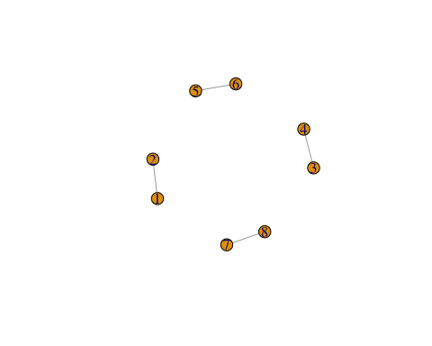

# Erdos-Renyi Random Graphs

In graph theory, the [Erdos-Renyi model](https://en.wikipedia.org/wiki/Erd%C5%91s%E2%80%93R%C3%A9nyi_model) is either of two closely related models for generating random graphs. They are named after Paul Erdős and Alfréd Rényi.

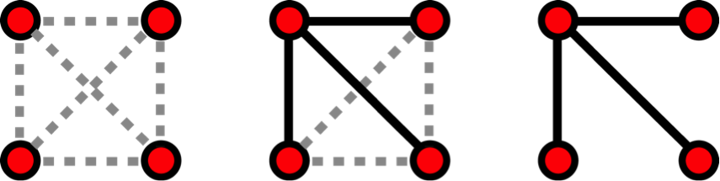  
- Erdos-Renyi model is generated with N = 4 nodes. from en.wikipedia.org/wiki/Network\_science#/media/<File:ER_model.png>

The G(n, M) model, \* n is the the number of vertices or nodes  
\* M is the the number of edges \* 0 $≤$ p $≤$ 1 \* for each pair (i,j), generate the edge (i,j) independently with probability p

Equivalently, all graphs with n nodes and M edges have equal probability of

$$p^{M}(1−p)^{\left({n \atop 2}\right)−M}.$$

The parameter p in this model can be thought of as a weighting function; as p increases from 0 to 1, the model becomes more and more likely to include graphs with more edges and less and less likely to include graphs with fewer edges.

Random graphs degree distribution follows a binomial.

$$P(deg(v)=k)=\left({n−1 \atop k}\right)p^{k}(1−p)^{n−1−k},$$

where n is the total number of vertices in the graph. Since

$$P(deg(v)=k)→\frac{(np)^{k}e^{−np}}{k!} as n→∞ and np=const,$$

this distribution is Poisson for large n and np = const.

# create a random graph  
random.graph.1 <- sample\_gnp(n=12, p=.3, directed=T)  
plot.igraph(random.graph.1)

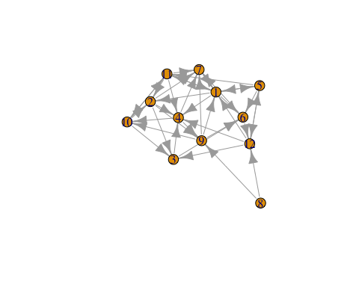

random.graph.2 <- sample\_gnm(n=15, m=20, directed=T, loops=T)  
plot.igraph(random.graph.2)

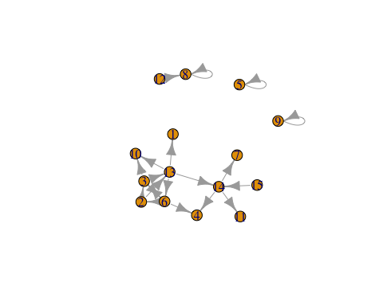

# create a scale-free graph  
scale.free.graph <- sample\_pa(n=10,power=1)  
plot.igraph(scale.free.graph)

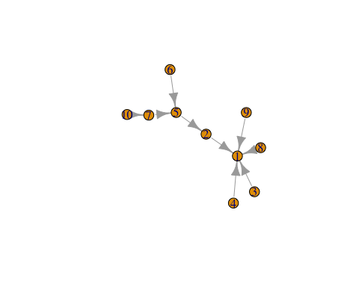

# create a small-world graph  
small.world.graph <- sample\_smallworld(1, 50, 5, 0.025, loops=T, multiple=F)  
plot.igraph(small.world.graph)

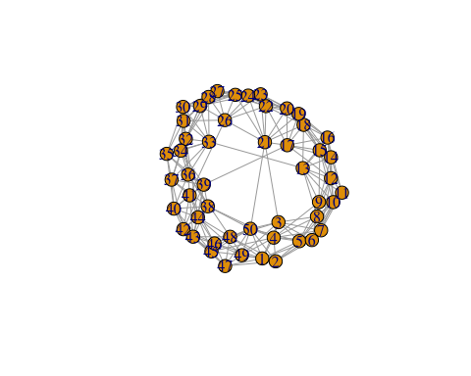

# convert a graph to an adjacency matrix  
matrix.3 <- as\_adjacency\_matrix(graph.3, sparse=F)  
matrix.3

## Miley Justin Taylor Ariana Nicki Iggy Jessie  
## Miley 0 1 0 0 0 0 0  
## Justin 1 0 1 0 0 0 0  
## Taylor 0 0 0 0 0 0 0  
## Ariana 0 0 0 0 1 1 0  
## Nicki 0 0 0 0 0 0 1  
## Iggy 0 0 0 0 0 0 1  
## Jessie 0 0 0 0 0 0 0

# convert a graph to an adjacency list  
adjlist.3 <- as\_adj\_list(graph.3)  
adjlist.3

## $Miley  
## + 2/7 vertices, named:  
## [1] Justin Justin  
##   
## $Justin  
## + 3/7 vertices, named:  
## [1] Miley Miley Taylor  
##   
## $Taylor  
## + 1/7 vertex, named:  
## [1] Justin  
##   
## $Ariana  
## + 2/7 vertices, named:  
## [1] Nicki Iggy   
##   
## $Nicki  
## + 2/7 vertices, named:  
## [1] Ariana Jessie  
##   
## $Iggy  
## + 2/7 vertices, named:  
## [1] Ariana Jessie  
##   
## $Jessie  
## + 2/7 vertices, named:  
## [1] Nicki Iggy

# convert a graph to an edge list  
edgelist.3 <- as\_edgelist(graph.3, names = TRUE)  
edgelist.3

## [,1] [,2]   
## [1,] "Miley" "Justin"  
## [2,] "Justin" "Miley"   
## [3,] "Justin" "Taylor"  
## [4,] "Ariana" "Nicki"   
## [5,] "Ariana" "Iggy"   
## [6,] "Nicki" "Jessie"  
## [7,] "Iggy" "Jessie"

# convert a graph to an incidence matrix  
# only bipartite graphs can be converted to an incidence matrix  
incidence.4 <- as\_incidence\_matrix(graph.4, sparse=F)  
incidence.4

## 2 4 6 8  
## 1 1 0 0 0  
## 3 0 1 0 0  
## 5 0 0 1 0  
## 7 0 0 0 1

# Network Motifs

[Network motifs](https://en.wikipedia.org/wiki/Network_motif), are recurrent and statistically significant sub-graphs or patterns.

# Motifs  
# create a directed scale-free graph  
graph.5 <- sample\_pa(n=20,power=1)  
plot.igraph(graph.5)

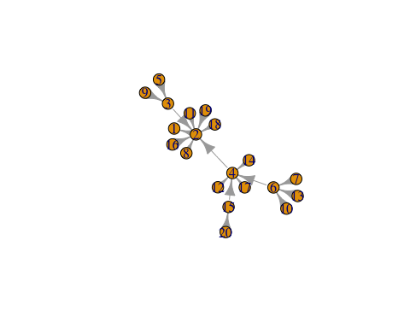

# total number of motifs of size 3  
count\_motifs(graph.5, size = 3)

## [1] 53

# number of occurences of each motif in a graph  
motifs(graph.5, size = 3)

## [1] NA NA 35 NA 18 0 0 0 0 0 0 0 0 0 0 0

# estimate for the total number of motifs in a graph  
sample\_motifs(graph.5, size = 3, cut.prob=c(0.25,0.5,0.75),   
 sample.size=15)

## [1] 4

# total number of motifs of size 4  
count\_motifs(graph.5, size = 4)

## [1] 150

# number of occurences of each motif in a graph  
motifs(graph.5, size = 4)

## [1] NA NA NA 46 NA NA NA 35 0 NA NA NA 58 0 0 NA 0 0 0 0 0 0 NA  
## [24] NA 0 0 0 NA NA 11 0 0 0 NA NA 0 0 0 0 NA 0 0 0 0 0 0  
## [47] 0 0 0 0 0 0 0 0 0 0 0 0 0 0 0 0 NA 0 0 0 0 0 0  
## [70] 0 0 0 0 0 0 0 0 0 0 0 0 0 0 0 0 0 0 0 0 0 0 0  
## [93] 0 0 0 0 0 0 0 0 0 0 0 0 0 0 0 0 0 0 0 0 0 0 0  
## [116] 0 0 0 0 0 NA 0 0 0 0 0 0 0 0 0 0 0 0 0 0 0 0 0  
## [139] 0 0 0 0 0 0 0 0 0 0 0 0 0 0 0 0 0 0 0 0 0 0 0  
## [162] 0 0 0 0 0 0 0 0 0 0 0 0 0 0 0 0 0 0 0 0 0 0 0  
## [185] 0 0 0 0 0 0 0 0 0 0 0 0 0 0 0 0 0 0 0 0 0 0 0  
## [208] 0 0 0 0 0 0 0 0 0 0 0

# estimate for the total number of motifs in a graph  
sample\_motifs(graph.5, size = 4, cut.prob=c(0.2,0.4,0.6,0.8), sample.size=15)

## [1] 0

# create an undirected scale-free graph  
graph.6 <- sample\_pa(n=20,power=1, directed=F)  
plot.igraph(graph.6)

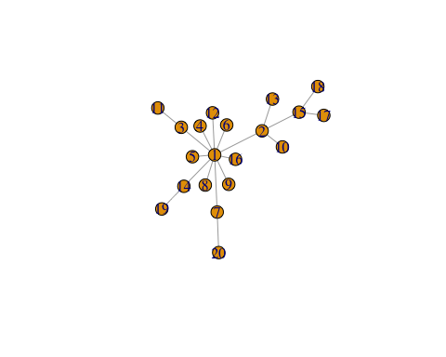

# total number of motifs of size 3  
count\_motifs(graph.6, size = 3)

## [1] 67

# number of occurences of each motif in a graph  
motifs(graph.6, size = 3)

## [1] NA NA 67 0

# estimate for the total number of motifs in a graph  
sample\_motifs(graph.6, size = 3, cut.prob=c(0.25,0.5,0.75), sample.size=15)

## [1] 0

# total number of motifs of size 4  
count\_motifs(graph.6, size = 4)

## [1] 236

# number of occurences of each motif in a graph  
motifs(graph.6, size = 4)

## [1] NA NA NA NA 170 NA 66 0 0 0 0

# estimate for the total number of motifs in a graph  
sample\_motifs(graph.6, size = 4, cut.prob=c(0.2,0.4,0.6,0.8), sample.size=15)

## [1] 0

# Cliques - only for undirected graphs   
# If calculated for directed graphs - directions are ignored  
# create a random undirected graph  
graph.7 <- sample\_gnm(100,1000)  
plot(graph.7)

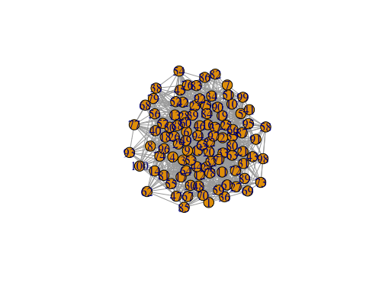

# Cliques

A clique is a fully connected graph. A graph that has all possible n(n-1)/2 edges.

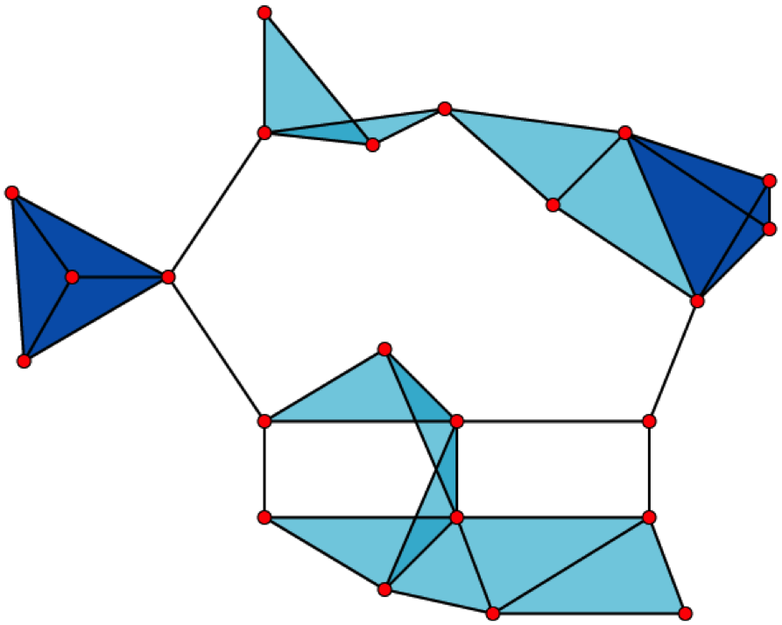

Clique (graph theory)

A graph with \* 23 x 1-vertex cliques (the vertices), \* 42 x 2-vertex cliques (the edges), \* 19 x 3-vertex cliques (the light and dark blue triangles), and \* 2 x 4-vertex cliques (just the dark blue areas).

The 11 light blue triangles form maximal cliques. The two dark blue 4-cliques are both maximum and maximal, and the clique number of the graph is 4.

from [Clique (graph theory)](https://en.wikipedia.org/wiki/Clique_(graph_theory))

# find all complete subgraphs - i.e. cliques  
all\_cliq <- cliques(graph.7)  
length(all\_cliq) # this is the total number of cliques

## [1] 2757

# head(all\_cliq)  
# tail(all\_cliq)  
# size of the largest clique(s)  
large\_cliq\_size <- clique\_num(graph.7)  
large\_cliq\_size

## [1] 5

# find all largest cliques  
large\_cliq <- largest\_cliques(graph.7)  
# alternate way of finding all largest cliques  
large\_cliq <- cliques(graph.7, min=large\_cliq\_size)  
length(large\_cliq) # this is the total number of largest cliques

## [1] 10

# head(large\_cliq)  
# tail(large\_cliq)  
# find all maximal cliques  
max\_cliq <- max\_cliques(graph.7)  
length(max\_cliq) # this is the total number of maximal cliques

## [1] 807

count\_max\_cliques(graph.7) # alterate way

## [1] 807

# head(max\_cliq)  
# tail(max\_cliq)

# PageRank

[PageRank](https://en.wikipedia.org/wiki/PageRank) counts the number weighted by the quality of links to a node from other nodes to determine a numeric estimate of the importance the node.

# PageRank  
# create a random directed graph  
graph.8 <- sample\_gnm(25,100, directed=T)  
plot(graph.8)

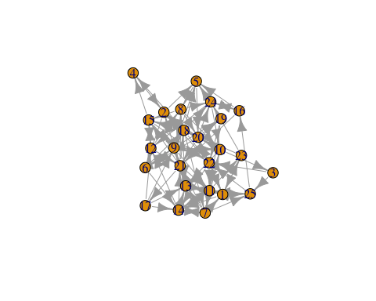

# calculate PageRank for all the vertices in the graph  
unweighted\_rank <- page\_rank(graph.8)  
unweighted\_rank

## $vector  
## [1] 0.04605462 0.05483732 0.01411234 0.02061032 0.04819744 0.03426307  
## [7] 0.04278549 0.03841993 0.04820532 0.03817573 0.07089383 0.03851107  
## [13] 0.05415951 0.05961126 0.03786037 0.02435347 0.01385252 0.05406463  
## [19] 0.01915211 0.04082408 0.06466782 0.03899980 0.03261099 0.04019352  
## [25] 0.02458343  
##   
## $value  
## [1] 1  
##   
## $options  
## NULL

which.max(unweighted\_rank$vector)

## [1] 11

# calculate the PageRank of vertices 1 through 5, using the power algorithm  
page\_rank(graph.8, algo=c("power"), vids=c(1:5))

## Warning in .Call("R\_igraph\_personalized\_pagerank", graph, algo, vids - 1, :  
## At structural\_properties.c:1379 :igraph\_pagerank\_old is deprecated from  
## igraph 0.7, use igraph\_pagerank instead

## $vector  
## [1] 0.04615115 0.05497201 0.01414209 0.02067163 0.04829088  
##   
## $value  
## [1] 2.251334e-314  
##   
## $options  
## $options$niter  
## [1] 1000  
##   
## $options$eps  
## [1] 0.001

# the parameter algo can take three values - prpack(default), arpack and power  
# add weights to all the edges and then calculate PageRank  
# damping - the damping factor - can be between 0 and 1  
# 0.85 is generally the most accepted value and also the default here  
# $vector gives only the PageRank vector  
weighted\_rank <- page\_rank(graph.8, damping=0.85, weights=runif(ecount(graph.8)))$vector  
weighted\_rank

## [1] 0.030133391 0.045098401 0.009399175 0.021359492 0.040032608  
## [6] 0.032036619 0.047735059 0.048925489 0.049363210 0.034417749  
## [11] 0.072035092 0.036545348 0.046671880 0.069466292 0.043554555  
## [16] 0.035601859 0.016658766 0.052722306 0.022200767 0.038212310  
## [21] 0.074698909 0.025486600 0.032512191 0.053636346 0.021495584

which.max(weighted\_rank)

## [1] 21

# Personalized PageRank  
personalProbability <- runif(vcount(graph.8))  
personalized\_rank <- page\_rank(graph.8, personalized=personalProbability)  
personalized\_rank$vector

## [1] 0.04647270 0.05470722 0.01883314 0.02502730 0.04479117 0.03624188  
## [7] 0.03575532 0.03647921 0.04647589 0.04132948 0.06900015 0.04227732  
## [13] 0.05428811 0.05452446 0.03556873 0.02633643 0.01534525 0.05329480  
## [19] 0.02257017 0.04146449 0.06342205 0.04042483 0.02856420 0.04134910  
## [25] 0.02545660

which.max(personalized\_rank$vector)

## [1] 11

# Assingment

Answer the following questions:  
\* Can some form of Social Network analysis help in your research project?  
\* If it can apply Social Network analysis to your research project? Does it help?  
\* If (and only if) you can't use some form of Social Network analysis help in your research project then apply a form of Social Network analysis to the data the Twiiter time series data set  
\* Note you only need to use ONE Social Network analysis approach from Module 12, so there will be only ONE assingment for all the modules and the same assingment for all the modules.

# Resources

* [Network visualization in R with the igraph package](https://rulesofreason.wordpress.com/2012/11/05/network-visualization-in-r-with-the-igraph-package/)
* [Making prettier network graphs with sna and igraph via @rbloggers](<http://www.r-bloggers.com/making-prettier-network-graphs-with-sna-and-igraph/>)
* [igraph R manual pages](http://igraph.org/r/doc/)

# References

The data, R code and lessons are based upon:

Graph theory/data structures:  
\* <http://math.tut.fi/~ruohonen/GT_English.pdf>  
\* <http://www.cl.cam.ac.uk/teaching/1011/PrincComm/slides-lpr/graph_theory_1-11.pdf>  
\* <http://www.researchgate.net/publication/228300013_Graph_Theory_A_Primer_for_Using_R_Visualization_Techniques_in_the_Applications_of_the_Adjacency_Matrix>  
\* <http://www.boost.org/doc/libs/1_59_0/libs/graph/doc/graph_theory_review.html>  
SNA:  
\* <http://files.meetup.com/1406240/sna_in_R.pdf>  
\* <http://www2.unb.ca/~ddu/6634/Lecture_notes/Lec1_intro_handout.pdf>  
\* <http://www.faculty.ucr.edu/~hanneman/nettext/>  
\* <http://citeseerx.ist.psu.edu/viewdoc/download?doi=10.1.1.372.1960&rep=rep1&type=pdf>  
\* <http://www.rdatamining.com/examples/social-network-analysis>

igraph:  
\* <http://statmath.wu.ac.at/research/friday/resources_WS0708_SS08/igraph.pdf>  
\* <http://blog.revolutionanalytics.com/2014/11/a-look-at-the-igraph-package.html>  
\* <http://www.r-bloggers.com/igraph-and-sna-an-amateurs-dabbling/>  
\* <http://www.r-bloggers.com/going-viral-with-rs-igraph-package/>  
\* <https://cran.r-project.org/web/packages/igraph/igraph.pdf>

Other famous packages for SNA:  
\* <http://www.r-bloggers.com/must-have-r-packages-for-social-scientists/>  
\* <https://cran.r-project.org/web/views/SocialSciences.html>  
\* <https://cran.r-project.org/web/packages/sna/sna.pdf>  
\* <https://cran.r-project.org/web/packages/RSiena/RSiena.pdf>  
\* <https://cran.r-project.org/web/packages/network/network.pdf>  
\* <https://www.bioconductor.org/packages/release/bioc/manuals/graph/man/graph.pdf>  
\* <http://www.statnet.org/>

In-depth SNA tutorials:  
\* <http://sna.stanford.edu/rlabs.php>  
\* <http://www.stats.ox.ac.uk/~snijders/sna_course.htm>  
\* <http://www.shizukalab.com/toolkits>

Sample projects:

* <http://www.orgnet.com/cases.html>

Motifs:  
\* <http://igraph.org/r/doc/motifs.html>  
\* <https://en.wikipedia.org/wiki/Network_motif>  
\* <http://www.cs.columbia.edu/4761/notes07/chapter8.2-topology.pdf>  
\* <https://sites.google.com/site/networkanalysisacourse/schedule/networkmotifs>  
Cliques:  
\* <http://igraph.org/r/doc/cliques.html>  
\* <http://faculty.ucr.edu/~hanneman/nettext/C11_Cliques.html>  
\* <https://courses.cs.washington.edu/courses/cse527/01au/oct25/oct25.html>  
\* ttp://www.mathcove.net/petersen/lessons/get-lesson?les=29  
\* <http://news.stanford.edu/news/2014/november/cliques-high-school-110514.html>  
PageRank:  
\* <http://igraph.org/r/doc/page_rank.html>  
\* <http://ilpubs.stanford.edu:8090/422/1/1999-66.pdf>  
\* <http://www.cs.princeton.edu/~chazelle/courses/BIB/pagerank.htm>  
\* <http://www.stat.cmu.edu/~ryantibs/datamining/lectures/03-pr-marked.pdf>  
\* <http://smallstats.blogspot.com/2014/04/from-random-walks-to-personalized.html>  
\* <http://blog.revolutionanalytics.com/2014/12/a-reproducible-r-example-finding-the-most-popular-packages-using-the-pagerank-algorithm.html>  
\* Mining Massive Datasets on Coursera - Week 1, Videos 5 through 11 explain PageRank elegantly. The course maybe unavailable (or archived) by the time this module is out

Dataset:  
\* <http://moreno.ss.uci.edu/data.html#padgett>  
\* <http://home.uchicago.edu/~jpadgett/papers/unpublished/maelite.pdf>

Other SNA:  
\* <http://www.r-bloggers.com/experiments-with-igraph/>  
\* <http://cran.us.r-project.org/doc/contrib/Zhao_R_and_data_mining.pdf>