Linear Discriminant Analysis

Nik Bear Brown

In this lesson we'll learn the theory behind using Linear Discriminant Analysis (LDA) as a supervised classification technique. We'll then use LDA to classify the UCI wine dataset in R.

# Additional packages needed

To run the code you may need additional packages.

* If necessary install the followings packages.

install.packages("ggplot2");  
install.packages("MASS");  
install.packages("car");

require(ggplot2)

## Loading required package: ggplot2

require(MASS)

## Loading required package: MASS

require(car)

## Loading required package: car

# Data

We will be using the [UCI Machine Learning Repository: Wine Data Set](https://archive.ics.uci.edu/ml/datasets/Wine). These data are the results of a chemical analysis of wines grown in the same region in Italy but derived from three different cultivars. The analysis determined the quantities of 13 constituents found in each of the three types of wines.

The attributes are:  
1) Alcohol  
2) Malic acid  
3) Ash  
4) Alcalinity of ash  
5) Magnesium  
6) Total phenols  
7) Flavanoids  
8) Nonflavanoid phenols  
9) Proanthocyanins  
10) Color intensity  
11) Hue  
12) OD280/OD315 of diluted wines  
13) Proline

Feel free to tweet questions to [@NikBearBrown](<https://twitter.com/NikBearBrown>)

# Load our data  
data_url <- 'http://nikbearbrown.com/YouTube/MachineLearning/M07/wine.csv'  
wn <- read.csv(url(data_url))  
head(wn)

## Cultivar Alcohol Malic.acid Ash Alcalinity.ash Magnesium Total.phenols  
## 1 1 14.23 1.71 2.43 15.6 127 2.80  
## 2 1 13.20 1.78 2.14 11.2 100 2.65  
## 3 1 13.16 2.36 2.67 18.6 101 2.80  
## 4 1 14.37 1.95 2.50 16.8 113 3.85  
## 5 1 13.24 2.59 2.87 21.0 118 2.80  
## 6 1 14.20 1.76 2.45 15.2 112 3.27  
## Flavanoids Nonflavanoid.phenols Proanthocyanins Color.intensity Hue  
## 1 3.06 0.28 2.29 5.64 1.04  
## 2 2.76 0.26 1.28 4.38 1.05  
## 3 3.24 0.30 2.81 5.68 1.03  
## 4 3.49 0.24 2.18 7.80 0.86  
## 5 2.69 0.39 1.82 4.32 1.04  
## 6 3.39 0.34 1.97 6.75 1.05  
## OD280.OD315 Proline  
## 1 3.92 1065  
## 2 3.40 1050  
## 3 3.17 1185  
## 4 3.45 1480  
## 5 2.93 735  
## 6 2.85 1450

# Linear Discriminant Analysis

[Linear Discriminant Analysis (LDA)](https://en.wikipedia.org/wiki/Linear_discriminant_analysis) is a generalization of Fisher's linear discriminant to find a linear combination of features that characterizes or separates two or more classes of objects or events. Discriminant analysis seeks to generate lines that are efficient for discrimination.

LDA is also closely related to [principal component analysis (PCA)](https://en.wikipedia.org/wiki/Principal_component_analysis) and factor analysis in that they both look for linear combinations of variables which best explain the data. In the case of LDA, we are maximizing the linear compenent axes for class discrimination. In the case of PCA, we are finding basis that maximize the variance.

LDA can also be used as a supervised technique by finding a discriminant projection that maximizing between-class distance and minimizing within-class distance.

LDA classifies $n$ items $X=x_{1},...x_{n}$ to one of $G$ groups based on measurements on $p$ predictors. Similar to linear regression except our line(s) act to seperate groups.

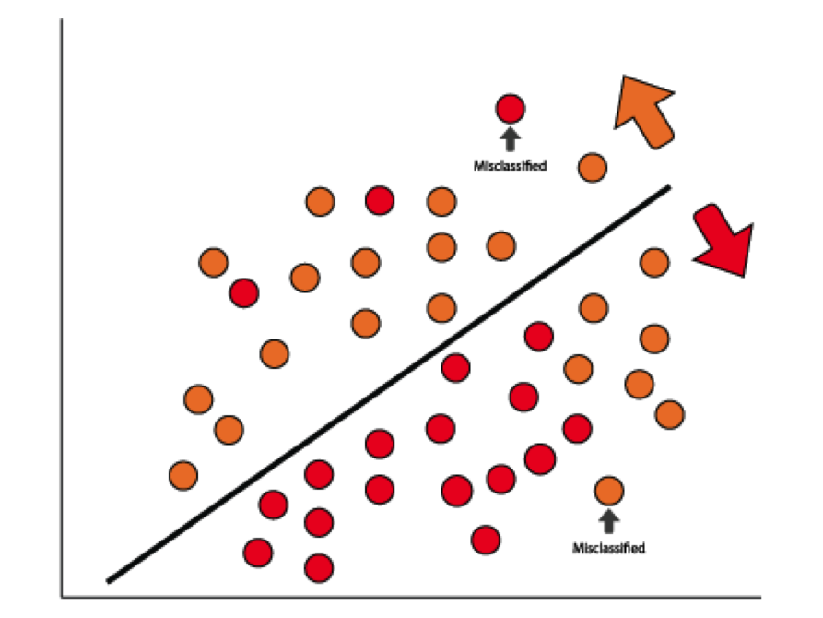

Linear Discriminants seperate groups

*Linear Discriminants seperate groups*

## LDA for two classes

Consider a set of observations $\overset{⃗}{x}$ and a known class y

LDA approaches the problem by assuming that the conditional probability density functions $p(\overset{⃗}{x}|y=0)$ and $p(\overset{⃗}{x}|y=1)$ are both normally distributed with mean and covariance parameters $\left({\overset{⃗}{μ}}_{0},Σ_{0}\right)$ and $\left({\overset{⃗}{μ}}_{1},Σ_{1}\right)$

LDA instead makes the additional simplifying homoscedasticity assumption (i.e. that the class covariances are identical, so $(Σ_{0}=Σ_{1}=Σ)$ and that the covariances have full rank.

In this case, several terms cancel:

$${\overset{⃗}{x}}^{T}Σ_{0}^{−1}\overset{⃗}{x}={\overset{⃗}{x}}^{T}Σ_{1}^{−1}\overset{⃗}{x}{\overset{⃗}{x}}^{T}{Σ_{i}}^{−1}\overset{⃗}{μ_{i}}={\overset{⃗}{μ_{i}}}^{T}{Σ_{i}}^{−1}\overset{⃗}{x}$$

because $Σ_{i}$ is [Hermitian](https://en.wikipedia.org/wiki/Hermitian_matrix) (i.e. a square matrix with complex entries that is equal to its own conjugate transpose) and the above decision criterion becomes a threshold on the dot product $\overset{⃗}{w}⋅\overset{⃗}{x}>c$ for some threshold constant c, where $\overset{⃗}{w}=Σ^{−1}({\overset{⃗}{μ}}_{1}−{\overset{⃗}{μ}}_{0})c=\frac{1}{2}(T−{\overset{⃗}{μ_{0}}}^{T}Σ_{0}^{−1}\overset{⃗}{μ_{0}}+{\overset{⃗}{μ_{1}}}^{T}Σ_{1}^{−1}\overset{⃗}{μ_{1}})$

This means that the criterion of an input $\overset{⃗}{x}$ being in a class y is purely a function of this linear combination of the known observations. That is the $\overset{⃗}{x}$ postion is classified by n-lines and its postion in n-dimensional space determines its class.

## Fisher's linear discriminant

Suppose two classes of observations have means ${\overset{⃗}{μ}}_{0},{\overset{⃗}{μ}}_{1}$ and covariances $Σ_{0},Σ_{1}$. Then the linear combination of features $w x $ will have means $\overset{⃗}{w}⋅\overset{⃗}{μ_{i}}$ and variances ${\overset{⃗}{w}}^{T}Σ_{i}\overset{⃗}{w}$ for i=0,1 . Fisher defined the separation between these two distributions to be the ratio of the variance between the classes to the variance within the classes:

$$S=\frac{σ_{between}^{2}}{σ_{within}^{2}}=\frac{(\overset{⃗}{w}⋅{\overset{⃗}{μ}}_{1}−\overset{⃗}{w}⋅{\overset{⃗}{μ}}_{0})^{2}}{{\overset{⃗}{w}}^{T}Σ_{1}\overset{⃗}{w}+{\overset{⃗}{w}}^{T}Σ_{0}\overset{⃗}{w}}=\frac{(\overset{⃗}{w}⋅({\overset{⃗}{μ}}_{1}−{\overset{⃗}{μ}}_{0}))^{2}}{{\overset{⃗}{w}}^{T}(Σ_{0}+Σ_{1})\overset{⃗}{w}}$$

This measure is, in some sense, a measure of the signal-to-noise ratio for the class labelling. It can be shown that the maximum separation occurs when $\overset{⃗}{w}∝(Σ_{0}+Σ_{1})^{−1}({\overset{⃗}{μ}}_{1}−{\overset{⃗}{μ}}_{0})$

When the assumptions of LDA are satisfied, the above equation is equivalent to LDA.

## Multiclass LDA

In the case where there are more than two classes, the analysis used in the derivation of the Fisher discriminant can be extended to find a subspace which appears to contain all of the class variability. This generalization is due to CR. Rao.Suppose that each of C classes has a mean $μ_{i}$ and the same covariance $Σ$. Then the scatter between class variability may be defined by the sample covariance of the class means $Σ_{b}=\frac{1}{C}\sum_{i=1}^{C}{(}μ_{i}−μ)(μ_{i}−μ)^{T}$ where $μ$ is the mean of the class means. The class separation in a direction $\overset{⃗}{w}$ in this case will be given by

$$S=\frac{{\overset{⃗}{w}}^{T}Σ_{b}\overset{⃗}{w}}{{\overset{⃗}{w}}^{T}Σ\overset{⃗}{w}}$$

This means that when $\overset{⃗}{w}$ is an eigenvector of $Σ^{−1}Σ_{b}$ the separation will be equal to the corresponding eigenvalue. If $Σ^{−1}Σ_{b}$ is diagonalizable, the variability between features will be contained in the subspace spanned by the eigenvectors corresponding to the C − 1 largest eigenvalues (since $Σ_{b}$ is of rank C − 1 at most). These eigenvectors are primarily used in feature reduction, as in PCA. The eigenvectors corresponding to the smaller eigenvalues will tend to be very sensitive to the exact choice of training data, and it is often necessary to use regularization.

# Linear Discriminant Analysis in R

LDA function ... outcome must be categories

head(wn)

## Cultivar Alcohol Malic.acid Ash Alcalinity.ash Magnesium Total.phenols  
## 1 1 14.23 1.71 2.43 15.6 127 2.80  
## 2 1 13.20 1.78 2.14 11.2 100 2.65  
## 3 1 13.16 2.36 2.67 18.6 101 2.80  
## 4 1 14.37 1.95 2.50 16.8 113 3.85  
## 5 1 13.24 2.59 2.87 21.0 118 2.80  
## 6 1 14.20 1.76 2.45 15.2 112 3.27  
## Flavanoids Nonflavanoid.phenols Proanthocyanins Color.intensity Hue  
## 1 3.06 0.28 2.29 5.64 1.04  
## 2 2.76 0.26 1.28 4.38 1.05  
## 3 3.24 0.30 2.81 5.68 1.03  
## 4 3.49 0.24 2.18 7.80 0.86  
## 5 2.69 0.39 1.82 4.32 1.04  
## 6 3.39 0.34 1.97 6.75 1.05  
## OD280.OD315 Proline  
## 1 3.92 1065  
## 2 3.40 1050  
## 3 3.17 1185  
## 4 3.45 1480  
## 5 2.93 735  
## 6 2.85 1450

summary(wn)

## Cultivar Alcohol Malic.acid Ash   
## Min. :1.000 Min. :11.03 Min. :0.740 Min. :1.360   
## 1st Qu.:1.000 1st Qu.:12.36 1st Qu.:1.603 1st Qu.:2.210   
## Median :2.000 Median :13.05 Median :1.865 Median :2.360   
## Mean :1.938 Mean :13.00 Mean :2.336 Mean :2.367   
## 3rd Qu.:3.000 3rd Qu.:13.68 3rd Qu.:3.083 3rd Qu.:2.558   
## Max. :3.000 Max. :14.83 Max. :5.800 Max. :3.230   
## Alcalinity.ash Magnesium Total.phenols Flavanoids   
## Min. :10.60 Min. : 70.00 Min. :0.980 Min. :0.340   
## 1st Qu.:17.20 1st Qu.: 88.00 1st Qu.:1.742 1st Qu.:1.205   
## Median :19.50 Median : 98.00 Median :2.355 Median :2.135   
## Mean :19.49 Mean : 99.74 Mean :2.295 Mean :2.029   
## 3rd Qu.:21.50 3rd Qu.:107.00 3rd Qu.:2.800 3rd Qu.:2.875   
## Max. :30.00 Max. :162.00 Max. :3.880 Max. :5.080   
## Nonflavanoid.phenols Proanthocyanins Color.intensity Hue   
## Min. :0.1300 Min. :0.410 Min. : 1.280 Min. :0.4800   
## 1st Qu.:0.2700 1st Qu.:1.250 1st Qu.: 3.220 1st Qu.:0.7825   
## Median :0.3400 Median :1.555 Median : 4.690 Median :0.9650   
## Mean :0.3619 Mean :1.591 Mean : 5.058 Mean :0.9574   
## 3rd Qu.:0.4375 3rd Qu.:1.950 3rd Qu.: 6.200 3rd Qu.:1.1200   
## Max. :0.6600 Max. :3.580 Max. :13.000 Max. :1.7100   
## OD280.OD315 Proline   
## Min. :1.270 Min. : 278.0   
## 1st Qu.:1.938 1st Qu.: 500.5   
## Median :2.780 Median : 673.5   
## Mean :2.612 Mean : 746.9   
## 3rd Qu.:3.170 3rd Qu.: 985.0   
## Max. :4.000 Max. :1680.0

length(wn)

## [1] 14

You can also embed plots, for example:

names(wn)

## [1] "Cultivar" "Alcohol" "Malic.acid"   
## [4] "Ash" "Alcalinity.ash" "Magnesium"   
## [7] "Total.phenols" "Flavanoids" "Nonflavanoid.phenols"  
## [10] "Proanthocyanins" "Color.intensity" "Hue"   
## [13] "OD280.OD315" "Proline"

scatterplotMatrix(wn[2:6])

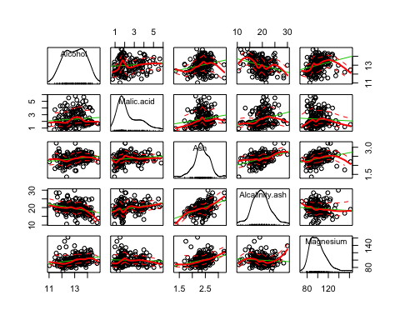

pairs(wn[,2:14])

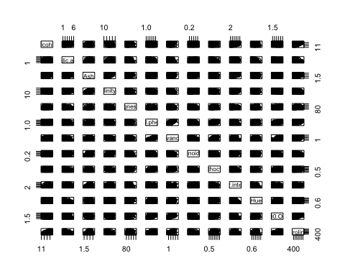

qplot(wn$Alcohol,wn$Ash,data=wn)+geom_point(aes(colour = factor(wn$Cultivar),shape = factor(wn$Cultivar)))

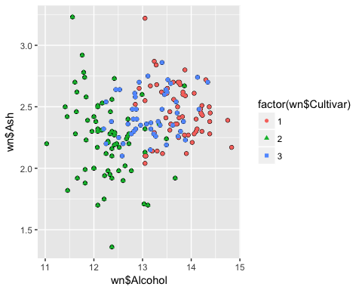

qplot(wn$Malic.acid,wn$Alcohol,data=wn)+geom_point(aes(colour = factor(wn$Cultivar),shape = factor(wn$Cultivar)))

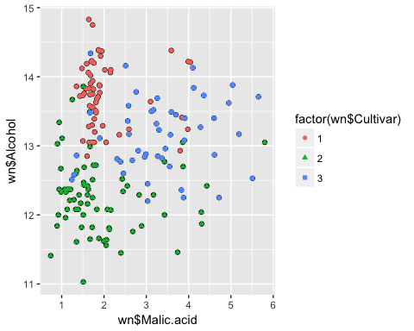

You can also embed plots, for example:

lsa.m1<-lda(Cultivar ~ Malic.acid + Alcohol, data=wn)  
lsa.m1

## Call:  
## lda(Cultivar ~ Malic.acid + Alcohol, data = wn)  
##   
## Prior probabilities of groups:  
## 1 2 3   
## 0.3314607 0.3988764 0.2696629   
##   
## Group means:  
## Malic.acid Alcohol  
## 1 2.010678 13.74475  
## 2 1.932676 12.27873  
## 3 3.333750 13.15375  
##   
## Coefficients of linear discriminants:  
## LD1 LD2  
## Malic.acid -0.1258716 1.0541258  
## Alcohol -1.9357609 -0.2644917  
##   
## Proportion of trace:  
## LD1 LD2   
## 0.7955 0.2045

You can also embed plots, for example:

wine<-wn[which(wn$Cultivar!=1),]  
head(wine)

## Cultivar Alcohol Malic.acid Ash Alcalinity.ash Magnesium Total.phenols  
## 60 2 12.37 0.94 1.36 10.6 88 1.98  
## 61 2 12.33 1.10 2.28 16.0 101 2.05  
## 62 2 12.64 1.36 2.02 16.8 100 2.02  
## 63 2 13.67 1.25 1.92 18.0 94 2.10  
## 64 2 12.37 1.13 2.16 19.0 87 3.50  
## 65 2 12.17 1.45 2.53 19.0 104 1.89  
## Flavanoids Nonflavanoid.phenols Proanthocyanins Color.intensity Hue  
## 60 0.57 0.28 0.42 1.95 1.05  
## 61 1.09 0.63 0.41 3.27 1.25  
## 62 1.41 0.53 0.62 5.75 0.98  
## 63 1.79 0.32 0.73 3.80 1.23  
## 64 3.10 0.19 1.87 4.45 1.22  
## 65 1.75 0.45 1.03 2.95 1.45  
## OD280.OD315 Proline  
## 60 1.82 520  
## 61 1.67 680  
## 62 1.59 450  
## 63 2.46 630  
## 64 2.87 420  
## 65 2.23 355

summary(wine)

## Cultivar Alcohol Malic.acid Ash   
## Min. :2.000 Min. :11.03 Min. :0.740 Min. :1.360   
## 1st Qu.:2.000 1st Qu.:12.16 1st Qu.:1.490 1st Qu.:2.195   
## Median :2.000 Median :12.52 Median :2.160 Median :2.320   
## Mean :2.403 Mean :12.63 Mean :2.498 Mean :2.322   
## 3rd Qu.:3.000 3rd Qu.:13.11 3rd Qu.:3.400 3rd Qu.:2.500   
## Max. :3.000 Max. :14.34 Max. :5.800 Max. :3.230   
## Alcalinity.ash Magnesium Total.phenols Flavanoids   
## Min. :10.60 Min. : 70.00 Min. :0.980 Min. :0.340   
## 1st Qu.:18.90 1st Qu.: 86.00 1st Qu.:1.615 1st Qu.:0.760   
## Median :20.50 Median : 93.00 Median :1.950 Median :1.500   
## Mean :20.71 Mean : 96.47 Mean :2.025 Mean :1.557   
## 3rd Qu.:22.50 3rd Qu.:102.50 3rd Qu.:2.420 3rd Qu.:2.135   
## Max. :30.00 Max. :162.00 Max. :3.520 Max. :5.080   
## Nonflavanoid.phenols Proanthocyanins Color.intensity Hue   
## Min. :0.1300 Min. :0.410 Min. : 1.280 Min. :0.4800   
## 1st Qu.:0.2900 1st Qu.:1.035 1st Qu.: 2.800 1st Qu.:0.7000   
## Median :0.4000 Median :1.400 Median : 3.800 Median :0.8900   
## Mean :0.3975 Mean :1.438 Mean : 4.825 Mean :0.9056   
## 3rd Qu.:0.5000 3rd Qu.:1.735 3rd Qu.: 5.940 3rd Qu.:1.0650   
## Max. :0.6600 Max. :3.580 Max. :13.000 Max. :1.7100   
## OD280.OD315 Proline   
## Min. :1.270 Min. :278.0   
## 1st Qu.:1.720 1st Qu.:450.0   
## Median :2.300 Median :560.0   
## Mean :2.341 Mean :564.0   
## 3rd Qu.:2.960 3rd Qu.:673.5   
## Max. :3.690 Max. :985.0

qplot(wine$Alcohol,wine$Ash,data=wine)+geom_point(aes(colour = factor(wine$Cultivar),shape = factor(wine$Cultivar)))

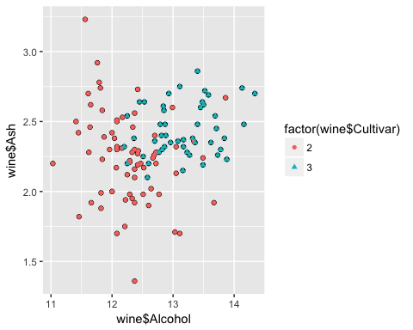

You can also embed plots, for example:

lsa.m2<-lda(Cultivar ~ Alcohol + Ash, data=wine)  
lsa.m2

## Call:  
## lda(Cultivar ~ Alcohol + Ash, data = wine)  
##   
## Prior probabilities of groups:  
## 2 3   
## 0.5966387 0.4033613   
##   
## Group means:  
## Alcohol Ash  
## 2 12.27873 2.244789  
## 3 13.15375 2.437083  
##   
## Coefficients of linear discriminants:  
## LD1  
## Alcohol 1.731380  
## Ash 1.711451

You can also embed plots, for example:

qplot(wine$Malic.acid,wine$Alcohol,data=wine)+geom_point(aes(colour = factor(wine$Cultivar),shape = factor(wine$Cultivar)))

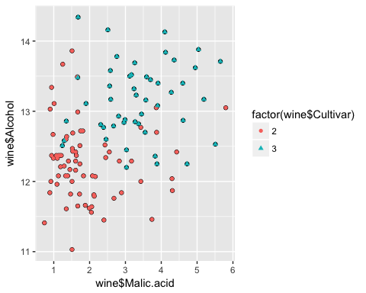

lsa.m3<-lda(Cultivar ~ Malic.acid + Alcohol, data=wine)  
lsa.m3

## Call:  
## lda(Cultivar ~ Malic.acid + Alcohol, data = wine)  
##   
## Prior probabilities of groups:  
## 2 3   
## 0.5966387 0.4033613   
##   
## Group means:  
## Malic.acid Alcohol  
## 2 1.932676 12.27873  
## 3 3.333750 13.15375  
##   
## Coefficients of linear discriminants:  
## LD1  
## Malic.acid 0.5917897  
## Alcohol 1.4310158

You can also embed plots, for example:

names(wine) # Alcohol (2) + Malic.acid(3) + Ash (4)

## [1] "Cultivar" "Alcohol" "Malic.acid"   
## [4] "Ash" "Alcalinity.ash" "Magnesium"   
## [7] "Total.phenols" "Flavanoids" "Nonflavanoid.phenols"  
## [10] "Proanthocyanins" "Color.intensity" "Hue"   
## [13] "OD280.OD315" "Proline"

lsa.m2.p<-predict(lsa.m2, newdata = wine[,c(2,4)])  
lsa.m2.p

## $class  
## [1] 2 2 2 3 2 2 2 2 2 3 2 2 3 3 3 2 2 2 2 2 2 2 2 2 3 2 2 2 2 2 2 2 2 2 2  
## [36] 2 2 2 2 2 2 2 2 2 2 2 2 2 2 2 2 2 2 2 2 2 2 2 2 2 2 2 2 2 3 2 2 2 2 2  
## [71] 2 3 3 3 2 2 2 2 2 3 3 3 3 3 3 2 3 3 3 3 3 3 3 3 3 2 3 3 2 3 3 2 3 3 3  
## [106] 3 3 3 2 3 3 2 2 3 3 3 3 3 3  
## Levels: 2 3  
##   
## $posterior  
## 2 3  
## 60 0.989977684 0.010022316  
## 61 0.860205334 0.139794666  
## 62 0.838593501 0.161406499  
## 63 0.209954614 0.790045386  
## 64 0.887755020 0.112244980  
## 65 0.823294624 0.176705376  
## 66 0.691167667 0.308832333  
## 67 0.760808366 0.239191634  
## 68 0.944036698 0.055963302  
## 69 0.159729938 0.840270062  
## 70 0.979624822 0.020375178  
## 71 0.897120725 0.102879275  
## 72 0.013401616 0.986598384  
## 73 0.146736039 0.853263961  
## 74 0.214129980 0.785870020  
## 75 0.949560229 0.050439771  
## 76 0.993894082 0.006105918  
## 77 0.799148583 0.200851417  
## 78 0.971785045 0.028214955  
## 79 0.945756380 0.054243620  
## 80 0.563880013 0.436119987  
## 81 0.977119573 0.022880427  
## 82 0.695144470 0.304855530  
## 83 0.868676341 0.131323659  
## 84 0.352497800 0.647502200  
## 85 0.919432248 0.080567752  
## 86 0.702175704 0.297824296  
## 87 0.905944583 0.094055417  
## 88 0.948585474 0.051414526  
## 89 0.969289259 0.030710741  
## 90 0.927713154 0.072286846  
## 91 0.923364171 0.076635829  
## 92 0.918995588 0.081004412  
## 93 0.674959331 0.325040669  
## 94 0.894171102 0.105828898  
## 95 0.983437283 0.016562717  
## 96 0.835137841 0.164862159  
## 97 0.883445568 0.116554432  
## 98 0.947426162 0.052573838  
## 99 0.905284898 0.094715102  
## 100 0.897120725 0.102879275  
## 101 0.988407338 0.011592662  
## 102 0.896064451 0.103935549  
## 103 0.771530871 0.228469129  
## 104 0.991055782 0.008944218  
## 105 0.899267283 0.100732717  
## 106 0.826525939 0.173474061  
## 107 0.929392410 0.070607590  
## 108 0.639177508 0.360822492  
## 109 0.962358167 0.037641833  
## 110 0.942148220 0.057851780  
## 111 0.997639559 0.002360441  
## 112 0.825998365 0.174001635  
## 113 0.834383702 0.165616298  
## 114 0.983044410 0.016955590  
## 115 0.872235013 0.127764987  
## 116 0.998015001 0.001984999  
## 117 0.987390259 0.012609741  
## 118 0.859807113 0.140192887  
## 119 0.795593234 0.204406766  
## 120 0.977119573 0.022880427  
## 121 0.985003517 0.014996483  
## 122 0.781973158 0.218026842  
## 123 0.527325472 0.472674528  
## 124 0.497893897 0.502106103  
## 125 0.949718413 0.050281587  
## 126 0.952315853 0.047684147  
## 127 0.812472048 0.187527952  
## 128 0.876866423 0.123133577  
## 129 0.835643218 0.164356782  
## 130 0.918886086 0.081113914  
## 131 0.499639567 0.500360433  
## 132 0.421215952 0.578784048  
## 133 0.476445877 0.523554123  
## 134 0.594636691 0.405363309  
## 135 0.791991332 0.208008668  
## 136 0.769842178 0.230157822  
## 137 0.777618886 0.222381114  
## 138 0.510560146 0.489439854  
## 139 0.167614340 0.832385660  
## 140 0.298836253 0.701163747  
## 141 0.193996818 0.806003182  
## 142 0.155442810 0.844557190  
## 143 0.033209945 0.966790055  
## 144 0.074284258 0.925715742  
## 145 0.910918990 0.089081010  
## 146 0.395857398 0.604142602  
## 147 0.048610995 0.951389005  
## 148 0.368573548 0.631426452  
## 149 0.159828615 0.840171385  
## 150 0.303622813 0.696377187  
## 151 0.047803683 0.952196317  
## 152 0.429739155 0.570260845  
## 153 0.103701465 0.896298535  
## 154 0.257970672 0.742029328  
## 155 0.830177214 0.169822786  
## 156 0.270671886 0.729328114  
## 157 0.034899121 0.965100879  
## 158 0.573873462 0.426126538  
## 159 0.002661702 0.997338298  
## 160 0.047837151 0.952162849  
## 161 0.803071776 0.196928224  
## 162 0.034032344 0.965967656  
## 163 0.312148962 0.687851038  
## 164 0.397616578 0.602383422  
## 165 0.053367143 0.946632857  
## 166 0.069795677 0.930204323  
## 167 0.059027745 0.940972255  
## 168 0.547207109 0.452792891  
## 169 0.030236009 0.969763991  
## 170 0.031375696 0.968624304  
## 171 0.891467608 0.108532392  
## 172 0.601604497 0.398395503  
## 173 0.009404846 0.990595154  
## 174 0.042062372 0.957937628  
## 175 0.097041615 0.902958385  
## 176 0.245800940 0.754199060  
## 177 0.240668148 0.759331852  
## 178 0.004578137 0.995421863  
##   
## $x  
## LD1  
## 60 -2.100088299  
## 61 -0.594808825  
## 62 -0.503058244  
## 63 1.109117982  
## 64 -0.730927716  
## 65 -0.443966927  
## 66 -0.046347425  
## 67 -0.236973923  
## 68 -1.141675891  
## 69 1.290800935  
## 70 -1.709643299  
## 71 -0.783865572  
## 72 2.721668210  
## 73 1.345133833  
## 74 1.095566144  
## 75 -1.201190374  
## 76 -2.370955621  
## 77 -0.358369808  
## 78 -1.528757513  
## 79 -1.159587565  
## 80 0.251175826  
## 81 -1.645370396  
## 82 -0.056486721  
## 83 -0.634020133  
## 84 0.720242734  
## 85 -0.929749759  
## 86 -0.074597687  
## 87 -0.837799886  
## 88 -1.190253911  
## 89 -1.481399826  
## 90 -0.993424786  
## 91 -0.959195771  
## 92 -0.926561091  
## 93 -0.005741075  
## 94 -0.766751065  
## 95 -1.824088555  
## 96 -0.489331697  
## 97 -0.707859039  
## 98 -1.177499239  
## 99 -0.833614760  
## 100 -0.783865572  
## 101 -2.020295223  
## 102 -0.777687528  
## 103 -0.269433895  
## 104 -2.162392866  
## 105 -0.796595661  
## 106 -0.456099141  
## 107 -1.007151334  
## 108 0.080429337  
## 109 -1.367153862  
## 110 -1.122593049  
## 111 -2.888376675  
## 112 -0.454106224  
## 113 -0.486366903  
## 114 -1.811159175  
## 115 -0.651134640  
## 116 -2.982518756  
## 117 -1.974133286  
## 118 -0.593015199  
## 119 -0.346436886  
## 120 -1.645370396  
## 121 -1.878820037  
## 122 -0.302093158  
## 123 0.331168194  
## 124 0.395067096  
## 125 -1.202984000  
## 126 -1.233227180  
## 127 -0.404556327  
## 128 -0.674028608  
## 129 -0.491324614  
## 130 -0.925763924  
## 131 0.391280552  
## 132 0.562824209  
## 133 0.441627616  
## 134 0.182717797  
## 135 -0.334503964  
## 136 -0.264252310  
## 137 -0.288342028  
## 138 0.367589418  
## 139 1.259561296  
## 140 0.852973666  
## 141 1.162828422  
## 142 1.308314025  
## 143 2.218571579  
## 144 1.758472800  
## 145 -0.870235275  
## 146 0.619747899  
## 147 2.003257487  
## 148 0.682426468  
## 149 1.290402351  
## 150 0.840642160  
## 151 2.012798908  
## 152 0.543916076  
## 153 1.560049341  
## 154 0.963433087  
## 155 -0.470024980  
## 156 0.928008322  
## 157 2.190719900  
## 158 0.229079025  
## 159 3.604074084  
## 160 2.012400325  
## 161 -0.371722355  
## 162 2.204845031  
## 163 0.818943943  
## 164 0.615762065  
## 165 1.949921048  
## 166 1.794894024  
## 167 1.892000899  
## 168 0.287796342  
## 169 2.271110851  
## 170 2.250409093  
## 171 -0.751430183  
## 172 0.166998332  
## 173 2.915906542  
## 174 2.085442064  
## 175 1.600057816  
## 176 0.998459269  
## 177 1.013580859  
## 178 3.308942334

lsa.m2.p$class

## [1] 2 2 2 3 2 2 2 2 2 3 2 2 3 3 3 2 2 2 2 2 2 2 2 2 3 2 2 2 2 2 2 2 2 2 2  
## [36] 2 2 2 2 2 2 2 2 2 2 2 2 2 2 2 2 2 2 2 2 2 2 2 2 2 2 2 2 2 3 2 2 2 2 2  
## [71] 2 3 3 3 2 2 2 2 2 3 3 3 3 3 3 2 3 3 3 3 3 3 3 3 3 2 3 3 2 3 3 2 3 3 3  
## [106] 3 3 3 2 3 3 2 2 3 3 3 3 3 3  
## Levels: 2 3

You can also embed plots, for example:

lsa.m3.p<-predict(lsa.m3, newdata = wine[,c(2,3)])  
lsa.m1.p<-predict(lsa.m1, newdata = wn[,c(2,3)])

You can also embed plots, for example:

cm.m1<-table(lsa.m1.p$class,wn[,c(1)])  
cm.m1

##   
## 1 2 3  
## 1 51 5 7  
## 2 1 61 9  
## 3 7 5 32

cm.m2<-table(lsa.m2.p$class,wine[,c(1)])  
cm.m2

##   
## 2 3  
## 2 64 12  
## 3 7 36

cm.m3<-table(lsa.m3.p$class,wine[,c(1)])  
cm.m3

##   
## 2 3  
## 2 63 11  
## 3 8 37

# Resources

* [Discriminant Function Analysis](http://blog.datacamp.com/machine-learning-in-r/)
* [Computing and visualizing LDA in R](https://tgmstat.wordpress.com/2014/01/15/computing-and-visualizing-lda-in-r/)
* [Computing and visualizing LDA in R](http://www.r-bloggers.com/computing-and-visualizing-lda-in-r/)