Spectral Analysis

Nik Bear Brown

In this lesson we'll learn the how to implement Spectral Analysis in R.

# Additional packages needed

To run the code you may need additional packages.

* If necessary install the followings packages.

install.packages("TSA");

library(TSA)

## Loading required package: leaps

## Loading required package: locfit

## locfit 1.5-9.1 2013-03-22

## Loading required package: mgcv

## Loading required package: nlme

## This is mgcv 1.8-15. For overview type 'help("mgcv-package")'.

## Loading required package: tseries

##   
## Attaching package: 'TSA'

## The following objects are masked from 'package:stats':  
##   
## acf, arima

## The following object is masked from 'package:utils':  
##   
## tar

# Data

We will be using two data sets:

A. Monthly Deaths from Lung Diseases in the UK. It consists of three time series giving the monthly deaths from bronchitis, emphysema and asthma in the UK, 1974-1979, both sexes (ldeaths), males (mdeaths) and females (fdeaths).

B. A regular time series giving the luteinizing hormone in blood samples at 10 mins intervals from a human female, 48 samples.

data(lh)  
lh

## Time Series:  
## Start = 1   
## End = 48   
## Frequency = 1   
## [1] 2.4 2.4 2.4 2.2 2.1 1.5 2.3 2.3 2.5 2.0 1.9 1.7 2.2 1.8 3.2 3.2 2.7  
## [18] 2.2 2.2 1.9 1.9 1.8 2.7 3.0 2.3 2.0 2.0 2.9 2.9 2.7 2.7 2.3 2.6 2.4  
## [35] 1.8 1.7 1.5 1.4 2.1 3.3 3.5 3.5 3.1 2.6 2.1 3.4 3.0 2.9

head(lh)

## [1] 2.4 2.4 2.4 2.2 2.1 1.5

names(lh)

## NULL

data(UKLungDeaths)  
deaths <- ts.union(mdeaths, fdeaths)  
head(deaths)

## mdeaths fdeaths  
## [1,] 2134 901  
## [2,] 1863 689  
## [3,] 1877 827  
## [4,] 1877 677  
## [5,] 1492 522  
## [6,] 1249 406

names(deaths)

## NULL

# Spectral Analysis

Spectral analysis or Spectrum analysis is based on the analysis of frequencies rather than fluctuations of numbers. In statistical signal processing, the goal of spectral density estimation (SDE) is to estimate the spectral density (also known as the power spectral density) of a random signal from a sequence of time samples of the signal. Intuitively speaking, the spectral density characterizes the frequency content of the signal. One purpose of estimating the spectral density is to detect any periodicities in the data, by observing peaks at the frequencies corresponding to these periodicities.

statistics and signal processing, an algorithm that estimates the strength of different frequency components (the power spectrum) of a time-domain signal. This may also be called frequency domain analysis. There are many approaches to spectral density. Below is a partial list of parametric and non-parametric spectral density estimation techniques.

Non-parametric spectral density estimation techniques:

* Periodogram, the basic modulus-squared of the discrete Fourier transform
* Bartlett's method is the average of the periodograms taken of multiple segments of the signal to reduce variance of the spectral density estimate  
  Welch's method a windowed version of Bartlett's method that uses overlapping segments
* Multitaper is a periodogram-based method that uses multiple tapers, or windows, to form independent estimates of the spectral density to reduce variance of the spectral density estimate
* Least-squares spectral analysis, based on least squares fitting to known frequencies
* Non-uniform discrete Fourier transform is used when the signal samples are unevenly spaced in time
* Singular spectrum analysis is a nonparametric method that uses a singular value decomposition of the covariance matrix to estimate the spectral density Short-time Fourier transform

Parametric spectral density estimation techniques:

* Autoregressive model (AR) estimation, which assumes that the nth sample is correlated with the previous p samples.
* Moving-average model (MA) estimation, which assumes that the nth sample is correlated with noise terms in the previous p samples.
* Autoregressive moving average (ARMA) estimation, which generalizes the AR and MA models.
* Maximum entropy spectral estimation is an all-poles method useful for SDE when singular spectral features, such as sharp peaks, are expected.

# Periodogram

Gvien a signal that is sampled at N different times, with the samples uniformly spaced by $Δt$, giving values $x_{n}$. Since the power spectral density of a continuous function defined on the entire real line is the modulus squared of its Fourier transform, the simplest technique to estimate the spectrum is the periodogram, given by the modulus squared of the discrete Fourier transform,

$$S(f)=\frac{Δt}{N}{\left|\sum_{n=0}^{N−1}{x_{n}}e^{−i2πnf}\right|}^{2}, −\frac{1}{2Δt}<f≤\frac{1}{2Δt}$$

where $1/(2Δt)$ is the Nyquist frequency. The name "periodogram" was coined by Arthur Schuster in 1898. Despite the simplicity of the periodogram, the method suffers from severe deficiencies. It is an inconsistent estimator because it does not converge to the true spectral density as $N→∞$. It exhibits very high spectral leakage although this can be reduced by multiplying $x_{n}$ by a window function. In the presence of additive noise, the estimate has a positive bias.

# Fourier analysis

[Fourier analysis](https://en.wikipedia.org/wiki/Fourier_analysis) is the study of the way general functions may be represented or approximated by sums of simpler trigonometric functions. Fourier analysis grew from the study of Fourier series. A [Fourier series](https://en.wikipedia.org/wiki/Fourier_series) is a way to represent a (wave-like) function as the sum of simple sine waves

If, s(x) denotes a function of the real variable x, and s is integrable on an interval [x0, x0 + P], for real numbers x0 and P. We will attempt to represent s in that interval as an infinite sum, or series, of harmonically related sinusoidal functions. Outside the interval, the series is periodic with period P (frequency 1/P). It follows that if s also has that property, the approximation is valid on the entire real line. We can begin with a finite summation (or partial sum):

$$
s_N(x) = \frac{A_0}{2} + \sum_{n=1}^N A_n\cdot \sin(\tfrac{2\pi nx}{P}+\phi_n), \quad \scriptstyle \text{for integer}\ N\ \ge\ 1.
$$

$s_{N}(x)$ is a periodic function with period P. Using the identities:

$$sin({2πnx}/P+ϕ_{n})≡sin(ϕ_{n})cos({2πnx}/P)+cos(ϕ_{n})sin({2πnx}/P)$$

$$sin({2πnx}/P+ϕ_{n})≡Re\left\{\frac{1}{i}⋅e^{i\left({2πnx}/P+ϕ_{n}\right)}\right\}=\frac{1}{2i}⋅e^{i\left({2πnx}/P+ϕ_{n}\right)}+{\left(\frac{1}{2i}⋅e^{i\left({2πnx}/P+ϕ_{n}\right)}\right)}^{*},$$

Function s(x) (in red) is a sum of six sine functions of different amplitudes and harmonically related frequencies. Their summation is called a Fourier series. The Fourier transform, S(f) (in blue), which depicts amplitude vs frequency, reveals the 6 frequencies and their amplitudes.

# Spectral Analysis in R

tsp(mdeaths)

## [1] 1974.000 1979.917 12.000

start(mdeaths)

## [1] 1974 1

end(mdeaths)

## [1] 1979 12

frequency(mdeaths)

## [1] 12

cycle(deaths)

## Jan Feb Mar Apr May Jun Jul Aug Sep Oct Nov Dec  
## 1974 1 2 3 4 5 6 7 8 9 10 11 12  
## 1975 1 2 3 4 5 6 7 8 9 10 11 12  
## 1976 1 2 3 4 5 6 7 8 9 10 11 12  
## 1977 1 2 3 4 5 6 7 8 9 10 11 12  
## 1978 1 2 3 4 5 6 7 8 9 10 11 12  
## 1979 1 2 3 4 5 6 7 8 9 10 11 12

# Plot time series  
par(mfrow = c(2, 2))  
ts.plot(lh)  
ts.plot(deaths, mdeaths, fdeaths,  
 lty = c(1, 3, 4), xlab = "year", ylab = "deaths")  
#obtain quarterly sums or annual means of deaths  
aggregate(deaths, 1,sum)

## Time Series:  
## Start = 1974   
## End = 1979   
## Frequency = 1   
## mdeaths fdeaths  
## 1974 19071 7069  
## 1975 19247 6854  
## 1976 18697 7021  
## 1977 16927 6302  
## 1978 17329 6622  
## 1979 16437 6501

aggregate(deaths, 1, mean)

## Time Series:  
## Start = 1974   
## End = 1979   
## Frequency = 1   
## mdeaths fdeaths  
## 1974 1589.250 589.0833  
## 1975 1603.917 571.1667  
## 1976 1558.083 585.0833  
## 1977 1410.583 525.1667  
## 1978 1444.083 551.8333  
## 1979 1369.750 541.7500

#Second-Order Summaries  
#acf for multiple time series:  
acf(lh)  
acf(lh, type = "covariance")

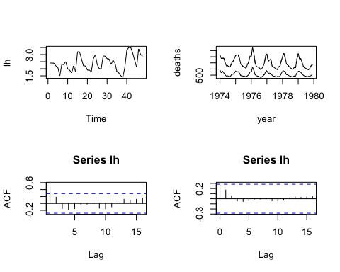

acf(deaths)  
acf(ts.union(mdeaths, fdeaths))  
#Note: spectrum by de-fault removes a linear trend from the series before estimating the spectral density  
par(mfrow = c(2, 2))

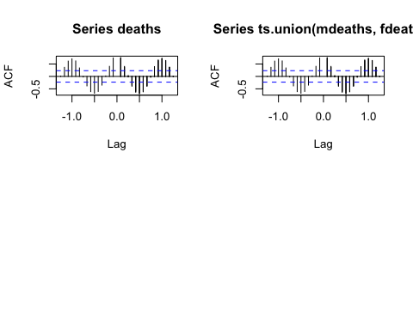

spectrum(lh)  
spectrum(deaths)  
#deaths.spec <- spectrum(deaths, plot=FALSE)  
#deaths.spec$spec # these are the periodogram ordinates for both series  
#deaths.spec$freq # these are the frequencies omega  
#The function spectrum also produces smoothed plots, using repeated  
#smoothing with modified Daniell smoothers (Bloomfield, 2000, p. 157), which  
#are moving averages giving half weight to the end values of the span. Trial-and-  
#error is needed to choose the spans  
# The function spectrum estimates of the spectral density at frequencies   
par(mfrow = c(2, 2))

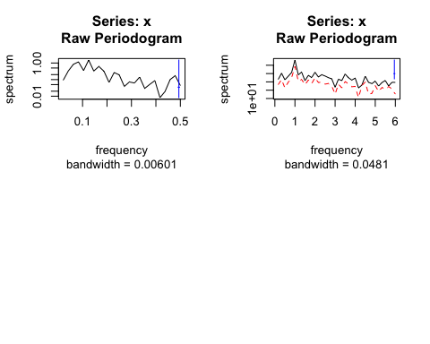

spectrum(lh)  
spectrum(lh, spans = 3)  
spectrum(lh, spans = c(3, 3))  
spectrum(lh, spans = c(3, 5))

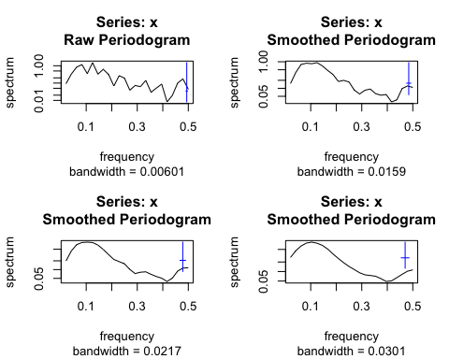

spectrum(mdeaths)  
spectrum(mdeaths, spans = c(3, 3))  
spectrum(mdeaths, spans = c(3, 5))  
spectrum(mdeaths, spans = c(5, 7))

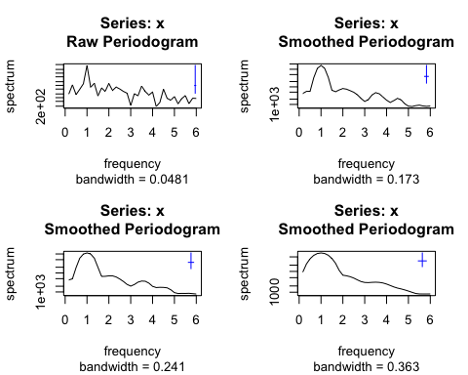

# plot the cumulative periodogram  
cpgram(lh)  
cpgram(mdeaths)  
cpgram(fdeaths)  
# ARIMA models  
acf(lh, type = "partial")

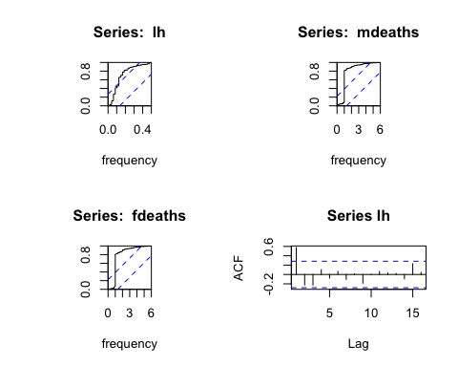

acf(deaths, type = "partial")  
# Model Fitting   
lh.ar1 <- ar(lh, aic = F, order.max = 1)  
cpgram(lh.ar1$resid, main = "AR(1) fit to lh")  
lh.ar <- ar(lh, order.max = 9)  
lh.ar$aic

## 0 1 2 3 4 5   
## 18.3066645 0.9956542 0.5380214 0.0000000 1.4903597 3.2127890   
## 6 7 8 9   
## 4.9932119 6.4694960 8.4625678 8.7411958

cpgram(lh.ar$resid, main = "AR(3) fit to lh")  
lh.arima1 <- arima(lh, order = c(1,0,0))  
tsdiag(lh.arima1)

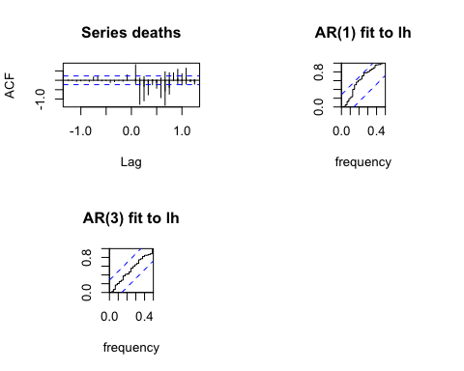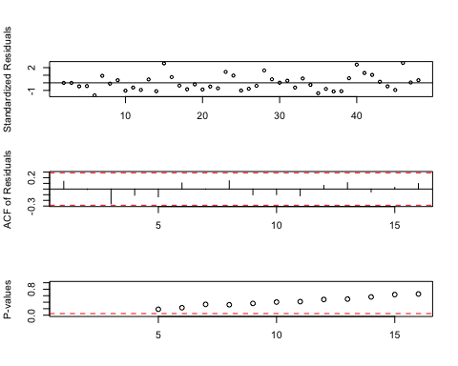

lh.arima3 <- arima(lh, order = c(3,0,0))  
tsdiag(lh.arima3)

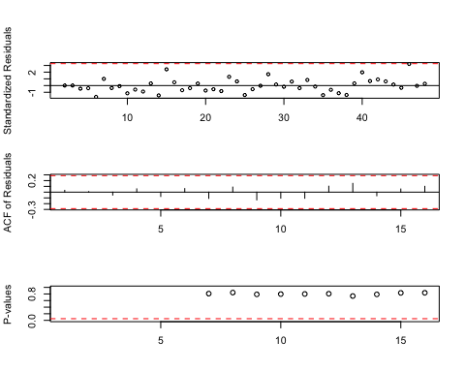

lh.arima11 <- arima(lh, order = c(1,0,1))  
tsdiag(lh.arima11)

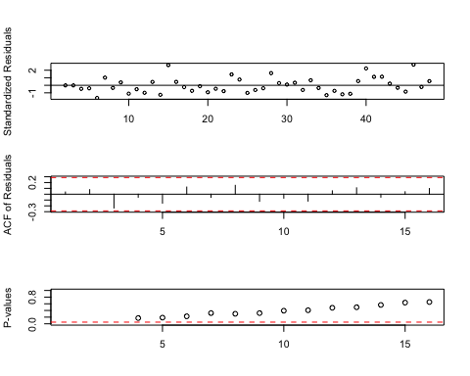

##-----------------Forecasting ------------------------  
lh.fore <- predict(lh.arima3, 12)  
ts.plot(lh, lh.fore$pred, lh.fore$pred + 2*lh.fore$se,  
 lh.fore$pred - 2*lh.fore$se)

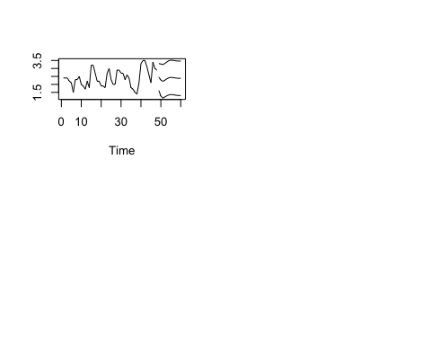

# Resources

* [Spectral Analysis](https://onlinecourses.science.psu.edu/stat510/?q=book/export/html/57)
* [R Time Series Tutorial](http://www.stat.pitt.edu/stoffer/tsa3/R_toot.htm)
* [Time Series Analysis with R](http://www.stats.uwo.ca/faculty/aim/tsar/tsar.pdf)
* [Spectral Analysis - The R Book - Safari Books Online](https://www.safaribooksonline.com/library/view/the-r-book/9780470510247/ch022-sec008.html)

# References

The data, R code and lessons are based upon:

1. Time Series Analysis :

Data Source: <http://www.geophysics.geol.uoa.gr/catalog/catgr_20002008.epi>

Code References :

Book : Mastering Predictive Analytic with R  
Author: Rui Miguel Forte  
<https://www.safaribooksonline.com/library/view/mastering-predictive-analytics/9781783982806/>

Chapter 9: Time series Analysis

<http://www.statoek.wiso.uni-goettingen.de/veranstaltungen/zeitreihen/sommer03/ts_r_intro.pdf>

<http://www.stat.pitt.edu/stoffer/tsa3/R_toot.htm>

<http://www.statoek.wiso.uni-goettingen.de/veranstaltungen/zeitreihen/sommer03/ts_r_intro.pdf>

1. Trend Analysis

Code References :

Book : Mastering Predictive Analytic with R  
Author: Rui Miguel Forte  
<https://www.safaribooksonline.com/library/view/mastering-predictive-analytics/9781783982806/>

<http://www.r-bloggers.com/seasonal-trend-decomposition-in-r/>

1. Seasonal Models

Code references :

Book: Time Series Analysis and Its Applications  
Author: Robert H. Shumway . David S. Stoffer  
Link: <http://www.springer.com/us/book/9781441978646#otherversion=9781461427599>

<http://a-little-book-of-r-for-time-series.readthedocs.org/en/latest/src/timeseries.html>

<https://onlinecourses.science.psu.edu/stat510/?q=node/47>

<https://rpubs.com/ryankelly/tsa5>

<https://onlinecourses.science.psu.edu/stat510/node/68>

Data Reference : <https://github.com/RMDK/TimeSeriesAnalysis/blob/master/colorado_river.csv>

1. Spectral Analysis

Code References:  
Book:  
Modern Applied Statistics with S Fourth edition  
Author: W. N. Venables and B. D. Ripley  
Link: Modern Applied Statistics with S Fourth edition

<http://www.maths.adelaide.edu.au/patty.solomon/TS2004/tsprac3_2004.pdf>