NLP – LYRICS GENERATION

General / Architecture:

* Goal: Building a language model 🡪 model that predicts next word
* Using pretrained models and fine tune those
* Universal Language Model Fine-tuning (ULMFit)

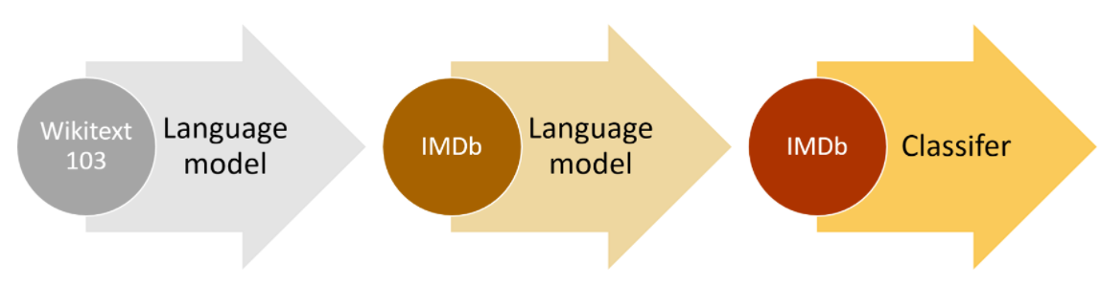

* Here: only steps 1 and 2
* S

Preprocessing:

Model Building: