IT Help Desk Triage Lite
Software Requirements Document (SRD)

Version 0.1 (Draft)

1. System Overview
IT Help Desk Triage Lite is an internal ticket intake and prioritization system designed to support structured IT request management within a small organizational environment. The system standardizes ticket submission, applies defined prioritization rules, and supports basic status tracking and repeat-issue reporting.
The system is intended to improve visibility and consistency in request handling while maintaining simplicity. It is scoped as a lightweight internal solution and is designed to be implementable using standard programming tools (e.g., Python) without reliance on external integrations or enterprise authentication systems.

2. Input Types
IT-01: New Ticket Submission
Fields: Email, Category, Description, Urgency
IT-02: Staff Status Update
Fields: Ticket ID, Status Change, Resolution Notes
IT-03: User Follow-Up Comment
Fields: Ticket ID, Additional Information

3. Output Types
OT-01: Ticket Receipt Summary
Displays Ticket ID, submitted data, assigned priority level, and timestamp.
OT-02: Prioritized Queue Report
Displays ordered list of open tickets sorted by assigned priority and creation time.
OT-03: Repeat-Issue Summary Report
Displays category-based frequency analysis of tickets within a selected time window.

4. User Requirements (UR)
UR-01: Users shall be able to submit a support ticket.
UR-02: Users shall be able to indicate urgency level.
UR-03: Staff shall be able to update ticket status.
UR-04: Users shall receive a confirmation receipt.
UR-05: IT staff shall be able to view a prioritized queue.
UR-06: IT staff shall be able to generate a repeat-issue summary report.

5. System Requirements (SR)
SR-01: The system shall accept structured ticket input including Email, Category, Description, and Urgency.
SR-02: The system shall automatically assign a unique ticket ID upon submission.
SR-03: The system shall assign ticket priority based on predefined category rules.
SR-04: The system shall store ticket data including email address and timestamps.
SR-05: The system shall allow authorized staff to update ticket status.
SR-06: The system shall record timestamps for ticket creation and resolution.
SR-07: The system shall detect potential duplicate tickets within the same category using keyword similarity.
SR-08: The system shall allow the user to select which output report to generate.

6. Functional Requirements (FR)
FR-01: The system shall support ticket creation and storage.
FR-02: The system shall maintain a prioritized ticket queue.
FR-03: The system shall support duplicate detection logic.
FR-04: The system shall generate selectable reports based on stored ticket data.

7. Non-Functional Requirements (NFR)
NFR-01: The system shall respond in 2 seconds under normal operational load (up to 500 stored tickets).
NFR-02: The system shall store ticket data securely in local storage accessible only to authorized staff.
NFR-03: The system shall require no more than four mandatory input fields for ticket submission.
NFR-04: The system shall be implementable using standard Python without reliance on external enterprise integrations.

8. Ambiguity and Assumption Log (Version 0.1)

A-01 – SS-02 – Priority vs Urgency
IT staff want tickets prioritized automatically, but users want to set urgency themselves.
Ambiguity: It is unclear how automatic prioritization should interact with user-selected urgency and whether one should override the other.
Resolution (v0.1): The system assigns priority using predefined category rules. User urgency is recorded but does not override system priority.
Justification: Structured and consistent prioritization improves fairness and prevents queue manipulation.
Explicit Assumption: Each ticket category can be mapped to a default priority level that governs queue order.

A-02 – SS-05 – Authentication Scope
IT wants SSO login, but another stakeholder states no authentication work should be done for the first version.
Ambiguity: It is unclear whether authentication should be implemented, delayed, or simplified.
Resolution (v0.1): No SSO integration will be implemented. Users will provide an email address only.
Justification: Authentication integration increases complexity and conflicts with the lightweight scope.
Explicit Assumption: Email without verification is sufficient for early tracking in Version 0.1.

A-03 – SS-06 – Duplicate Detection Criteria
The system should detect duplicate requests, but ticket entry should remain fast and simple.
Ambiguity: The definition of a duplicate ticket is not specified.
Resolution (v0.1): Duplicate detection will be based on keyword similarity within the same category.
Justification: Simple text similarity balances detection capability with system simplicity.
Explicit Assumption: Basic keyword similarity checking is sufficient for Version 0.1.

A-04 – SS-08 – Time-to-Close Metrics
IT wants time-to-close metrics, but staff do not want to manually track time.
Ambiguity: The definition of time-to-close is not specified.
Resolution (v0.1): Time-to-close equals the difference between creation timestamp and first “Resolved” status.
Justification: Automatically recorded timestamps eliminate manual tracking overhead.
Explicit Assumption: The first recorded “Resolved” status marks official ticket closure.

A-05 – SS-09 – Security vs Minimal Friction
The system should be secure but easy for users with minimal friction.
Ambiguity: “Secure” and “minimal friction” are undefined and may conflict.
Resolution (v0.1): Basic local data protection with limited required fields.
Justification: Lightweight security aligns with the internal-only scope while maintaining usability.
Explicit Assumption: Local storage with restricted access is acceptable for V. 0.1.

A-06 – SS-04 – Repeat-Issue Summary Definition
The system should provide a repeat-issue summary as one of the required outputs.
Ambiguity: It does not define what qualifies as a repeat issue.
Resolution (v0.1): Repeat issues are defined as multiple tickets in the same category within a selected time period.
Justification: Category frequency is measurable and implementable in Python.
Explicit Assumption: Category frequency is sufficient to represent repeat issues in Version 0.1.

9. Requirement Conflicts and Trade-Offs (Version 0.1)

C-01 – System Priority vs User Urgency
Competing Requirements:
- IT staff want automatic prioritization.
- Users want to indicate urgency and influence queue position.
Trade-Off Decision: Category-based system priority governs queue order. User urgency is recorded but does not override.
Requirement Prioritized: System-defined priority rules.
Reasoning: Predictable triage logic improves operational consistency.
Risk Introduced: Users may perceive reduced control over urgency.

C-02 – SSO Integration vs Lightweight Scope
Competing Requirements:
- Stakeholder requests SSO authentication.
- Stakeholder requires no authentication implementation for Version 0.1.
Trade-Off Decision: No SSO integration implemented.
Requirement Prioritized: Lightweight implementation scope.
Reasoning: SSO increases technical complexity and external dependencies.
Risk Introduced: Email identity may not be verified.

C-03 – Duplicate Detection Depth vs Fast Submission
Competing Requirements:
- Detect duplicate tickets.
- Maintain fast and simple submission process.
Trade-Off Decision: Use simple keyword similarity detection.
Requirement Prioritized: Fast submission process.
Reasoning: Advanced duplicate algorithms increase complexity and may affect performance.
Risk Introduced: Some duplicates may not be detected.

10. Traceability Matrix (Version 0.1)

Stakeholder ID | User Req ID | System Req ID | Implementation ID
SS-02 | UR-02 | SR-03 | PY-PRIORITY-01
SS-05 | UR-01 | SR-04 | PY-INPUT-01
SS-06 | UR-01 | SR-07 | PY-VALID-01
SS-08 | UR-05 | SR-06 | PY-TIME-01
SS-04 | UR-06 | SR-08 | PY-OUTPUT-02
SS-09 | UR-01 | SR-04 | PY-STORAGE-01

11. Version History
Version 0.1 establishes the initial structured interpretation of stakeholder needs. This version defines system scope, formalized user and system requirements, ambiguity resolutions with explicit assumptions, documented requirement conflicts and trade-off decisions, and a complete traceability mapping from stakeholder statements to implementation placeholders. Version 0.1 represents the baseline draft for peer review and iterative refinement.

Peer Feedback Summary
Version 0.1 was shared with the team member via Microsoft Teams and GSW email for review prior to refinement. Feedback focused on priority logic (SS-02), duplicate detection criteria (SS-06), clarification of the System Requirements layer, and completeness of the traceability matrix.
For SS-02 (Priority vs. Urgency), Version 0.1 relied on category-based priority rules where user urgency did not directly affect queue order. Peer discussion identified the need for clearer and more measurable prioritization logic. A numeric weighted model was recommended to improve transparency and testability. Version 1.0 implements a priority calculation using predefined category base values combined with a user-selected urgency modifier, producing a consistent and reproducible priority score.
For SS-06 (Duplicate Detection Criteria), Version 0.1 used a percentage-based similarity approach. Peer feedback identified potential false positives with short descriptions. Version 1.0 adopts a difference-based model that flags potential duplicates when the category matches and descriptions differ by no more than two keywords within a seven-day window after removal of common stop-words. Flagged tickets require staff confirmation.
Peer review also identified the need to formalize certain internal behaviors as explicit System Requirements rather than embedding them within Functional Requirements. Version 1.0 separates and clarifies system-level processing rules to strengthen layering and traceability. The traceability matrix was refined to ensure complete vertical mapping from stakeholder statements through user requirements and system requirements to implementation placeholders.
Overall, peer feedback improved Version 1.0 by increasing requirement precision, structural clarity, and traceability completeness while maintaining alignment with stakeholder intent.

IT Help Desk Triage Lite
Software Requirements Document

Version 1.0

System Overview
IT Help Desk Triage Lite remains an internal ticket intake and prioritization system designed to support structured IT request management within a small organizational environment. The system standardizes ticket submission, applies defined prioritization rules, and supports structured status tracking and repeat-issue reporting.
In v1.0, requirement definitions have been refined to improve clarity, measurability, and traceability while maintaining the original scope. The system continues to operate as a lightweight internal solution, implementable using standard programming tools (e.g., Python), without reliance on external integrations or enterprise authentication systems.

Requirements Refinement Evidence
The initial requirements defined in Version 0.1 were used as the foundation and then reviewed to identify ambiguity, stakeholder conflicts, and areas that needed clearer definition. Based on this review and peer feedback, Version 1.0 reflects targeted improvements that make the system’s behavior more precise and easier to test.
One key refinement involved priority assignment. In Version 0.1, priority was primarily determined by category rules, while user urgency was recorded but did not clearly affect queue order. This created a gap because the system needed to keep triage consistent for staff, but users also needed their urgency level to have some controlled influence. In Version 1.0, this was improved by using a weighted numeric model that combines category base values with a user-selected urgency modifier. For example, a critical infrastructure issue receives a higher category base value than a general request, while a high urgency selection adds a limited modifier. This keeps priority assignment structured while still allowing urgency to be considered. As a result, SR-03 became more precise, measurable, and directly testable through PY-PRIORITY-01.

Another major refinement involved duplicate detection. In Version 0.1, duplicate identification relied on general keyword similarity, which did not clearly define how similar two tickets had to be before the system should flag them. This could create confusion for staff and lead to inconsistent results, especially with short ticket descriptions. In Version 1.0, this was replaced with a rule-based approach that compares tickets in the same category, checks whether they were submitted within a seven-day window, and flags them when the keyword difference is less than or equal to two. This makes duplicate detection more specific and easier to apply consistently. Staff confirmation was also added before merging or dismissing duplicate tickets, which helps prevent valid issues from being removed by mistake. As a result, SR-07 became clearer, more testable, and better connected to PY-VALID-01.

These updates show that the requirements were refined through structured analysis and peer feedback. Each change was made to resolve a specific ambiguity, reduce uncertainty, or improve consistency in system behavior. The refined requirements are now more clearly defined, measurable, and directly connected to system logic, testing scenarios, and implementation components. This ensures that the system behaves in a predictable and controlled way while also making it easier to validate through testing and improve through dependability enhancements.

Requirements Validation and Feasibility
The requirements were validated by reviewing the Version 1.0 requirements against the original stakeholder needs, peer feedback, ambiguity log, and traceability matrix. This review confirmed that the final requirements were not only listed, but also clear enough to guide design, implementation, testing, and dependability improvements. Each major requirement was evaluated for purpose, measurable system behavior, and traceability to an implementation identifier.
Validation confirmed that the requirements are testable and consistently applicable. SR-03 defines priority as a numeric score calculated from category base values and urgency modifiers, ensuring that the same inputs always produce the same priority result. SR-07 defines duplicate detection using a keyword-difference rule within a seven-day window, establishing a clear boundary for when the system should flag a ticket as a potential duplicate. These refinements remove vague wording and convert both requirements into verifiable system behaviors.
Stakeholder and peer feedback directly shaped the final requirement decisions. The priority requirement resolves the conflict between staff-controlled triage and user-selected urgency by allowing urgency to influence the score without overpowering the category rules. The duplicate detection requirement resolves the conflict between automation and staff oversight by flagging possible duplicates while requiring staff confirmation before any merge or dismissal occurs. These decisions strengthen system consistency and reduce the risk of incorrect prioritization or accidental ticket removal.
The requirements are feasible because the system remains intentionally lightweight. Core functions can be implemented with standard Python logic, structured ticket data, input validation, timestamp generation, priority calculation, duplicate-checking rules, and basic report generation. The system does not require enterprise authentication, outside APIs, or complex infrastructure, which keeps the scope realistic for a small IT support environment. This makes the system practical to build, test, deploy locally, and maintain while still meeting the needs of users, IT staff, and system administrators.

User Requirements (UR)
UR-01: Users shall be able to submit a help desk ticket including category selection, urgency selection, and description.
UR-02: Users shall have urgency influence considered in ticket prioritization.
UR-03: Staff shall view tickets ordered from highest to lowest priority score.
UR-04: Staff shall be notified when potential duplicate tickets are detected.
UR-05: Staff shall confirm or dismiss duplicate ticket flags.
UR-06: The system shall maintain traceable mappings between stakeholder statements, user requirements, system requirements, and implementation identifiers.

System Requirements (SR)
SR-01: The system shall require category selection before ticket submission.
SR-02: The system shall require urgency selection before ticket submission.
SR-03 (Refined in Version 1.0): The system shall calculate a numeric priority score using predefined category base values combined with a user-selected urgency modifier.
SR-04: The system shall store ticket input data.
SR-05: The system shall evaluate new tickets against tickets submitted within the previous 7 days.
SR-06: The system shall compare ticket submission timestamps.
SR-07 (Refined in Version 1.0): The system shall flag tickets as potential duplicates when the keyword difference between descriptions is less than or equal to 2 within a 7-day submission window.
SR-08: The system shall require staff confirmation before merging or dismissing duplicate tickets.

Functional Requirements (FR)
FR-01: The system shall allow users to create and submit tickets with required fields.
FR-02: The system shall store ticket data in structured format.
FR-03 (Version 1.0 – Refined Priority Logic):
Final Priority Score = Category Base Value + Urgency Modifier
Defined Values:
Category Base Values:
Critical Infrastructure Issue = 3
Software/System Issue = 2
General/Minor Request = 1
Urgency Modifier:
Low = +0
High = +1
Maximum possible score = 4.
Tickets shall be sorted in descending order based on calculated score.
FR-04: The system shall display tickets ordered highest to lowest.
FR-05: The system shall compare ticket descriptions for duplicate detection.
FR-06: The system shall compute keyword differences between ticket descriptions.
FR-07: The system shall flag potential duplicates when keyword difference ≤ 2 within 7 days.
FR-08: The system shall require staff validation before duplicate resolution.

Non-Functional Requirements (NFR)
NFR-01: The system shall respond to ticket submission within 2 seconds.
NFR-02: Priority calculations shall be deterministic and consistent.
NFR-03: Duplicate detection decisions shall be logged for audit purposes.
NFR-04: Duplicate resolution actions shall be restricted to authorized staff users.

Ambiguity and Assumption Log (Version 1.0)

SS-02 — Priority Logic Ambiguity
Ambiguity: It was unclear whether user urgency should override or be ignored by system category rules.
Resolution: Adopt a weighted numeric model combining category base value and urgency modifier.
Justification: Balances structured triage with measurable urgency influence.
Assumption: Category base values remain fixed across system use.

SS-06 — Duplicate Definition Ambiguity
Ambiguity: The definition of “duplicate” was not clearly defined.
Resolution: Duplicate defined as keyword difference ≤ 2 within a 7-day window.
Justification: Provides measurable and testable duplicate detection criteria.
Assumption: Keyword tokenization is consistent across submissions.

SS-05 — Duplicate Handling Authority
Ambiguity: It was unclear whether duplicate tickets would merge automatically.
Resolution: Staff confirmation required before merging or dismissal.
Justification: Prevents unintended ticket loss.
Assumption: Staff users are trained to evaluate duplicates.

SS-02 — Urgency Scale Ambiguity
Ambiguity: The urgency scale was unspecified.
Resolution: Urgency modifier defined as Low (+0) and High (+1).
Justification: Limits excessive influence while preserving user input.
Assumption: Users select urgency honestly.

SS-03 — Queue Ordering Ambiguity
Ambiguity: The ticket sorting method was not defined.
Resolution: Tickets sorted highest to lowest based on numeric score.
Justification: Ensures deterministic and transparent ordering.
Assumption: Numeric scores are calculated consistently.

Requirement Conflicts and Trade-Offs (Version 1.0)

SS-02 — Category Control vs User Urgency
Competing Requirements: System-controlled triage vs user urgency influence.
Decision: Weighted numeric model combining both.
Prioritized: Balanced integration.
Risk: Users may inflate urgency selections; category base values limit impact.

SS-06 — Automation vs Human Oversight
Competing Requirements: Automatic duplicate handling vs staff review.
Decision: Require staff confirmation.
Prioritized: Accuracy over automation speed.
Risk: Minor processing delay.

SS-06 — Broad Matching vs Precision
Competing Requirements: High sensitivity vs false positives.
Decision: Keyword difference threshold ≤ 2.
Prioritized: Controlled detection sensitivity.
Risk: Some semantic duplicates may not be detected.

Traceability Matrix (Version 1.0)

Stakeholder ID | User Req ID | System Req ID | Implementation ID
SS-02 | UR-02 | SR-03 | PY-PRIORITY-01
SS-05 | UR-01 | SR-04 | PY-INPUT-01
SS-06 | UR-01 | SR-07 | PY-VALID-01
SS-08 | UR-05 | SR-06 | PY-TIME-01
SS-04 | UR-06 | SR-08 | PY-OUTPUT-02
SS-09 | UR-01 | SR-04 | PY-STORAGE-01

Version History
Version 0.1 established the initial structured interpretation of stakeholder needs including scope, ambiguity analysis, conflict identification, and traceability mapping.
Version 1.0 refines priority logic to a weighted numeric model incorporating urgency and formalizes duplicate detection criteria using a keyword-difference threshold (≤ 2) within a 7-day window requiring staff confirmation. Requirement wording and ambiguity resolutions were updated accordingly while maintaining consistent traceability identifiers.

Change Log (Version 0.1 → Version 1.0)

Structured Change Table
Change ID | Section Affected | Version 0.1 Description | Version 1.0 Revision | Reason for Change
CL-01 | SR-03 / FR-03 Priority Logic | Priority primarily determined by category rules; urgency influence not formally defined | Implemented numeric weighted model: Category Base Value (3/2/1) + Urgency Modifier (+0 / +1); sorted descending | Resolved SS-02 ambiguity; improved measurability and deterministic ordering
CL-02 | SR-07 / FR-07 Duplicate Detection | Duplicate detection based on percentage similarity threshold | Replaced with keyword-difference rule (≤ 2 keywords within 7-day window); requires staff confirmation | Increased precision, reduced false positives, strengthened testability
CL-03 | Ambiguity & Conflict Sections | Ambiguities identified but resolution thresholds loosely defined | Updated resolutions to include explicit numeric limits and bounded logic | Strengthened requirement clarity and stakeholder alignment

Version 1.0 introduces measurable refinements to priority calculation and duplicate detection while preserving the original system scope. The priority model (SR-03 / FR-03) was revised from a general category-based interpretation to a formally defined numeric weighted structure. Explicit base values (3, 2, 1) and bounded urgency modifiers (+0 / +1) were introduced, producing a maximum priority score of 4 and enforcing deterministic descending queue ordering. This refinement resolves the SS-02 ambiguity by balancing system-controlled triage with controlled user influence.
Duplicate detection logic (SR-07 / FR-07) was similarly refined. The prior percentage-based similarity approach was replaced with a defined keyword-difference threshold (≤ 2 keywords) within a 7-day submission window. This establishes objective classification boundaries and reduces ambiguity in duplicate identification. Staff confirmation was retained to prevent unintended automation errors.
No stakeholder identifiers, requirement IDs, or implementation placeholders were modified between versions. All changes occurred within existing requirement definitions, preserving traceability continuity and demonstrating structured refinement rather than functional expansion.

System Modeling and Design
The system design for IT Help Desk Triage Lite translates the refined requirements into a structured view of how the system works. This section shows how users and IT staff interact with the system, how ticket data moves through the workflow, and how key processes such as input validation, priority calculation, timestamp generation, duplicate detection, and reporting are handled.
The design models are based on the finalized requirements from Version 1.0. The use case diagram identifies the main actions performed by users and IT staff. The activity diagram shows the ticket submission workflow from entry to confirmation. The sequence diagram shows how the user, system, and data storage interact during ticket creation. Together, these models support implementation and testing by making the system behavior easier to understand, verify, and maintain.
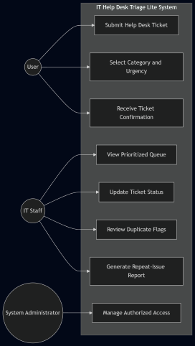
Figure 1: Use Case Diagram for IT Help Desk Triage Lite
(This diagram shows the primary interactions between users, IT staff, and the system. It identifies the main system functions, including ticket submission, queue management, duplicate review, and report generation.)
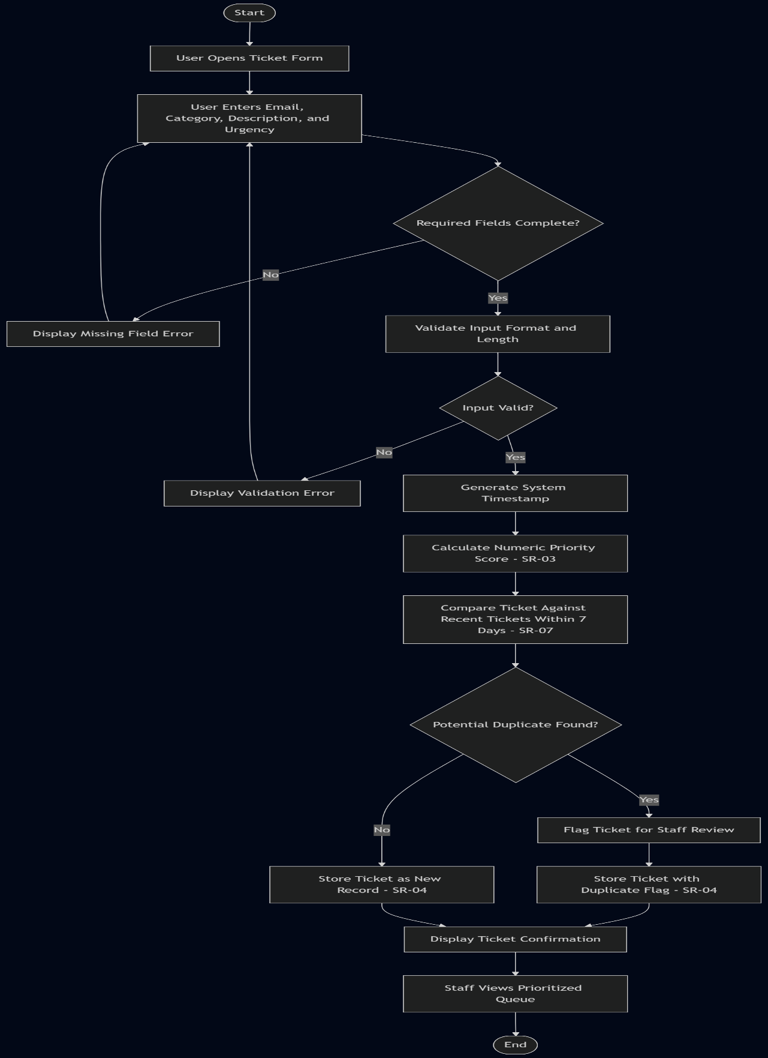
Figure 2: Activity Diagram for Ticket Submission Workflow
(This diagram represents the workflow for ticket submission and processing. It includes validation steps, priority calculation, duplicate detection, and final confirmation, showing how the system handles both valid and invalid inputs.)

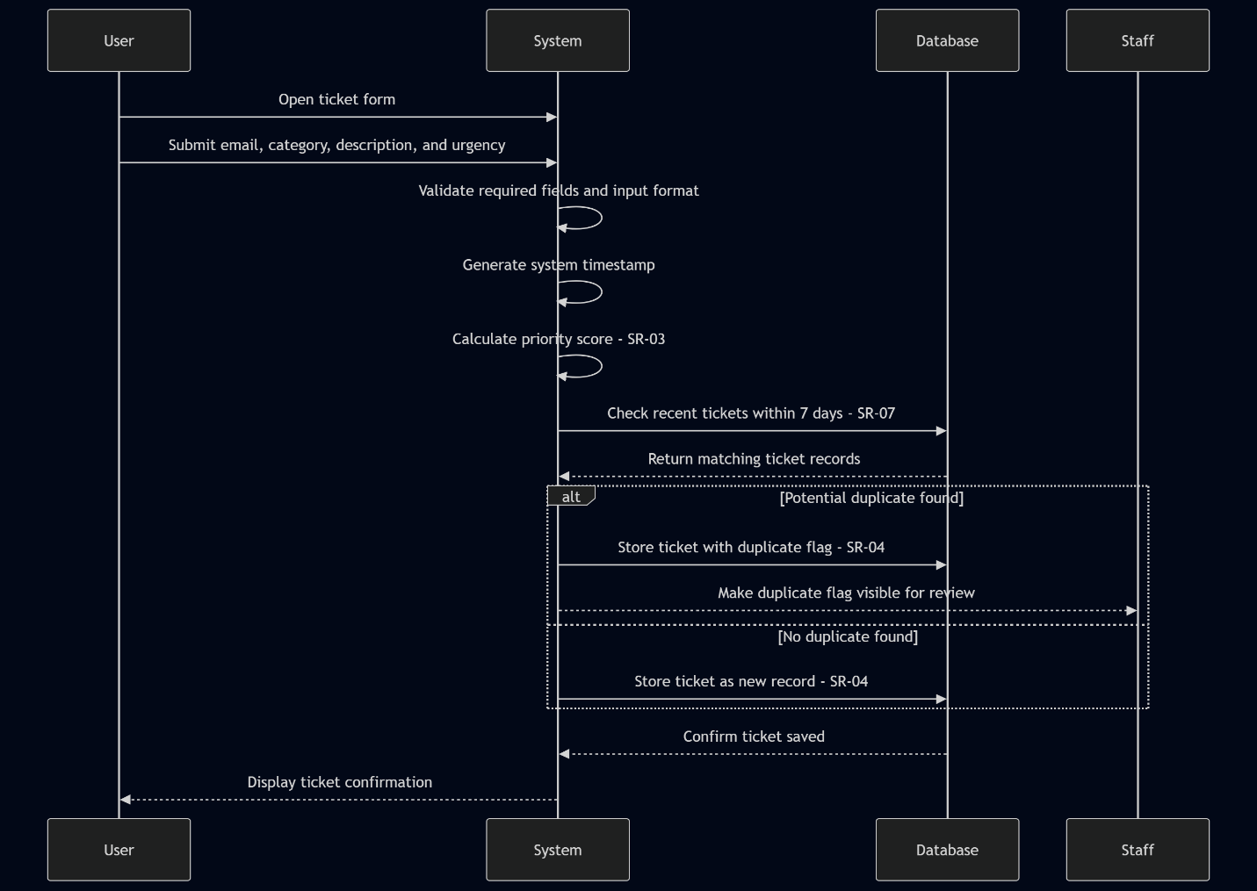
Figure 3: Sequence Diagram for Ticket Creation and Processing
(This diagram shows how the user, system, and database interact during ticket creation. It highlights validation, priority calculation, duplicate checking, and data storage, including alternate flows for duplicate detection.)

IMPLEMENTATION
The implementation of the IT Help Desk Triage Lite system was developed using Python to simulate a functional ticket triage system aligned with the defined system requirements. The system was intentionally implemented as a lightweight, modular prototype to demonstrate core processing logic, data validation, and controlled workflow execution without reliance on external infrastructure. The system architecture is function-based, where each major requirement is implemented as a dedicated operation. The primary workflow is driven through a create_ticket() function, which acts as the central processing unit of the system. This function orchestrates multiple steps, including input validation, timestamp generation, priority calculation, duplicate detection, and data storage. By structuring the system in this way, all ticket processing follows a consistent and repeatable sequence, reducing the risk of inconsistent system behavior.

Input validation (SR-04) is implemented as an initial gatekeeping step to ensure that all required fields—category, issue description, and urgency—are present and correctly formatted before any processing occurs. Invalid inputs are rejected early in the workflow, preventing corrupted or incomplete data from entering the system. Priority calculation (SR-03) is implemented using a deterministic weighted model that combines predefined category base values with urgency modifiers. This ensures that the system produces consistent and predictable prioritization outcomes. The use of a numeric scoring approach eliminates ambiguity and supports ordered queue processing.

Timestamp generation (SR-06) is handled using system-generated values to ensure accuracy and prevent user manipulation. Each ticket is automatically assigned a timestamp at the time of creation, which supports chronological tracking and enables time-based logic such as duplicate detection windows. Duplicate detection (SR-07) is implemented using a rule-based comparison approach. The system evaluates whether two tickets belong to the same category and compares their issue descriptions by analyzing keyword differences. A threshold is applied to determine similarity, and matching tickets are flagged as potential duplicates. This approach balances automation with control, as duplicate identification is assisted by the system while still allowing for review.

Queue assignment and ticket handling are implemented to reflect operational workflow. Tickets are categorized and routed based on their type, ensuring that issues are directed to the appropriate support group. This supports efficient handling and aligns with real-world help desk practices. Report generation (SR-08) is implemented with controlled output validation. The system only accepts supported formats (PDF, XLSX, CSV), and invalid requests are rejected before processing. This prevents incorrect outputs and enforces consistency in reporting functionality. The system uses in-memory data structures to simulate ticket storage, allowing for efficient testing and validation without requiring a database. While simplified, this approach preserves the integrity of system behavior and supports full traceability between requirements, implementation logic, and testing scenarios.

Overall, the implementation emphasizes clarity, determinism, and alignment with defined requirements. Each component was designed to directly support system behavior, ensuring that the system is both testable and reliable within its intended scope.

Testing and Validation – TDD
TDD Improvement Based on Feedback
The testing approach was refined based on prior feedback from Assignment 4. The original test file included structured scenarios, but some tests relied too heavily on comparing hardcoded values instead of calling real system functions. To improve the final version, the tests were revised to validate actual system behavior through functions such as create_ticket(), detect_duplicate(), update_status(), assign_queue(), and generate_report().
This improved approach better reflects Test-Driven Development because each test now exercises system logic directly and checks meaningful outcomes. For example, priority tests validate the numeric priority calculation, duplicate detection tests call the duplicate-checking function, and report generation tests confirm that valid formats are accepted while invalid formats are rejected. This strengthens the connection between requirements, implementation, and validation.

Major SR Test Scenarios

SR-03
Journey Map
Actor: Sonny Calzone
Scenario: Sonny needs to be able to select an urgency modifier that ties together with categorical values to determine a numeric priority score.
Expectations: Selection of urgency is simple, “click select”, priority calculations are hidden from the user.
Phases:
Create Ticket -> Data Entry -> Select Urgency -> Submit Ticket
Actions, Mindsets, Emotions:
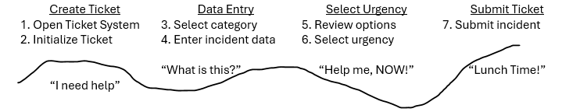
Opportunities: Users have chance to enter details and influence ticket priority via urgency selection.

SR-03 Happy Scenario: Place Ticket Successfully
- Title: Ticket Creation
- Precondition: User has access to create incidents.
- Steps:
  - User navigates to the "IT Help Desk" intranet site.
  - User opens a ticket, selects the category and enters issue information, picks an urgency.
  - User submits the incident form.
  - System calculates priority based on Weighted Category and Urgency combination.
- Expected Outcome: The system creates the incident, assigning the ticket priority via appropriate calculations combining Category and Urgency values.
- Traceability: (SR-03, PY-PRIORITY-01)

SR-03 Edge Case Scenario: Priority Assignment with Maximum Urgency
- Title: Ticket Creation with Maximum Urgency
- Precondition: User has access to create incidents.
- Steps:
  - User navigates to the "IT Help Desk" intranet site.
  - User opens a ticket, selects the category, enters issue information, and selects an urgency level.
  - System calculates priority based on Category and Weighted Urgency combination.
- Expected Outcome: The system successfully creates the incident and assigns the correct ticket priority based on the category and maximum urgency level.
- Traceability: (SR-03, PY-PRIORITY-01)

SR-04
Journey Map – Not Applicable

SR-04 Happy Scenario: Ticket Data Stored Successfully
- Title: Ticket Data Saved
- Precondition: User has submitted a valid incident form.
- Steps:
  - User submits incident with all details.
  - System reads form data at incident submission.
  - System creates new record in Incident DB to save incident form details
- Expected Outcome: The system stores submitted incident data in the Incident Database successfully.
- Traceability: (SR-04, PY-INPUT-01, PY-STORAGE-01)

SR-04 Failure Case Scenario: Incomplete Ticket Data Not Stored
- Title: Rejected Ticket Data
- Precondition: User has submitted an incident form with missing or invalid required data.
- Steps:
  - User submits an incident form with missing or invalid data.
  - System validates the submitted form data.
  - System detects that the form data is incomplete or invalid.
  - System stops submission from being stored.
- Expected Outcome:
- The system rejects the submission, displays a validation error message, and does not create a record in the Incident database.
- Traceability: (SR-04, PY-INPUT-01, PY-STORAGE-01)

SR-06
Journey Map – Not Applicable

SR-06 Happy Scenario: Ticket Creation Date/Time Data Stored Successfully
- Title: Ticket Time Data Saved
- Precondition: User has submitted incident.
- Steps:
  - User submits incident with all details.
  - System reads date/time at incident submission.
  - System includes date and time data in new record in Incident DB to save incident form details
- Expected Outcome: The system creates Incident DB record with date and time stamp successfully.
- Traceability: (SR-06, PY-TIME-01)

SR-06 Edge Scenario: Invalid Timestamp Handling
- Title: Invalid Ticket Time Data
- Precondition: User has submitted incident.
- Steps:
  - User submits incident with all details.
  - System reads incorrect date/time at incident submission.
  - System detects that the provided timestamp is invalid.
  - System replaces the invalid timestamp with the system-generated time.
- Expected Outcome: The system creates the Incident DB record using a valid system generated timestamp instead of the invalid input.
- Traceability: (SR-06, PY-TIME-01)

SR-07
Journey Map – Not Applicable

SR-07 Happy Scenario: Ticket Duplication Detection Success
- Title: Ticket Duplication Check
- Precondition: Ticket Data Saved.
- Steps:
  - New Incident DB record saved with Date / Time stamp details.
  - System reads user and category data and identifies incident keywords.
  - System compares incident keywords to other open incidents with the same category.
  - System detects no duplication.
- Expected Outcome: The system validates Incident DB record as a unique record.
- Traceability: (SR-07, PY-VALID-01)

SR-07 Failure Scenario: Duplicate Ticket Detected
- Title: Ticket Duplication Check
- Precondition: Ticket Data Saved.
- Steps:
  - New Incident DB record saved with Date / Time stamp details.
  - System reads user and category data and identifies incident keywords.
  - System compares incident keywords to other open incidents with the same category.
  - System detects duplication via category and keyword matching.
- Expected Outcome: The system invalidates Incident DB record as a duplicate record.
- Traceability: (SR-07, PY-VALID-01)

SR-08
Journey Map
Actor: Lucy Lawfull
Scenario: Lucy needs to be able to select which output report is needed for her weekly reporting requirements.
Expectations: Report selection should be easy for the user, preferably via dropdown menus, a preview window, and submit button.
Phases:
Access Reporting Form -> Pick Report -> Submit Form -> Receive Report
Actions, Mindsets, Emotions:
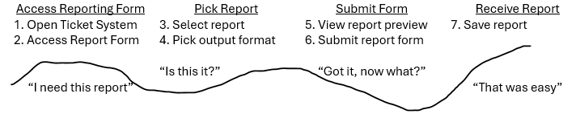
Opportunities: User can preview report prior to submitting form to verify that the output will match their needs.

SR-08 Happy Scenario: Report Output Success
- Title: Reporting Form Requirement
- Precondition: User has access to Report Form.
- Steps:
  - User accesses Report Form in Ticket System.
  - User picks report and report output format (xlsx, pdf, csv).
  - User reviews report preview and submits report form.
  - User saves output file as needed.
- Expected Outcome: The system outputs the selected report in the selected output format successfully.
- Traceability: (SR-08, PY-OUTPUT-02)

SR-08 Report Output Success with Alternate Format
- Title: Invalid Report Format
- Precondition: User has access to Report Form.
- Steps:
  - User accesses Report Form in Ticket System.
  - User selects a report and an alternate output format (PDF, XLSX, or CSV).
  - User reviews the report form and submits the request.
  - System processes the request and generates the report file.
- Expected Outcome: The system successfully generates and outputs the selected report in the chosen format.
- Traceability: (SR-08, PY-OUTPUT-02)

Dependability Enhancements
SR Dependability Analysis and Enhanced System Proposals
The system was modified to address key dependability issues by improving validation, processing logic, and access control. These changes focus on preventing incorrect prioritization, incomplete data storage, duplicate ticket creation, and unauthorized system access.
For priority assignment (SR-03), a consistent weighted calculation was implemented to combine category and urgency values. Input validation ensures both fields are provided before processing, preventing incorrect or missing priority results. For data storage (SR-04), the system now follows a controlled submission process where tickets are only saved after all validation and calculations are successfully completed. This prevents partial or corrupted records. For timestamp handling (SR-06), system-generated timestamps replace user input to ensure accuracy and prevent manipulation. For duplicate detection (SR-07), rule-based comparison logic was added to identify similar tickets using category, keywords, and time constraints, reducing redundant entries. For reporting and access control (SR-08), validation ensures only supported formats are processed, and access restrictions prevent unauthorized users from viewing sensitive data.
Overall, these modifications introduce validation, controlled execution, and security enforcement to ensure the system behaves consistently under both normal and failure conditions, improving reliability, safety, security, and availability.

Additional Dependability Enhancements
In addition to validation-based controls, further enhancements were incorporated to improve system resilience and operational stability. Retry logic was introduced to handle temporary failures in ticket processing, allowing the system to reattempt operations rather than failing immediately. This reduces the likelihood of data loss during transient issues. Rate limiting was also conceptually applied to prevent excessive or repeated ticket submissions within a short time frame. This helps control potential abuse scenarios and reduces the risk of duplicate or unnecessary ticket creation, improving overall system reliability and performance.
These enhancements extend beyond basic validation by introducing controlled system behavior under stress or abnormal conditions.

SR-03 – Priority Assignment
Failures (Cause → Impact → Dependability)
- Missing inputs → No validation → Incorrect priority → Reliability, Safety
- Incorrect logic → Faulty formula → Wrong prioritization → Reliability, Safety
- Inconsistent results → Non-deterministic logic → Unpredictable output → Reliability
- Not stored → Save failure → Missing priority → Reliability, Safety
Enhanced System Proposal
- Added required field validation so that priority is not calculated unless category and urgency are selected. If missing, submission is blocked with an error.
- Implemented fixed weighted formula combining category and urgency so same inputs always produce the same result.
- Standardized calculation logic to eliminate inconsistent outputs.
- Added database save confirmation, so tickets are not submitted unless priority is successfully stored.

Dependability TDD Tests

SR-03 Failure Scenario: Missing Category or Urgency
Title: Invalid Priority Input
Precondition: User has access to create incidents.
Steps:
- User submits a ticket without selecting category or urgency.
- System attempts to calculate priority.
- System blocks submission and displays an error.
Expected Outcome: System blocks the ticket submission, displays a validation error, and does not calculate or store a priority value.
Traceability: (SR-03, PY-PRIORITY-01)

SR-03 Boundary Scenario: Maximum Urgency Priority Assignment
Title: Highest Valid Urgency Value
Precondition: User has access to create incidents.
Steps:
- 1. User opens a ticket
- 2. User selects a valid category.
- 3. User selects the maximum allowed urgency value.
- 4. System calculates priority using the weighted category and urgency combination.
Expected Outcome: System assigns the correct highest valid priority based on the selected category and maximum allowed urgency.
Traceability: (SR-03, PY-PRIORITY-01)

SR-03 Security Scenario: Unauthorized Ticket Creation Attempt
Title: Unauthorized Incident Submission
Precondition: User does NOT have access to create incidents.
Steps:
- 1. Unauthorized user attempts to open ticket creation form
- 2. User attempts to submit incident data.
- 3. System checks permissions before allowing submission.
Expected Outcome: System denies ticket creation and displays an authorization error before any priority calculation occurs.
Traceability: (SR-03, PY-PRIORITY-01)

SR-04 – Data Storage
Failures (Cause → Impact → Dependability)
- Missing data → No validation → Incomplete ticket → Reliability
- Invalid data → Weak validation → Corrupted records → Reliability
- Malicious input → No sanitization → Security risk → Security
- Storage failure → DB issue → Data loss → Reliability, Availability
Enhanced System Proposal
- Added required field validation so incomplete tickets cannot be submitted.
- Enforced input format and length validation before storage.
- Implemented server-side input sanitization to prevent unsafe data.
- Used transaction-based storage so failed saves do not create partial records.

Dependability TDD Tests

SR-04 Failure Scenario: Incomplete Ticket Data Not Stored
Title: Missing Required Fields
Precondition: User has access to submit an incident form.
Steps:
- 1. User submits incident form with missing required fields.
- 2. System attempts to validate input data.
- 3. System detects incomplete submission.
Expected Outcome: System rejects the submission, displays a validation error message, and does not store the ticket in the database.
Traceability: (SR-04, PY-INPUT-01, PY-STORAGE-01)

SR-04 Boundary Scenario: Maximum Input Length Handling
Title: Input Field Length Limit
Precondition: User has access to submit an incident form.
Steps:
- 1. User enters data at the maximum allowed character limit.
- 2. User submits the form.
- 3. System validates input length.
Expected Outcome: System accepts valid input within limits and successfully stores the ticket in the database.
Traceability: (SR-04, PY-INPUT-01, PY-STORAGE-01)

SR-04 Security Scenario: Malicious Input Prevention
Title: Input Sanitization
Precondition: User has access to submit an incident form.
Steps:
- 1. User enters script or unsafe input into form fields.
- 2. System processes the input.
- 3. System sanitizes the input before storage.
Expected Outcome: System removes unsafe content, prevents malicious execution, and stores only sanitized data.
Traceability: (SR-04, PY-INPUT-01, PY-STORAGE-01)

SR-06 – Timestamp Handling
Failures (Cause → Impact → Dependability)
- Invalid timestamp → No validation → Incorrect ordering → Reliability
- Manipulated timestamp → User override → Unfair prioritization → Security
- Inconsistent time → No standard → Confusion → Reliability
- Missing timestamp → Save failure → No tracking → Reliability
Enhanced System Proposal
- Replaced user timestamps with system-generated timestamps at submission.
- Ignored user-provided time inputs to prevent manipulation.
- Standardized time format across system.
- Automatically generated timestamp for every ticket.

Dependability TDD Tests

SR-06 Failure Scenario: Invalid Timestamp Handling
Title: Invalid Date/Time Input
Precondition: User has submitted an incident.
Steps:
- 1. User submits an incident with an invalid or improperly formatted timestamp.
- 2. System reads the timestamp during submission.
- 3. System validates timestamp format.
Expected Outcome: System detects invalid timestamp input, ignores user-provided value, and generates a valid system timestamp for storage.
Traceability: (SR-06, PY-TIME-01)

SR-06 Boundary Scenario: Timestamp Format Standardization
Title: Edge Case Time Format
Precondition: User has submitted an incident.
Steps:
- 1. User submits incident at the boundary of valid time format (e.g., exact minute/second limits).
- 2. System reads timestamp input.
- 3. System standardizes the timestamp format.
Expected Outcome: System correctly processes and stores the timestamp using a consistent system-defined format.
Traceability: (SR-06, PY-TIME-01)

SR-06 Security Scenario: Timestamp Manipulation Prevention
Title: Unauthorized Timestamp Override
Precondition: User has submitted an incident
Steps:
- 1. User attempts to manually alter timestamp input.
- 2. System processes the submission.
- 3. System ignores user-provided timestamp values.
Expected Outcome: System replaces user input with a system-generated timestamp and prevents manipulation.
Traceability: (SR-06, PY-TIME-01)

SR-07 – Duplicate Detection
Failures (Cause → Impact → Dependability)
- Missed duplicate → Weak logic → Wasted effort → Reliability
- False duplicate → Overly strict → Missed valid issue → Reliability, Safety
- Time window error → No limit → Incorrect matches → Reliability
- Inconsistent detection → Logic variance → Unreliable results → Reliability
Enhanced System Proposal
- Implemented category + keyword + time window rule for duplicate detection.
- Adjusted similarity threshold to balance false positives and negatives.
- Limited duplicate comparison to a defined time window (e.g., 7 days).
- Standardized duplicate detection logic to ensure consistent results.
- To further improve reliability, rate limiting was incorporated as a supporting control to prevent repeated duplicate submissions within a short time window. This reduces system load and minimizes unnecessary duplicate processing.

Dependability TDD Tests

SR-07 Failure Scenario: Duplicate Ticket Not Detected
Title: Missed Duplicate Detection
Precondition: Ticket data has been saved.
Steps:
- 1. A new incident record is saved with date and time details.
- 2. System reads user and category data and identifies incident keywords.
- 3. System compares incident keywords to other open incidents in the same category.
- 4. Duplicate matching logic fails to recognize the similar ticket.
Expected Outcome: System should flag the ticket as a potential duplicate based on matching category and similar keywords instead of allowing it to pass as a unique record.
Traceability: (SR-07, PY-VALID-01)

SR-07 Boundary Scenario: Duplicate Threshold Limit
Title: Keyword Difference Boundary
Precondition: Ticket data has been saved.
Steps:
- 1. A new incident record is saved with date and time details.
- 2. System compares the new ticket to an existing open ticket in the same category.
- 3. The two descriptions differ by only the maximum allowed keyword limit.
- 4. System then applies the duplicate threshold rule.

Expected Outcome: System should still flag the ticket as a duplicate when it falls exactly at the defined keyword-difference boundary.
Traceability: (SR-07, PY-VALID-01)

SR-07 Security Scenario: Duplicate Bypass Attempt
Title: Duplicate Evasion Attempt
Precondition: Ticket data has been saved.
Steps:
- 1. User submits a ticket for an issue that already exists.
- 2. User slightly changes wording in the description to avoid detection.
- 3. System compares category and meaningful keywords against open incidents.
- 4. System applies duplicate detection rules.
Expected Outcome: System should still identify the ticket as a potential duplicate and prevent simple wording changes from bypassing duplicate detection.
Traceability: (SR-07, PY-VALID-01)

SR-08 – Reporting Output
Failures (Cause → Impact → Dependability)
- Report failure → System error → No access → Availability
- Invalid format → No validation → Unusable output → Reliability
- Unauthorized access → No auth → Data breach → Security
- Incorrect data → Processing error → Bad decisions → Reliability
Enhanced System Proposal
- Added controlled error handling during report generation.
- Restricted output formats to supported types (PDF, XLSX, CSV).
- Required authenticated user access before report generation.
- Validated report data before generation to ensure accuracy.

Dependability TDD Tests

SR-08 Failure Scenario: Invalid Report Format Handling
Title: Unsupported Output Format
Precondition: User has access to Report Form.
Steps:
- 1. User accesses the Report Form.
- 2. User selects a report.
- 3. User selects an unsupported or invalid output format.
- 4. System attempts to process the request.
Expected Outcome: System rejects the request, displays an error message, and does not generate the report.
Traceability: (SR-08, PY-OUTPUT-02)

SR-08 Boundary Scenario: Output Format Selection Limit
Title: Valid Format Selection Boundary
Precondition: User has access to Report Form.
Steps:
- 1. User accesses the Report Form.
- 2. User selects a report.
- 3. User selects a valid output format (PDF, XLSX, or CSV).
- 4. System processes the report generation.
Expected Outcome: System successfully generates the report in the selected format without errors and preserving data accuracy.
Traceability: (SR-08, PY-OUTPUT-02)

SR-08 Security Scenario: Unauthorized Report Access and Data Exposure Prevention
Title: Restricted and Protected Report Generation
Precondition: User does NOT have permission to access reports.
Steps:
- 1. User attempts to directly access the Report Form or report generation endpoint.
- 2. User attempts to generate a report using a valid format (PDF, XLSX, or CSV).
- 3. System verifies user authentication and authorization before processing the request.
- 4. System detects that the user does not have proper permissions.
Expected Outcome: System denies access, prevents report generation, and ensures no report data is exposed or returned. An authorization error is displayed, and the request is logged.
Traceability: (SR-08, PY-OUTPUT-02)

Refined TDD Approach

The refined TDD approach will continue to be used throughout development to test system updates and ensure that dependability features remain effective over time. Instead of only testing normal functionality, new test cases are designed to explicitly simulate possible real-world failure conditions, boundary conditions, and security attacks. For failure conditions, tests include scenarios such as a missing category or urgency during ticket creation and database save operation failures, verifying that the system blocks submission and prevents incomplete data from being stored.

For boundary conditions, tests check valid edge cases such as maximum urgency values and input limits to ensure the system still processes data correctly without errors. For security attacks, tests simulate unauthorized users attempting to create tickets or access reports, confirming that authentication and access control mechanisms prevent these actions. These test cases ensure that the system continues to behave in a controlled and predictable way by enforcing validation, protecting data, and maintaining reliability, safety, security, and availability during real-world use.

The testing approach primarily focused on unit testing through TDD. However, the system design also supports integration and system-level validation by testing interactions between ticket processing, duplicate detection, and reporting components.

Impact Assessment

The system is improved by addressing failures before they can affect system behavior or user outcomes. Instead of allowing incorrect or incomplete data to move through the system, validation rules ensure that required inputs are present, correctly formatted, and safe before processing begins. This reduces the risk of incorrect priority assignment and prevents incomplete or invalid tickets from being stored. Priority assignment is more dependable because the system now enforces required inputs and applies a consistently weighted calculation. This ensures that similar inputs always produce the same result, reducing unpredictable behavior and improving both reliability and safety when handling urgent issues.

Data storage is strengthened by preventing partial data saves and requiring confirmation that ticket information, including priority, is successfully stored before submission is completed. This reduces the risk of missing or corrupted data and ensures that the system maintains accurate and complete records over time. Timestamp handling reduces the risk of manipulation by replacing user-provided values with system-generated timestamps. This ensures accurate tracking of incidents and prevents users from altering the order or timing of events, improving both reliability and system integrity.

Duplicate detection improvements reduce the risk of missed or repeated incidents by applying consistent comparison rules based on category, keywords, and time windows. This helps prevent duplicate work while also ensuring that valid issues are not incorrectly ignored, improving both efficiency and safety. Security risks are reduced by enforcing access control on system actions such as ticket creation and report generation. Unauthorized users are blocked from performing restricted actions, and invalid requests are rejected before processing. This protects system data and prevents misuse.

System availability is improved by handling failures through controlled responses instead of allowing the system to crash or produce incorrect outputs. When an error occurs, such as an invalid input or failed operation, the system returns clear messages and maintains stable operation. Overall, these improvements reduce system risk by ensuring that any errors are detected early, handled correctly, and prevented from affecting system reliability, safety, security, or availability. This results in a system that behaves consistently and predictably under real-world conditions, benefiting stakeholders such as end users, IT support staff, and system administrators by providing a more reliable system, reducing errors in ticket handling, improving response times, and ensuring secure and accurate data management.

DEPLOYMENT
IT Help Desk Triage Lite would be deployed as a lightweight Python-based system in a local or internal environment. Since the system does not rely on outside services or enterprise tools, deployment can stay simple and controlled. Before release, the Python environment would be set up and the required files would be placed in the correct project folder. The main system functions, including ticket creation, validation, priority calculation, duplicate detection, and report generation, would be checked before users are given access.

Testing would be completed before deployment to make sure the system works the way the requirements describe. This includes checking that priority scores calculate correctly; duplicate tickets are flagged properly, and unsupported report formats are rejected. Access would be limited based on user roles. Regular users would submit tickets, while staff would handle ticket updates, duplicate review, and reports. This keeps sensitive actions away from unauthorized users. The first release would be small. A limited group of users could try the system first so that issues can be found early. After fixes are made, access could be expanded to the rest of the organization.

Deployment would be standardized and would follow the same steps for each site where the Help Desk Triage system is deployed. These steps would be as follows:
1) Install Python 3.x on the system; make sure not to use older versions of Python as those versions are not likely to provide the necessary support for the program to function.
2) Download the project files, currently hosted on GitHub, and extract them to an appropriate installation location.
3) Open the project in an IDE; it is recommended to use the same IDE for all deployments, such as VS Code, for consistency in the validation results.
4) Run the main system file and execute test cases using the “unittest” command to validate system functionality.
Following these steps will ensure that the new deployment is fully functional and ready for use as a stable production environment.

MAINTENANCE AND EVOLUTION
After deployment, IT Help Desk Triage Lite will need regular maintenance to keep it useful and dependable. Maintenance would include fixing bugs, reviewing failed test results, checking duplicate detection behavior, and making sure ticket data is still handled correctly. Updates would be made in small steps instead of changing the whole system at once. This lowers the chance of breaking features that already work.

After each change, the test cases would be rerun to confirm that priority calculation, validation, timestamps, duplicate detection, and report generation still behave correctly. Future improvements could include a better user interface, stronger duplicate detection, more detailed reporting, and stronger access controls for staff actions. If the system grows, ticket storage could also move from in-memory storage to a small database. User and staff feedback would guide which improvements come first. For example, if staff notice too many duplicate tickets are being flagged, the duplicate threshold could be adjusted. If users struggle with urgency selection, the verbiage used in the form could be improved for clarity as needed.
This maintenance plan keeps the system realistic for a small IT environment while still allowing it to grow over time.

