**Design Document**

|  |
| --- |
| American Video Game Company |
| CRM System Proposal |
|  |

|  |
| --- |
| Andrew Bright  10-30-2021  Version 1.0 |

Contents

A. Introduction 3

A.1. Purpose Statement 3

A.2. Overview of the Problem 3

A.3. Goals and Objectives 3

A.4. Prerequisites 4

A.5. Scope 4

A.6. Environment 4

B. Requirements 5

B.1. Business Requirements 5

B.2. User Requirements 5

B.3. Functional Requirements 6

B.4. NonFunctional Requirements 7

C. Software Development Methodology 9

C.1. Advantages of the waterfall method 9

C.2. Disadvantages of the waterfall method 9

C.3. Advantages of the waterfall with feedback method 10

C.4. Disadvantages of the waterfall with feedback method 10

C.5. Best suited 10

D. Design 11

D.1. Flowchart 11

D.2. GUI Mockups 12

E. Testing 21

E.1. Testing Details 21

E.1.1. Testing Mobile GUI for Sales 21

E.1.2. Creating a Contact 22

E.1.3. Hard Deletion of a Contract 23

F. Sources 24

# Introduction

The purpose of this document and proposal is to provide a foundation for the new CRM system that the American Video Game Company will utilize in the future. The current systems are too disorganized, and with AVGC’s recognition and sales growth of 42% in the last two years alone, a new system will be necessary to handle even further expansion. The new system will need to build upon and integrate the current systems, be easy to use and share data, reports, and workflow all while allowing for more efficient business growth.

# A.1. PUrpose Statement

The proposed CRM system will modernize and bring a method of cohesion to the system that AVGC uses. In this document, I will examine the company’s needs and expectations, and lay a groundwork for creating and implementing the new system.

# A.2. Overview of THE PROBLEM

The current systems that AVGC uses are unfortunately slowing the company down with expansion. It uses a “disconnected set of custom-built tools in a spreadsheet software and database management software, as well as many manual steps and processes. The tools are also spread across multiple offices and have many team members who work remotely.” AVGC is wanting to keep the internal infrastructure as intact as possible and is wanting integration with Exchange/Outlook and Active Directory, as well as be hosted internally and communicate with internal databases. (*CRM Requirements, 4*)

# A.3. Goals and Objectives

This document proposes the development of a completely internal system that is used widely by the company and hosted within the company’s hardware infrastructure.

Goals of this proposal will be to keep the internal infrastructure and systems in mind to make integration as seamless as possible. One of the main goals in this solution is to combine all business and contact information within the company. Another is to report, manage, and track activities, interactions, and sales with those contacts. It will include scalable features and permissions for internal and external users, allow data and report sharing between those users, and be secure enough to only allow access to those necessary to perform their job. (*CRM Requirements, 5, 6*)

# A.4. Prerequisites

This project requires prerequisites in place prior to the design, development, and implementation of the project proposed in this document. These are as follows:

|  |  |  |  |
| --- | --- | --- | --- |
| Number | Prerequisite | Description | Completion Date |
| 1 | None | Stated problem and expected requirements as listed in the CRM Requirements document, and the basis of a direction for the project. | 11-01-2021 |
| 2 | 1 | This document is approved and accepted as the solution and general scope of the project by the architecture and development teams. | 11-05-2021 |
| 3 | 2 | Development time and internal budget approval by the company’s board/executives. | 11-12-2021 |

# A.5. Scope

This document will not cover the internal hardware or maintenance costs to host or upgrade the system or software as it is intended for internal use.

The scope of this project will be to develop a custom internal system to cover all expectations outlined in the CRM Requirements. This document will outline systems and programs that the software is required to be compatible with, details of what the software will provide, the GUI, development, and testing. The software will keep the internal infrastructure intact and build upon it.

# A.6. Environment

The American Video Game Company currently has an Active Directory server that the CRM software will work with. It will also require communication with Outlook/Exchange.

The new system will need to be compatible with the following browsers:

* Chrome and Chromium (including Chromium-based browsers)
* Firefox
* IE 9 and above
* Safari
* iOS Safari, Chrome, and Firefox
* Android Chrome

The hardware environment will be the on-premises servers to host the software, database, and end-user web interface.

# Requirements

Due to a 42% increase in sales within the last two years and other planned growth, the American Video Game Company requires a new CRM system to incorporate its contacts and allow the company to more efficiently process business transactions, monitor and track activities, and generate reports.

# Business Requirements

500 concurrent users are expected to be using the CRM system simultaneously, as well as delegate access to 2,000 users.

The expectations of the new CRM system are:

1. Combine all business and contact information into one place, as well as report on that information.
2. Incorporate role-based access for internal and remote employees.
3. Allow and delegate access to third party marketing contractors.
4. Manage business contact activities, track and generate sales reports.
5. Allow the flow of data through other company hardware/software systems.
6. Have robust security, manage permissions, be scalable to the number of users, and be user-friendly.
7. Have a clear developmental roadmap for updates, future features and upgrades.
8. Have a clear licensing model and defined ownership rights.
9. Work with the on-premises hardware infrastructure for hosting the application, database, and end-user environment.
10. Store all data within the United States unless approved to be shared elsewhere.
11. Be compliant with data protection laws and regulations.

# User Requirements

The proposed CRM system will feature a variety of requirements for the users, such as:

1. **Contact management** with specific user-level settings and broad-level business organization
2. A **ticketing system** for all communications regarding a business contact
3. A robust **reporting system** that will feature report generation as well as overall dashboards
4. **Sales tracking** – specifically **activity management** for stakeholders, **opportunity tracking** for potential customers, a **quoting system** for sales propositions, **forecasting** for sales and revenue, **order tracking** for following a quote, and **contracting** for tracking the process of the final contract agreement.

# Functional Requirements

The proposed CRM system will utilize Role-Based Access Control (RBAC) for permissions. Permissions will be granted based on the current roles defined within Active Directory to save money on another defined system. Administrators must have the ability to assign and manage permissions for specific access within the software.

Other requirements are as follows:

1. Include recording of creation and modification of data on a per-user basis at all levels. This will allow for ease of auditing as well as performing any rollbacks or troubleshooting. Versioning of the data creation and further modification will be dictated by the database schema.
2. Allow for a soft and hard delete of all data. Hard deletes will be restricted to certain levels of permissions.
3. Be easily scalable and allow for testing in multiple areas. This will be supported by using a developmental architecture following this document and the requirements previously outlined.
4. Include a clear roadmap for updates, future features and upgrades.
5. Include a clear licensing model with defined rights of ownership.
6. Include a well-defined process regarding approvals and permissions.
7. Store all data within the borders of the United States. This data can only be processed, analyzed, and shared within the United States unless approved otherwise. Since the data will be hosted by the company’s existing infrastructure in the United States, this shouldn’t be an issue unless there are plans to expand internationally.

Specific requirements for the different aspects of the CRM system are as follows:

***Contact Management***

Within this system, the contacts for the entire company will be held. This system will import and utilize the existing contacts within the company and allow for flagging of possible duplicates. A recommendation system will present adding to an existing contact if a similar one has been found. Contact classification will be sorted by type or allow for individual tagging, making it easier to track an individual contact.

Any contact can be assigned to multiple companies, offices, roles, etc. Each field in the contact form will have a recommended information type, and will allow partial entries, but will be flagged for completion if so. A user can tag inquiries to an existing contact during or after a sales call or create a new contact if necessary.

***Ticketing***

The ticketing system will allow employees to enter and track all communications regarding contacts. Each individual ticket will track the caller, the reason for the call, date/time, and allow for a follow up and contain a place for any specific details. Each ticket number will be a unique identifier, and all emails related to the ticket will be picked up by the system. The database layout will allow these features as well as containing audit logs for all writes and changes.

***Reporting***

The reporting system will allow for report generation based upon pre-defined and user-defined filters across all data types, and users will be able to click through the data for more details. The interface will have an overall dashboard to show pre-fetched data and “recommended favorites”, as well as allow for the creation of a custom dashboard with the ability to host historical reports, executive summaries, or any detailed report the user would like.

***Activity Management (Visits & Meetings)***

This system will act as a hub for data regarding meetings and activities with business clients and stakeholders. It allows tracking based on the ticketing system, as well as communication between Exchange/Outlook. Activities and meetings will be able to be linked to specific employees, as well as any information regarding that specified activity.

***Opportunity Management***

This system will track the pipeline along the sales process. It will feature the ability to perform win/loss analysis, competitive analysis for other companies and their products, as well as hosting and approving discounts for a sale.

***Quoting***

This system will host the quoting process behind a sale, as well as generation and assembly. It will manage discounting, tax, and freight costs, currency to be exchanged, electronic signatures to each document that requires one, and configuring the price quote, the price catalog, contract pricing and final pricing. It will also allow for substitution of a product, inventory availability, and track shipping and delivery.

***Forecasting***

This system will manage the process of predicting sales and revenue. It will allow Sales managers the ability to adjust currencies including foreign currencies, apply baselining, and allow manager adjustments to pricing or discounts. It will also include the upsides, machine and product forecasting, as well as forecasting periods and sales distributions.

***Order Management***

This system will allow for the overseeing of a quote into an order for a sale. It will allow order tracking, taking orders, conversion of a quote into an order, reordering, part ordering, and include a self-serve portal to access information for customers.

***Contracting***

This system will track the specific contracts for a sale. It will host contract creation, track the terms of the contract, signing, and termination. It will have authorization and approval for those contracts via RBAC.

# NonFunctional Requirements

The new system must be easy to use and user-friendly. It must be easily extended or modified to integrate with tools in the future, as well as not rely on support from a single team. It must integrate with existing tools and Exchange/Outlook, as well as be an upgrade from the previous system. It must be secure and have a clear licensing model with ownership rights. It must be compliant with applicable laws and regulations.

# SOFTWARE DEVELOPMENT METHODOLOGY

The company has selected the Waterfall software development methodology for this project. This is because the method has a clear stage process of requirements, design, implementation, verification, deployment, and finally maintenance. This has been chosen because the requirements are defined in advance to starting the project, no requirements are left out, and the scope will not change while the project is being developed.

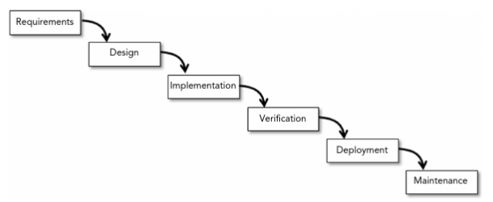

Figure 12-1 (*Beginning Software Engineering, 270*)

# Advantages of the waterfall method

The Waterfall method allows clear goals within the projects, and a stage of development is completed fully before moving onto the next stage. This method is quite rigid, but it will follow the guidelines and requirements specifically outlined for the project. It makes the project easy to track as well as monitor progress. The design aspect solely relies on the requirements, and the coding relies upon the finalized design criteria. Any troubleshooting and testing of different features will be completed in the verification phase, before the system has been deployed. (*Beginning Software Engineering, 270-271*)

# disAdvantages of the waterfall method

For the Waterfall method, its primary feature can also be a disadvantage. This is because it has a rigid structure that must be adhered to, and it does not allow the stages to regress if an issue arises. It does not allow an increase in scope or features, as everything is decided upon before progressing. This could potentially become an issue if everything is not planned out completely, leading to deadlines being missed and possible bugs or missing features. (*Beginning Software Engineering, 270-271*)

# Advantages of WaterFall With FeedBack

The Waterfall with Feedback method borrows heavily from the Waterfall method but allows you to go back to a previous stage of development if needed. This will allow a process to return to a previous one if an issue is found, in order to revise the issue and return to the next stage. This is advantageous in case the requirements or design is wrong, or something needs to be added. (*Beginning Software Engineering, 271-272*)

# disAdvantages OF waterfall with Feedback

The Waterfall with Feedback method is useful if the development process needs to change, however, it starts to fall apart further along the process. If there is an issue with the requirements or design that is discovered during the deployment phase, that is most likely better suited for a future feature addition, rather than going backwards to add it in. This can cause hurdles and delays if multiple issues are discovered throughout the development process. (*Beginning Software Engineering, 271-272*)

# best SUITED

The method of development best suited for this project is the overall Waterfall method. Ideas and steps are clearly defined and laid out, with a specific structure that will be followed. With an experienced team and specific milestones and goals to reach, this will allow for a smooth development process. Some steps can be completed alongside others in order to speed up the process and deploy the software earlier than expected.

# Design

The American Video Game Company needs a new CRM system in order to keep up with their recent growth and further expansion. Since sales are up 42% in the last two years alone, the company has since reached the limits of their old system. This new system will allow for contact consolidation, manage activities with clients, track sales and contracts, and produce various reports.

# Storyboard or Flowchart (Change title to fit needs)

The following image illustrates a basic concept of adding a contact, and the various steps afterwards.

# GUI Mockups

Here I will provide an overview and mock-ups of the proposed system, including:

1. Contact Management
2. Ticketing
3. Reports
4. Activity Management – Visits & Meetings
5. Opportunity Management
6. Forecasting
7. Order Management
8. Contracting

***Contact Management***

Contacts can be sorted by company, with a company selection to organize contacts tagged to that company. Contacts can either be specified as belonging to a company or entered as individual contacts. There will be selections to filter results as well as a date search, as well as attaching additional documents and images. End users will need to be able to self-serve a simplified interface to set personal marketing preferences.

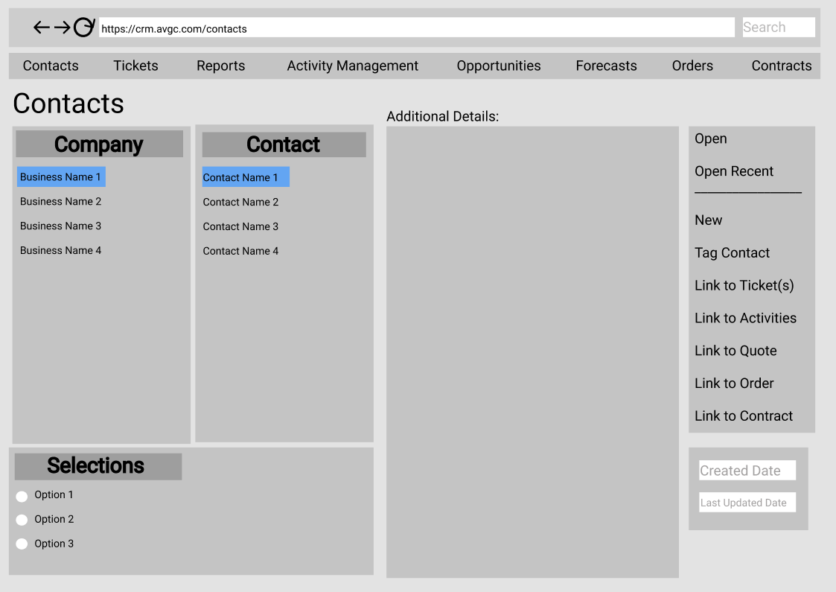

***Ticketing***

The ticketing system will retain the contact system to select a ticket on a per-contact basis. Each individual ticket will track the caller, the reason for the call, date/time, and allow for a follow up and contain a place for any specific details. Each ticket number will be a unique identifier, and all emails related to the ticket will be picked up by the system.

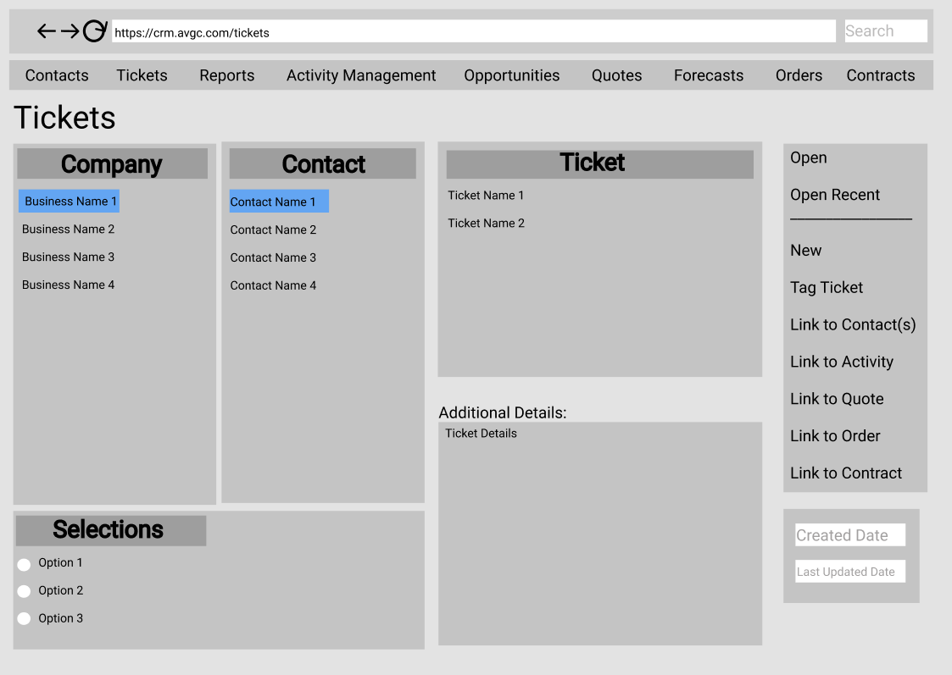

***Reports***

The reporting system will contain saved favorites for user-specified filters but will also generate recommended graphs and reports. The data can be clicked through for more details. Custom dashboards can be created with historical reports, executive summaries, or any type of graph the user would like.

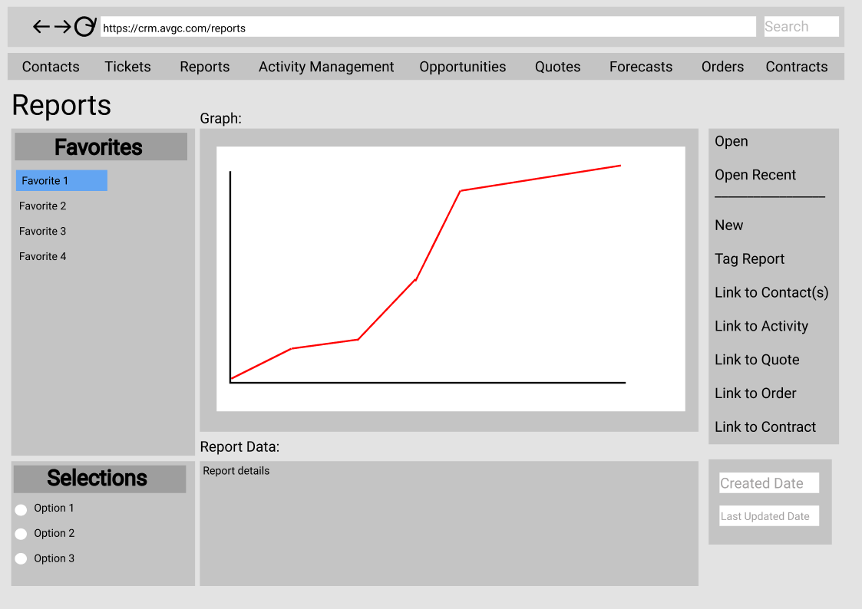

***Activity Management***

The activity management system will act as a hub for data regarding meetings and activities with business clients and stakeholders. It will allow tracking to the ticketing system and email system, as well as be tracked to a specific employee.

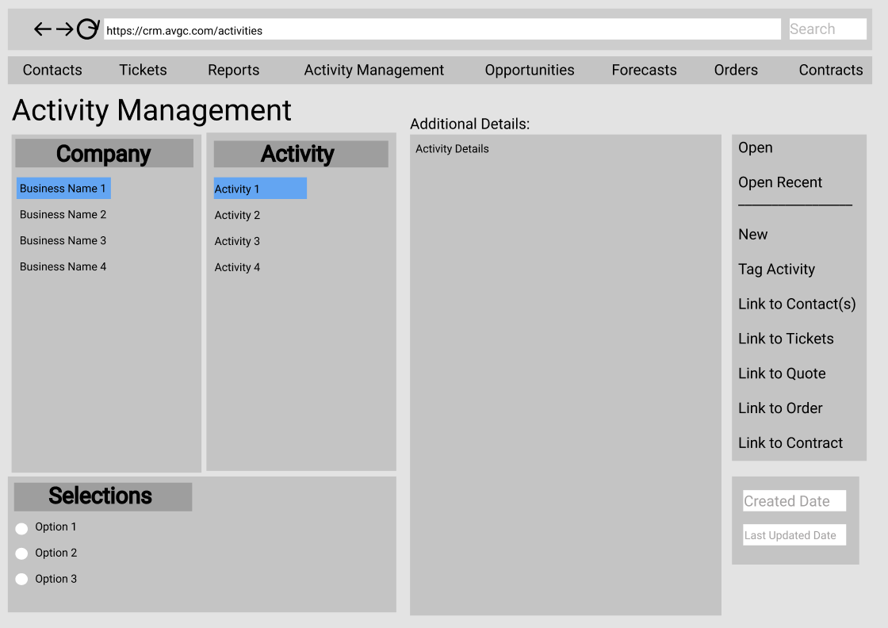

***Opportunity Management***

This section will allow for tracking the pipeline along the sales process, feature win/loss ratios per selected opportunity, provide analysis amongst other companies and their products, and host/approve discounts for a sale.

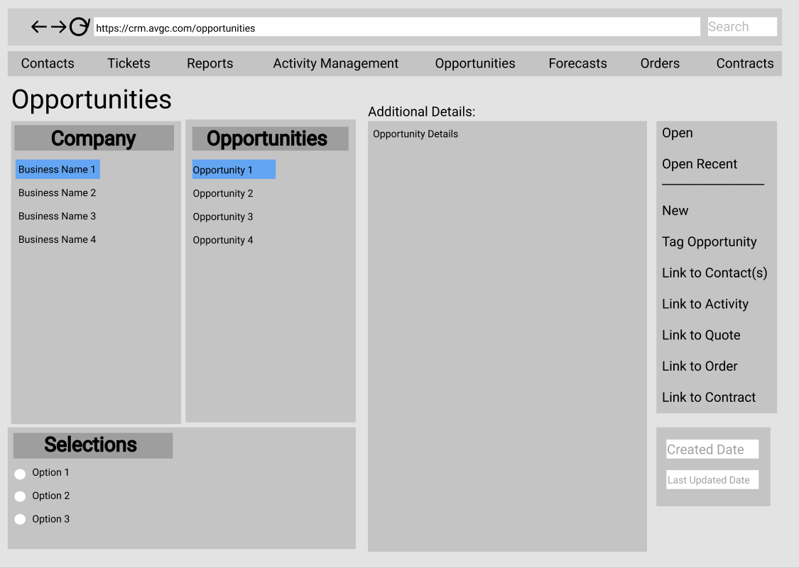

***Quoting***

Employees will use this system to create quotes on a per-company basis. It will feature the ability to perform all functions specified in the requirements: discounting, tax, and freight costs, currency to be exchanged, electronic signatures to each document that requires one, and configuring the price quote, the price catalog, contract pricing and final pricing. It’ll also allow for substituting a product as well as tracking inventory.

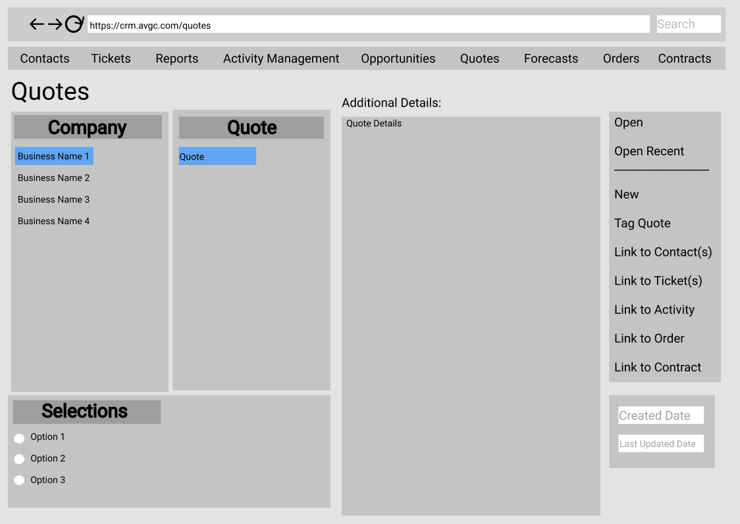

***Forecasting***

This screen will allow for predicting sales and revenue and allow Sales managers to make specific adjustments via RBAC. It will include upsides, machine and product forecasting, and providing forecasting periods and sales distributions.

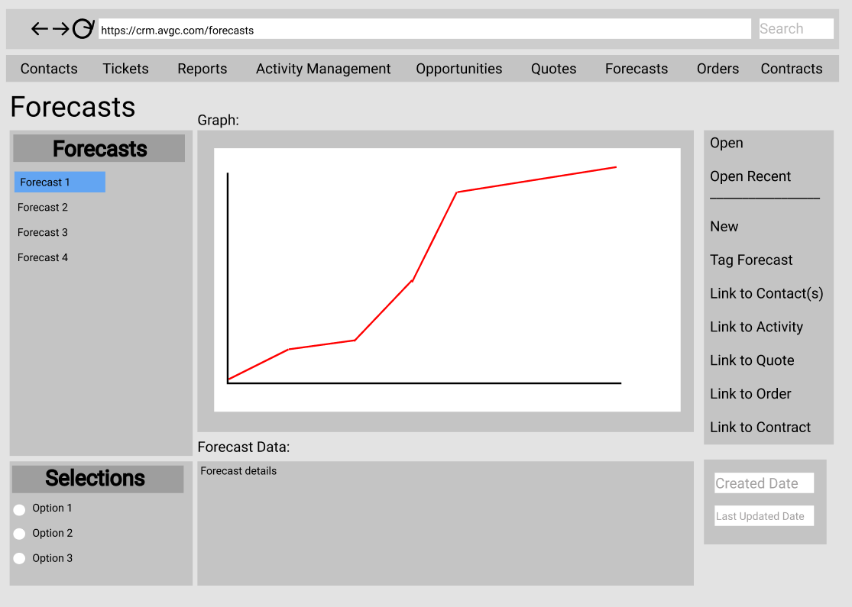

***Order Management***

This section will allow for overseeing a quote that is turned into a sale. It will allow order tracking, converting a quote into an order, as well as include a simplified self-serve portal for customers to access information.

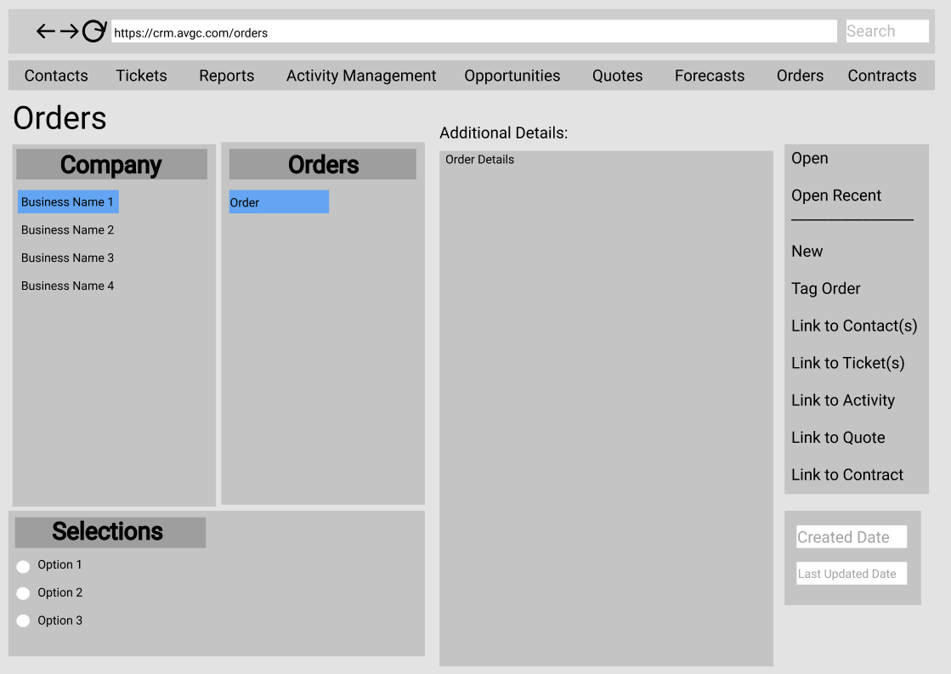

***Contracting:***

This will track contracts related to a sale. It will host creating a contract, terms, signing conditions, and termination. Approval and authorization will be delegated to those necessary to perform that duty via RBAC.

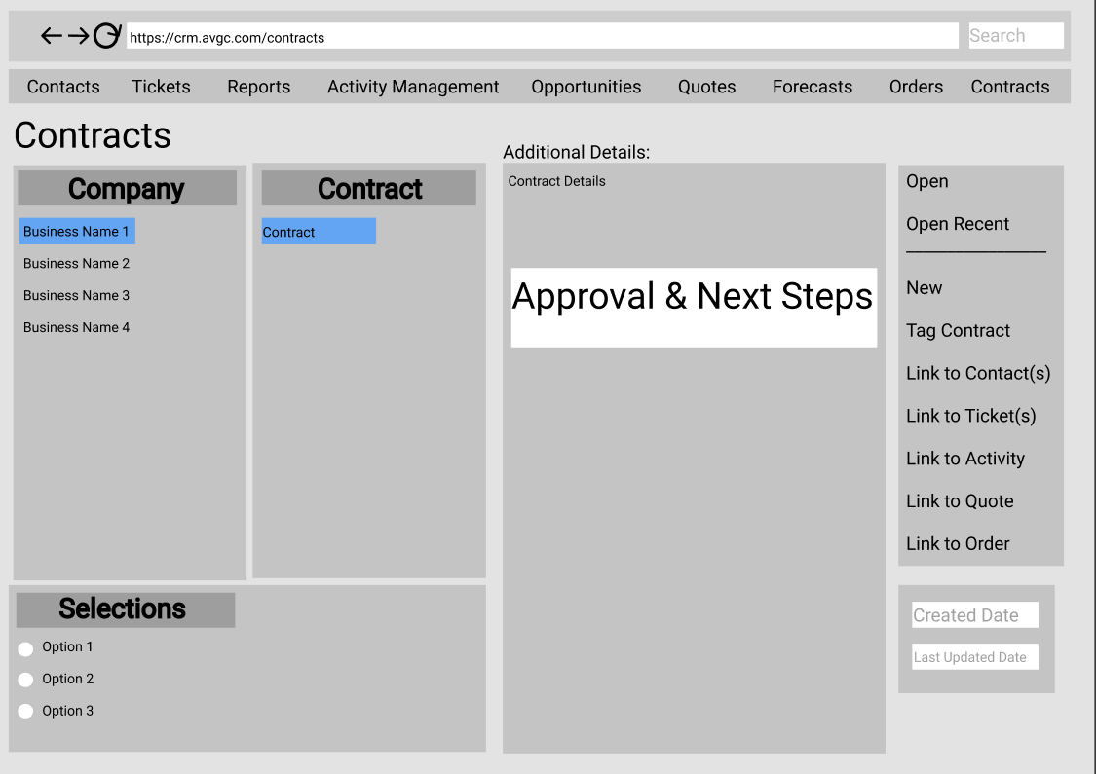

# Testing

The following is proposed to test the Contact workflow.

# Testing Details

We will perform the following tests on the workflows: Search the sales GUI from a mobile device, creating a contact, and hard deleting a contract.

# Testing mobile gui for sales

|  |
| --- |
| Requirement to be tested  Searching for a sale within the GUI on mobile. |
| Preconditions:  We will require the GUI for this test, as well as the relevant database configurations for this test and others, including contacts, tagging, ticketing, etc. |
| Steps: The steps the tester must execute to test the feature.   1. Create a test sale to track and search for. 2. Search for the sale using the Global Search at the top of the page. Mark if successful/unsuccessful. 3. Repeat from searching within another tab as if we were to link a sale, for example the activities page. |
| Expected results:  View the test sale created for this test properly on a mobile browser. |
| Pass/Fail:  Pass |

# Creating a Contact

|  |
| --- |
| Requirement to be tested  Creation of a new contact. |
| Preconditions:  We will not require the GUI for this test but will at least need the API for the GUI to test basic functionality. We will also require the database to be configured to store contacts, tagging, ticketing, etc. |
| Steps: The steps the tester must execute to test the feature.   1. Gather data to create a test contact. 2. Call the API for a new contact with the data using a command line interface. 3. Mark successful/unsuccessful contact creation via a database query. 4. Confirm correct labeling and organization for the contact’s details within the database. |
| Expected results:  The new contact created matches the gathered data, and the fields are populated with the correct information. |
| Pass/Fail:  Pass |

# Hard deleting a Contract

|  |
| --- |
| Requirement to be tested  Hard deletion of a contract |
| Preconditions:  We will not require the GUI but will need the API for the GUI to test basic functionality. The database will need to be properly configured beforehand, and audit logs must be enabled to track modification and deletion. |
| Steps: The steps the tester must execute to test the feature.   1. Gather data to create a test contract. 2. Create a test contract via command line interface for the API. 3. Call deletion of the contract via command line interface for the API. 4. Mark successful/unsuccessful not only the creation but deletion. 5. Confirm within the audit logs that the contract was properly deleted. |
| Expected results:  The contract is unable to be found, and a record of the deletion will be recorded alongside the authorized user. |
| Pass/Fail:  Pass |

# Sources

1. Figure 12-1: Waterfall development method image from *Beginning Software Engineering, 270*, 31October 2021.
2. Stephens, R. (2015). *Beginning Software Engineering.* John Wiley & Sons, Inc.
3. Workflow generated 31 October 2021, <https://app.diagrams.net/>
4. GUI Mockups generated 31 October 2021, <https://www.figma.com/>