Neoclassical Realism Goes South: Diffusion, Adaptation, and the Global South Uptake of NCR

Thales Carvalho
Alana Camoça Oliveira
Jeffrey Taliaferro
Augusto Dall’Agnol

Abstract

Neoclassical Realism (NCR) has consolidated itself as a widely used IR Theory over the past decades. Yet its diffusion and the ways scholars repurpose it across contexts remain underexplored. This article argues that, despite its canonical formulation by scholars largely based in Europe and the United States, NCR has become a “working theory” for Global South research agendas. Its appeal lies in analytical flexibility: NCR accommodates diverse variables and legitimizes explanations that connect systemic incentives to domestic constraints – an especially useful move where foreign policy outcomes are jointly shaped by external pressures and domestic politics. We show it by surveying 349 journal articles indexed by Scopus or Web of Science published between 1998 and 2025, combining statistical and text-as-data techniques. Our findings show that NCR became frequently used by Global South scholars rather than Global North researchers. We also find regional variation in how authors operationalize NCR. This suggests adaptation rather than simple theoretical replication, denoting that flexibility has been a key element of NCR's appeal. These results help understand how IR theories travel, why flexibility facilitates theory uptake, and what NCR’s trajectory reveals about the evolving foundations and internationalization of Global South IR scholarship(s).

Keywords: Neoclassical Realism; IR Theory; Scientometrics; Global IR

Introduction
Neoclassical realism has traveled farther than its architects could anticipate, and what it became along the way has gone largely unexamined. Since Gideon Rose (1998) coined the term, NCR has expanded from a cluster of North American foreign policy studies into a recognizable global research program, generating scholarship across Europe, Asia, the Middle East, Latin America, and Africa (Foulon and Meibauer 2020). From 1998 to 2025, more than 350 articles deploying or examining the framework have appeared in indexed journals with an exponential increase over the past decade, as shown in Figure 1.

Figure 1 – Yearly Production
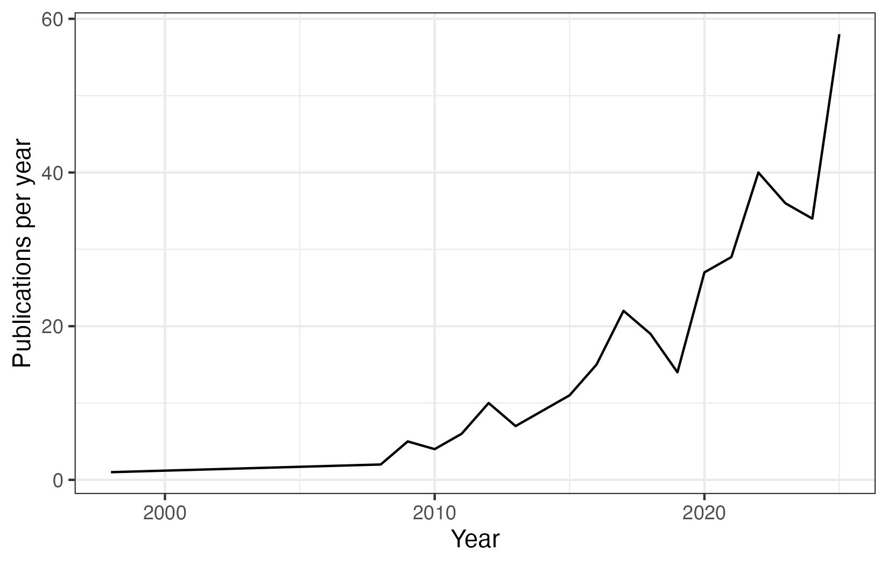
Source: own elaboration, based on information retrieved from Scopus and Web of Science databases.

The exponential growth shown in Figure 1 raises a question that existing scholarship has not fully addressed: how did NCR diffuse across the globe? Foulon and Meibauer (2020) offer the most systematic prior mapping of NCR scholarship, surveying 149 publications by 96 scholars. Their analysis revealed an early expansion into Europe and initial signs of diffusion beyond the Global North. However, it was fundamentally prospective. They argued that NCR could contribute to Global IR if scholars embraced the theory's analytical openness and developed collaborative research designs that bridged the North-South divide. What actually happened – whether, how, and with what consequences NCR spread to the Global South – was left for future work to establish.
That question is particularly interesting because of NCR's distinguishing feature, which is its analytical flexibility. While theories such as Structural Realism and Neoliberal Institutionalism are often restricted to specific variables (e.g., trade or power distribution), NCR integrates domestic and international variables to understand foreign policy and international outputs. This flexibility has generated productive debates about which variables can be incorporated, how they interact, and what NCR ultimately explains about world politics (Meibauer et al. 2021; Götz 2021). This enables scholars across different regions to adapt NCR to explain their own realities by incorporating variables and concepts. At the same time, the results of this flexibility demand proper evaluation, aiming to understand theory development and adaptation processes. Did NCR actually spread to the Global South? Did Global South scholars adopt NCR as formulated by its canonical architects? Did they adapt it to their own empirical and intellectual contexts? And if adaptation occurred, does it follow any systematic pattern, or is it the accumulated noise of scholars working in isolation from one another?
These are not merely questions about NCR's internal development. They bear directly on a central debate in contemporary IR, discussing whether the growing participation of non-Western scholars represents genuine pluralization of the discipline's theoretical foundations, or whether it reproduces the same asymmetric structure in a new geographical arena. That binary is hard to sustain once we recognize that diffusion rarely means either wholesale adoption or full hybridization. Acharya's (2004) own account of norm localization, Levitt and Merry's (2009) study of vernacularization, and Sil and Katzenstein's (2010) defense of analytic eclecticism each treat diffusion as a process that lies between adoption and pluralization. Localization presupposes contestation that loops back to reshape the originating site; we do not find that loop. Vernacularization depends on intermediary brokers bridging global and local registers. Analytic eclecticism is something individual authors do on purpose and with intent. Thus, which of these intermediate forms structures Southern engagement with Northern theory in practice remains an open question, for which we have little systematic evidence.
In our article, we intend to propose a different concept. We argue that Southern scholars adopted NCR as a theoretical anchor for regionally grounded research agendas, selectively drawing on local intellectual traditions in the process, and did so without epistemic integration with the producing core. What we argue is that the NCR label travelled intact, but the theory underneath it did not. We call it peripheral adaptation. It is noteworthy that this concept is distinct from what Hynek and Šenk (2026) identify as a Global NCR tradition. The concept is a category describing works that challenge Western-originated concepts from within the NCR program's hard core. Peripheral adaptation is not a tradition within NCR. It can be seen as a mechanism of diffusion, thus it describes how a framework travels and fragments across different conditions, regardless of whether the resulting scholarship meets the epistemological criteria of any recognized tradition.
It is known that the Global IR literature has established, with considerable force, that scholars beyond the North Atlantic are agents in knowledge production, not passive recipients (Acharya 2014; Buzan and Acharya 2019; Cerioli 2024). However, what it lacks is systematic comparative evidence about how that agency operates in practice. In other words, through which mechanisms a specific Northern framework is taken up, transformed, and reproduced across diverse Southern scholarly communities over time.
This article provides that evidence. We survey 349 journal articles published in Web of Science and Scopus-indexed outlets between 1998 and 2025, more than doubling the empirical basis of prior work (Foulon and Meibauer 2020). Also, while Hynek and Šenk (2026) recently mapped NCR's internal traditions through an analysis of 265 scholarly works, asking what NCR is from within the research program itself, we ask how it actually traveled. We aim to show who adopted it, from where, and whether that adoption produced replication or adaptation. We ask not only who uses NCR and from where, but what they use it for and how.
Our analysis proceeds in two steps. First, we map the geographical spread of NCR scholarship using georeferenced data on authors' institutional affiliations and temporal production patterns, establishing when and where the theory's center of gravity shifted. Second, we examine how NCR is deployed across regions, combining a Structural Topic Model that identifies the research agendas scholars pursue under the NCR label with a citation analysis using text-as-data and network techniques that reveals the theoretical traditions mobilized alongside the approach in different parts of the world.
This article makes three contributions. First, it provides the most comprehensive empirical mapping of NCR's global diffusion to date, extending prior work in both scale and temporal scope. Second, it advances the methodological toolkit for studying theory diffusion by combining georeferenced bibliometric data, structural topic modeling, and systematic citation analysis. Third, and most substantively, it introduces the concept of peripheral adaptation as an analytical category for understanding how Southern scholars engage with Northern theoretical frameworks. We understand that this concept also travels beyond the case of NCR, offering a portable tool for scholars interested in how theoretical knowledge circulates (and fragments) across the discipline's unequal geographical landscape.
The article proceeds as follows. The next section reviews NCR's core assumptions and analytical scope, with particular attention to the theoretical flexibility that has shaped its appeal across diverse empirical contexts. The third section presents our empirical design and data. The fourth section maps NCR's geographical spread and documents the shift in North-South production. The fifth section examines regional variation in how NCR is intellectually grounded across the world. A final section draws out implications for debates on NCR's development and the sociology of knowledge production in Global IR.

Neoclassical Realism: core assumptions and analytical scope
Neoclassical realism emerged as a response to the theoretical tensions of the late 1990s, seeking to recover realist perspectives. The end of the Cold War brought the diffusion of approaches that emphasized culture, identities, and domestic variables, and called for reflections on international politics beyond the narrow focus on trade or material power capabilities. At the same time, the collapse of the Soviet Union reinforced existing criticisms that structural realism had failed to anticipate key developments of the late 1980s and struggled to account for the behavior of states that did not conform to its systemic predictions.
It was in this context that a group of scholars began reintegrating domestic politics into realist analysis, retaining the primacy of systemic incentives while insisting that unit-level variables shape how states perceive, process, and respond to structural pressures. The first mention and systematization of the term “neoclassical realism” are attributed to Gideon Rose and his article “Neoclassical Realism and Foreign Policy Theories.” Rose (1998) identifies a common emerging research agenda among authors such as Christensen (1996), who demonstrated that external threats only translate into coherent foreign strategy when political leaders are capable of mobilizing domestic support; Zakaria (1998), who argued that a state’s external behavior relates to its ability to extract and mobilize resources from society; and Schweller (1996), who poses a challenge to the neorealist axiom of universal balancing behavior by introducing unit-level variables, showing that elite preferences, revisionist state goals, and the nature of domestic coalitions help explain a wider range of strategies, including underbalancing or bandwagoning. Rose's key contribution was not to originate these arguments but to name the research program they collectively constituted and to clarify its theoretical logic in which systemic incentives shape foreign policy outcomes, but they do so through intervening variables at the unit level.
These foundational studies reintroduced domestic politics into realist analysis and established a framework that models how systemic incentives are transmitted into states’ foreign policy behavior through unit-level intervening variables, bridging structural and classical realism. Not by chance, as Taliaferro (2006, pp. 464–495) emphasizes, the approach draws not only on Waltzian parsimony but also on the analytical tradition of classical realists such as Morgenthau, Kissinger, and Wolfers, who foregrounded decision-makers, domestic constraints, and the gap between systemic incentives and foreign policy outputs. NCR inherits from structural realism the causal primacy of the international environment and from classical realism the insistence that this environment is refracted through domestic political processes before it shapes state behavior (Rathbun 2008).
Efforts to systematize this research program culminated in the contributions of Lobell, Ripsman, and Taliaferro (2009, 2016). Ripsman et al. (2016) propose a unified analytical framework organized around two pillars: (i) a foundational commitment to a realist theory of systemic incentives – whether offensive, defensive, or otherwise specified – and (ii) four clusters of intervening variables: leader images, strategic culture, state-society relations, and domestic institutions. This typology sought to impose theoretical discipline on a proliferating field in which scholars had mobilized a wide and heterogeneous array of domestic-level factors. The framework also clarified NCR's scope regarding systemic incentives that provide states with "considerable latitude" in articulating their interests and merely "set parameters" for behavior (Lobell et al. 2009: 7), leaving substantial room for unit-level variation in foreign policy actions.
Even as NCR consolidated as a recognized research program, empirical scholarship continued expanding its repertoire of intervening variables well beyond the four canonical clusters. Examples include: extraction and mobilization capacity (Christensen, 1996; Zakaria, 1998; Taliaferro, 2006), public opinion (Brawley, 2009), regime type (Juneau, 2015), national institutions (Friedberg, 2000; Taliaferro, 2009; Ripsman, 2002), national identity (Sterling-Folker, 2009; Hadfield-Amkhan, 2010), nationalism (Lai, 2013; Schweller, 2018; Oliveira, 2021), strategic culture (Dueck, 2004; Oliveira, 2021), government vulnerability (Schweller 2006; Dawood; Oliveira, 2025 forthcoming), ideas (Kitchen, 2010; Meibauer, 2020) and elite beliefs (He, 2017), among others. This proliferation follows directly from the theory's internal logic. If systemic incentives are mediated by domestic structures, and if domestic structures vary across states and contexts, then the set of potentially relevant intervening mechanisms is, in principle, open-ended.
This openness has been NCR's most persistent source of both analytical appeal and theoretical controversy. Critics argue that the framework lacks consistency, employs intervening variables in an ad hoc manner, and risks degenerating into a "laundry list" that can accommodate any outcome post hoc (Legro and Moravcsik 1999; Narizny 2017; Wivel 2005). For these critics, NCR's explanatory gains come at an unacceptable cost to theoretical parsimony and falsifiability. NCR’s proponents, however, resist this characterization. Lobell, Ripsman, and Taliaferro (2009: 10) themselves acknowledge that "there is no single neoclassical realist theory, but rather a diversity of neoclassical realist theories" – a heterogeneity they regard not as a sign of theoretical problem but as a practical response to empirical variation - and regional differences, as we will show in the article.
More recently, Meibauer et al. (2021) and Götz (2021) revisited NCR's paradigmatic boundaries with greater analytical precision, distinguishing between legitimate theoretical extension and problematic eclecticism. The line they draw is straightforward. A new intervening variable counts as a legitimate extension when it is theoretically motivated by NCR's transmission-belt logic, specifying how systemic pressures are mediated into state behavior – anchoring new propositions to the realist commitment to relative power and external incentives. It crosses into eclecticism when it is imported from incompatible theoretical traditions without that anchoring, or when it is invoked post hoc to fit an outcome the framework would otherwise fail to explain. By extension, we can infer that regional adaptation of NCR is legitimate when it foregrounds variables that respond to empirical realities the canonical framework underspecifies; it stops being legitimate when it severs the realist core.
Based on this assumption, and in line with NCR's proponents, we argue that the framework's flexibility is analytically productive precisely because it enables adaptation to diverse empirical contexts. While parsimony is a genuine theoretical virtue, rigidity carries a cost. Scholars confronting empirical settings that do not conform to a theory's original scope face a difficult choice between abandoning the framework altogether or engaging in conceptual stretching. Sometimes, the result is a misapplication of concepts, variables, and categories to fit realities for which they were not designed (Sartori 1970; Collier and Mahon 1993).
NCR's flexibility mitigates this trade-off by allowing scholars to incorporate variables (and concepts) relevant to their own contexts while retaining the broader explanatory architecture provided by realist systemic logic. As Foulon and Meibauer (2020) put it, "unit-level variables differentiate states, historicize and contextualize behavior, and lend agency to decision-makers." Different domestic structures, regional contexts, and historical conjunctures may legitimately foreground different intervening mechanisms without departing from a realist foundation centered on relative power and external incentives. This contextual flexibility distinguishes NCR from more parsimonious structural theories and is precisely what may enable the framework to travel across empirical settings that structural realism treats as anomalous or underdetermined. A theory built this way is unlikely to land the same way everywhere. The patterns its global reception produces may tell us something about the theory and about the communities adopting it.

NCR's Flexibility and Global South Resonance
NCR's flexibility may offer special incentives for scholars working in the Global South, understood here as the heterogeneous group of developing and middle-income states that occupy peripheral or semi-peripheral positions in the international political and economic system, to adopt and adapt the framework. NCR's realist foundations, i.e., systemic pressures, relative power, and the constraints imposed by an anarchical environment, resonate with intellectual traditions that scholars in Latin America, the Middle East, and Asia developed largely independently from the neoclassical realist label.
The concept of peripheral realism (Escudé 1992; Schenoni and Escudé 2016), Ayoob's (1983, 2002) subaltern realism, Jaguaribe's (1980) framework of peripheral autonomy, and Puig's (1980) doctrine of Latin American autonomy all share with NCR a central preoccupation: how do states operating under material constraints and facing stronger external actors navigate the tension between systemic pressures and domestic political imperatives? In the Middle Eastern context, Korany (1987) and Sayigh (1991) similarly foregrounded the interaction between external vulnerability and domestic fragility as the defining condition of Third World foreign policy, mapping directly onto NCR's transmission belt logic. In Asia, Johnston's (1995) work on strategic culture in Chinese grand strategy offered an early demonstration that domestically embedded variables shape how systemic incentives are interpreted and acted upon, anticipating central NCR arguments before the label existed. These resonances are not generic. Each tradition pulls toward a different cluster of NCR's intervening variables. Different scholarly communities arrive at NCR with different complementary frameworks already in hand, and whatever variants of NCR they produce will carry the marks of that intellectual inheritance.
These traditions emerged from the empirical realities of peripheral statehood, and their convergence with NCR's analytical logic creates a prior theoretical resonance that may have facilitated the theory's uptake beyond the North Atlantic. Indeed, NCR's intervening variables, e.g., state-society relations, resource extraction capacity, elite vulnerability, and strategic culture, map naturally onto the concerns that Global South scholarship had long identified as central to understanding foreign policy in peripheral settings (Carvalho and Mares 2025; Tickner 2003; Russell and Tokatlian 2003).
NCR's potential to spread across the Global South was perceived early. Foulon and Meibauer (2020), while surveying 149 NCR publications by 96 scholars, noted an increasing trend of Global Southern production. Hynek and Šenk (2026), mapping 265 works through a broader topographical analysis, confirmed this diversity, identifying a nascent Global NCR tradition emphasizing non-Western yet still realist perspectives. Subsequent scholarship confirmed the pattern: NCR has been applied to cases as varied as Brazil (Baracuhy 2006; de Oliveira and Dawood 2024), China (Lai 2013; Lim and Gill 2025), Vietnam (Gill 2023), Indonesia (Sari 2018), the Philippines (Magcamit 2019), and Turkey (Alagoz 2021), among many others. These works offer important reflections on how the theory, though originating in the Global North, has traveled and been adapted across diverse empirical and regional contexts.
Recent scholarship has begun to take this convergence seriously. Cerioli (2024) argues that fully realizing NCR's analytical potential requires engaging with how it is adapted, contested, and transformed outside its original North Atlantic centers of production. As she notes, "traditions are negotiated across time and space, mutating according to the intellectual demands of a scholarly community" (Cerioli 2024: 5). It is a process of negotiation that is not merely degenerative but can produce theoretical enrichment when the empirical demands of peripheral contexts introduce new analytical problems that existing NCR variables do not adequately capture. This points toward the possibility that Global South scholars may have reshaped NCR rather than just applied it, pairing it with regional theoretical traditions and the intervening variables those traditions privilege. If so, what we should find is not a single global NCR but a set of regional variants whose contours track the intellectual inheritance of the communities producing them.

NCR meets Global IR: Global Southern agency in theory production and adaptation

This possibility connects directly to a broader debate within IR about the role of Global South scholars in the production of theoretical knowledge. A central argument of the Global IR literature is that scholars beyond the North Atlantic are not merely consumers of theory developed elsewhere but active agents in the production and transformation of disciplinary knowledge (Acharya 2014; Buzan and Acharya 2019). This claim has been developed along several lines. Tickner and Wæver (2009) document how different regions produce distinct "geocultural epistemologies", understood as ways of knowing international relations that reflect the historical experiences, institutional structures, and intellectual traditions of particular scholarly communities rather than universal disciplinary standards.
Tickner (2003) continues this discussion by focusing specifically that Latin American IR scholars have long engaged with mainstream frameworks not as passive recipients but as critical interlocutors, taking up Northern theories and reformulating them in light of Southern empirical realities. Alejandro (2019) examines the internationalization of IR in Brazil and India, and demonstrates that this process of selective engagement produces nationally and regionally inflected variants of mainstream approaches that diverge systematically from their original formulations. More broadly, Wæver (1998) and Kristensen (2018) have shown that the sociology of the discipline – its citation networks, institutional hierarchies, and publishing structures – shapes what counts as theoretical knowledge and whose contributions gain visibility, creating conditions under which Southern adaptation may occur without ever registering as such in the mainstream literature.
A more recent body of work makes the structural argument harder to ignore. Demeter (2020) documents the systematic underrepresentation of Global South authors in indexed publication. Aydinli and Aydinli (2024) show that Anglophone hegemony in academic writing imposes specific costs on non-native English speakers and filters who can plausibly access mainstream journals. Lohaus and Wemheuer-Vogelaar (2021), mapping the geographic diversity of Global IR journals, find that the publishing infrastructure of the discipline remains heavily concentrated in the Global North despite three decades of pluralizing rhetoric. These conditions matter for how Northern theory travels. It allows, for example, a condition in which Southern scholars can take up Northern frameworks, do substantive theoretical work with them, and remain aside from the central communities that introduced the frameworks. Adoption can happen at scale, but integration does not have to follow.

Empirical Design

This article investigates NCR's global diffusion through a two-step research design that moves from the geography of knowledge production to the intellectual content of regional scholarship. The first step maps who produces NCR scholarship and from where; the second characterizes how the framework is deployed across regions. The two steps speak to different questions and require different methods. The first asks whether NCR has actually spread to the Global South, which is a question about authors, affiliations, and counts. The second asks whether that spread looks like replication or adaptation, which is a question about what scholars do with the framework once they pick it up. Together, these steps allow us to move beyond counting users of a theory to examining what they do with it – a methodological choice that reflects the article's core analytical ambition. In this section, we describe data collection procedures and the analytical steps deployed in our analysis.

Data

We surveyed the scholarly production about this theory. We used the query “neoclassical realism” to search for academic publications in the two main platforms for research tools – Web of Science (WoS) and Scopus. Our WoS search returned 343 results, while we found 422 results in Scopus. We then merged both datasets and removed duplicate observations based on titles, journals, and Digital Object Identifiers (DOI). Finally, we retained only journal articles for the analysis, excluding books, book chapters, and working papers, for three reasons: (1) journal articles provide more complete metadata, presenting full information about authors, affiliations, abstracts, and citations, which are all key for our analysis; (2) they consist of validated peer-reviewed production, which is also (3) open to unsolicited submissions, making them more accessible for a broader range of scholars across institutional contexts, thus reducing selection bias toward established or invited contributors.
Our final sample includes 349 journal articles published between 1998 and 2025. These articles mention "neoclassical realism" at any point, whether employing NCR as their primary analytical framework, engaging with it critically, or situating their work in relation to it. This inclusive criterion reflects our research design: we are interested in the sociology of NCR scholarship as a whole, including the intellectual ecosystem that surrounds its use, rather than in a narrow sample of articles that self-identify as NCR applications.

Methods: Step 1

Having assembled a dataset of all indexed publications mentioning NCR from 1998 to 2025, we begin by mapping the spread of NCR across the world and identifying where it has gained leverage since Rose (1998). Establishing the geographical scope and temporal trajectory of NCR diffusion is a necessary precondition for the analysis of adaptation: regions with substantial NCR production are those where we can meaningfully examine whether the framework has been modified, and how.
We combine statistical analysis with georeferenced data on authors' institutional affiliations at the time of publication. For co-authored articles spanning multiple regions, we assign one entry to each distinct regional affiliation, meaning a North-South co-authored paper is counted in both groups. This decision reflects our interest in the volume of scholarly engagement across regions rather than in article counts alone. Countries are classified into Global North and Global South following the IMF's Advanced Economies classification (IMF, 2025), which we adopt as our operationalization of core and peripheral positions in the global political economy.

Methods: Step 2

After mapping NCR's spread across the world, the second step examines the intellectual structure of NCR scholarship across regions. We focus on two dimensions: (i) the substantive research agendas that scholars pursue under the NCR label, and (ii) the theoretical traditions they mobilize alongside the framework. We assume that theoretical adaptation would only make sense if scholars are studying their own regions, so that they end up needing to include concepts and variables related to their contexts.
For the first dimension, we rely on a Structural Topic Model (STM) estimated on the abstracts of all 349 articles. STM is an unsupervised machine-learning method that identifies latent topics in a text corpus by modeling the co-occurrence of words across documents, while allowing topic prevalence to vary as a function of document-level covariates (Roberts et al. 2014; Grimmer et al. 2022). This makes STM particularly well suited to our analytical purpose, since unlike standard topic models, it can estimate whether the distribution of topics varies systematically across regions, which is precisely the quantity of interest for our argument about regional adaptation. Although the corpus contains articles published in multiple languages, all indexed journals require authors to provide titles and abstracts in English. This is why our textual analysis relies on English-language abstracts across the full sample, ensuring comparability without restricting the geographic scope of the corpus.
Before estimation, we applied a standard pre-processing pipeline: tokenization, lowercasing, punctuation removal, stopword removal, stemming, and elimination of terms appearing in fewer than 35 or more than 104 documents. We selected the number of topics by maximizing semantic coherence and exclusivity scores across a range of candidate models (Mimno et al. 2011; Roberts et al. 2014), settling on a final solution of K = 10 topics. All pre-processing decisions and model diagnostics are reported in the Supplementary Materials. Topics were interpreted and labeled by the authors through close reading of the highest-probability terms and the most representative documents for each topic, followed by a joint discussion process to resolve disagreements.
For the second dimension, we examine which theoretical traditions appear alongside NCR in the reference lists of the articles in our corpus. We constructed a list of representative authors for each of the major theoretical schools present in IR (Structural Realism, Classical Realism, Liberalism, Constructivism, the English School, and Decolonial and Feminist approaches) and searched reference lists for citations to any work by these authors. The complete list of authors used to represent each school is available in the Appendix. We then calculated, for each region, the proportion of articles citing at least one author from each theoretical school, producing the regional citation profiles. We complement this analysis with a network analysis of co-citations between scholars, aiming to unveil to what extent are regional scholars included in intellectual structures.

The NCR spread around the world

Despite being created in the US, the theory has spread around the world since Rose (1998) labelled it “Neoclassical Realism.” Figure 2 below displays the number of NCR articles published by country – the darker the country, the more articles scholars based on its territory have published. It shows that while US-based scholars continue to lead NCR production, European researchers, especially those based in Germany and the United Kingdom, have also embraced the theory. The European continent has actually become the leading source of NCR articles, reaching 152 publications, compared to 53 articles published by US-based scholars. This actually follows broader trends in the field, as Global Northern scholars tend to have more access to indexed publications (Kristensen 2018; Lohaus and Wemheuer-Vogelaar 2020)
Figure 2 – Geographical distribution of NCR publications
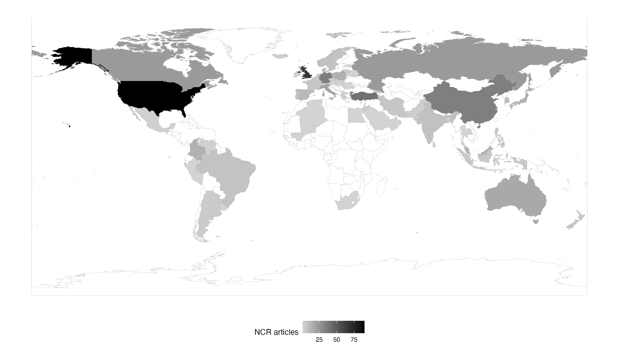
At the same time, despite the difficulties in accessing indexed publications, Global Southern countries also presented a significant incorporation of NCR. This incorporation, however, was somehow unequal across regions. Sub-Saharan African states are relatively absent from NCR dynamics, having published only two articles. Such incorporation was more advanced in South Asia (9 articles) and Latin America (28 articles), suggesting the theory's applicability in alternative regional contexts. Still, two regions emerged as key sites for Neoclassical Realism: the Middle East and North Africa (48 articles) and Asia-Pacific (80 articles). While Turkey leads NCR production in the former (33 articles), China (28) is the powerhouse of such scholarship in Asia, followed by two countries acknowledged as Global Northern: Australia (12) and Japan (10).
These numbers are based on indexed publications, which is not the case for most journals in Global Southern regions. However, they have been boosted by the increasing indexation of these journals, as well as area studies publications. Most Latin American articles were published in flagship Latin American journals, such as Foro Internacional (3), Colombia Internacional, Estudos Internacionais, and Revista Brasileira de Política Internacional (2 articles in each journal). In the Middle East, Turkish journals – All Azimuth (6) and Uluslararasi Iliskiler (4) – and area studies publications – Contemporary Review of the Middle East (3) and Southeast European and Black Sea Studies (3) – accounted for most articles. A similar outcome happened in Asia-Pacific: the Journal of Asian Security and International Affairs, Millennial Asia (3 articles each), Pacific Focus, Korean Journal of Defense Analysis, Akademika, and the Asian Journal of Middle Eastern and Islamic Studies (2 articles each) were the key outlets for regional NCR publications.
On the other hand, Sub-Saharan African countries present a low number of publications, all concentrated in South Africa. This gap deserves a more careful discussion, as one could promptly argue that it happens due to the absence of indexed publications. There are indexed regional outlets and area studies publications, such as the South African Journal of International Affairs, African Security Review, and African Affairs being the most prominent. But we found only two articles from African scholars. We consider it can denote preferences in African IR scholarship, which has historically engaged more intensively with TWAIL and decolonial traditions than with mainstream realist frameworks. A proper discussion on African publication preferences could be helpful, but is beyond the scope of this article, consisting of a fruitful avenue for future research.
Overall, the NCR advance in the Global South was such that there are currently more publications by Global Southern scholars than those in the Global North. Figure 3 below illustrates these dynamics, tracking yearly NCR production by Global Southern and Northern scholars. The figure reveals that Global Northern scholars dominated NCR production through the 2000s. Then, during the 2010s, Southern production grew steadily and consistently, closing the gap with the North. By the end of the period under analysis, Global Southern scholars account for a majority of indexed NCR publications - a consolidation of what Foulon and Meibauer (2020) had detected only as an incipient trend.

Figure 3 – Global South x North Productivity
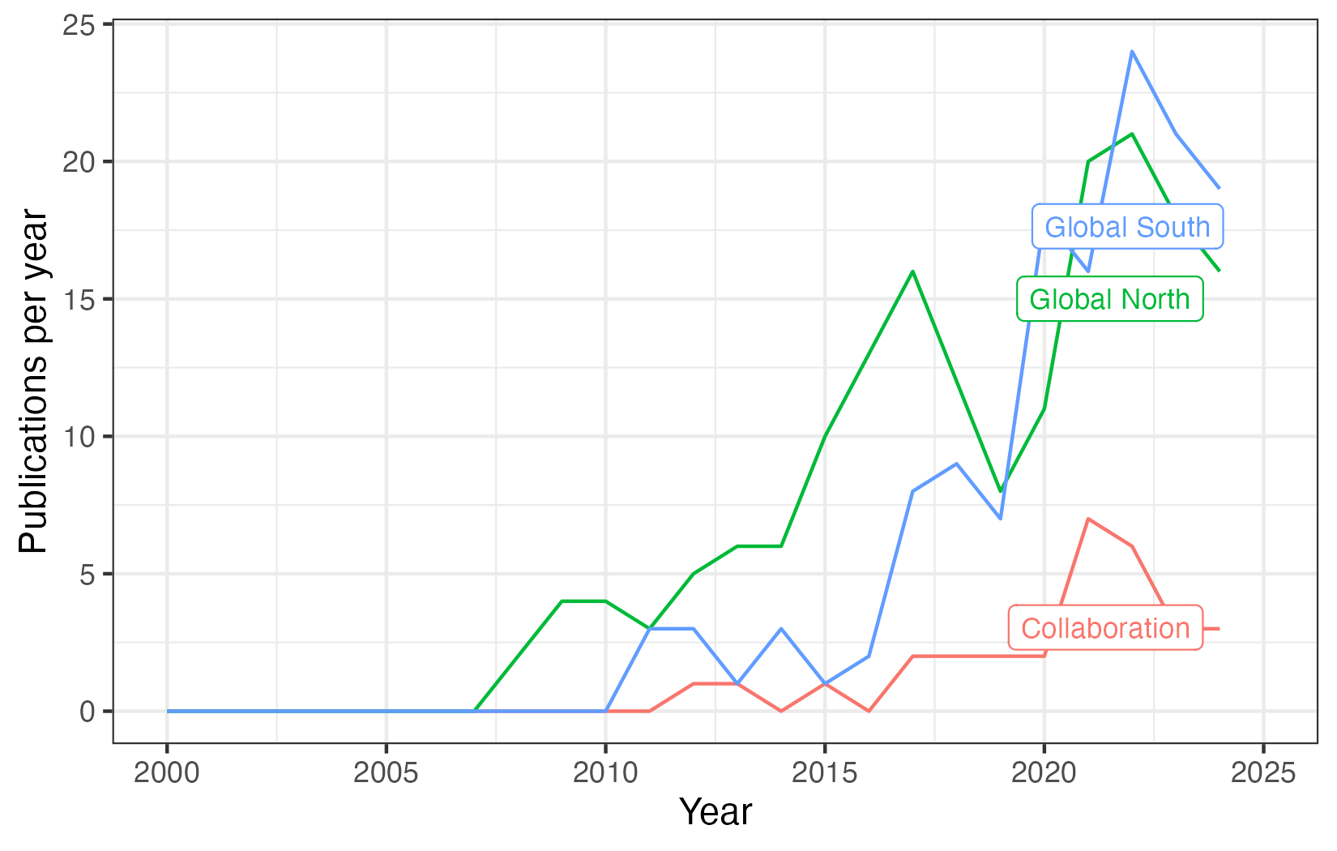

Still, despite NCR's potential to bridge knowledge production between core and peripheral scholarships due to its flexibility (Cerioli 2025), it has not yet shaped high levels of collaboration between Global Southern and Northern scholars. Figure 3 also shows that, despite increasing Global Southern participation in NCR knowledge production, collaboration between core and peripheral scholars remains relatively low, reaching around 20% of yearly publications. If Southern scholars were producing NCR in close dialogue with Northern counterparts, co-authorship rates should have risen alongside Southern participation. Their stability suggests instead that Southern scholars largely learned NCR through canonical Northern texts and adapted it to their own realities with limited feedback to the producing core.
This stability offers preliminary evidence of peripheral adaptation. Global Southern scholars have used and adapted NCR for their own analytical purposes, making it applicable to different issues, contexts, and intellectual traditions. However, their contributions remain largely confined to their own regional communities, without being absorbed by the epistemic core that produced the framework. Whether this reflects deliberate intellectual choice or structural constraints such as language barriers and limited access to international networks is a question our design cannot fully resolve. What the distribution of publications cannot tell us, however, is whether this process produced genuine theoretical adaptation, in which distinct regional variants of NCR with different intellectual foundations occur under a common label of NCR. That is precisely the question the next section addresses.

The intellectual bases of NCR across regions

This section examines the usage of NCR in the Global South through two complementary analyses: a structural topic model that identifies the research agendas scholars pursue under the NCR label, and a citation analysis that reveals the theoretical traditions they mobilize alongside it. Together, they allow us to move from observing that the South adopted NCR to characterizing how.
Existing scholarship argues that IR scholarship outside the Global North tends to be parochial, focused on studying their own countries and regions (Biersteker 2009; Alejandro 2019; Carvalho et al. 2024). Therefore, it is reasonable to expect that scholars outside Europe and the US are focused on topics related to their regions, while American and European researchers may focus on other issues. However, it is still necessary to understand whether this actually applies.
In order to investigate it, we divide all countries into seven regions, as defined by the World Bank Development Indicators (WDI). The only exception was Turkey, which was previously coded as being part of “Europe & Central Asia” but, considering that most of its population does not live in the European part of the country – and, therefore, its academic dynamics may not be as European as those of other countries – we coded it as part of “Middle East & North Africa.” Then, we rely on a text analysis of the abstracts of all documents in our dataset by relying on a Structural Topic Model – we have previously discussed the procedures for preprocessing and model selection. The resulting model contained 10 topics, which were labeled based on the most frequent and exclusive words – Table A1 in the Supplementary Material presents the words related to each topic. Figure 4 below presents the average prevalence of each topic in the documents used in this analysis.

Figure 4 – Topic prevalence in the analyzed sample
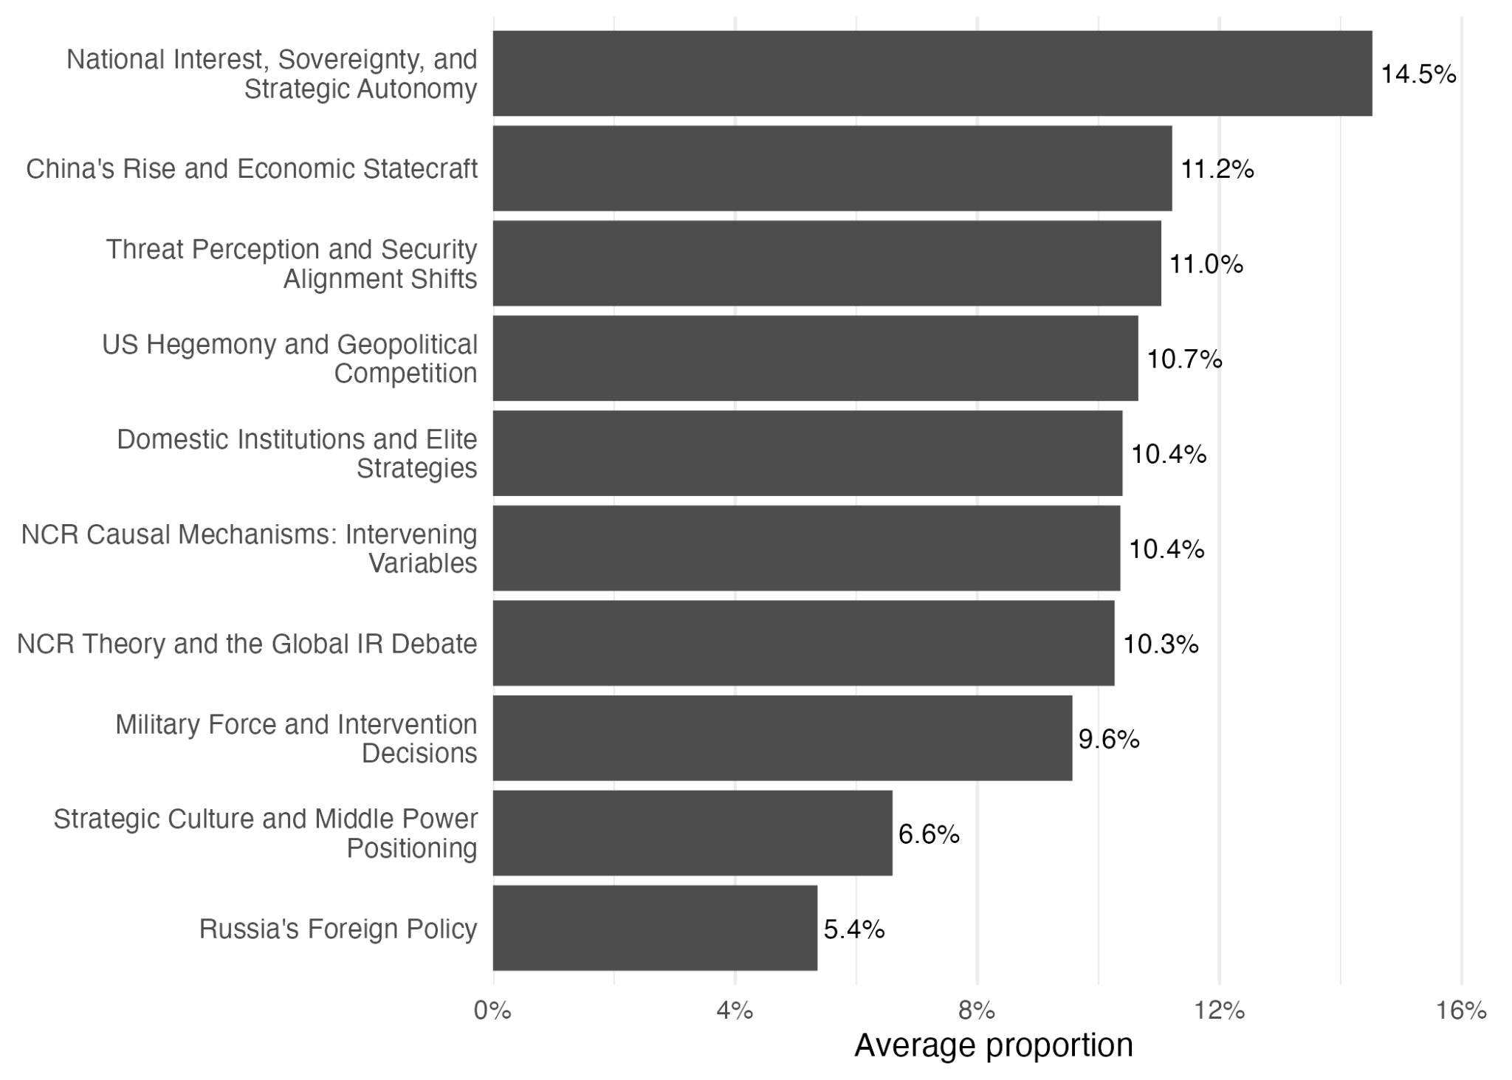
Figure 4 shows that NCR publications are distributed across a varied substantive landscape. The largest share of the scholarly output addresses specific empirical objects: the national interest and strategic autonomy of states (14.5%), the rise of China (11.2%), the foreign policy of the United States (10.7%), military force and grand strategy (9.6%), and Russian foreign policy (5.4%). These proportions together show that scholars spent most of the time applying the theory to their objects of interest (51.4% on aggregate), focusing on improving the understanding of those issues.
There was also a substantial part of the documents (38.4% on aggregate) that discussed NCR's independent and intervening variables, such as threat perception (11%), elites and domestic institutions (10.4%), strategic culture (6.6%), and other intervening variables (10.7%). Still, there was room for discussing the making of the theory: scholars directed 10.3% of all words to discussing the theory and how NCR could fit regions beyond Europe and the US, contributing to the field of IR itself. Overall, it shows a plural field for NCR, being applicable to multiple issues, discussing multiple variables, and open for discussion and adaptation. It evidences what we discussed in the theoretical section. At the same time, they are part of a similar research program by consistently engaging with its core analytical vocabulary of systemic incentives, unit-level variables, and the transmission belt between them.
This research program, however, responds to different interests of scholars from different regions. We discuss it by estimating linear regression models. Results for each topic-region pair are available in Figure 5 below – full models are available in the Appendix. We only report the results for estimates that have shown any degree of statistical significance in order to make results easier to interpret – blank cells mean that coefficients presented p-values higher than 0.05, which means that one cannot infer that a region's behavior may be similar from the cross-regional average. The more intense the blue color in a cell, the more positive the coefficient estimated for that topic in that region, which means that a certain topic was more approached in that region than in the overall average. The inverse applies to red cells: the more intense the red color, the less the topic was approached in that region compared to the global overall average.

Figure 5 – Variation in topic prevalence per region
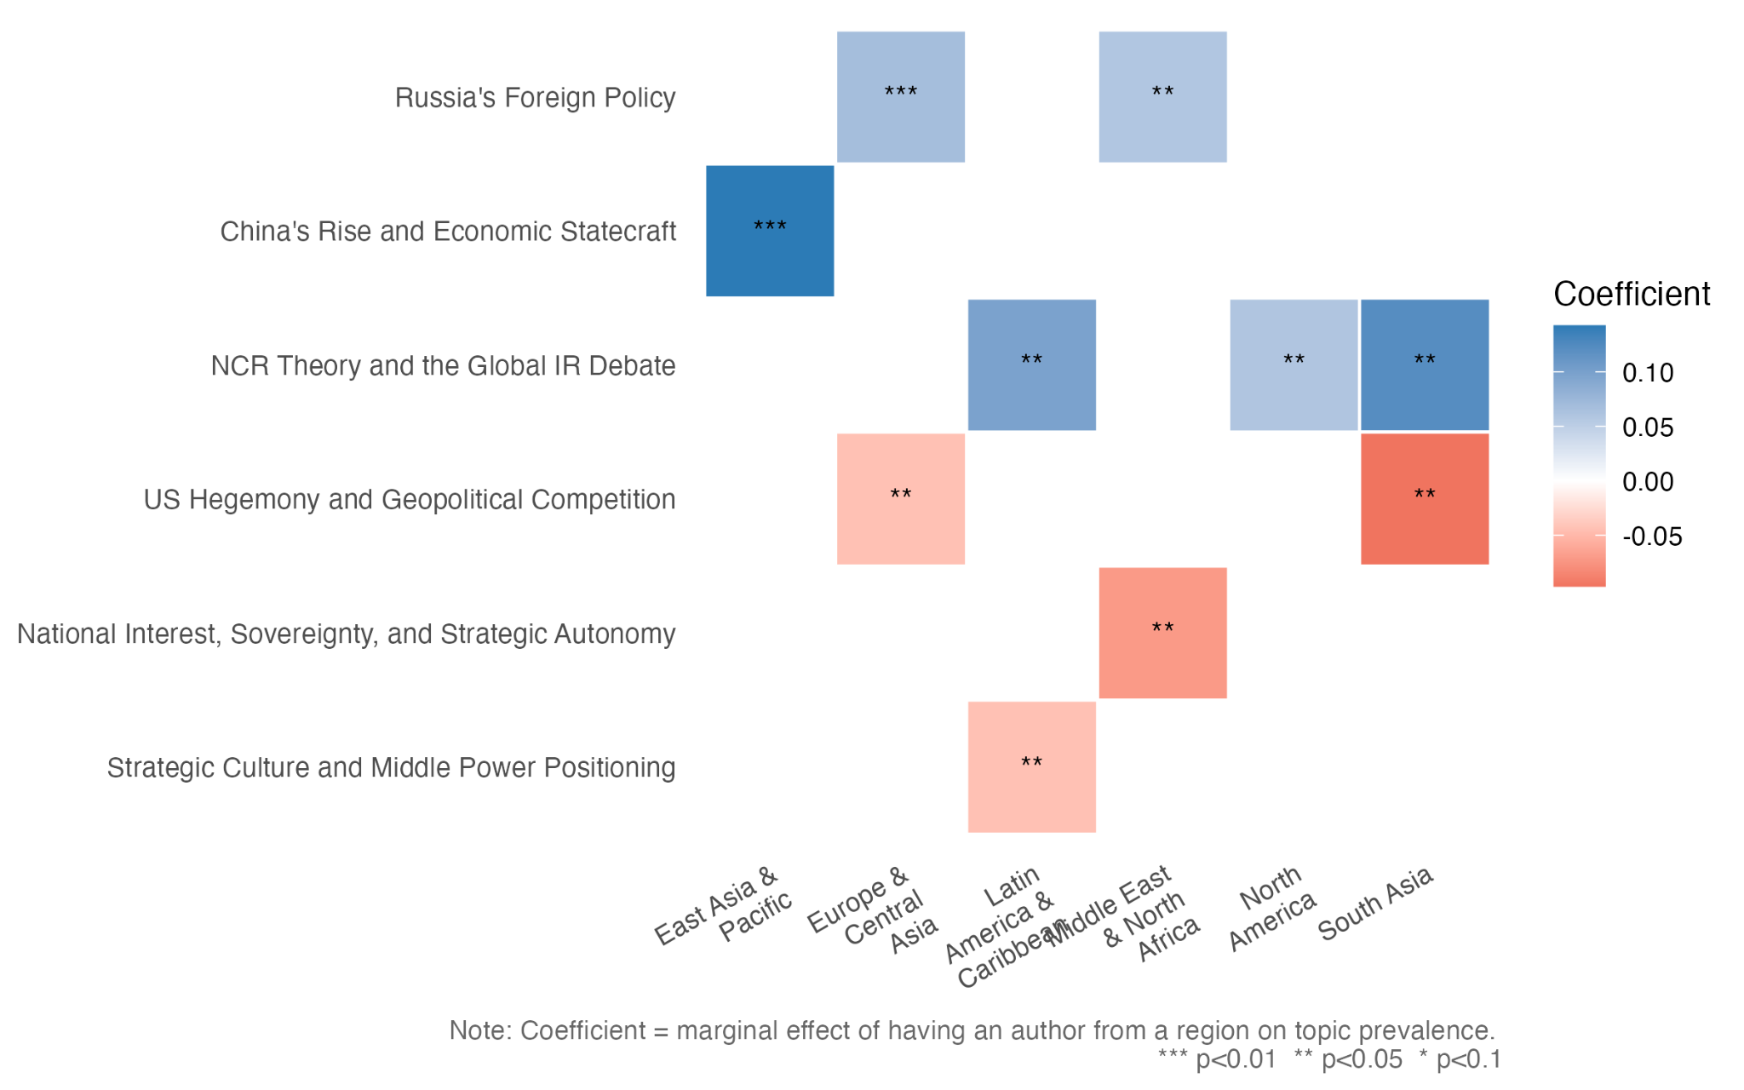
Source: own elaboration

Figure 5 shows some degree of parochialism across regions. Asia-Pacific scholars, for example, tend to focus on their own region. They often mobilize NCR around regionally specific empirical objects related to Chinese power projection, economic statecraft, alliance dynamics. However, the conceptual vocabulary they deploy alongside it remains largely North Atlantic in origin, drawing on strategic culture (Johnston 1995), hedging (Kuik 2008), and nationalism as a domestic intervening variable (Lim, 2008).
A similar feature emerges in Europe and Central Asia, where NCR scholars tend to have a more specific focus on Russia (and the Ukraine War) than the global average. These scholars tend to focus their studies on great power politics in Russia rather than the US, considering the negative and statistically significant coefficient for the topic of Washington's hegemony. Middle Eastern and North African scholars similarly seem to focus on Gulf security, Russia, and its relations with Iran and the Ukraine War, reflecting the region's specific exposure to Russian engagement in Syria, Libya, and Iranian affairs.
North American scholars deviate from this pattern in a theoretically significant way, because they over-represent the meta-theoretical debate. This is consistent with the fact that NCR's founding fathers were all based in the US. At the same time, the major controversies about NCR's scope, parsimony, and variables have largely unfolded in North American and European journals. This suggests that the scholars closest to the theory's core continue to bear primary responsibility for its self-examination and the proposition of new debates.
The Latin American pattern is the most analytically distinctive in the corpus. Latin American scholars show higher engagement with theoretical debate, as well as Global IR debates. The combination is not coincidental. It reflects the region's longstanding intellectual tradition of connecting mainstream IR frameworks with indigenous concepts of peripheral autonomy – what Jaguaribe (1980), Puig (1980), and Escudé (1992) theorized as the central problematic of Latin American foreign policy. When Latin American scholars engage with NCR's theoretical apparatus, they integrate it with an autonomous regional conceptual vocabulary.
South Asian scholars exhibit the most concentrated regional pattern in the dataset. The scholars on India-Pakistan disputes are not writing about Washington's grand strategy but about the specific security dilemma in their own neighborhood, where nuclear-armed rivals sharing contested borders generate a self-contained analytical universe. The systemic incentives that matter most are not global polarity but bilateral deterrence, territorial rivalry, and escalation management. This intense empirical focus, as the citation analysis below confirms, correlates with a dramatically reduced engagement with theoretical frameworks beyond NCR's realist core.
Taken together, these patterns confirm that the parochialism of peripheral scholarship documented in prior work is not a uniform phenomenon but a regionally structured one (Biersteker 2009; Alejandro 2019; Carvalho et al. 2024). The analysis also shows that this pattern is also true in the Global North. Scholars in each region mobilize NCR as a lens for their specific environments. So, North Americans look toward meta-theoretical debate, Europeans and Central Asians toward Russia, Latin American, Asia-Pacific, MENA, and South Asian scholars toward their own strategic contexts. The pattern is structurally similar across regions; what differs is that Southern adaptation does not feed back into the producing core. Regional differentiation at the level of research agendas is therefore only the first observable signature of peripheral adaptation.
Research agendas, however, do not fully reveal theoretical adaptation. Scholars may focus on different empirical objects while drawing on the same intellectual canon. To examine this, we complemented our analysis with a citation-based approach, mapping which theoretical traditions appear alongside NCR in each region's reference lists through a dictionary of representative authors for each major IR school. The full list is available in the Supplementary Material. Figure 6 presents the results in two plots, with Panel A displaying the proportion of papers in the whole sample citing at least one author connected to each theoretical framework. Panel B uses a linear regression to test the differences in the probabilities of articles published by scholars from each region to cite each theoretical approach. As we did in Figure 5, we report only those coefficients that have registered statistical significance (p < 0.05).

Figure 6 – Theoretical approaches discussed together with NCR
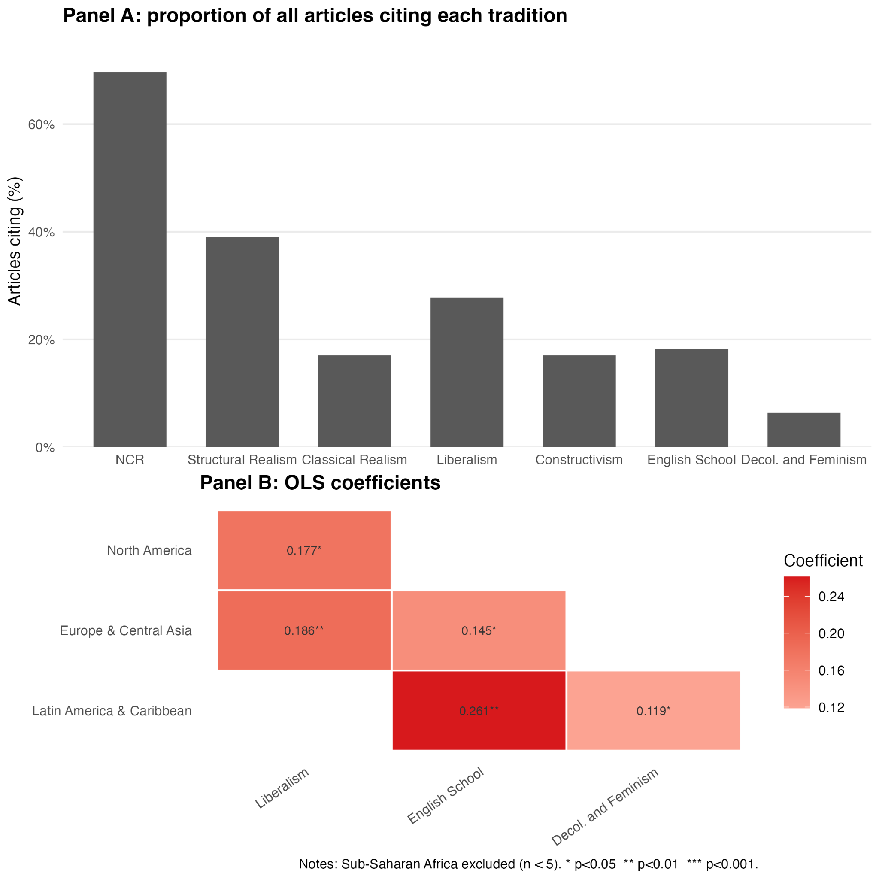

Several patterns in Panel A deserve attention before turning to regional variation. First, as expected, NCR's canonical authors are the most frequently cited, appearing in approximately 70% of the corpus. Structural Realism emerges as the second most cited tradition, which reflects NCR's theoretical origins: the approach was constituted as a response to and extension of Waltzian neorealism (Waltz 1979; Mearsheimer 2001), and most NCR studies frame their contribution by situating themselves within or against that structural baseline. Classical Realism, by contrast, is cited at surprisingly low rates despite NCR's explicit claims to classical lineage. This suggests that the bridge between NCR and its classical predecessors, such as Morgenthau, Carr, and Kissinger, remains more rhetorical than operational in most empirical NCR scholarship.
What Figure 6 reveals more directly is that theoretical traditions are mobilized differently across regions. Liberal frameworks are significantly more cited by North American and European scholars than by those in the Global South, a gap that reflects intellectual geography of the South. The neo-neo debate that structured much of American IR in the 1980s and 1990s (Keohane and Nye 1977; Keohane 1984; Baldwin 1993) was a primarily North Atlantic conversation, and Southern scholars who adopted NCR did not inherit that context. The Liberalism gap is a mark of selective adaptation.
Latin American scholars cite English School authors at the highest rate across all regions. This pattern is aligned with some expectations, since English School's emphasis on international society, sovereign equality, and norms of non-intervention resonates directly with Latin American IR's longstanding engagement with autonomy, multilateralism, and the politics of peripheral states within an institutionalized international order (Tickner 2003; Belém Lopes, Nicolini, and Carvalho 2022; Russell and Tokatlian 2003). When Latin American scholars use NCR, they complement the realist systemic logic with a normative and historical vocabulary drawn from the English School. This produces a variant of the framework that has no direct equivalent in North American literature.
Latin American scholars also register the highest citation rate for decolonial and feminist approaches across all regions in the dataset. This reflects the region's distinctive critical intellectual tradition. The same scholarly community that engages with autonomy concepts and the English School has also sustained a critical conversation about knowledge hierarchies, the colonial roots of IR theory, and the politics of representation in the discipline (Tickner 2003; Tickner and Wæver 2009). The combination of NCR's realist systemic logic, the English School's normative vocabulary, and a decolonial awareness of the politics of knowledge production constitutes the most theoretically layered regional variant of NCR in the entire dataset. It is, in our reading, the clearest case of peripheral adaptation as an active intellectual project, as these scholars adopted a Northern framework, paired it with regional and critical traditions, and produced something that has no equivalent in the core literature.
Finally, a network analysis of co-citation networks can offer some final evidence of NCR adaptation in peripheral regions. Figures 8 to 11 display networks for each Global Southern region – Sub-Saharan Africa is the only exception due to the lack of published articles. Points (nodes) represent cited authors and were sized according to their eigenvector centrality, and colored according to a network clustering algorithm. Lines (edges) are shown when two authors were co-cited in texts and were sized according to the number of co-citations.
Figure 8 - Co-citation Network: Latin America
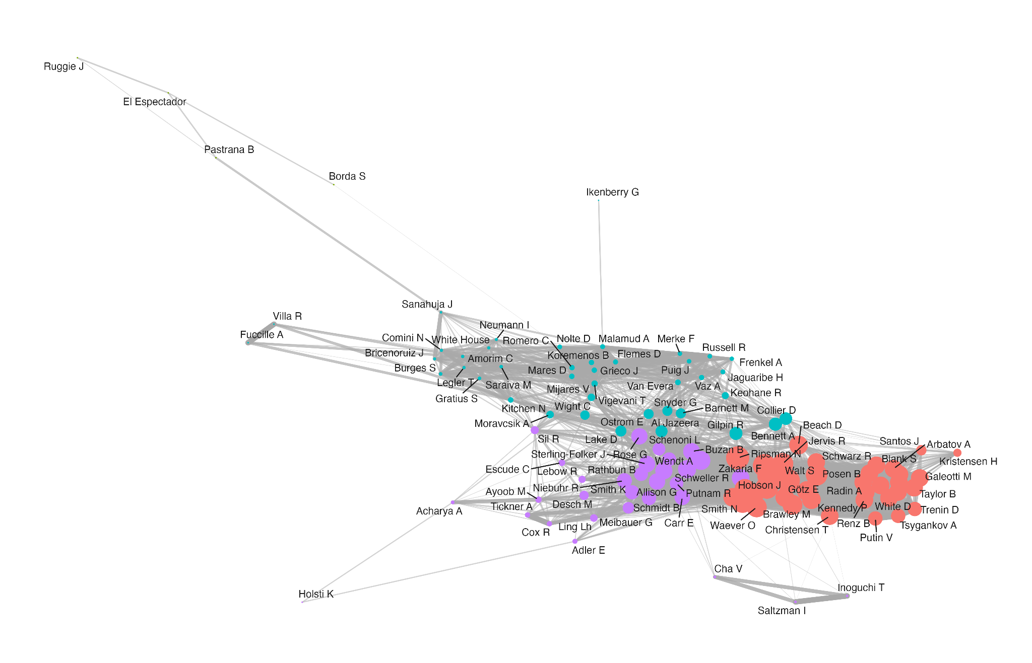

The co-citation network for Latin America (Figure 8) confirms and deepens what we suggested in the above lines. The network displays a dense core of canonical NCR and structural realist authors in the red cluster – Christensen, Götz, Ripsman, Schweller, Zakaria, Walt – that anchors the region's production within the broader disciplinary mainstream. At the same time, the purple cluster combines NCR scholars such as Meibauer and Sterling-Folker, with authors from other theoretical currents that may have influenced NCR scholars in the region, such as Wendt, Adler, and Allison. There are also Latin American prominent Latin American scholars who advocated for theory adaptation, such as Tickner, and Escudé and Schenoni, who worked on Peripheral Realism. This particular cluster highlights the region's search to adapt NCR with other theoretical assumptions. This is complemented by the red cluster, which includes authors such as Jaguaribe and Puig, who proposed and discussed a key Latin American concept: autonomy. Put together, this denotes evidence of peripheral adaptation, by combining theories and bringing regional insights to analysis using NCR.
Asia's network shows differences between them and the others already analyzed. In East Asia's case (Figure 9), the NCR core remains present, but there is more fragmentation, which may reflect the region's geographic and intellectual heterogeneity. Even so it is noteworthy that authors tend to mobilize a wider array of empirical references together with the theoretical core. At the same time, at least two clusters seem to incorporate regional ideas do NCR. The blue cluster displays a range of Asia-Pacific scholars, such as Goh, Chen, and Zha, having Kai He, a prominent Asian scholar who studies the impacts of Asian leaders’ in foreign policy, as its most central author. On the other hand, the beige cluster displays other scholars, having Yan Xuetong, a scholar who prioritizes the whole of Chinese traditions in explaining foreign policy, as its most central scholar.
South Asia shows a similar trend. It contains a cluster is composed of Southeast Asian security scholars, such as Goh, Kuik, Sukma and others, which may reflect the region's empirical orientation toward understanding broader Asian security dynamics using Asian perspectives (Figure 10). On the other hand, MENA's network displays a huge prominence of NCR core scholars. Region-specific authors, such as Ramazani, Akbarzadeh, and Kamrava, present low centralities, and seem to form a cluster with more sparse connections to the center (Figure 11).

Figure 9 - Co-citation Network: East Asia
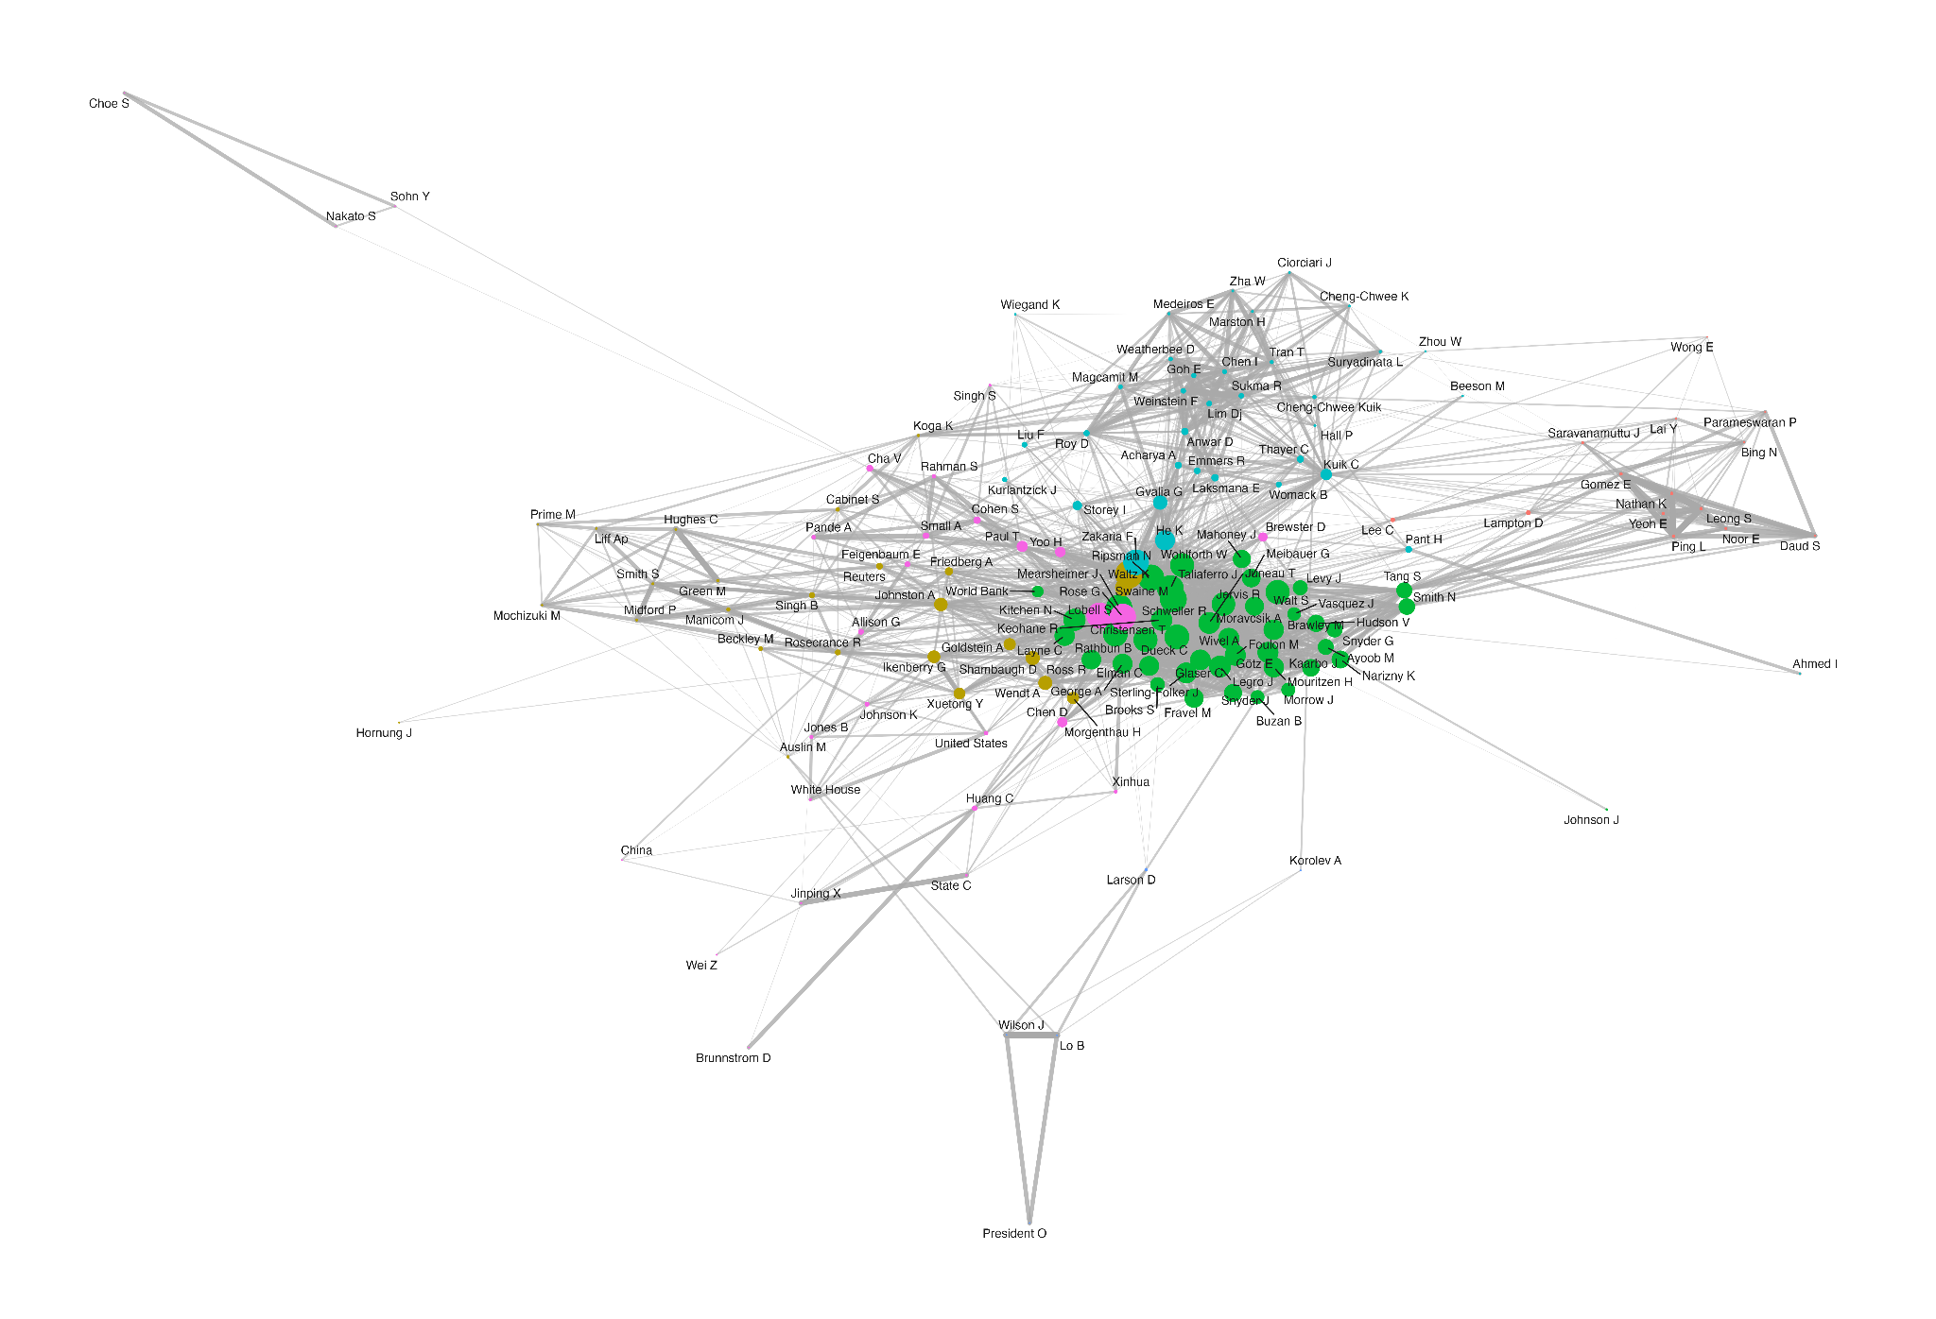
Figure 10 - Co-citation Network: South Asia
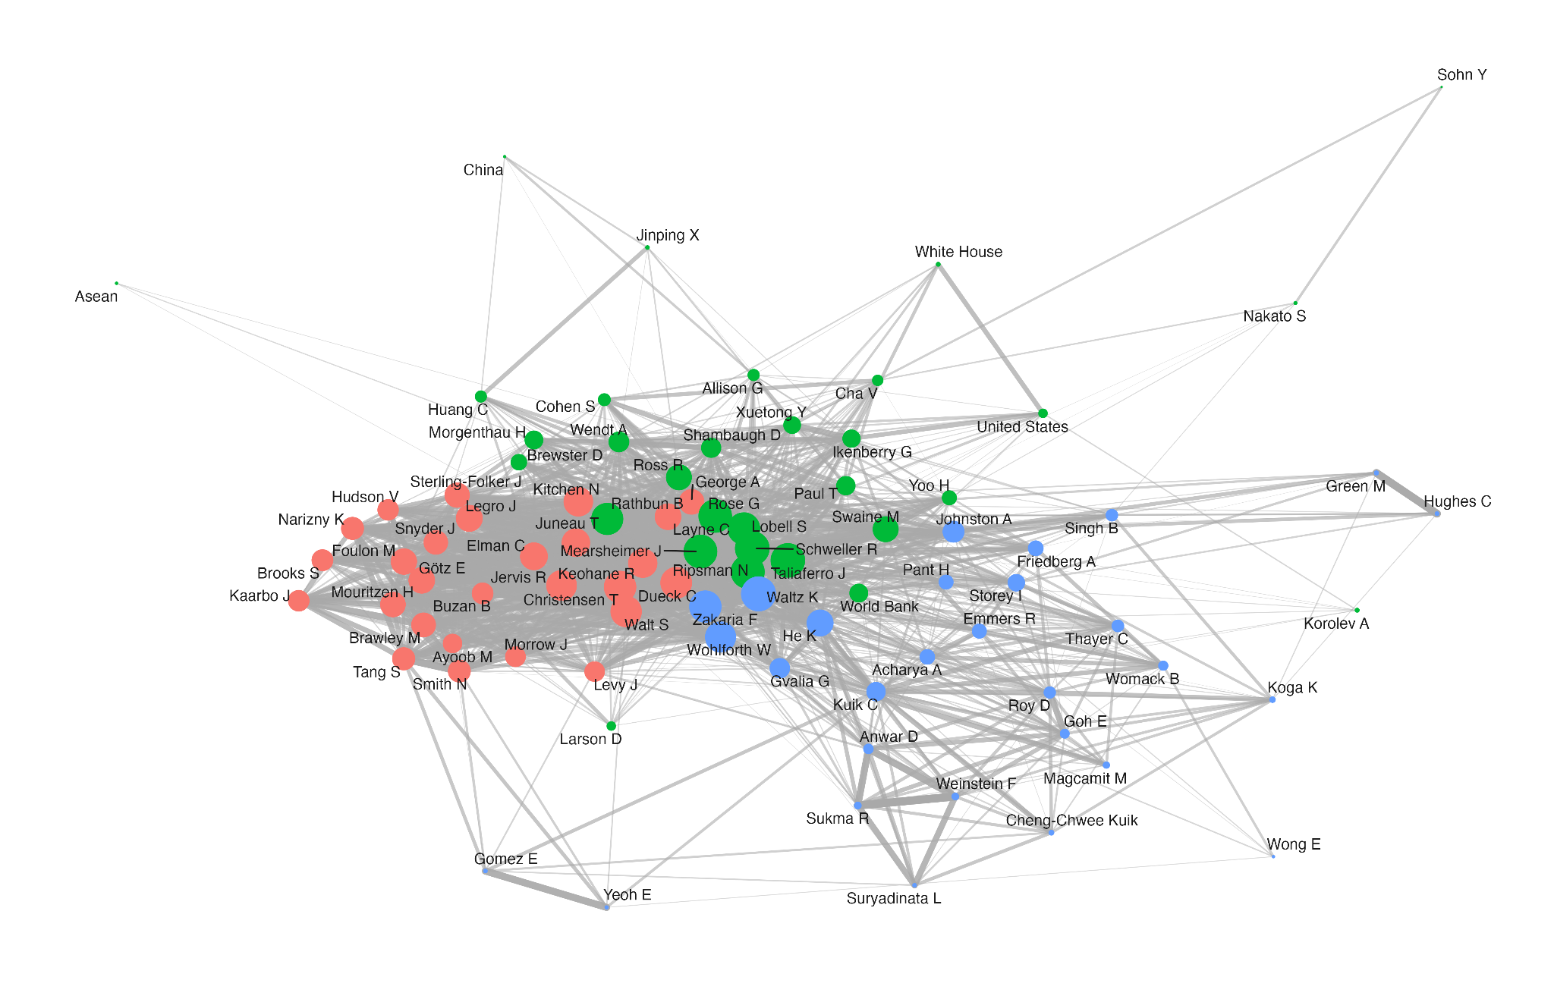

Figure 11 - Co-citation Network: MENA
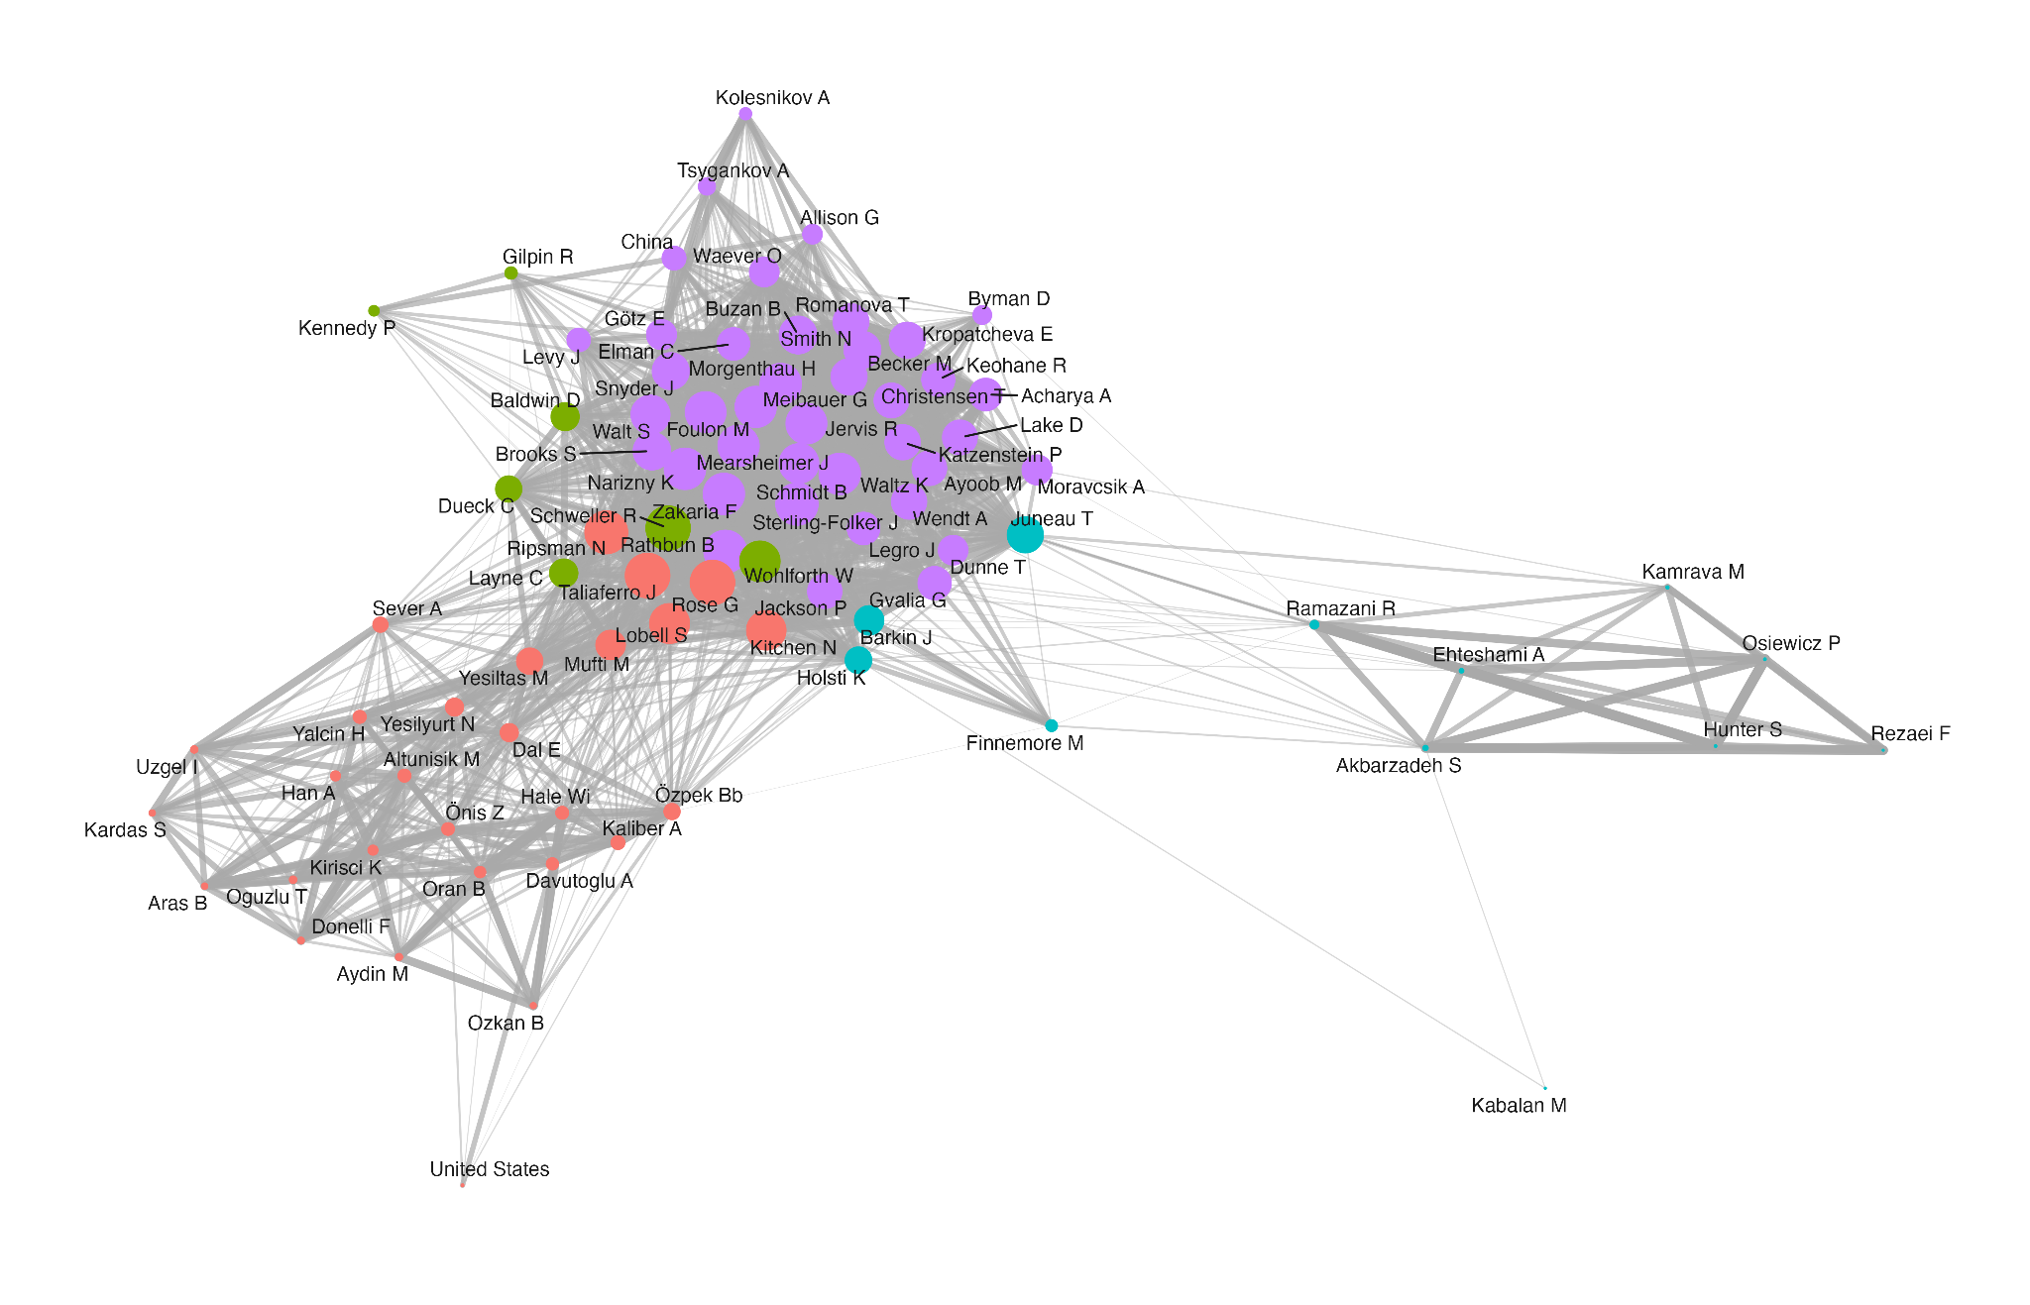

Taken together, the STM, citation, and network analyses build a coherent portrait of theoretical engagement that is neither uniform replication nor deliberate hybridization. Scholars in different regions use NCR to study their own environments, incorporate theoretical traditions that resonate with their regional intellectual landscapes, and do so without tight citation fidelity to the theory's North Atlantic core. The co-citation networks confirm that these distinct intellectual layers are structures that emerge from the data itself. The NCR label provides a common background, but the intellectual architecture developed upon it varies systematically by region. This results in a set of regionally distinct neoclassical realisms that coexist under a common label, but each bearing the marks of the intellectual traditions and theoretical thoughts that shaped the community that produced it.

Conclusion

This article set out to answer a question that existing scholarship had left open in regards to the idea of what was produced in the Global South in regards to NCR. We argue that it is a mode of theoretical engagement in which a framework travels intact at the level of the label while fragmenting at the level of part of the content. As the data shows, Global South scholars now account for a majority of indexed NCR production, but even though the production remains neoclassical realist in its core logic, the intervening variables mobilized and the empirical objects analyzed shift according to regional concerns and historically situated theoretical traditions that are mobilized.
Latin American scholars pair NCR with the English School and decolonial frameworks, producing the most theoretically layered regional variant in the dataset. South Asian scholars narrow the framework to a single security dyad, generating recomposition through empirical concentration rather than conceptual elaboration. Asia-Pacific scholars mobilize NCR around Chinese power projection while drawing on a largely North Atlantic conceptual vocabulary. This also shows that the Global South, in other words, is not a single theoretical community but a set of distinct ones, each bending NCR toward the empirical and intellectual priorities that define its own regional and historical context.
However, co-authorship with Northern scholars has remained stable at roughly 20 percent, suggesting not that Southern scholars were excluded, but that they participated without integrating. The South produced regionally distinct works under the NCR label without that work reaching the communities that set the framework's agenda. In this sense, it shows peripheral adaptation which follows from a theory permissive enough to travel, one whose openness to intervening variables, domestic politics, and strategic context found intellectual traditions in the South already attuned to its logic, within a discipline structured to absorb Southern participation, but not necessarily promoting Southern integration.
Geographic diversification in knowledge production does not automatically produce epistemic integration. A discipline can become more geographically inclusive while its regional scholarly communities grow further apart in their theoretical reference points and collaborative networks, producing not necessarily a global and integrated IR. For NCR specifically, our findings suggest that the framework's flexibility, which is long debated as either its greatest asset or its central weakness, has functioned more as a diffusion mechanism than as a theoretical integrator. NCR traveled precisely because it could accommodate diverse contexts; but that same accommodation enabled regional fragmentation. Whether the resulting set of regional NCRs represents enrichment or dispersal is a question that the theoretical communities still need to address.

References

Acharya A (2014) Global international relations (IR) and regional worlds. International Studies Quarterly 58(4): 647–659.
Acharya, Amitav. 2014. ‘Global International Relations (IR) and Regional Worlds: A New Agenda for International Studies’. International Studies Quarterly 58 (4): 647–59.
Alagoz E (2021) Turkey’s own “pivot to Asia”: A neoclassical realist analysis. Asia Europe Journal 19: 291–307.
Alejandro, Audrey. 2019. Western Dominance in International Relations? The Internationalisation of IR in Brazil and India. London: Routledge.
Ayoob, Mohammed. 1983. ‘Security in the Third World: The Worm about to Turn?’ International Affairs 60 (1): 41–51.
Baracuhy B (2006) A crise da Liga das Nações de 1926: realismo neoclássico, multilateralismo e a natureza da política externa brasileira. Contexto Internacional 28(2): 355–397.
Belém Lopes, Dawisson, João Paulo Nicolini, and Thales Carvalho. 2022. ‘200 Years of International Relations in Brazil: Issues, Theories, and Methods’. In Oxford Research Encyclopedia of International Studies. Oxford University Press.
Biersteker, Thomas. 2009. ‘The Parochialism of Hegemony: Challenges for “American” International Relations’. In International Relations Scholarship around the World, edited by Arlene B. Tickner and Ole Wæver. Worlding beyond the West. Routledge.
Brawley MR (2009) Analytical liberalism versus neo-classical realism: domestic politics and British foreign policy, 1900–1914. Available at: http://papers.ssrn.com/abstract=1451538 (accessed 10 February 2026).
Buzan B and Acharya A (2019) The Making of Global International Relations: Origins and Evolution of IR at Its Centenary. Cambridge: Cambridge University Press.
Carvalho, Thales, and David Mares. 2025. ‘International Security Governance in Latin America: A Historical Assessment’. In Oxford Research Encyclopedia of International Studies. Oxford University Press.
Carvalho, Thales, Vinicius Santos, and Yulieth Martínez. 2024. ‘Following the Trail of Words: Mapping the Trending Topics of Graduate Research in the Brazilian IR Scholarship (1987-2018)’. Brazilian Political Science Review 18 (1): e0003.
Cerioli, Luíza. 2024. ‘Neoclassical Realism, Global International Relations, and the Unheard Echoes of Realist Practices from the South’. The British Journal of Politics and International Relations 27 (1): 369–86.
Christensen, Thomas J. 1996. Useful Adversaries: Grand Strategy, Domestic Mobilization, and Sino-American Conflict, 1947-1958. Princeton Studies in International History and Politics. Princeton University Press.
Collier, David, and James E. Mahon. 1993. "Conceptual 'Stretching' Revisited: Adapting Categories in Comparative Analysis." American Political Science Review 87(4): 845–855.
Dawood & Oliveira (2025, forthcoming)
de Oliveira A and Dawood L (2024) Reflexões sobre a liderança na política de defesa do Brasil para o Atlântico Sul. Carta Internacional 23: 273–310.
Dueck C (2004) Ideas and alternatives in American grand strategy, 2000–2004. Review of International Studies 30(4): 511–535.
Escudé, Carlos. 1992. Realismo Periférico: Fundamentos Para La Nueva Política Exterior Argentina. Política y Sociedad. Planeta.
Foulon M and Meibauer G (2020) Realist avenues to global International Relations. European Journal of International Relations 26(4): 1203–1229.
Friedberg AL (2000) In the Shadow of the Garrison State: America’s Anti-Statism and Its Cold War Grand Strategy. Princeton, NJ: Princeton University Press, pp. 245–295.
Gill D (2023) Locating the evolving Vietnam–India security partnership in Hanoi’s hedging strategy with major powers: A neoclassical realist analysis. Millennial Asia 0(0).
Götz, Elias. 2021. ‘Neoclassical Realist Theories, Intervening Variables, and Paradigmatic Boundaries’. Foreign Policy Analysis 17 (2): oraa026.
Grimmer, Justin, Margaret E. Roberts, and Brandon M. Stewart. 2022. Text as Data: A New Framework for Machine Learning and the Social Sciences. Princeton University Press.
Hadfield-Amkhan A (2010) British Foreign Policy, National Identity, and Neoclassical Realism. Lanham: Rowman & Littlefield.
He K (2017) Explaining United States–China relations: Neoclassical realism and the nexus of threat–interest perceptions. The Pacific Review 30(2): 133–151.
Hynek, N., & Šenk, M. (2026). Neoclassical realist research program for the 21st century: From topography and traditions to an abductive practical guide. European Journal of International Relations, 0(0).
Jaguaribe H (1980) Autonomia periférica e hegemonia cêntrica. Relações Internacionais 3: 91–130.
Johnston, Alastair Iain. 1995. Cultural Realism: Strategic Culture and Grand Strategy in Chinese History. Princeton: Princeton University Press.
Juneau T (2015) Squandered Opportunity: Neoclassical Realism and Iranian Foreign Policy. Stanford: Stanford University Press.
Kitchen N (2010) Systemic pressures and domestic ideas: A neoclassical realist model of grand strategy formation. Review of International Studies 36(1): 117–143.
Korany, Bahgat. 1987. "Foreign Policy in the Third World: An Introduction." International Political Science Review 8(1): 7–20.
Kristensen, Peter Marcus. 2018. ‘International Relations at the End: A Sociological Autopsy’. International Studies Quarterly, ahead of print, May 3.
Kuik, Cheng-Chwee. The essence of hedging: Malaysia and Singapore's response to a rising China. Contemporary Southeast Asia, Singapore, v. 30, n. 2, p. 159–185, ago. 2008. ISEAS – Yusof Ishak Institute.
Lai YM (2013) Nationalism and Power Politics in Japan's Relations with China: A Neoclassical Realist Interpretation. 1st ed. London: Routledge.
Legro JW and Moravcsik A (1999) Is anybody still a realist? International Security 24(2): 5–55.
Lim Y and Gill B (2025) Neoclassical realism, nationalism and the evolution of China’s revisionism in maritime East Asia. Journal of Asian Security and International Affairs 12(4): 433–459.
Lobell S, Taliaferro J and Ripsman N (eds) (2009) Neoclassical Realism, the State, and Foreign Policy. New York: Cambridge University Press.
Lobell, Steven E., Norrin M. Ripsman, and Jeffrey W. Taliaferro, eds. 2009. Neoclassical Realism, the State, and Foreign Policy. 1st edn. Cambridge University Press.
Lohaus, Mathis, and Wiebke Wemheuer-Vogelaar. 2020. ‘Who Publishes Where? Exploring the Geographic Diversity of Global IR Journals’. International Studies Review, August 29.
Magcamit M (2019) The Duterte method: A neoclassical realist guide to understanding a small power’s foreign policy and strategic behaviour in the Asia-Pacific. Asian Journal of Comparative Politics 5(4): 416–436.
Meibauer G (2020) Interests, ideas, and the study of state behaviour in neoclassical realism. Review of International Studies 46(1): 20–36.
Meibauer, Gustav, Linde Desmaele, Tudor Onea, et al. 2021. ‘Forum: Rethinking Neoclassical Realism at Theory’s End’. International Studies Review 23 (1): 268–95.
Mimno, David, Hanna Wallach, Edmund Talley, Miriam Leenders, and Andrew McCallum. 2011. ‘Optimizing Semantic Coherence in Topic Models’. Proceedings of the Conference on Empirical Methods in Natural Language Processing, 262–72.
Narizny K (2017) On systemic paradigms and domestic politics: A critique of the newest realism. International Security 42(2): 155–190.
Oliveira ACG de (2021) From panda to dragon: An analysis of China’s maritime actions and reactions in the East China Sea and their implications since 2012. Contexto Internacional 43(1): 147–171.
Puig, Juan Carlos. 1980. Doctrinas internacionales y autonomía latinoamericana. Caracas: IILDIS.
Rathbun, Brian C. 2008. "A Rose by Any Other Name: Neoclassical Realism as the Logical and Necessary Extension of Structural Realism." Security Studies 17(2): 294–321.
Ripsman N, Taliaferro J and Lobell S (2016) Neoclassical Realist Theory of International Politics. New York: Oxford University Press.
Ripsman NM (2002) Peacemaking by Democracies: The Effect of State Autonomy on the Post-World War Settlements. University Park: Penn State University Press.
Ripsman, Norrin M., Jeffrey W. Taliaferro, and Steven E. Lobell. 2016. Neoclassical Realist Theory of International Politics. Oxford University Press.
Roberts, Margaret E., Brandon M. Stewart, Dustin Tingley, et al. 2014. ‘Structural Topic Models for Open-Ended Survey Responses: STRUCTURAL TOPIC MODELS FOR SURVEY RESPONSES’. American Journal of Political Science 58 (4): 1064–82.
Rose, Gideon. 1998. ‘Neoclassical Realism and Theories of Foreign Policy’. World Politics 51 (1): 144–72.
Russell, Roberto, and Juan Gabriel Tokatlian. 2003. "From Antagonistic Autonomy to Relational Autonomy: A Theoretical Reflection from the Southern Cone." Latin American Politics and Society 45(1): 1–24.
Sari A (2018) A neoclassical realist explanation of Indonesia’s involvement in Muslim-related secessions in non-Muslim countries. Asian Journal of Comparative Politics 4(3): 213–241.
Sartori, Giovanni. 1970. "Concept Misformation in Comparative Politics." American Political Science Review 64(4): 1033–1053.
Sayigh, Yezid. 1991. "Confronting the 1990s: Security in the Developing Countries." Adelphi Papers 31(251). London: IISS.
Schenoni, Luis, and Carlos Escudé. 2016. ‘Peripheral Realism Revisited’. Revista Brasileira de Política Internacional 59 (1).
Schmidt BC (2014) A realist view of the Eurocentric conception of world politics. Millennium 42(2): 464–471.
Schweller R (1998) Deadly Imbalances: Tripolarity and Hitler’s Strategy of World Conquest. New York: Columbia University Press.
Schweller R (2018) Opposite but compatible nationalisms: A neoclassical realist approach to the future of US–China relations. The Chinese Journal of International Politics 11(1): 23–48.
Schweller RL (1996) Neorealism’s status-quo bias: What security dilemma? Security Studies 5(3): 90–121.
Schweller, Randall L. 2008. Unanswered Threats: Political Constraints on the Balance of Power. 1st paperback printing. Princeton Studies in International History and Politics. Princeton Univ. Press.
Snyder, Jack L. 1994. Myths of Empire: Domestic Politics and International Ambition. 2. print. Cornell Studies in Security Affairs. Cornell Univ. Press.
Sterling-Folker J (2009) Neoclassical realism and identity: Peril despite profit across the Taiwan Strait. In: Lobell S, Taliaferro J and Ripsman N (eds) Neoclassical Realism, the State, and Foreign Policy. New York: Cambridge University Press, pp. 99–139.
Sterling-Folker, Jennifer. 1997. ‘Realist Environment, Liberal Process, and Domestic-Level Variables’. International Studies Quarterly 41 (1): 1–26.
Taliaferro JW (2009) Neoclassical realism and resource extraction: State building for future war. In: Lobell SE, Ripsman NM and Taliaferro JW (eds) Neoclassical Realism, the State, and Foreign Policy. Cambridge: Cambridge University Press, pp. 194–226.
Taliaferro, Jeffrey W. 2006. ‘State Building for Future Wars: Neoclassical Realism and the Resource-Extractive State’. Security Studies 15 (3): 464–95.
Tickner, Arlene B. 2003. "Seeing IR Differently: Notes from the Third World." Millennium 32(2): 295–324.
Tickner, Arlene. 2009. ‘Latin America: Still Policy Dependent after All These Years?’ In International Relations Scholarship around the World, edited by Arlene B. Tickner and Ole Wæver. Worlding beyond the West. Routledge.
Tickner, Arlene B., and Ole Wæver (eds). 2009. International Relations Scholarship Around the World. London: Routledge.
Wæver, Ole. 1998. "The Sociology of a Not So International Discipline: American and European Developments in International Relations." International Organization 52(4): 687–727.
Wivel, Anders. 2005. "Explaining Why State X Made a Certain Move Last Tuesday: The Promise and Limitations of Realist Foreign Policy Analysis." Journal of International Relations and Development 8(4): 355–380.
Zakaria F (1998) From Wealth to Power: The Unusual Origins of America’s World Role. Princeton: Princeton University Press.
Zakaria, Fareed, and Jack Snyder. 1992. ‘Realism and Domestic Politics: A Review Essay’. International Security 17 (1): 177.

Although we acknowledge that logistic and probabilistic regressions are the most used tools to approaching dummy variables, we rely on linear regressions because it enables more straightforward interpretation. Still, robustness checks available in the appendix point to the same results.
Rio de Janeiro State University (UERJ), Brazil.
Rio de Janeiro State University (UERJ), Brazil.
Tufts University, United States.
The Federal University of Rio Grande do Sul (UFRGS), Brazil.

