Assignment 1
Abstract

Task abstract. Inheritance in JAVA.
Score: 5 pts

Task details

1). Set up BlueJ (or any IDE you like) environment on your computer if needed, and create a project with your preferred name.
2). Suppose there is a class declared as follows:
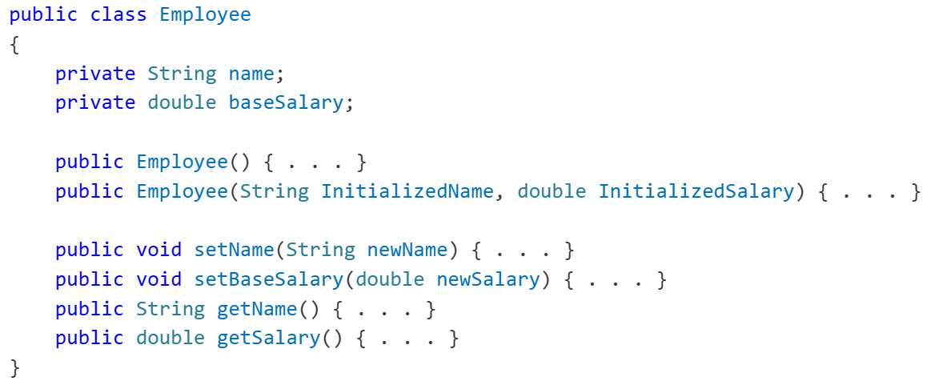
Please create the above class, Employee, and finish the code for its methods: Employee, setName, setBaseSalary, getName, and getSalary. Please refer to the mutator and accessor methods in CSCI 2101 if needed.

3). Declare a class, Manager, that inherits from the class Employee, adds an instance variable bonus for storing a salary bonus, and overrides the getSalary method to calculate the salary as the sum of baseSalary and bonus. In addition, please use a constructor method that initializes the bonus variable.

4). Declare a class, parttimeWorker, that inherits from the class Employee, adds two instance variables: hours for storing working hours; hourlyPay for the pay rate, and overrides the getSalary method to calculate the salary as hours hourlyPay. In addition, please use a constructor method that initializes the hours and hourlyPay variables.

5). Download the file testExtends.java from the Assignment 1 attachments on Blackboard and import it into the project you are working with. Run the main method and your output is expected as,
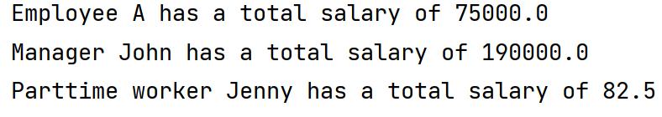

6). Make screenshots and upload your .java source code files.

