Hadoop Setup

Hadoop cluster is setup with 1 master node and 2 worker nodes.

|  |  |  |
| --- | --- | --- |
| **Computer Host Name** | **Type** | **IP Address** |
| DESKTOP-LGGIT28 | Master | 192.168.1.68 |
| Emon-Desk | Worker1 | 192.168.1.69 |
| Emon-Home | Worker2 | 192.168.1.80 |

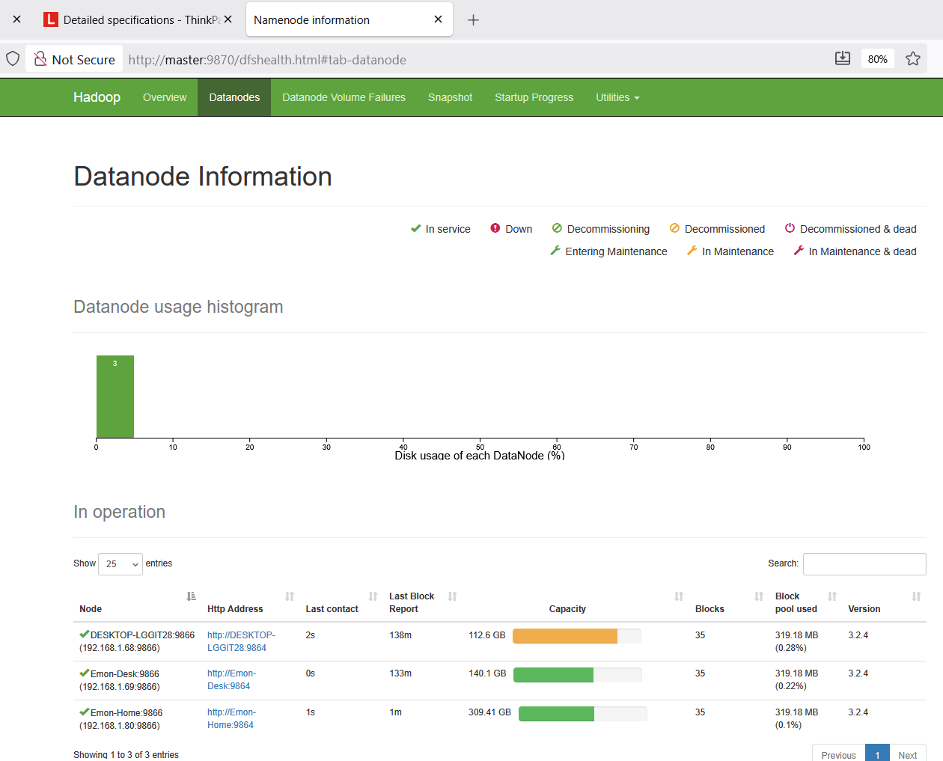

**Master Node Configuration**

Master & Worker host file:

Location: C:\Windows\System32\driver\etc\host

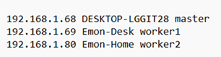

Core-site.xml

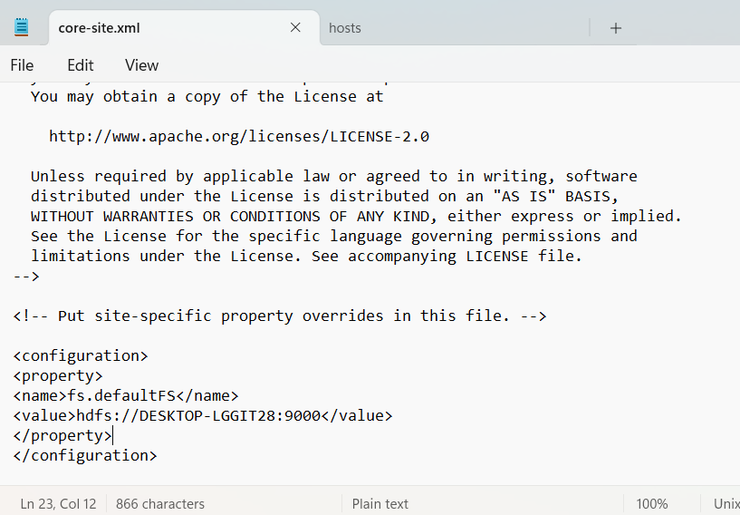

Hdfs-site.xml

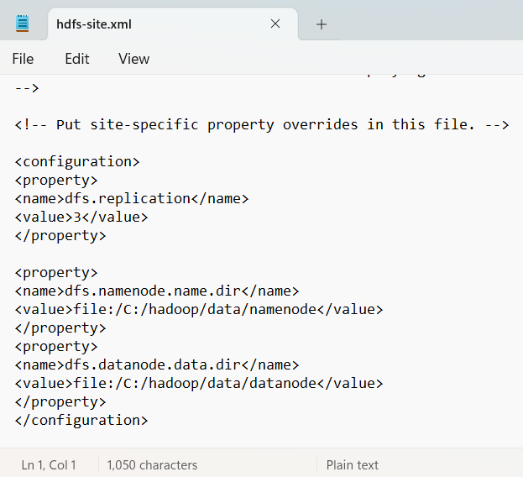

**Worker Nodes Configuration**

Core-site.xml

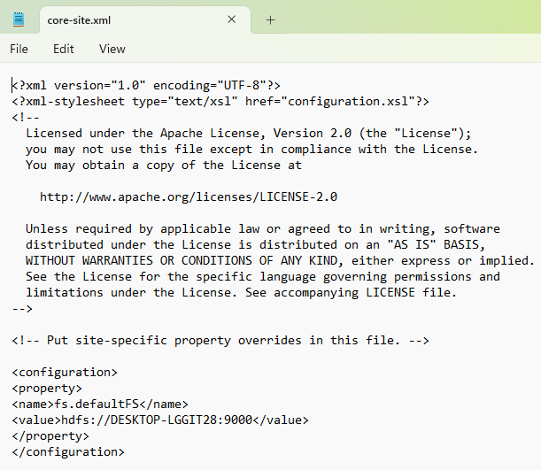

Yarn-site.xml

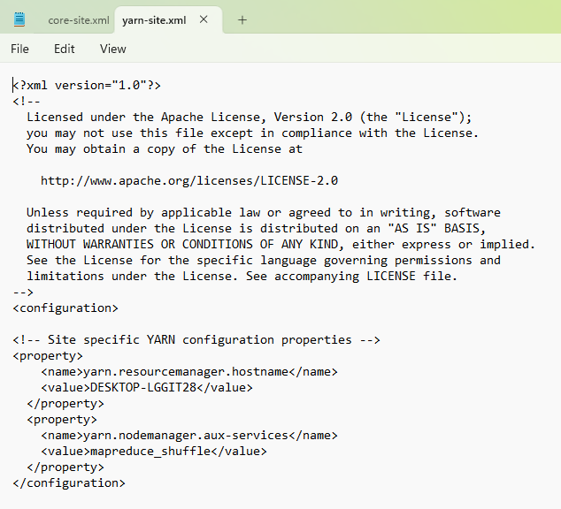

**Hadoop storage directory**

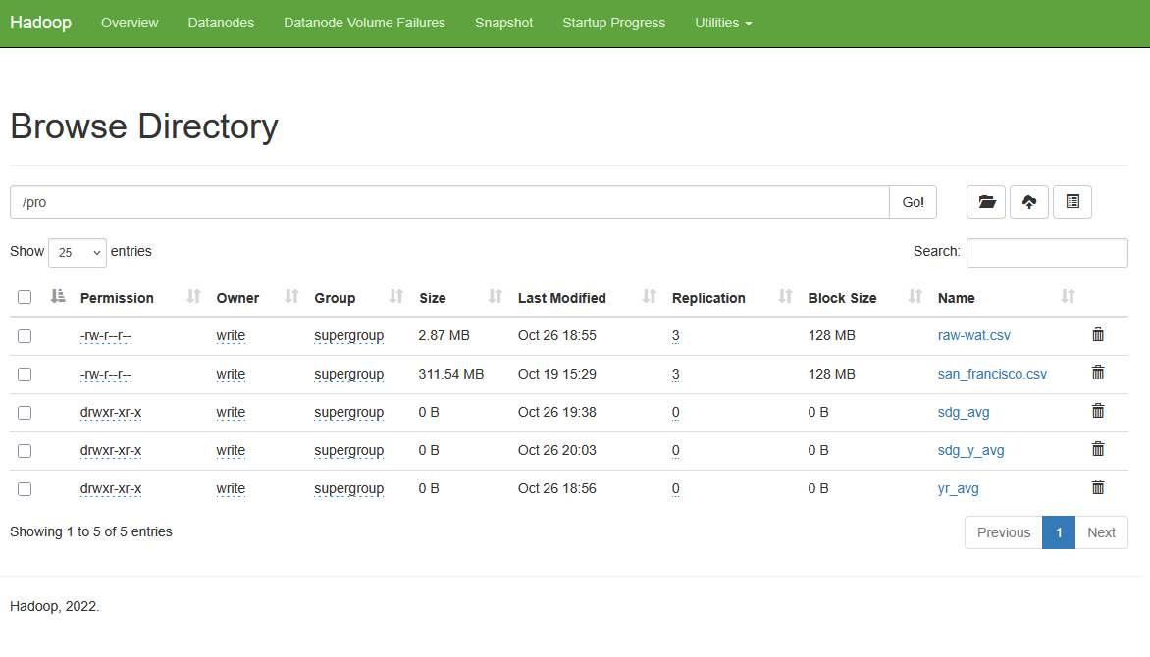

**Map-Reduce**

Hadoop Streaming Command

hadoop jar C:\hadoop\share\hadoop\tools\lib\hadoop-streaming-3.2.4.jar -input /pro/raw-wat.csv -output /pro/sdg_y_avg -mapper "python D:\bigdata_test\pro\mapper_sdg_y.py" -reducer "python D:\bigdata_test\pro\reducer_sdg_y.py"

Job Process:

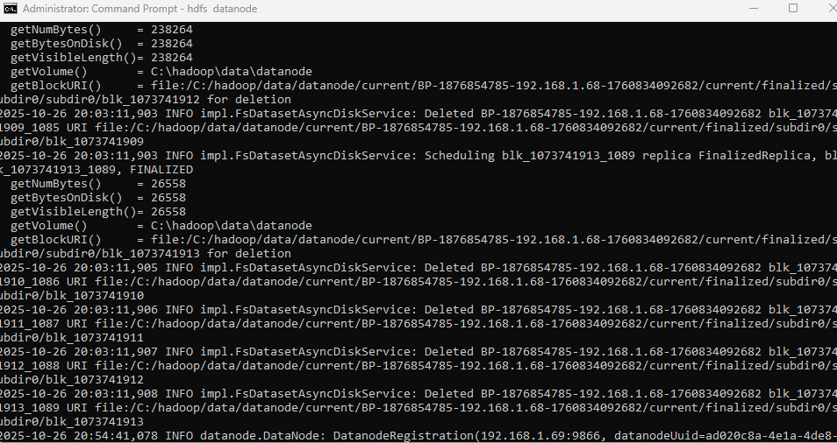

Job Report:

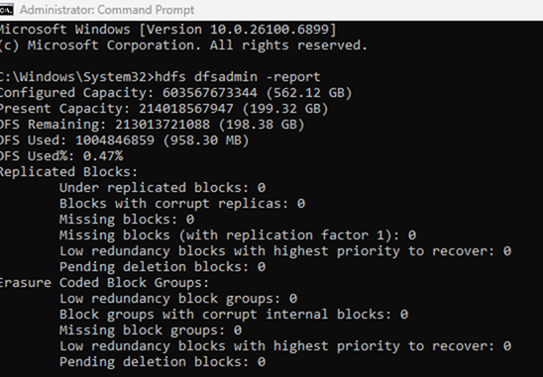

Master Node Report:

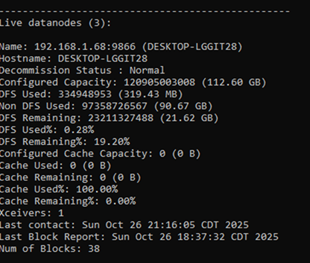

Worker Node Reports:

