Teen Mental Health Power BI Report
1. Project Objective & Business Problem Objective:
The objective of this project is to analyze factors associated with teenage mental health outcomes using a dataset sourced from Kaggle. The analysis focuses on how social media usage, sleep, stress, anxiety, addiction level, academic performance, physical activity, gender, age group, platform usage, and social interaction level relate to depression risk among teenagers.

The business problem addressed in this report is the need to better understand which behavioral and lifestyle factors may indicate higher mental health risk in teenagers. With increasing social media use among young people, schools, parents, health organizations, and youth support services can benefit from identifying patterns linked to higher stress, anxiety, addiction, and depression outcomes.

Business problem: The goal is to identify which lifestyle and social media factors are associated with higher depression risk among teenagers. The report helps answer questions such as:
- Do high social media users show higher depression rates?
- Are stress, anxiety, and addiction levels related to depression?
- Do platform usage, gender, age group, or social interaction level affect mental health outcomes?

2. Data Sources & Transformations Data source:
The dataset comes from: Teen_Mental_Health_Dataset.csv
The data was preprocessed using a Jupyter notebook: teen_mental_health_preprocessing.ipynb
The cleaned Power BI tables were exported into: processed/

For more transformation detail:
The dataset comes from:
Teen_Mental_Health_Dataset.csv
The data was preprocessed using a Jupyter notebook:
teen_mental_health_preprocessing.ipynb
The cleaned Power BI tables were exported into:
processed/
The notebook used Python and pandas to load, validate, clean, transform, and export the dataset into a Power BI-ready star schema.

First, the notebook loaded the raw CSV file and checked that the expected 13 columns were present. These columns included age, gender, daily social media hours, platform usage, sleep hours, screen time before sleep, academic performance, physical activity, social interaction level, stress level, anxiety level, addiction level, and depression label. The dataset contained 1,200 rows and 13 columns.

The notebook then selected only the expected columns for preprocessing. Text fields were cleaned by removing extra spaces and standardizing category labels. For example, gender values were standardized to Male and Female, platform values were standardized to Instagram, TikTok, and Both, and social interaction values were standardized to Low, Medium, and High. This helped ensure that Power BI would not treat different spellings or capitalizations as separate categories.

Numeric columns were converted into proper numeric data types. These included age, daily social media hours, sleep hours, screen time before sleep, academic performance, physical activity, stress level, anxiety level, addiction level, and depression label. The notebook used strict numeric conversion so that invalid numeric values would raise an error instead of being silently ignored.

The notebook also created an age_group field to make age analysis easier in Power BI. Ages were grouped as follows:
13-15 = Early Teen
16-17 = Middle Teen
18-19 = Late Teen
A validation check was included to ensure that every age value belonged to one of these configured teen age groups. The notebook also checked for missing values after the cleaning and transformation steps, and the processed dataset showed no missing values across the required fields.

Next, the notebook transformed the cleaned dataset into a star schema. It created four dimension tables:
Dim_Age
Dim_Gender
Dim_Platform
Dim_SocialInteraction
Dim_Age was created from distinct age and age group combinations. Each age was assigned an AgeKey, with ages ordered from 13 to 19.

Dim_Gender was created with an ordered key structure:
1 = Male
2 = Female

Dim_Platform was created with platform keys:
1 = Instagram
2 = TikTok
3 = Both

Dim_SocialInteraction was created with social interaction keys and a ranking column:
1 = Low
2 = Medium
3 = High

The InteractionRank column was added so Power BI can sort social interaction levels logically as Low, Medium, High instead of alphabetically.
After creating the dimension tables, the notebook created the fact table:
Fact_TeenMentalHealth

A unique RespondentID was generated for each row. The fact table was then joined with each dimension table to assign foreign keys:
AgeKey
GenderKey
PlatformKey
SocialInteractionKey

The final fact table kept the respondent ID, the foreign keys, and the measurable columns:
DailySocialMediaHours
SleepHours
ScreenTimeBeforeSleep
AcademicPerformance
PhysicalActivity
StressLevel
AnxietyLevel
AddictionLevel
DepressionLabel

Column names were converted from raw snake_case names into clearer Power BI-friendly names such as DailySocialMediaHours, SleepHours, StressLevel, AnxietyLevel, and DepressionLabel.
Before exporting, the notebook ran validation checks to confirm that the model was clean and ready for Power BI. It checked that dimension keys were unique, that all fact table foreign keys matched the dimension tables, and that RespondentID was unique in the fact table. The validation passed with:
Fact_TeenMentalHealth: 1,200 rows
Dim_Age: 7 rows
Dim_Gender: 2 rows
Dim_Platform: 3 rows
Dim_SocialInteraction: 3 rows

Finally, the notebook exported the cleaned star schema tables as CSV files into the processed/ folder:
processed/Dim_Age.csv
processed/Dim_Gender.csv
processed/Dim_Platform.csv
processed/Dim_SocialInteraction.csv
processed/Fact_TeenMentalHealth.csv
These exported CSV files were then loaded into Power BI to create relationships, DAX measures, slicers, and dashboard visuals.

Calculated Columns
Stress Category =
SWITCH(
TRUE(),
Fact_TeenMentalHealth[StressLevel] < 4, "Low",
Fact_TeenMentalHealth[StressLevel] < 7, "Medium",
"High"
)
Anxiety Category =
SWITCH(
TRUE(),
Fact_TeenMentalHealth[AnxietyLevel] < 4, "Low",
Fact_TeenMentalHealth[AnxietyLevel] < 7, "Medium",
"High"
)
Addiction Category =
SWITCH(
TRUE(),
Fact_TeenMentalHealth[AddictionLevel] < 4, "Low",
Fact_TeenMentalHealth[AddictionLevel] < 7, "Medium",
"High"
)
Social Media Usage Category =
SWITCH(
TRUE(),
Fact_TeenMentalHealth[DailySocialMediaHours] < 3, "Low",
Fact_TeenMentalHealth[DailySocialMediaHours] < 6, "Medium",
"High"
)

3. Data Model & DAX
The report uses a star schema. The fact table stores measurable values and foreign keys, while the dimension tables store descriptive attributes used for filtering and grouping.

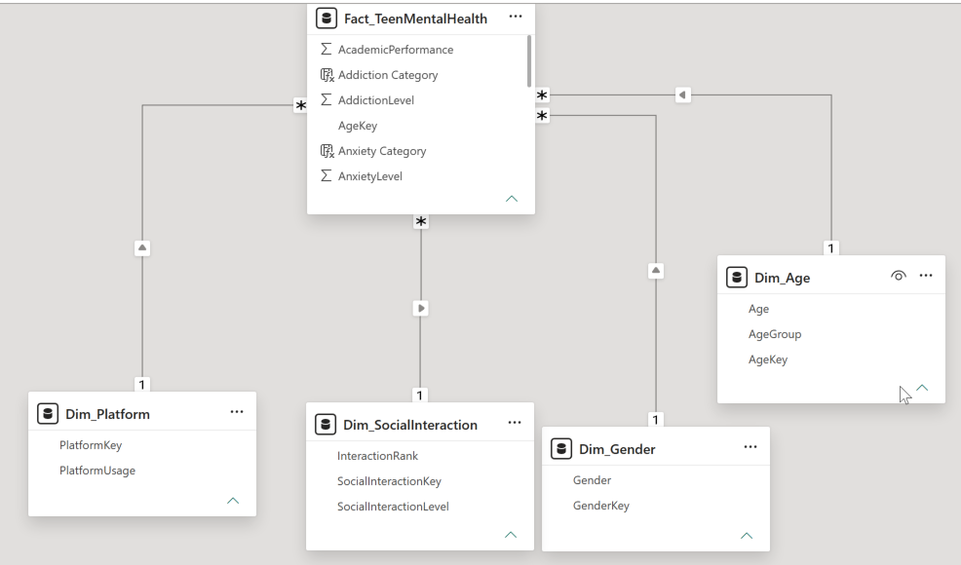
Fact table: Fact_TeenMentalHealth.
Dimension tables: Dim_Age, Dim_Gender, Dim_Platform, and Dim_SocialInteraction.
Relationships: Dim_Age[AgeKey] to Fact_TeenMentalHealth[AgeKey], Dim_Gender[GenderKey] to Fact_TeenMentalHealth[GenderKey], Dim_Platform[PlatformKey] to Fact_TeenMentalHealth[PlatformKey], and Dim_SocialInteraction[SocialInteractionKey] to Fact_TeenMentalHealth[SocialInteractionKey]. Each relationship is one-to-many, with single cross-filter direction.

Measures in Measure Table
Total Respondents =
COUNTROWS(Fact_TeenMentalHealth)

Depressed Respondents =
SUM(Fact_TeenMentalHealth[DepressionLabel])

Non-Depressed Respondents =
[Total Respondents] - [Depressed Respondents]

Depression Rate =
AVERAGE(Fact_TeenMentalHealth[DepressionLabel])

Average Social Media Hours =
AVERAGE(Fact_TeenMentalHealth[DailySocialMediaHours])

Average Sleep Hours =
AVERAGE(Fact_TeenMentalHealth[SleepHours])

Average Screen Time Before Sleep =
AVERAGE(Fact_TeenMentalHealth[ScreenTimeBeforeSleep])

Average Academic Performance =
AVERAGE(Fact_TeenMentalHealth[AcademicPerformance])

Average Physical Activity =
AVERAGE(Fact_TeenMentalHealth[PhysicalActivity])

Average Stress Level =
AVERAGE(Fact_TeenMentalHealth[StressLevel])

Average Anxiety Level =
AVERAGE(Fact_TeenMentalHealth[AnxietyLevel])

Average Addiction Level =
AVERAGE(Fact_TeenMentalHealth[AddictionLevel])

High Social Media Users =
CALCULATE(
[Total Respondents],
Fact_TeenMentalHealth[DailySocialMediaHours] >= 6
)

High Social Media User Rate =
DIVIDE(
[High Social Media Users],
[Total Respondents]
)

High Social Media User Depression Rate =
CALCULATE(
[Depression Rate],
Fact_TeenMentalHealth[DailySocialMediaHours] >= 6
)

High Stress Respondents =
CALCULATE(
[Total Respondents],
Fact_TeenMentalHealth[StressLevel] >= 7
)

High Stress Rate =
DIVIDE(
[High Stress Respondents],
[Total Respondents]
)

High Addiction Respondents =
CALCULATE(
[Total Respondents],
Fact_TeenMentalHealth[AddictionLevel] >= 7
)

High Addiction Rate =
DIVIDE(
[High Addiction Respondents],
[Total Respondents]
)

Low Sleep Respondents =
CALCULATE(
[Total Respondents],
Fact_TeenMentalHealth[SleepHours] < 6
)

Low Sleep Rate =
DIVIDE(
[Low Sleep Respondents],
[Total Respondents]
)

4. Visuals & Key Insights

Dashboard 1: Teen Mental Health Overview
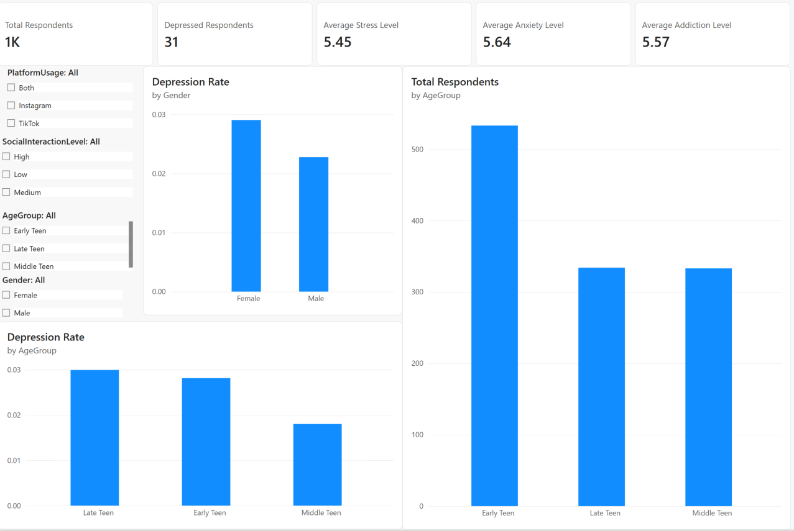
The first dashboard provides a high-level overview of the teenage mental health dataset. It summarizes the total number of respondents, the number of depressed respondents, and the average levels of stress, anxiety, and addiction across the dataset. This page is designed to give users a quick understanding of the overall mental health profile before exploring deeper analysis pages.
The dashboard includes five KPI cards:
Total Respondents
Depressed Respondents
Average Stress Level
Average Anxiety Level
Average Addiction Level
The dashboard also includes slicers for:
PlatformUsage
SocialInteractionLevel
AgeGroup
Gender
The main visuals show depression rate and respondent distribution across demographic groups. The depression rate by gender chart compares male and female respondents, while the depression rate by age group chart shows which age groups have higher depression rates. The total respondents by age group chart shows the distribution of respondents across early teen, middle teen, and late teen groups.

Key insights from this dashboard include that the dataset contains approximately 1,200 respondents, with 31 respondents labelled as depressed. The average stress level is 5.45, the average anxiety level is 5.64, and the average addiction level is 5.57. Female respondents show a slightly higher depression rate than male respondents. Late teens show the highest depression rate among age groups, while early teens make up the largest respondent group.

Interactive Features
The visuals are also connected through Power BI cross-filtering. When a user clicks a bar in one chart, the other charts and KPI cards update automatically based on that selection. For example, clicking Female in the depression rate by gender chart filters the age group charts and KPI cards to show results for female respondents only. The KPI cards respond to all slicer and chart selections. This allows users to quickly see how total respondents, depressed respondents, average stress level, average anxiety level, and average addiction level change across different groups. The dashboard also supports visual tooltips. When users hover over bars in the charts, Power BI displays extra details such as the selected category, depression rate, and total respondents. This makes it easier to understand exact values without overcrowding the page.

Dashboard 2: Social Media Impact
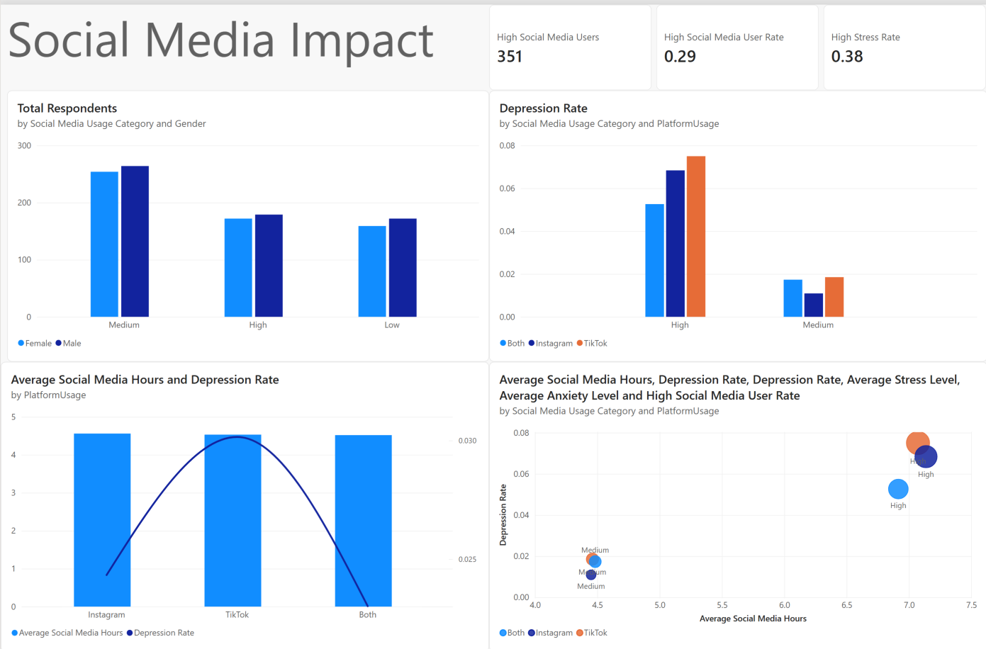
The second dashboard focuses on how social media usage relates to teenage mental health outcomes. It analyzes the number of high social media users, the rate of high social media usage, and the relationship between social media usage level, platform usage, stress, and depression rate. This page is designed to help users understand whether heavier social media use is associated with higher depression risk.
The dashboard includes three KPI cards:
High Social Media Users
High Social Media User Rate
High Stress Rate
Key insights from this dashboard include that there are 351 high social media users, representing a high social media user rate of 0.29. The high stress rate is 0.38. Depression rate is clearly higher among the high social media usage group than the medium group. TikTok users in the high usage category show the highest depression rate among the platform groups shown. The average social media hours are similar across Instagram, TikTok, and Both, but depression rate differs by platform and usage category.

- Interactive Features
The visuals are connected through Power BI cross-filtering. When a user clicks a platform, gender group, or social media usage category in one chart, the other visuals and KPI cards update automatically based on that selection. For example, selecting the High social media usage group filters the depression rate chart, combo chart, and KPI cards to focus only on high users.

The dashboard supports visual tooltips. When users hover over the charts, Power BI displays extra details such as platform usage, social media usage category, total respondents, depression rate, average social media hours, average stress level, and average anxiety level. The page allows users to compare social media behavior across gender and platform groups. This makes it easier to identify which usage categories and platforms are associated with higher mental health risk.

Dashboard 3: Stress and Anxiety Risk Analysis
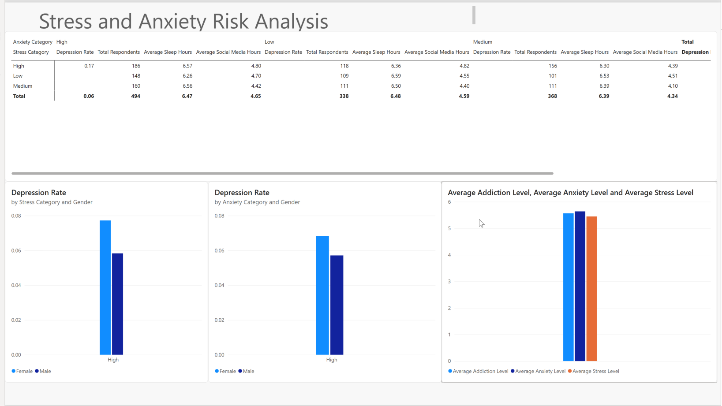
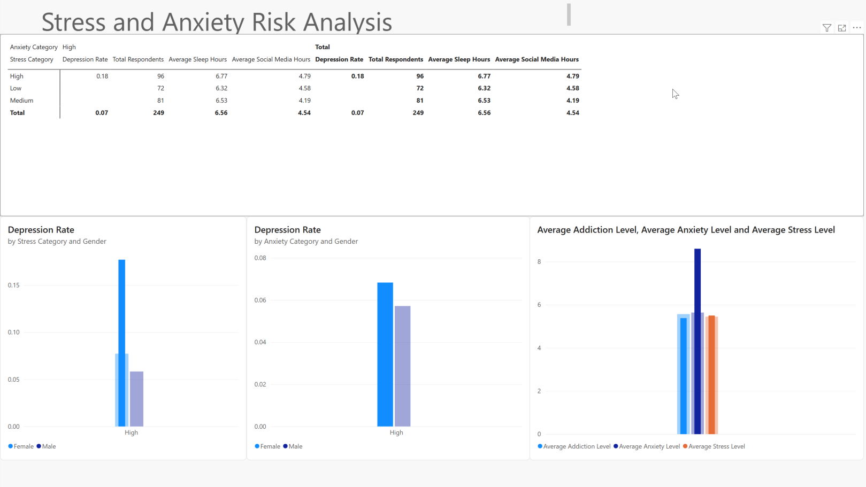
The third dashboard examines the relationship between stress, anxiety, and depression among teenagers. This page is designed to identify whether depression cases are concentrated in specific mental health risk groups, especially respondents with high stress or high anxiety levels.
The dashboard uses Stress Category and Anxiety Category, which were created from the original numeric scores. Stress and anxiety values below 4 are classified as Low, values from 4 to 6 are classified as Medium, and values from 7 to 10 are classified as High. These categories make the dashboard easier to interpret because users can compare risk groups instead of reading raw numeric scores.
At the top of the dashboard, a matrix visual compares stress and anxiety categories together. The matrix uses:

Rows:
Stress Category

Columns:
Anxiety Category

Values:
Depression Rate
Total Respondents
Average Sleep Hours
Average Social Media Hours

This matrix is important because it shows how depression rate changes when stress and anxiety are considered together. It also shows the number of respondents in each group, which helps users understand whether a depression rate is based on a large or small group. Average sleep hours and average social media hours are included to provide lifestyle context for each stress-anxiety group. The bottom left visual shows: Depression Rate by Anxiety Category and Gender

This chart performs the same type of comparison, but for anxiety. Depression appears mainly in the High anxiety category. This suggests that high anxiety is strongly associated with depression label outcomes in this dataset. The bottom right visual shows: Average Addiction Level, Average Anxiety Level and Average Stress Level

This chart summarizes the average mental health indicator levels together. It helps users compare whether addiction, anxiety, and stress are generally low, moderate, or high for the selected group. When users select a specific stress or anxiety category, this chart updates to show how the average mental health indicators change for that subgroup.

Key insights from this dashboard include that depression is concentrated in the high stress and high anxiety groups. Low and medium stress or anxiety categories show little or no depression cases. Female respondents appear to have a slightly higher depression rate than male respondents in the high stress and high anxiety categories. The matrix also shows that the high stress and high anxiety combination is one of the most important groups to monitor because it combines both major risk factors.

- Interactive Features
This dashboard is interactive through Power BI cross-filtering. When users click a stress category, anxiety category, gender group, or matrix value, the other visuals update automatically. For example, selecting the High stress category filters the anxiety chart, matrix, and average indicator chart to show only respondents with high stress.

The matrix allows users to explore combined risk groups. Users can compare depression rate across anxiety categories within each stress category, or compare stress categories within each anxiety category. This helps identify whether depression risk is higher when stress and anxiety are both high.

Tooltips are available when users hover over bars or matrix values. These tooltips show detailed values such as depression rate, total respondents, average sleep hours, average social media hours, average stress level, average anxiety level, and average addiction level. This allows users to see exact numbers without overcrowding the dashboard.
The dashboard can also be filtered using report slicers such as platform usage, age group, gender, social interaction level, and social media usage category. These filters allow users to investigate whether stress and anxiety patterns change for different demographic or behavioral groups.

Dashboard 4: Demographics and Lifestyle Factors
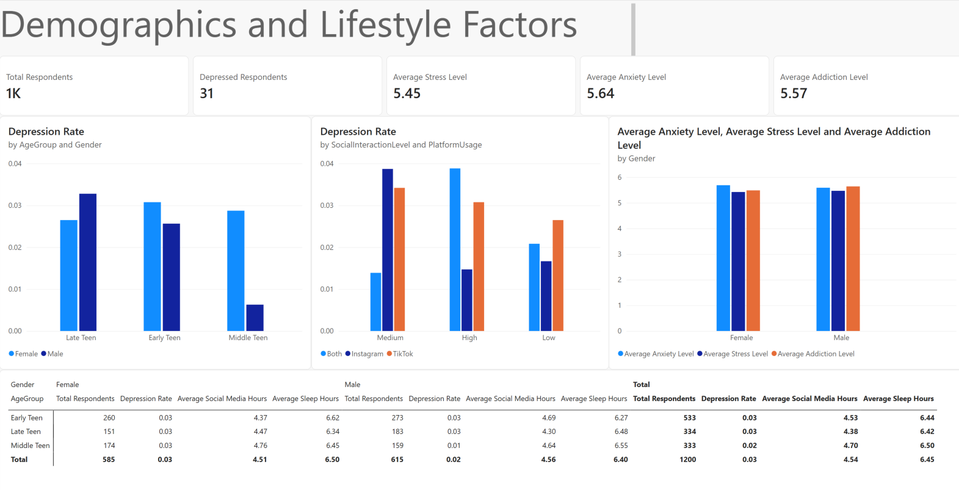

The fourth dashboard analyzes how teenage mental health outcomes differ across demographic and lifestyle groups. This page focuses on age group, gender, social interaction level, platform usage, and lifestyle indicators such as social media hours, sleep hours, stress, anxiety, and addiction. It is designed to help users compare whether certain demographic groups show higher depression rates or different lifestyle patterns.

The dashboard includes five KPI cards:
Total Respondents
Depressed Respondents
Average Stress Level
Average Anxiety Level
Average Addiction Level

These KPI cards provide a quick summary of the selected population. When users apply filters or click visuals, the cards update to reflect the selected demographic or lifestyle group.

The first visual shows: Depression Rate by AgeGroup and Gender
This chart compares depression rate across early teen, middle teen, and late teen groups, separated by gender. It helps identify whether depression rate differs by age group and whether male or female respondents show different patterns within each age group.

The second visual shows: Depression Rate by SocialInteractionLevel and PlatformUsage
This chart compares average mental health indicator scores between female and male respondents. It allows users to quickly see whether one gender group has higher average anxiety, stress, or addiction levels.
The matrix at the bottom compares:
Rows:
AgeGroup

Columns:
Gender

Values:
Total Respondents
Depression Rate
Average Social Media Hours
Average Sleep Hours

The matrix provides detailed demographic comparison. It shows the number of respondents in each age and gender group, their depression rate, average daily social media hours, and average sleep hours.

Key insights from this dashboard include that early teens make up the largest group in the dataset, while late teens show one of the higher depression rates. Female respondents show a slightly higher overall depression rate than male respondents. The matrix also shows that average social media hours and sleep hours vary slightly across age and gender groups, which helps provide context for differences in depression rate.

- Interactive Features
This dashboard is interactive through Power BI cross-filtering. When users click an age group, gender, social interaction level, or platform group in one visual, the other charts, matrix, and KPI cards update automatically. For example, selecting Late Teen filters the gender chart, social interaction chart, matrix, and KPI cards to show only late teen respondents.

The dashboard also supports slicers such as age group, gender, platform usage, social interaction level, and social media usage category. These slicers allow users to focus on specific demographic or lifestyle groups.

Tooltips provide additional detail when users hover over bars or matrix values. These tooltips can show values such as total respondents, depression rate, average social media hours, average sleep hours, average stress level, average anxiety level, and average addiction level.

The matrix allows users to compare demographic groups in a structured way. This makes it easier to identify which age and gender groups have higher depression rates and whether those groups also show different lifestyle patterns.

5. Recommendations
The report suggests that high social media usage, high stress, and high anxiety are important indicators associated with higher depression rates among teens.
Recommended actions include monitoring teenagers with 6 or more hours of daily social media usage, paying closer attention to teens reporting high stress and high anxiety, encouraging better sleep habits and balanced screen time, and using platform and demographic filters to identify groups that may need targeted support.

