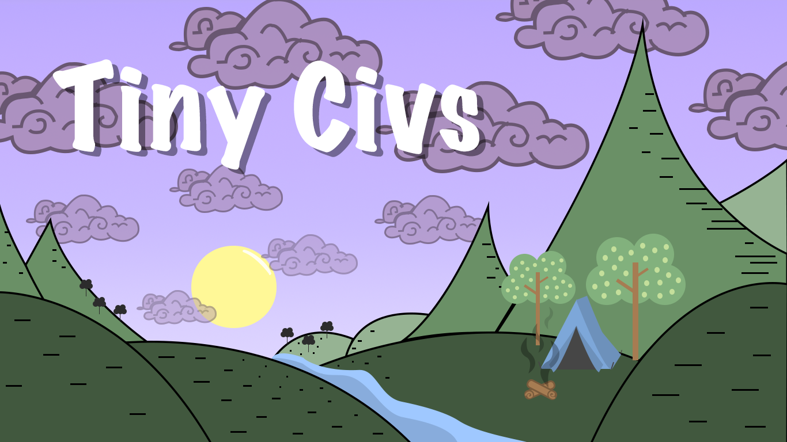

Individual Post Mortem

_______________________________________

Tuyet Le

Contents

Introduction………………………………………………………………………………………………………………………………3

Pre-Production………………………………………………………………………………………………………….………………3

Prototyping……………………………………………………………………………………………………………………3

Game Design………………………………………………………………………………………………….……..……3-4

Art……………………………………………………………………………………………………………………….…………4

Audio……………………………………………………………………………………………………………..………………4

Production………………………………………………………………………………………………………………………………4-5

Game Engine……………………………………………………………………………………………….…………………4

Version Control Methods…………………………………………………………………………….…………………5

Programming……………………………………………………………………………………………………………….…5

Art……………………………………………………………………………………………………………………….…………5

Assets Cutback…………………………………………………………………………………….…………………………5

Communication………………………………………………………………………………………………………………………6-7

Communication Methods………………………………………………………………………………………….……6

Tasks and Critique……………………………………………………………………………………………………….6-7

Introduction

*Tiny Civs* at its inception was inspired by a make-believe game called “Card Wars” that made in appearance in in season 4, episode 14 of the Cartoon Network animation *Adventure Time*. In the most basic explanation of the game, it can be call a crossover of Chess and a trading card game.

The name *Tiny Civs* was shorten from “tiny civilization” because of our group members’ attachment to the idea of crops during our brainstorming sessions. This was due to the fact that the game involves playing three different type of cards; soldier, spell and crop cards on a 6x6 grid board.

This post-mortem will discuss the process of our game from preproduction to our alpha release that took three months to make.

Pre-Production

Prototyping

The first thing we did in pre-production was to design a basic idea of how the game worked. Since the game involved many different cards to be made, our team did not make a prototype using codes but rather a physical game board and cards.

Each member of our team was assigned to create a deck with 20 cards. During our next meeting, we played each other to determine if the game was playable. The games took us about 20-30 minutes to finish because we were evaluating the play style and confirming what mechanic is legal and what is not.

One big problem we had at this stage was the cards’ balancing. Since each member created cards based on our own belief of how the cards should be balanced, it was chaotic how uneven our balancing was. For myself, I believe that cards should have low health and attack points if the mana it took to summon it was low and very powerful cards should have higher requirements for summoning.

The solution to this was to create a mathematical formula to balance each card so that it is fair to all cards. After this session, we laid out all our cards and voted on what cards were interesting to make and what cards might be too difficult to make.

Game Design

This phase of the whole process was the most fun we had working on this game. Every member took part in these meetings and the sky was the limit. We had a member that was not so familiar with trading card games so occasionally we had to stop to explain a definition of a term but that did not slow our process.

At this point, we did not think about how big the game will be. We did a lot of brainstorming on what each card type will include, information-wise. We concluded that soldiers will have points for Health, Attack, Movement and Range while spell cards will have points for Health and Size of the actual crop. Spell cards had points for Attack and a description of what the spell does.

What went well at this stage was that we had plenty of ideas and a concrete direction of how we want the game to be played. We also created an excel page on google documents to keep track to our data concerning each card.

Art

We had plenty of art ideas during pre-production. For the first two to three meeting sessions, we were all looking at different type of game art style and created a multi-page document with screenshots of different type of game art, including icons, game assets and titles. I was the team lead for this project, so I had a lot of input when it came to how the game will generally look. This means location of information on the menus and game assets as well as the in-game play screen. Initially layout was conceptualized and designed by me however when it came down to actual props, it was up to our team’s two artist to decide how it will look specifically.

Audio

We did not have a lot of discussions about audio and it was left entirely up to the team member whom wanted to be in charge of it.

Production

Game Engine

The game engine our team decided to use was Unity version 2017.3.1f1. This was an easy pick for us since our game is 2 dimensional with click and drag mechanics. Our programmers were also familiar with coding and maneuvering in Unity. I had personally worked on a previous team project and a personal project using Unity, so I am comfortable in using it. We did have some trouble occasionally when forgetting to reference an object in the hierarchy and ended up giving ourselves many errors, but it was a quick fix once the problem was identified.

Version Control Methods

To keep track of our coding and assets, we used GitHub as our version control. GitHub is already a widely used hosting service for version control as it is the number one program all Computer Science students at LSU is introduced to and expected to use in many projects.

Programming

For programing the game, I oversaw creating the different menus. That included the login and register scene, the title scene, the card collection scene and the deck selection scene. The card collection scene involved showing what cards are available to use and allowed users to create a custom deck to play with. I also coded a lot of the visuals such as drawing cards from the deck and putting them into the user’s hand in the in-game scene.

For the login and register menus, I used C# as well as PHP to create a database of registered users with their email, name, password and ladder points. The PHP was set up so that once a user is registered into the database, an email will be sent with their username and password for safekeeping. Ladder points were added into our project as an incentive to win and gain a tittle however this feature was not fully implemented due to time constraint. The only way for myself to implement the gaining and losing of ladder points was for our multiplayer feature to be working however, multiplayer is not fully operational at the time of our project submission.

Art

Art asset was handled by two artists in our team. One focused on drawing all the portrait for our game soldiers, spells and crops while the other focused on icons and sprites. I am content with the art for this project. The artist did a good job on the portraits and sprites were also nicely done however I am a bit unsatisfied with the menu icons. The in-game background was very charming however backgrounds and icons for the card collection and deck selection was not consistent with the art style of the one from in-game. Other than the inconsistency, I think overall, the artists did a great job.

Assets Cutback

Nearing the last 3 weeks of our project, we realized that we could not finish all the portraits for every card and we were having a hard time getting to the spell cards in term of coding because there were many errors and bugs with movement of soldiers and it’s attacking so we decided to cut all the spell cards for this alpha. Initially we had 16 soldiers, but we could only get to finish 8 soldiers. We had four crop cards but finished only 3, this was because our last card had a special damage condition that we could not code due to its similarity with spell cards. As for spell cards, we had 20 cards planned out but could not code them to work correctly. We were able to finish 4 of the spell art asset done but it could not be used. In totally we had 40 cards planned out from pre-production but were only able to finish 11 including the art portraits and in game sprites due to time constraint.

Communication

Communication Methods

Our team use a discord server to communicate with each other while working on this project. It was very useful as most of us were already using it for daily activities. It was easy to use for sharing images and documents. It also provided us with speech chat room if we didn’t to have meeting at home.