Purchasing Subsystem

# ERD for UX process

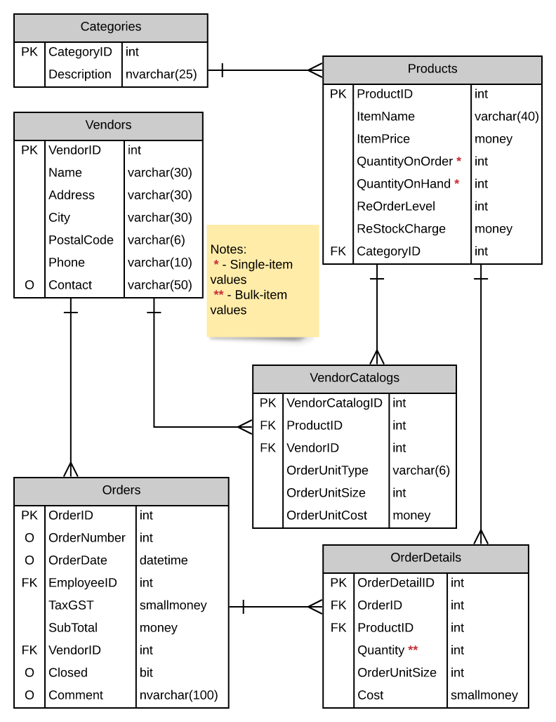

# Possible UX Interface

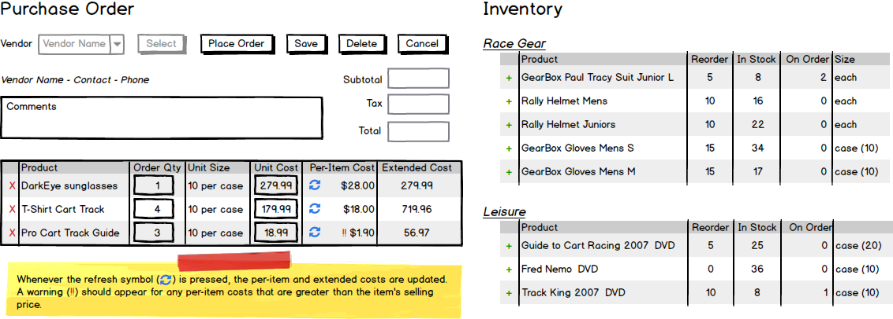

|  |  |  |
| --- | --- | --- |
| **Controls** | | **Events** |
| control name(s) | | web page event or ODS message   * bulleted list of actions outlining steps |
| **BBL Class(es) and Method (s)** | | |
| controller name | method header  statement about the method’s purpose. may include inputs and outputs   * bulleted list of actions outlining steps | |
| **SQL Table(s): (C,R,U,D)** | | **ViewModels** |
| name of sql table(s) involved and access | | name of any new ViewModel class |

# Event and Wiring Summations

# Activities

|  |  |  |
| --- | --- | --- |
|  | |  |
|  | |  |
|  | | |
|  |  | |
|  | |  |
|  | |  |

|  |  |  |
| --- | --- | --- |
|  | |  |
|  | |  |
|  | | |
|  |  | |
|  | |  |
|  | |  |

|  |  |  |
| --- | --- | --- |
|  | |  |
|  | |  |
|  | | |
|  |  | |
|  | |  |
|  | |  |

# ViewModels: