Assignment 5 Strategy Pattern Tlektes Kadyr SE-2501
Software Design Patterns (ShP-2216), Astana IT University
Topic A: Navigation / Route Planning (CarStrategy, WalkStrategy, CycleStrategy)

1. Introduction

The chosen domain for this assignment is route planning and navigation. The program helps a user plan a travel route from one place to another. The family of algorithms is the set of different ways to travel: by car, on foot, by bicycle, or by bus. Each transport mode calculates the travel time and cost in a different way using its own speed and pricing.
Without the Strategy pattern, all of these calculations would be in one big method with if/else or switch statements checking the transport type. Every time a new transport is added, that method would grow and become harder to read, test, and maintain. The Strategy pattern solves this by putting each algorithm into its own class.
The program is a console application. The user enters a starting point, a destination, and the distance in kilometers. Then the user picks a transport from a menu. The program calculates the travel time and cost, shows the result, and prints a short explanation of the Strategy pattern. The user can then pick another transport for the same route without re-entering the data, or enter a new route, or exit.
2. UML Class Diagram

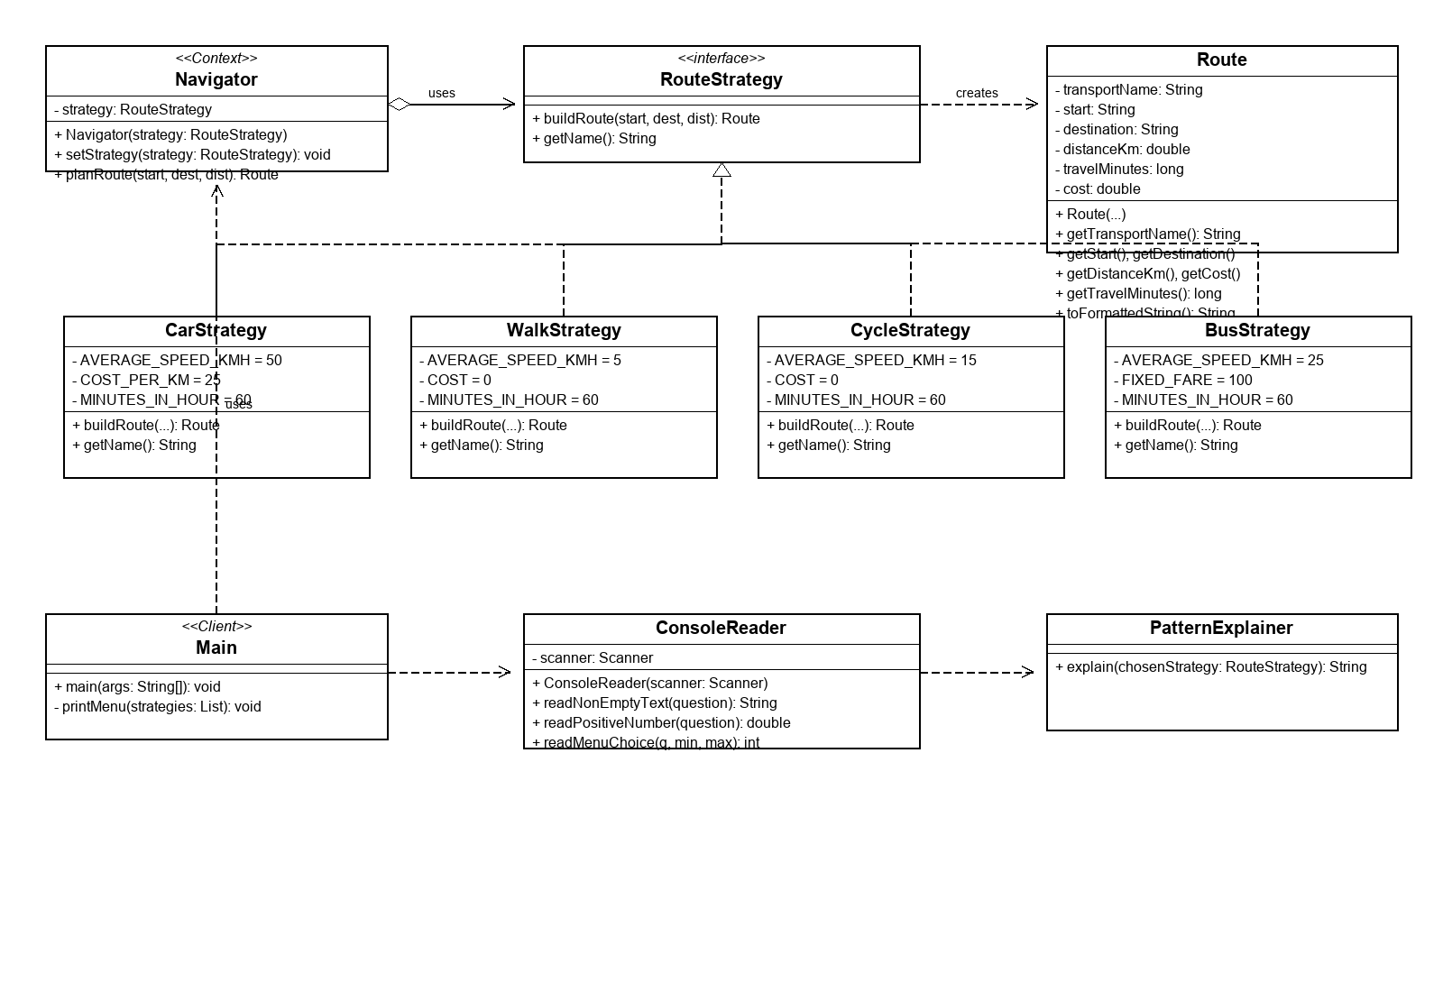

The diagram shows four roles of the Strategy pattern. RouteStrategy is the Strategy interface that declares the buildRoute and getName methods. CarStrategy, WalkStrategy, CycleStrategy, and BusStrategy are the Concrete Strategies, each implementing RouteStrategy with its own algorithm. Navigator is the Context. It holds a private reference to a RouteStrategy and delegates the planRoute call to it. Main is the Client. It creates the strategies, builds the menu, and sets the chosen strategy on the Navigator.
The realization arrows (dashed with a hollow triangle) from the four concrete strategies to RouteStrategy mean they implement the interface. The aggregation arrow (diamond) from Navigator to RouteStrategy labeled 'uses' means Navigator holds a strategy object that can be replaced at runtime. The dependency arrow (dashed) from RouteStrategy to Route labeled 'creates' indicates that strategies construct Route instances. The dependency arrows from Main to Navigator, RouteStrategy, ConsoleReader, and PatternExplainer mean Main creates and configures them.
3. Project Description

The project files are organized in a flat structure:
- RouteStrategy.java: the Strategy interface with buildRoute and getName methods.
- CarStrategy.java: concrete strategy for car travel (50 km/h, 25 KZT per km).
- WalkStrategy.java: concrete strategy for walking (5 km/h, free).
- CycleStrategy.java: concrete strategy for cycling (15 km/h, free).
- BusStrategy.java: concrete strategy for bus travel (25 km/h, fixed fare 100 KZT).
- Route.java: immutable data class that holds the result of route planning.
- Navigator.java: the Context class that holds a strategy and delegates to it.
- ConsoleReader.java: helper class for reading and validating console input.
- PatternExplainer.java: produces the pattern explanation text using the strategy name.
- Main.java: the Client that runs the program, shows the menu, and selects the strategy.

Runtime flow step by step:
1. The program greets the user and asks for a starting point, a destination, and the distance in kilometers. Input is validated in a loop.
2. The program shows a menu of transport strategies, built by looping over the strategies list and calling getName on each.
3. The user types a number. The Client takes the corresponding strategy from the list with strategies.get(choice - 1).
4. The Client calls navigator.setStrategy(chosenStrategy) to set the strategy on the Navigator.
5. The Client calls navigator.planRoute(start, destination, distanceKm). The Navigator delegates to strategy.buildRoute and returns a Route object.
6. The Client prints the Route result and then prints the pattern explanation from PatternExplainer.
7. The menu appears again. The user can pick another strategy for the same route (runtime switching), enter a new route, or exit.

Each strategy uses these numbers:
- Car: speed 50 km/h, cost 25 KZT per km.
- Walk: speed 5 km/h, cost 0 KZT.
- Cycle: speed 15 km/h, cost 0 KZT.
- Bus: speed 25 km/h, fixed fare 100 KZT regardless of distance.
Travel time formula: distanceKm / AVERAGE_SPEED_KMH * MINUTES_IN_HOUR, rounded to the nearest whole minute.

How to run:
In IntelliJ IDEA: open the project, make sure Source is marked as Sources Root, open Main.java, press Run.
In the terminal from the project root: javac -d Out Source/*.java then java -cp Out Main.
4. Clean Code Principles

4.1 Elimination of conditional logic in favor of polymorphism
Without the Strategy pattern, the route planning method would contain a chain of if/else statements checking the transport type as a string. Every new transport would add another branch. With the Strategy pattern, the Navigator simply calls strategy.buildRoute and the correct algorithm runs automatically because of polymorphism. No if, switch, or instanceof appears in the Navigator.
Before:
public Route planRoute(String start, String dest, double dist, String type) {
if (type.equals("car")) {
long time = Math.round(dist / 50 * 60);
double cost = dist * 25;
return new Route("Car", start, dest, dist, time, cost);
} else if (type.equals("walk")) {
long time = Math.round(dist / 5 * 60);
return new Route("Walk", start, dest, dist, time, 0);
} else if (type.equals("cycle")) {
long time = Math.round(dist / 15 * 60);
return new Route("Cycle", start, dest, dist, time, 0);
}
return null;
}
After (from Navigator.java):
public Route planRoute(String start, String destination, double distanceKm) {
return strategy.buildRoute(start, destination, distanceKm);
}

4.2 Meaningful, intention-revealing names
Every class, method, field, and constant has a name that tells the reader what it does. A reader does not need comments to understand the code. For example, CarStrategy clearly says this is a strategy for car travel. The method readPositiveNumber says exactly what it does: it reads a positive number from the user.
Before:
double s = 50;
double c = 25;
long t = Math.round(d / s * 60);
After (from CarStrategy.java):
private static final double AVERAGE_SPEED_KMH = 50;
private static final double COST_PER_KM = 25;
private static final int MINUTES_IN_HOUR = 60;
public Route buildRoute(String start, String destination, double distanceKm) {
long travelMinutes = Math.round(distanceKm / AVERAGE_SPEED_KMH * MINUTES_IN_HOUR);
double cost = distanceKm * COST_PER_KM;
return new Route(getName(), start, destination, distanceKm, travelMinutes, cost);
}

4.3 Single Responsibility Principle
Each class has exactly one reason to change. CarStrategy only calculates the car route. Route only holds route data. ConsoleReader only reads and validates input. PatternExplainer only produces explanation text. Navigator only delegates to the current strategy. Main only manages the user interaction.
Before (one class does everything):
public class RoutePlanner {
Scanner scanner = new Scanner(System.in);
public void run() {
String input = scanner.nextLine();
long time = Math.round(dist / 50 * 60);
System.out.println("Time: " + time);
}
}
After (each class has one job):
public class Navigator {
private RouteStrategy strategy;
public Route planRoute(String start, String destination, double distanceKm) {
return strategy.buildRoute(start, destination, distanceKm);
}
}

4.4 The Context is algorithm-agnostic (dependency on abstraction)
Navigator depends only on the RouteStrategy interface, never on CarStrategy, WalkStrategy, or any concrete class. It does not import them, does not mention them, and does not know how many strategies exist. This is the Dependency Inversion Principle: depend on abstractions, not on concrete implementations.
Before:
public class Navigator {
private CarStrategy car = new CarStrategy();
private WalkStrategy walk = new WalkStrategy();
}
After (from Navigator.java):
public class Navigator {
private RouteStrategy strategy;
public Navigator(RouteStrategy strategy) {
this.strategy = strategy;
}
public void setStrategy(RouteStrategy strategy) {
this.strategy = strategy;
}
}

4.5 Open/Closed Principle and easy extensibility
The code is open for extension but closed for modification. Adding BusStrategy required only one new class file and one new item in the strategies list in Main. The Navigator, CarStrategy, WalkStrategy, CycleStrategy, ConsoleReader, and PatternExplainer were not touched at all. This proves that a new strategy can be added safely without breaking existing code.
Before (three strategies):
List<RouteStrategy> strategies = List.of(
new CarStrategy(),
new WalkStrategy(),
new CycleStrategy()
);
After (four strategies, only one item added):
List<RouteStrategy> strategies = List.of(
new CarStrategy(),
new WalkStrategy(),
new CycleStrategy(),
new BusStrategy()
);

4.6 No magic numbers
Every number in the code is stored in a named constant. A reader does not have to guess what 50, 25, or 60 means. The constant name tells the meaning: AVERAGE_SPEED_KMH is 50, COST_PER_KM is 25, MINUTES_IN_HOUR is 60.
Before:
long time = Math.round(distance / 50 * 60);
After (from CarStrategy.java):
long travelMinutes = Math.round(distanceKm / AVERAGE_SPEED_KMH * MINUTES_IN_HOUR);

4.7 Small functions that do one thing, and separation of I/O from logic
Every method in the project is short, between 3 and 15 lines. Each method does exactly one thing: buildRoute calculates a route, readPositiveNumber reads a number, printMenu prints the menu, explain builds the explanation text. The strategies, Route, Navigator, and PatternExplainer never use Scanner or System.out. Only Main and ConsoleReader talk to the console. This separation makes the logic easy to test and reuse.
Example of a small, focused method (from ConsoleReader.java):
public double readPositiveNumber(String question) {
while (true) {
System.out.print(question);
String input = scanner.nextLine().trim();
try {
double value = Double.parseDouble(input);
if (value > 0) {
return value;
}
System.out.println("Please enter a positive number greater than zero.");
} catch (NumberFormatException exception) {
System.out.println("That is not a valid number. Please try again.");
}
}
}

4.8 No comments needed because the code explains itself
The Java source files contain zero comments: no line comments, no block comments, no Javadoc. This is intentional. The names of classes, methods, fields, and constants are clear enough that a reader can understand the code without any comments. For example, readNonEmptyText, AVERAGE_SPEED_KMH, and toFormattedString need no explanation.
The code uses names instead of comments:
public String readNonEmptyText(String question)
private static final double AVERAGE_SPEED_KMH = 50;
public String toFormattedString()
public Route planRoute(String start, String destination, double distanceKm)
5. Defense Preparation in Simple Language

Question: What is the Strategy pattern, in one or two sentences?
Answer: The Strategy pattern defines a family of algorithms, puts each one in its own class, and makes them interchangeable at runtime. The context object delegates the work to whichever strategy it currently holds, without knowing the details of the algorithm.

Question: Which class is the Strategy, the Concrete Strategy, the Context and the Client in your project?
Answer: RouteStrategy is the Strategy interface. CarStrategy, WalkStrategy, CycleStrategy, and BusStrategy are the Concrete Strategies. Navigator is the Context. Main is the Client.

Question: Why is there no if or switch inside Navigator? Where did the choice of the algorithm go?
Answer: Navigator only calls strategy.buildRoute. It does not know which concrete strategy it holds. The choice is made in Main (the Client), which picks the strategy from the list using strategies.get(choice - 1) and passes it to navigator.setStrategy. The polymorphism of the RouteStrategy interface handles the rest.

Question: How does switching the strategy at runtime work? Show which line of code does it.
Answer: The user picks a new transport from the menu without re-entering route data. Main calls navigator.setStrategy(chosenStrategy) with the new strategy. The Navigator replaces its internal strategy reference. The next call to navigator.planRoute uses the new strategy automatically.

Question: Is there any if or switch in your Main? Why is that fine?
Answer: Yes, Main has if/else to check if the user typed 0 (exit) or the new-route option number. But these check user menu input, not the strategy type. The choice among Car, Walk, Cycle, and Bus is done by strategies.get(choice - 1), which is a list lookup, not a branch on the strategy type. This is input handling, not strategy-type branching, so it does not violate the pattern.

Question: How would you add a new strategy, for example ScooterStrategy? Which files change and which do not?
Answer: I would create a new file ScooterStrategy.java that implements RouteStrategy with its own speed and cost constants. Then I would add one item in the list in Main.java: new ScooterStrategy(). No other file changes. Navigator stays the same, the existing strategies stay the same, ConsoleReader stays the same, and the menu automatically shows the new option because it loops over the list.

Question: Why did you use an interface and not an abstract class?
Answer: An interface is the simplest choice here. The strategies share no common code or state, only a contract (buildRoute and getName). Each strategy has its own constants and its own calculation. An abstract class would be used if the strategies shared some common implementation, but here they do not.

Question: What is the difference between Strategy and a simple if/else or an enum with a switch?
Answer: With if/else or switch, all algorithms live in one place and every new algorithm means editing that place. With Strategy, each algorithm is in its own class. Adding a new one does not touch existing code. Strategy also makes it easy to switch the algorithm at runtime by just setting a different object.

Question: What is the difference between the Strategy pattern and the State pattern?
Answer: Both patterns have a context that delegates to an object. In Strategy, the client picks the algorithm and the context does not change it. In State, the object itself can switch its state (and therefore its behavior) depending on what happens. Strategy is about choosing an algorithm; State is about changing behavior as internal state changes.

Question: What is the difference between the Strategy pattern and the Bridge pattern?
Answer: Strategy separates the algorithm from the context so algorithms can be swapped. Bridge separates an abstraction from its implementation so both can vary independently. Strategy has one dimension of variation (the algorithm), while Bridge has two (the abstraction and the implementation).

Question: What are the downsides of the Strategy pattern?
Answer: There are more classes: each algorithm needs its own class file, which increases the number of files in the project. Also, the client must know which strategies exist to pick one. If there are only two algorithms that will never change, Strategy adds unnecessary complexity.

Question: Why is Route a separate class? Why are the fields final?
Answer: Route is a separate class because it holds the result data and nothing else (Single Responsibility). The fields are final because a route result should not change after it is created. Making fields final makes the object immutable, which is safer and simpler.

Question: Where does the explanation of the pattern in the console come from, and why does it not use if/else?
Answer: The explanation comes from PatternExplainer.explain(chosenStrategy). It calls chosenStrategy.getName() to get the strategy name and inserts it into the text. It does not use if/else because it does not need to know which concrete strategy was chosen. It just asks the strategy for its name.

Question: What are the Clean Code principles you applied?
Answer: Elimination of conditional logic in favor of polymorphism. Meaningful, intention-revealing names. Single Responsibility Principle. The Context is algorithm-agnostic (depends on abstraction). Open/Closed Principle and easy extensibility. No magic numbers. Small functions that do one thing. Separation of I/O from logic. No comments because the code explains itself.

Question: Why did you choose List and strategies.get(choice - 1) instead of a Map or a factory?
Answer: A List is the simplest data structure for a numbered menu. The menu numbers match the list indexes (choice 1 is index 0, and so on). A Map or a factory would add complexity without any benefit for this simple program.

Question: What happens if the user enters invalid input?
Answer: ConsoleReader handles it. readNonEmptyText loops until the user types something that is not empty. readPositiveNumber loops until the user types a number greater than zero, catching NumberFormatException for non-numeric input. readMenuChoice loops until the number is within the valid range. The program never crashes from bad input.

Question: Could you use the Strategy pattern for something other than navigation?
Answer: Yes. The Strategy pattern works for any situation where you have a family of interchangeable algorithms. Examples: different sorting algorithms, different payment methods, different compression algorithms, different discount calculation rules.

Question: Why does PatternExplainer exist as a separate class instead of printing the explanation in Main?
Answer: Separating it into its own class follows the Single Responsibility Principle. Main handles the menu loop and user interaction. PatternExplainer handles building the explanation text. If the explanation needs to change, only PatternExplainer changes, not Main.

6. Conclusion

This project demonstrates the Strategy design pattern applied to a route planning problem. The program went from what would have been one big method with if/else branches for each transport type to ten small, focused files. Each file has a single clear responsibility.
The trade-off is more files: ten files instead of one. However, each file is short and easy to read. A new developer can open any single file and understand it in a minute. The biggest benefit is extensibility. Adding the fourth strategy (BusStrategy) required creating one new file and adding one item to the list in Main. The Navigator, the existing strategies, ConsoleReader, PatternExplainer, and Route were not modified at all.
The easy part was writing the strategies. Each one is a small class with a few constants and one formula. The harder part was organizing the console interaction so that Main stays clean and input validation does not mix with business logic. The ConsoleReader class solved this by encapsulating all input reading and validation in one place.
The Strategy pattern would not be a good choice if there were only two algorithms that are unlikely to ever change. In that case, a simple if/else would be simpler and more direct. But when the family of algorithms is expected to grow, Strategy makes the code safer to extend. In this project, the pattern clearly pays off: adding a fifth, sixth, or tenth transport would each be a one-class, one-line change.

