PARKING STRIP DESIGN

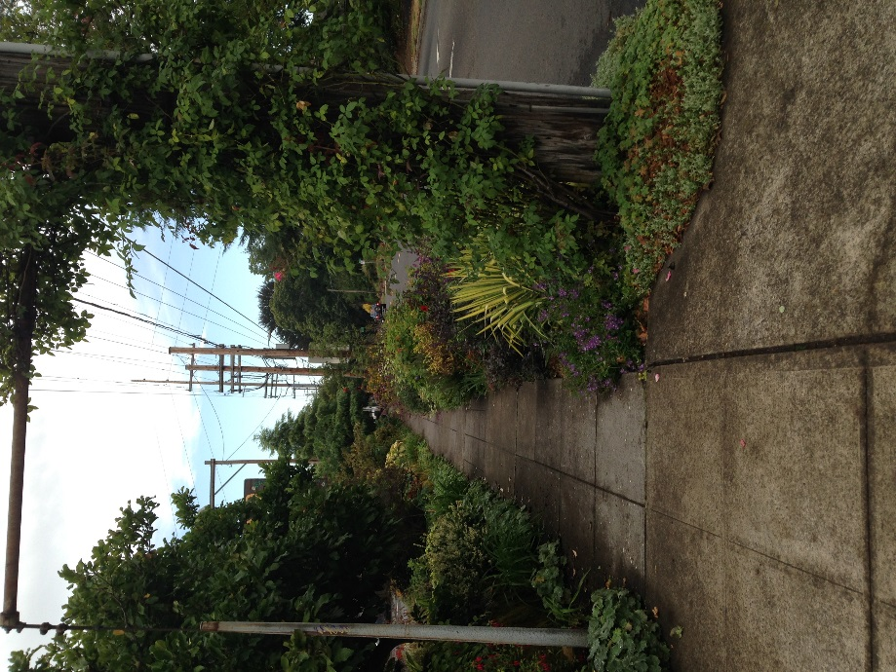

The parking strip is the area between the sidewalk and the street. It can be one of the most challenging area to design and keep looking good. Exposed parking strips get blasted with sun, soil is compacted from foot traffic, and it is often very difficult to water. To add to these challenges it is important for it to look good all the time since it is the first thing people see when coming to your residence.

Here are a few ideas from our staff and parking strip at our Stark location.

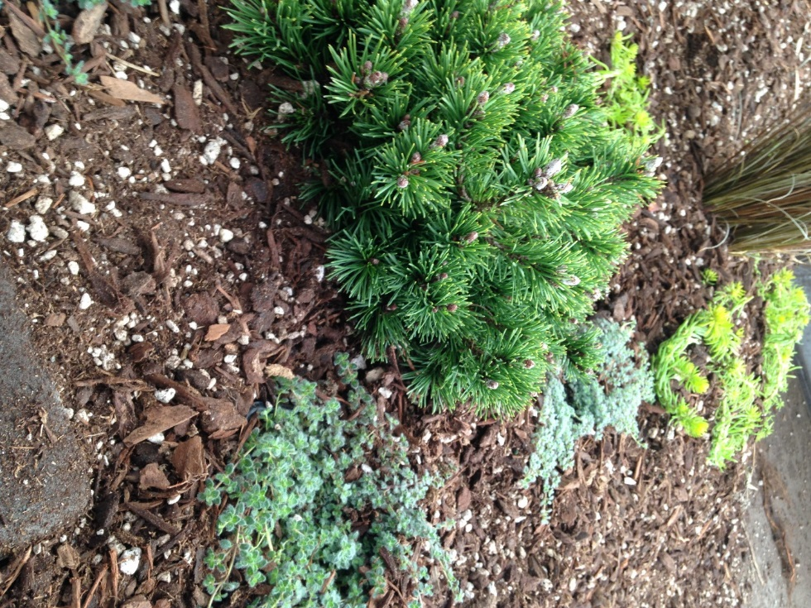

Carex buchananii, Sedum Angelina, Pinus mugo ‘Valley Cushion’, Wooly thyme- All plants are evergreen, low growing, and love all day sun

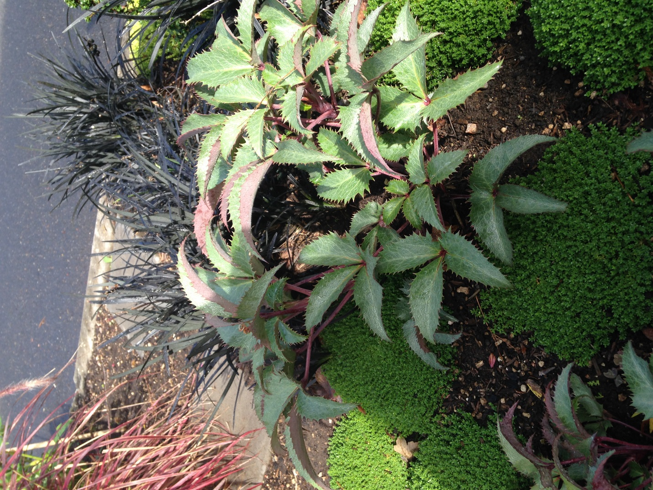

Ophiopogon nigrescens (Black Mondo grass), Herinaria ‘Greenn Carpet’, Helleborus x sternii ‘Blackthorn Group’- All plants are evergreen, drought tolerant when established and thrive in all day to partial sun.

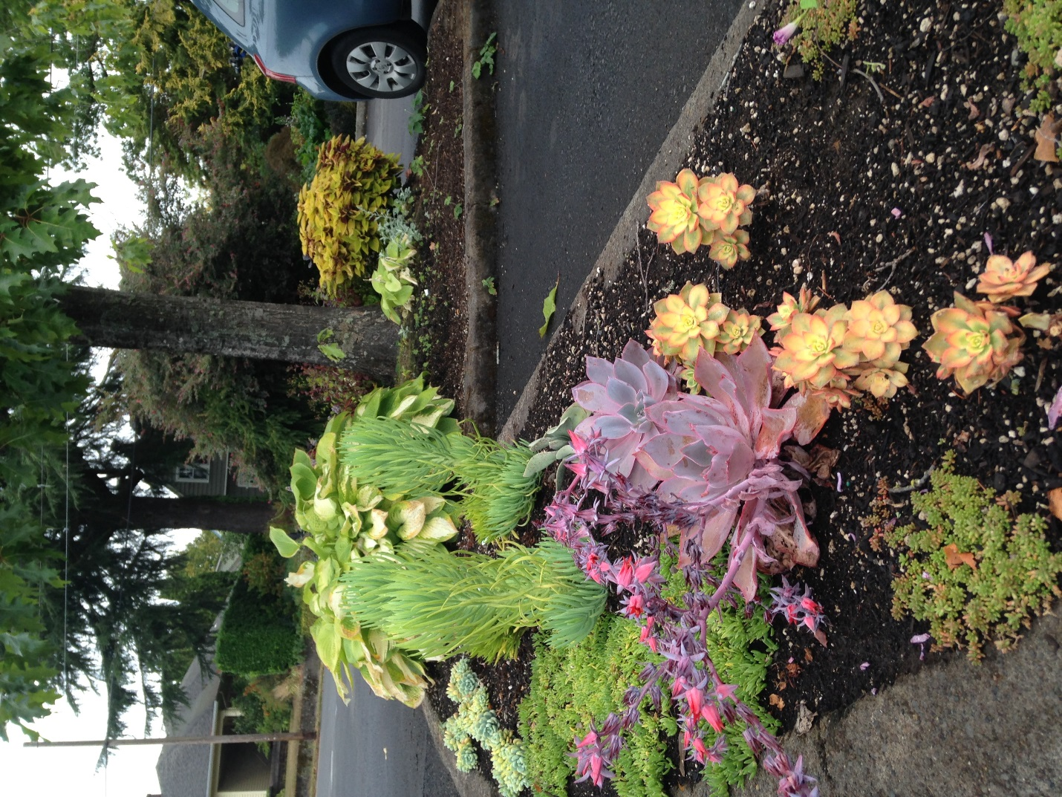 Although they need to be replanted every year, tender annual succulents can make a fantastic, dramatic accents to your parking strip.

Featured here:

Senecio ‘Blue Fingers’

Echeveria ‘Perle Nunberg’

And Aeonium ‘Kiwi’

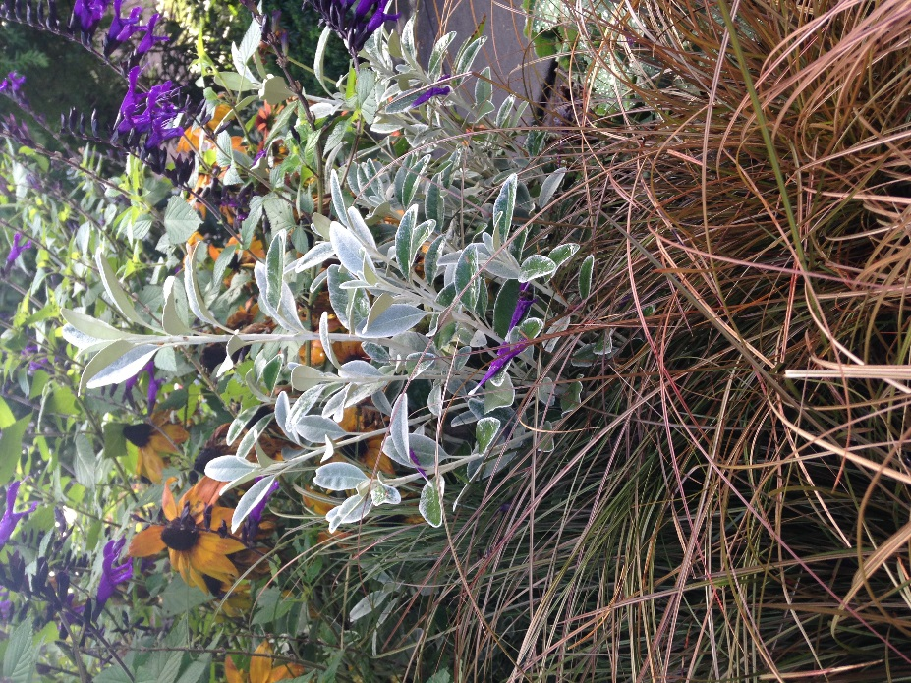Carex dispacea

Senecio greyi

Rudbeckia ‘Goldstrum’

Salvia ‘Amistad’

This combo is drought tolerant and thrives in full sun

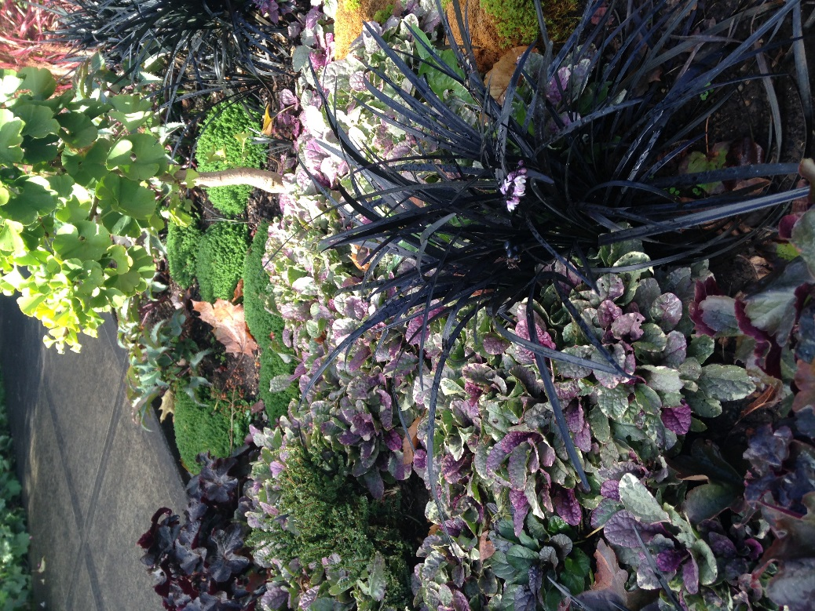

This design will need some regular water in the heat of the summer. It will thrive with at least 6 hours of sun or more.

Dwarf Ginko, *Ginko biloba* ‘Mariken’

Ajuga ‘Burgundy Glow’

Ophiopogon nigrescens

Tips, Care and Maintenance –

The right plants, some gravel or pavers plus some other tricks will get almost any parking strip off to a good start. Since this area sees a lot of foot traffic, car doors and maybe recycling bins it is useful to leave a few openings covered with gravel or pavers. The heavily compacted soil can be remedied by adding compost when planting. Lastly, fall planting is the best time to plant areas stressed by drought in the summer months.

\*The best time to plant parking strips is in the fall when rains will help the new roots stay moist.

\* If possible water in the first year when the top 2” of soil is dry. This will likely be daily in the heat of the summer.

\*Mulch with compost in the spring to help keep in moisture and maintain fertility.