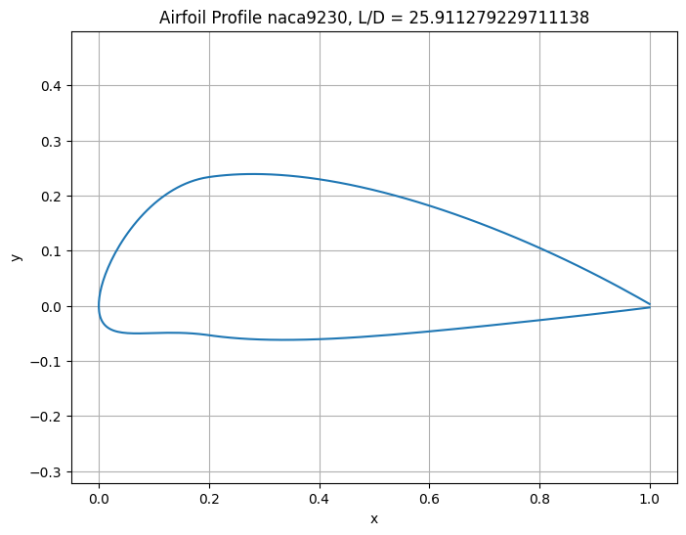

Best angle for naca9230 = 3°