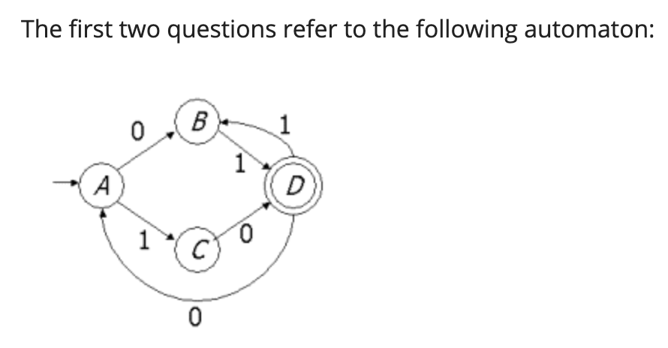

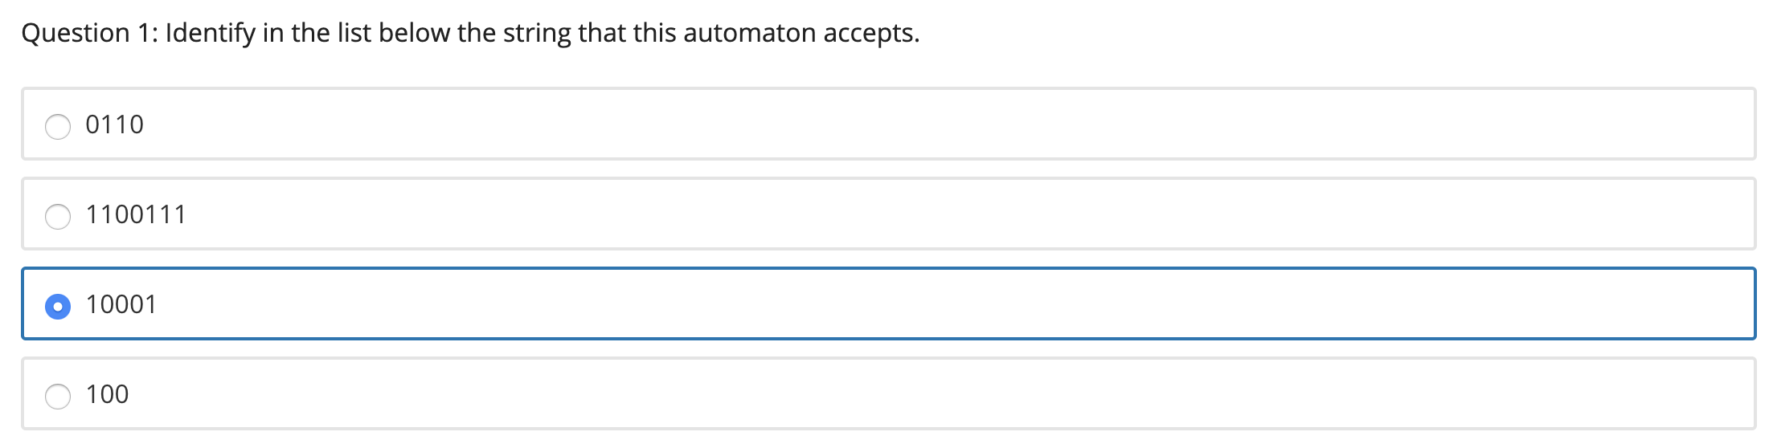

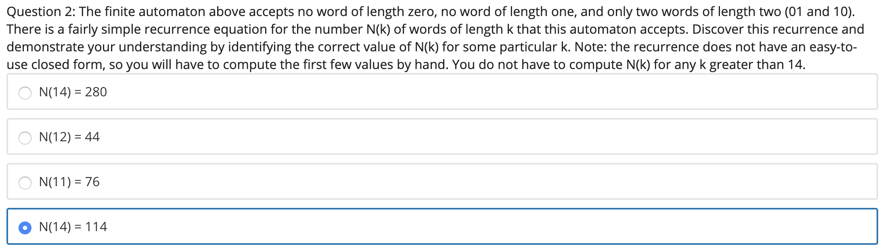

N(k) = 2 \* N(k - 3) + N(k - 2)

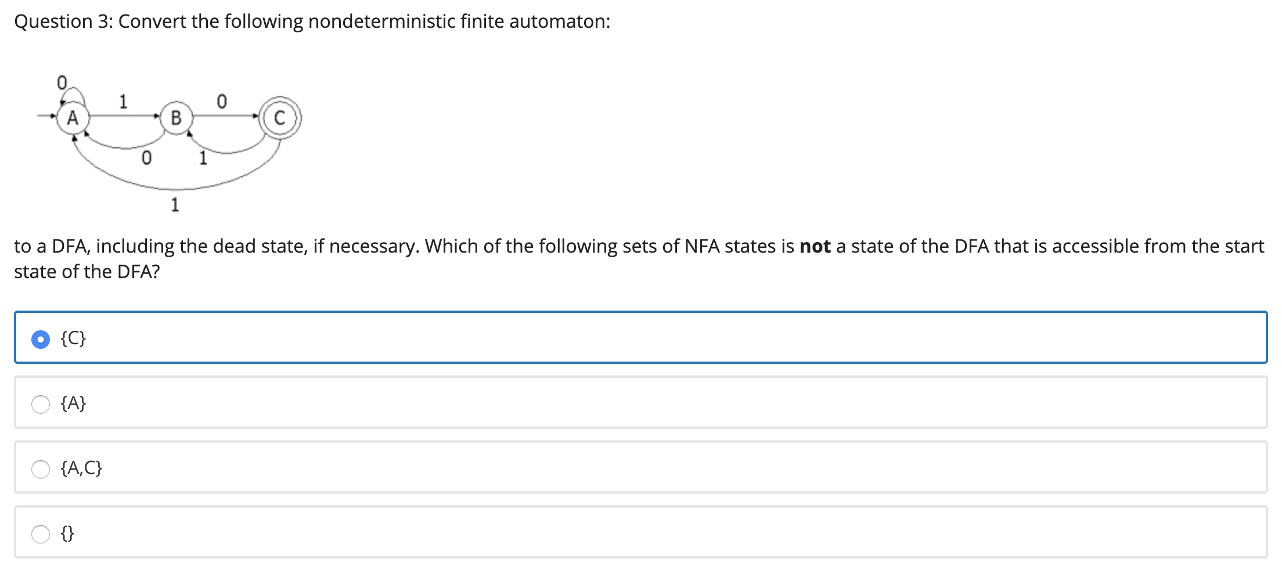

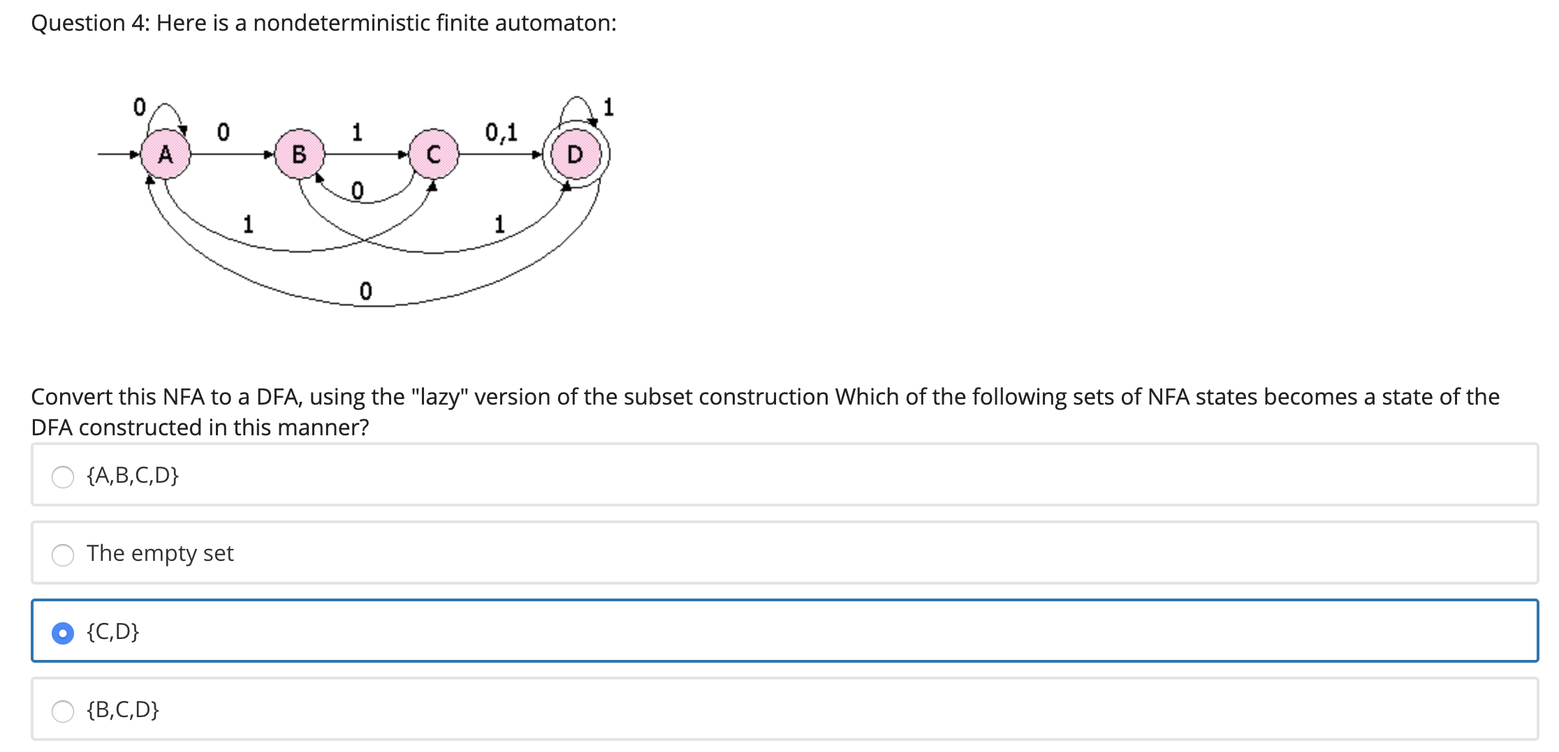

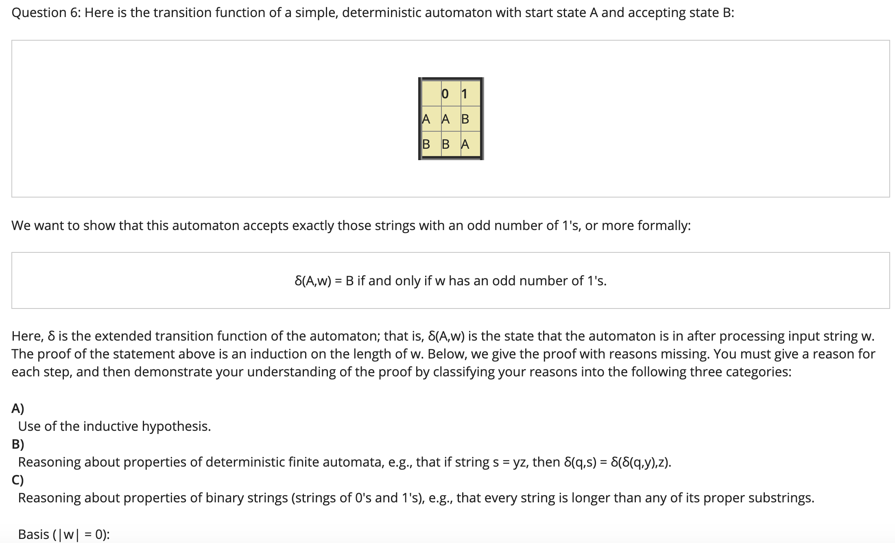

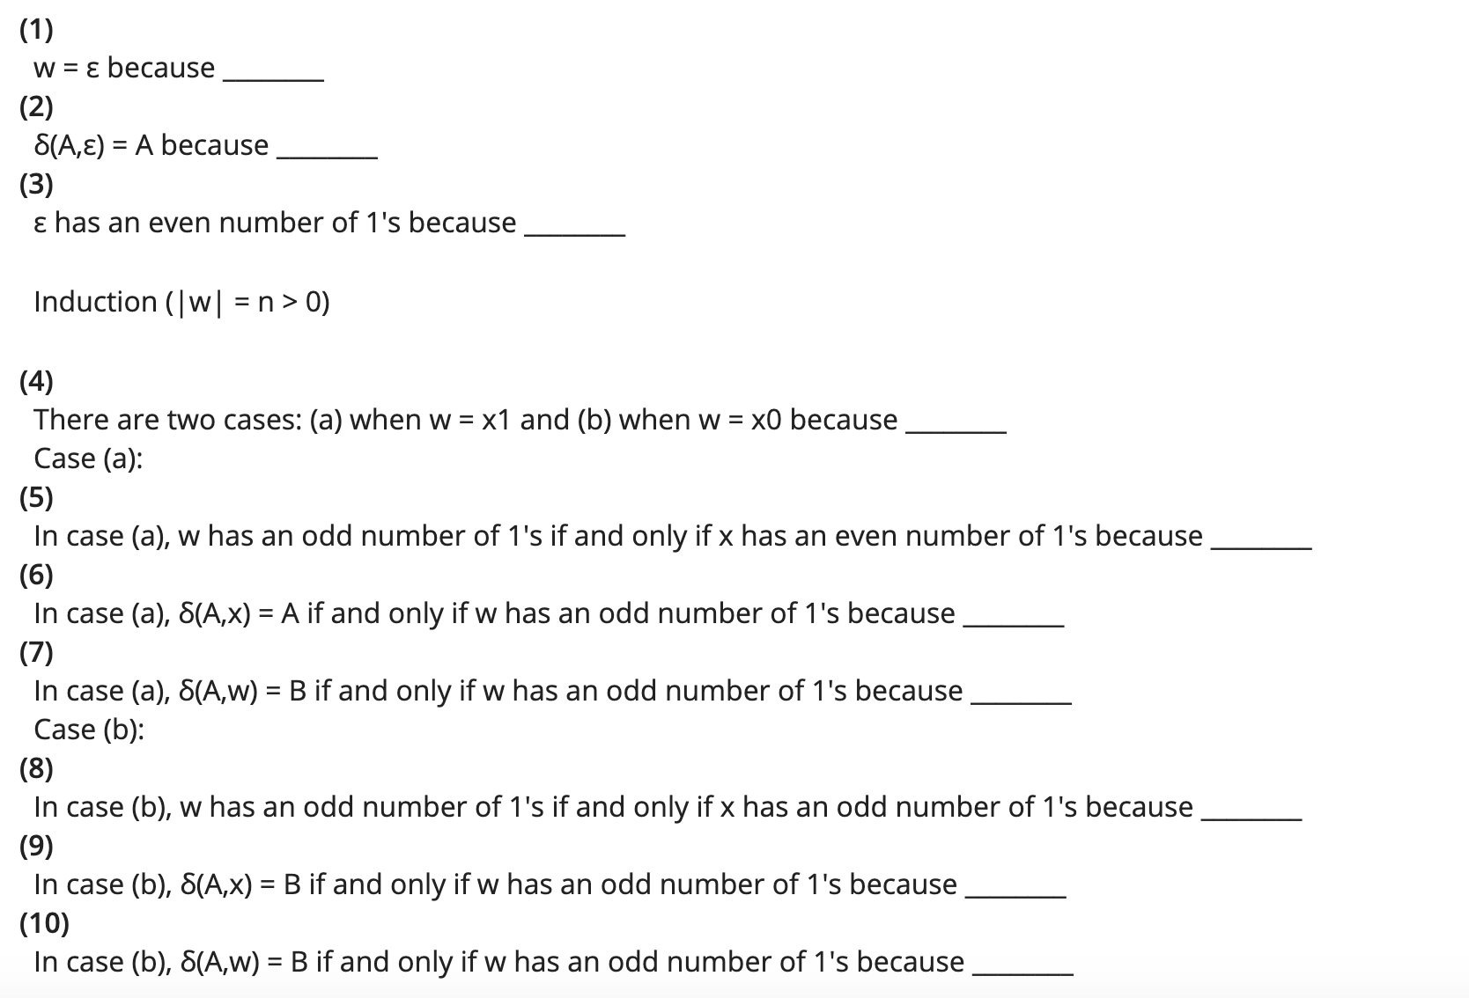

(4), (5), (8) for reason C.

(6), (9) for reason A: inductive hypothesis.

(7), (10) for reason B: properties of DFA.