1c.



3f.

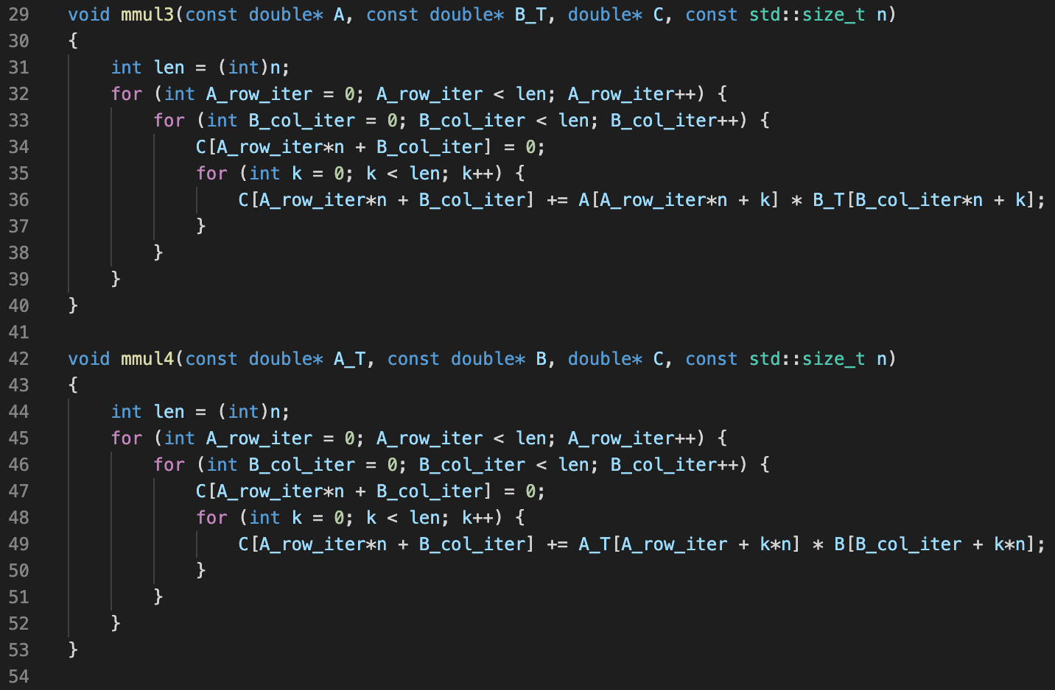

Since there is cache in hardware, we could utilize cache to speed up program execution time by either utilizing spatial locality or temporal locality. mmul3 is such a function that uses spatial locality in its most inner loop (line 36) which do a stride 1 increment when k increases by 1. On the contrary, mmul4 do a stride n increment when k increases by 1 (line 49), so mmul4 is less cache-friendly. As a result, mmul3 is much quicker than mmul4.