1.

a)

Level 1: perform scalar and vector based operations.

Level 2: perform matrix-vector operations.

Level 3: perform matrix-matrix operations.

b)

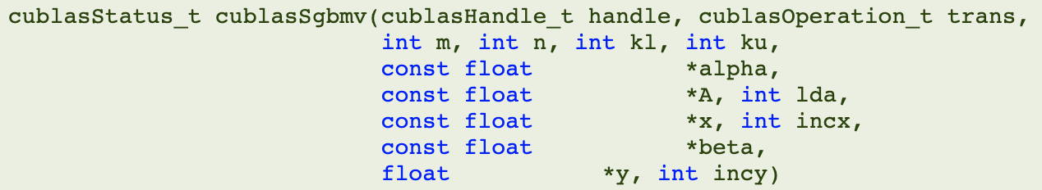

This function specifies matrix A to be column-major.

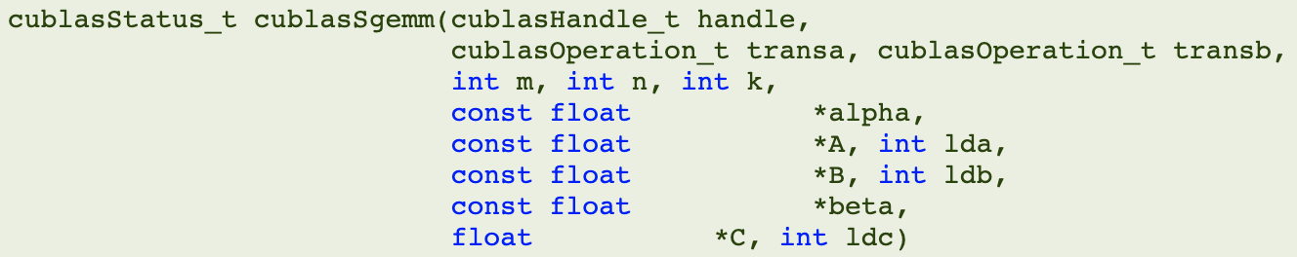

This function specifies matrix A, B, and C to be column-major.

e), f)



g)

When utilizing tensor code, the performance is better since the computation can be done within matrix-multiply-and-accumulate units to enhance throughput.

2 c)

