Trevor Gevers

A00071337

Assignment 1

<http://mcs.athens.edu/~tgevers/GeversASG1.html>

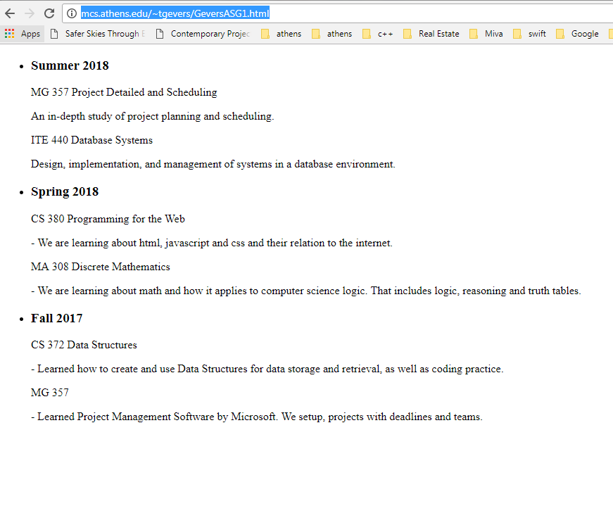

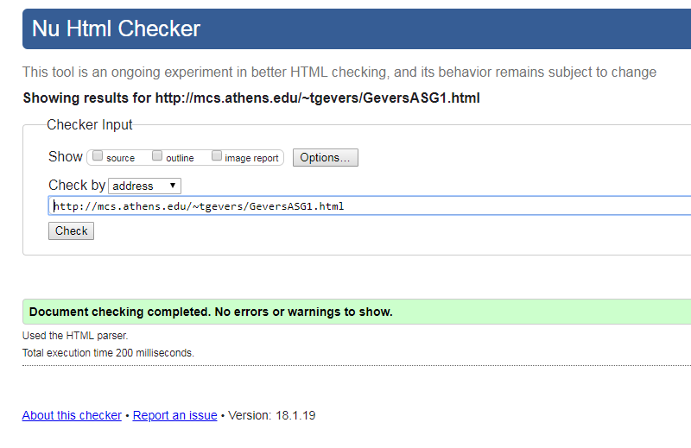

The results from the WAVE Evaluation Tool were: 0 Errors were found, 1 Alert was given for a missing first level heading h1 that I did not intend on using. The site consists of 4 structural elements 3 x h3 heading levels as we as an unordered list.