Trevor Gevers

A00071337

Assignment 10

<http://mcs.athens.edu/~tgevers/GeversASG10.html>

First load:

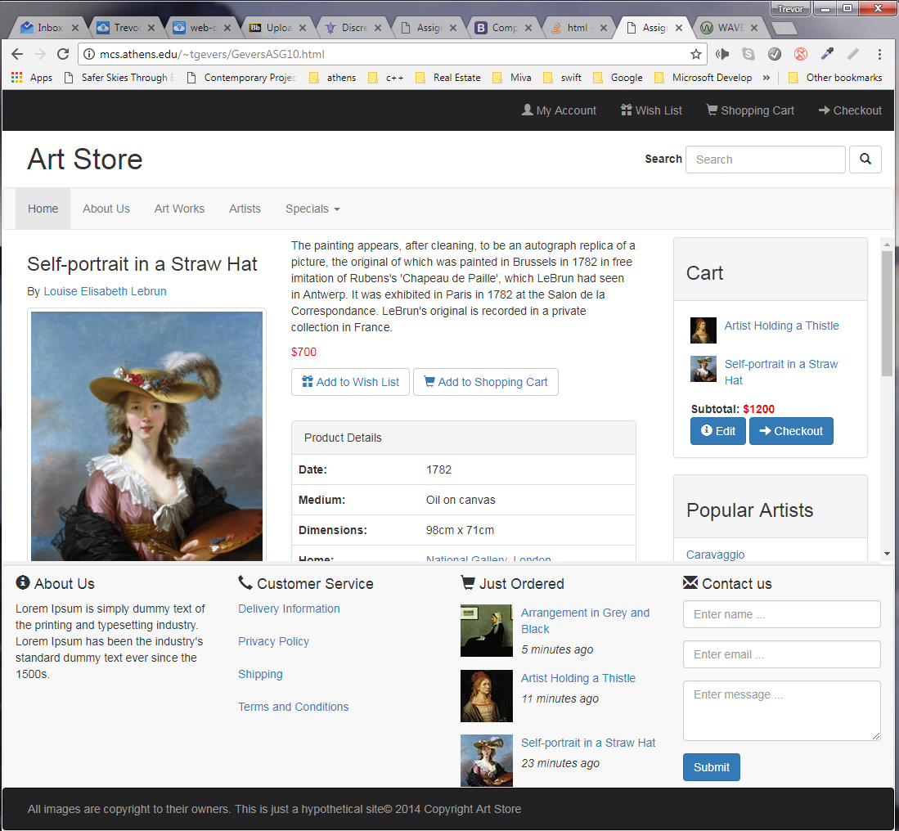

Scrolling in the center to the main content

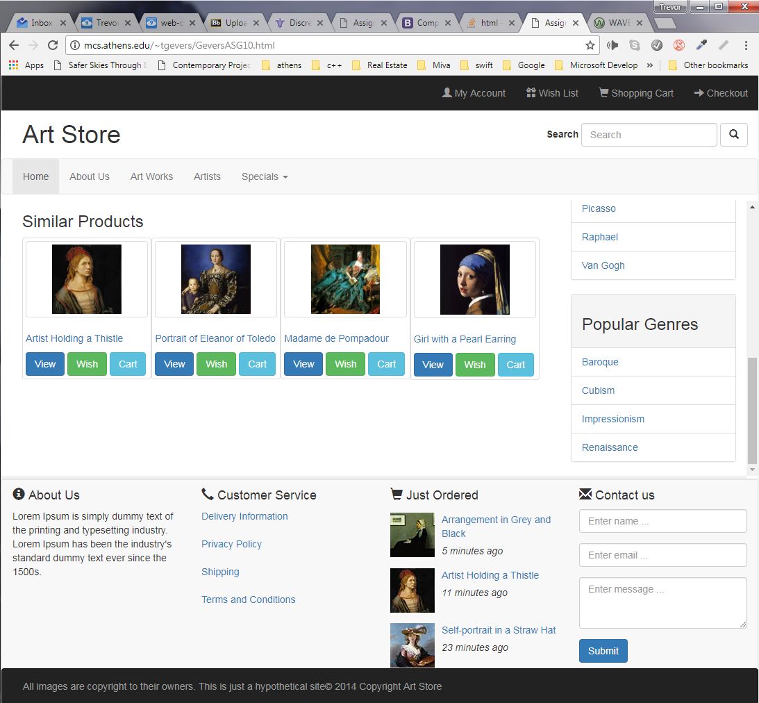

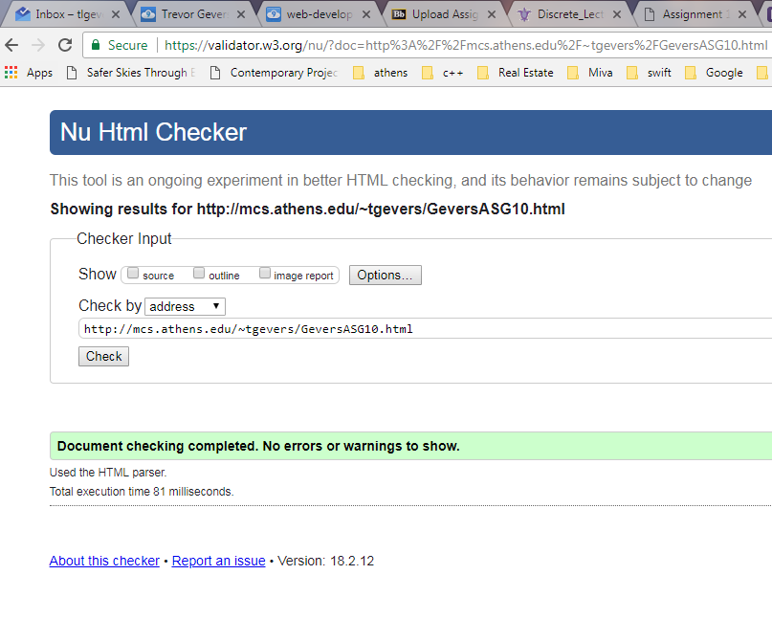

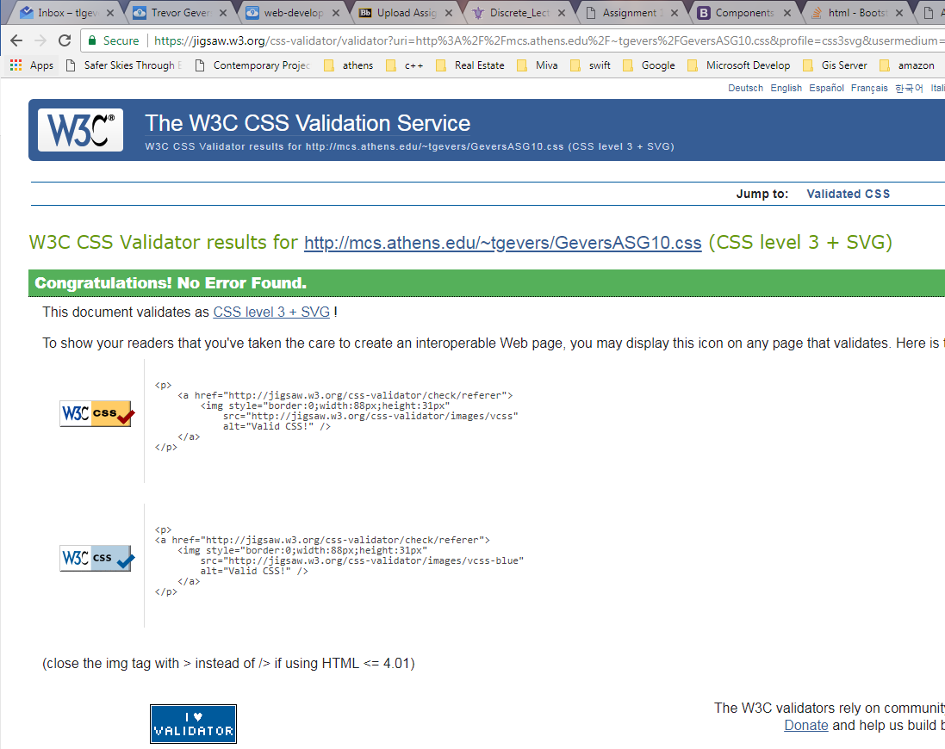

The results from the Wave Evaluation tool were: 0 Errors. 1 Alert that states there is a skipped heading level, 14 Features including 1 alternate text, 9 linked images with alternate text and 4 form labels, 23 structural elements 1 x data table, 6 table header cells, 1 heading level 1, 5 heading level 3, 4 heading level 4 and 6 unordered lists.

HTML5 and ARIA (22)

1 x Header

4 x Navigation

1 x Search

1 x Footer

14 x ARIA

1 x ARIA label or description