Trevor Gevers

A00071337

Assignment 2

<http://mcs.athens.edu/~tgevers/GeversASG2.html>

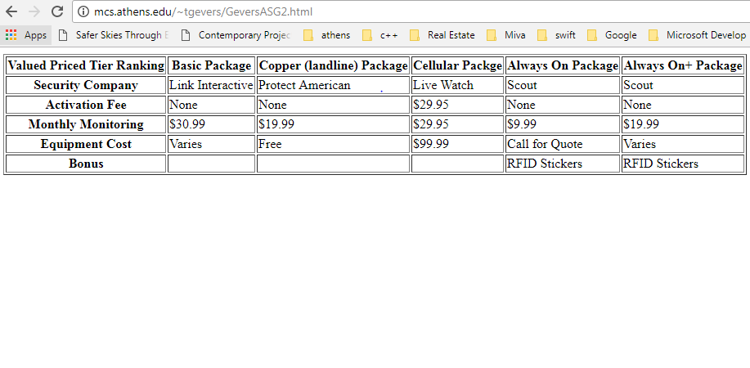

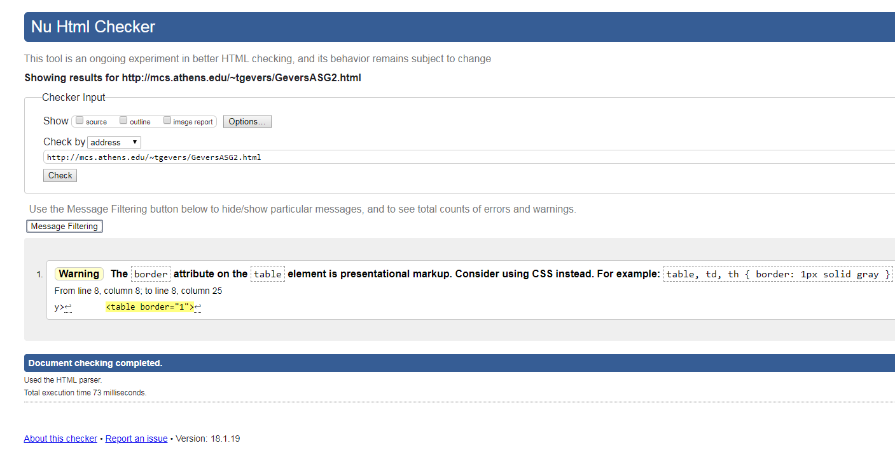

The results from the Wave Evaluation tool were: 0 Errors, 1 Alert in that no heading structure was found which was intentional. 12 Structural element were found, 1 Data Table and 11 Table Header Cells.