Trevor Gevers

A00071337

Assignment 3

<http://mcs.athens.edu/~tgevers/GeversASG3.html>

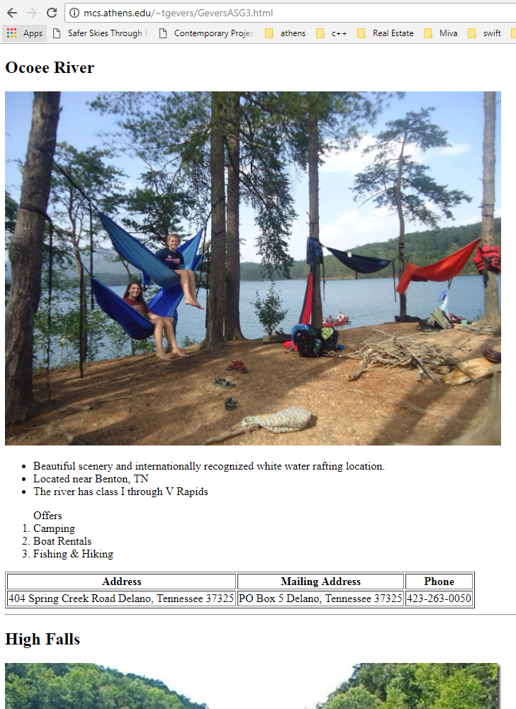

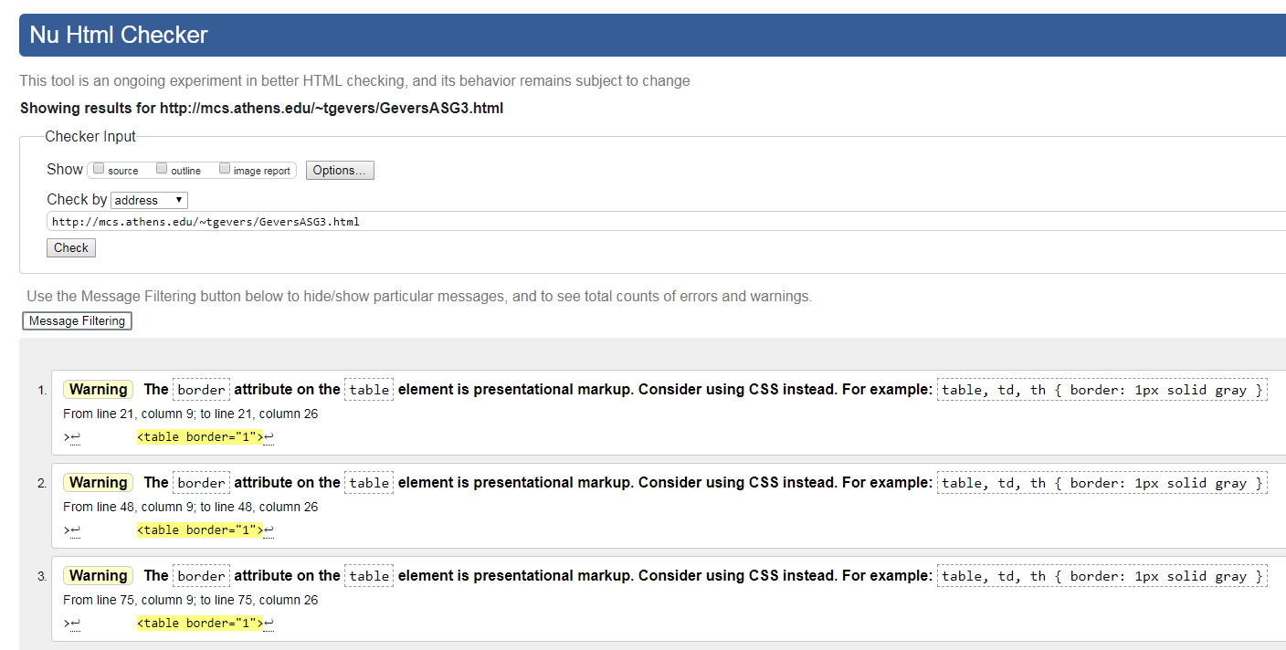

The results from the Wave Evaluation tool were: 0 Errors, 1 Alert for no user of a heading h1 which was intentional. The site consists of 3 Features, that include alt for alternative text for the 3 images shown on the site. There are 25 Structural Elements present in the site including 3 Data Tables, 9 Table Header Cells, 3 Heading Levels h2, an additional 3 heading levels h3, 3 Ordered Lists and 4 Unordered Lists.