Trevor Gevers

A00071337

Assignment 4

<http://mcs.athens.edu/~tgevers/GeversASG4.html>

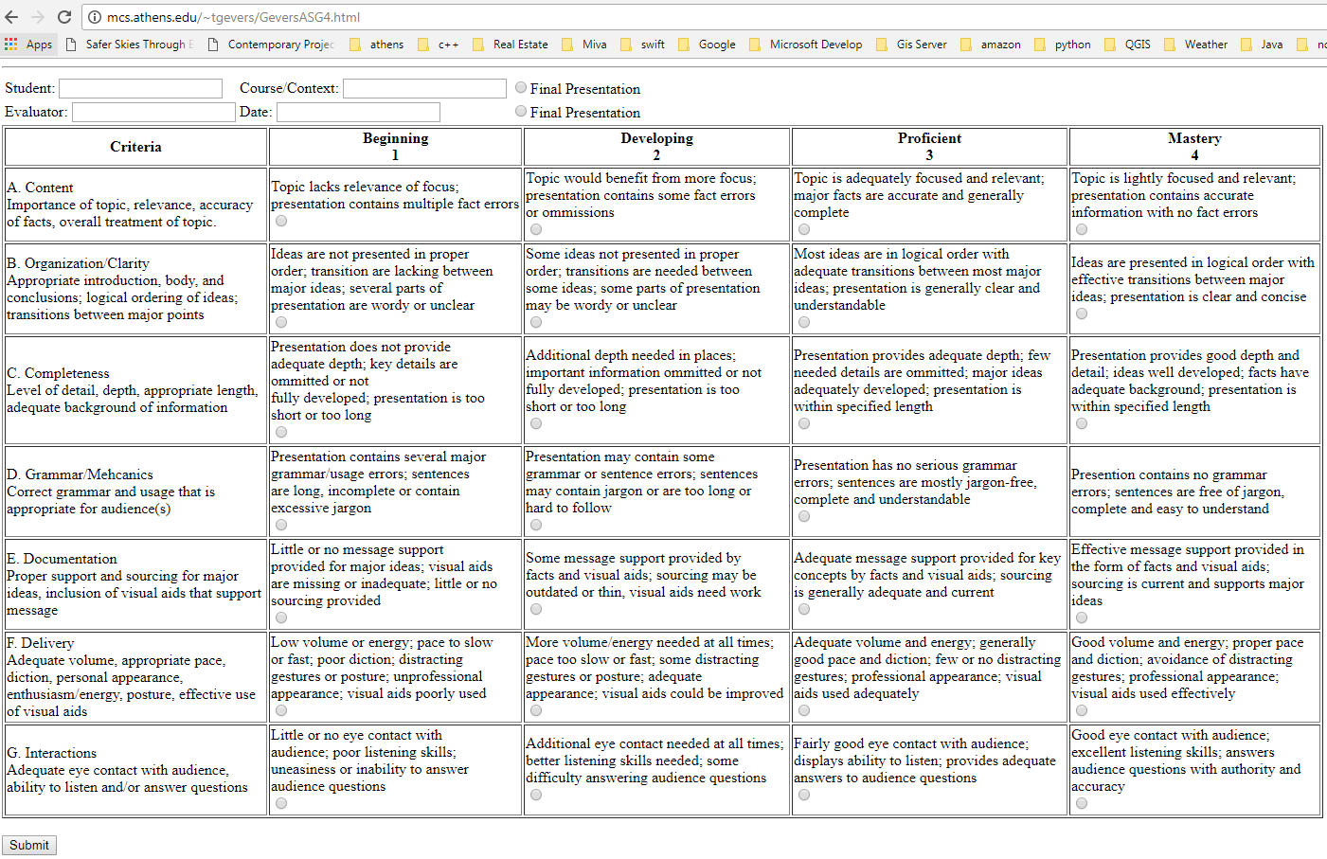

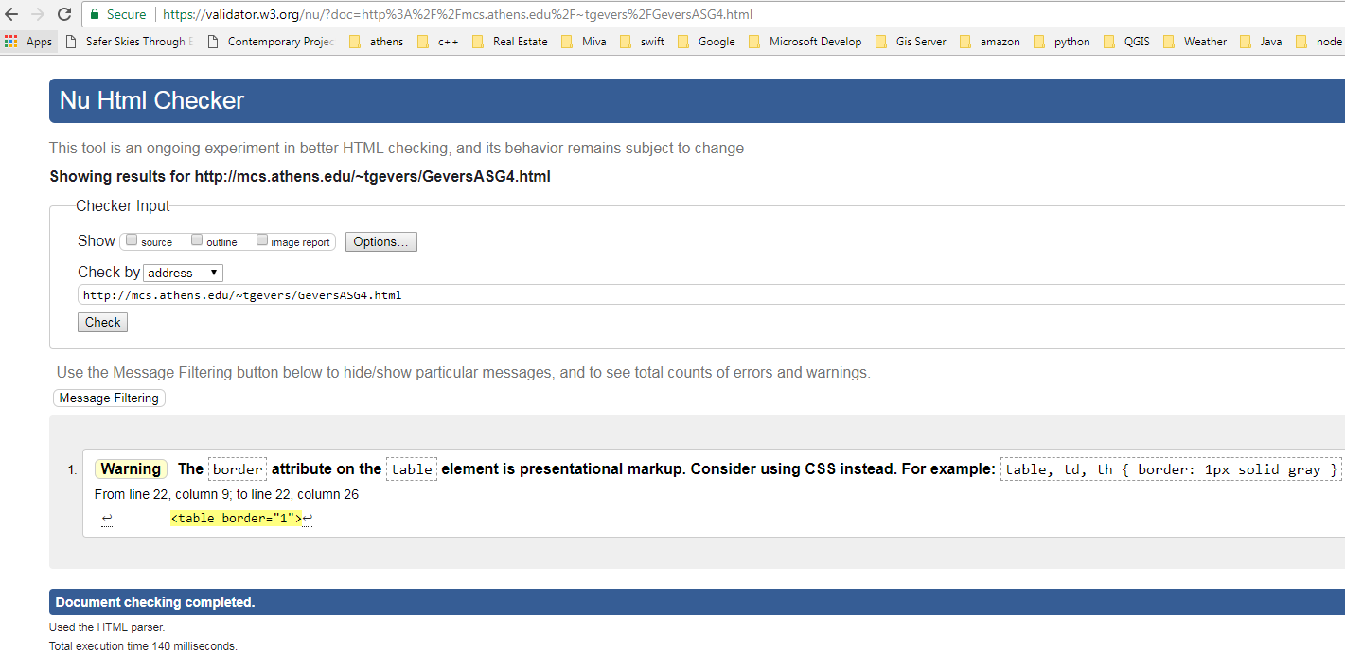

The results from the Wave Evaluation tool were: 0 Errors. The site consists of 34 Features, that included form labels, 8 structural elements including 1 layout table, 1 data table, 5 table header cells and 1 heading level 1