Trevor Gevers

A00071337

Assignment 5

<http://mcs.athens.edu/~tgevers/GeversASG5.html>

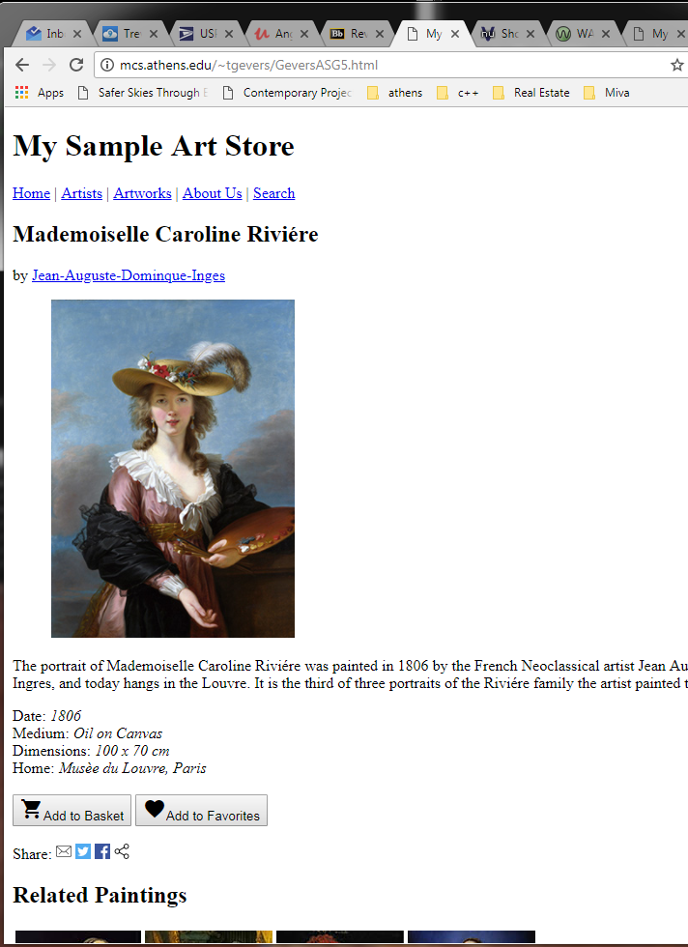

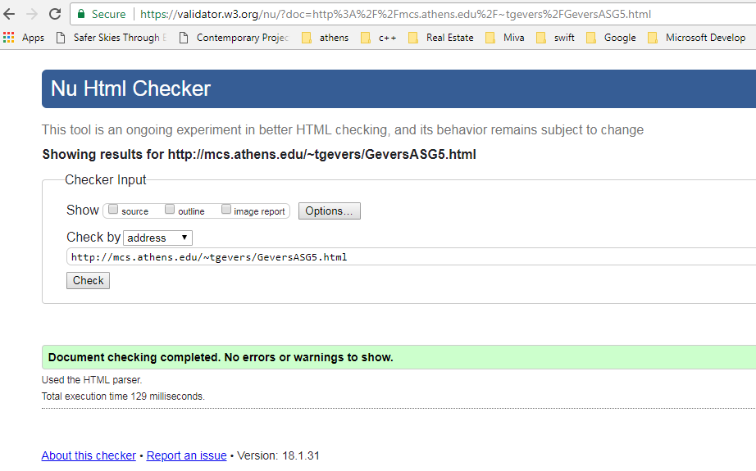

The results from the Wave Evaluation tool were: 0 Errors. There 3 Alerts given that I used a label tag in order to display text inline with the ratings, which wre not form inputs but actual icons, this accounts for two of the alerts, the third concerns the share links. These two were needed to be displayed inline, they are simply icon images and not actual linked buttons. The sample site contains 9 features that include 4 alternative text and 5 linked images with alternative text. 8 Structural elements including 1 layout table, 1 heading level 1, 4 heading level 2 and heading level 3. HTML5 and ARIA(5) included 1 header, 3 navigation and 1 footer.