Trevor Gevers

A00071337

Assignment 6

<http://mcs.athens.edu/~tgevers/GeversASG6.html>

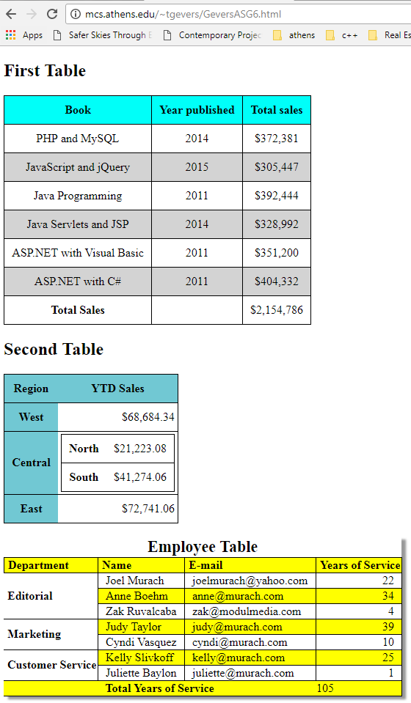

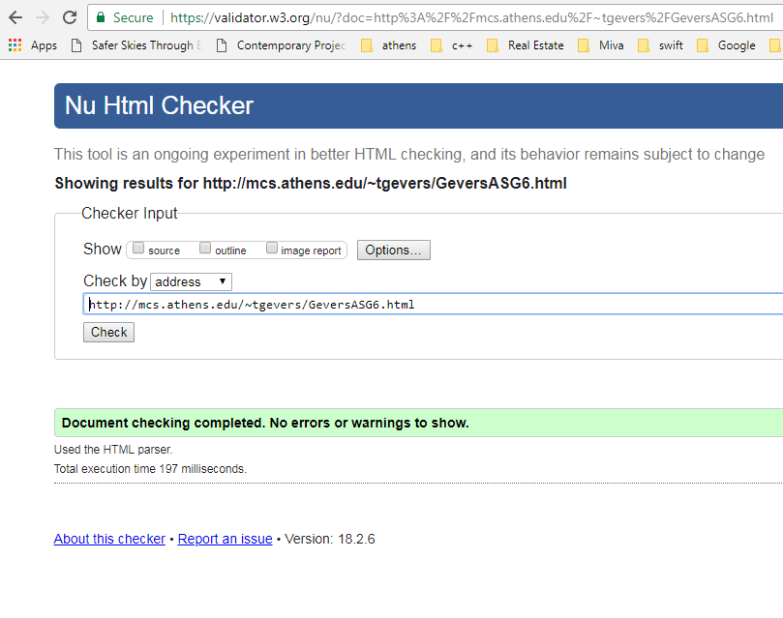

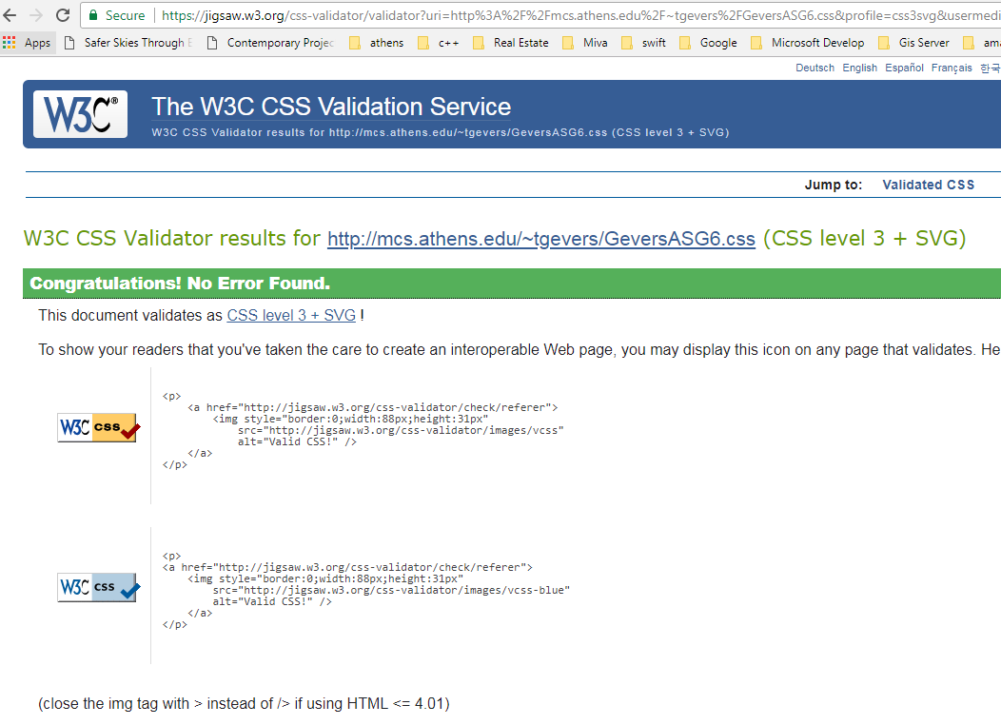

The results from the Wave Evaluation tool were: 0 Errors. 0 Alerts, 0 Features, 26 Structural Elements including 1 Layout Table, 3 Data Tables, 20 table header cells, a heading level 1 and 1 heading level 2.