Trevor Gevers

A00071337

Assignment 7

<http://mcs.athens.edu/~tgevers/GeversASG7.html>

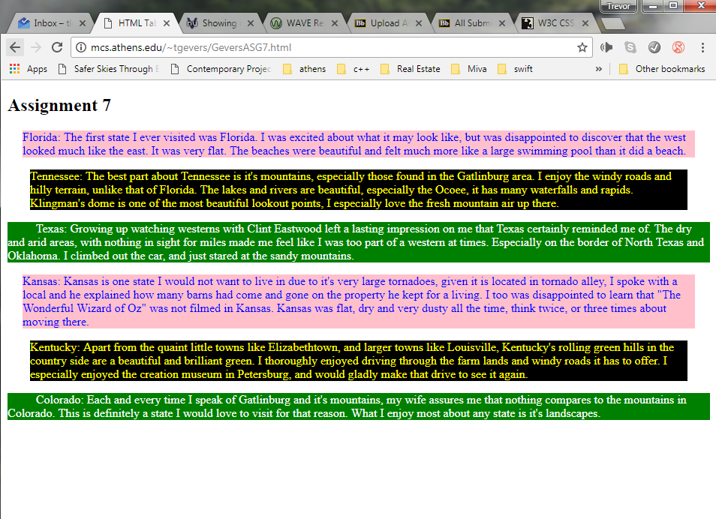

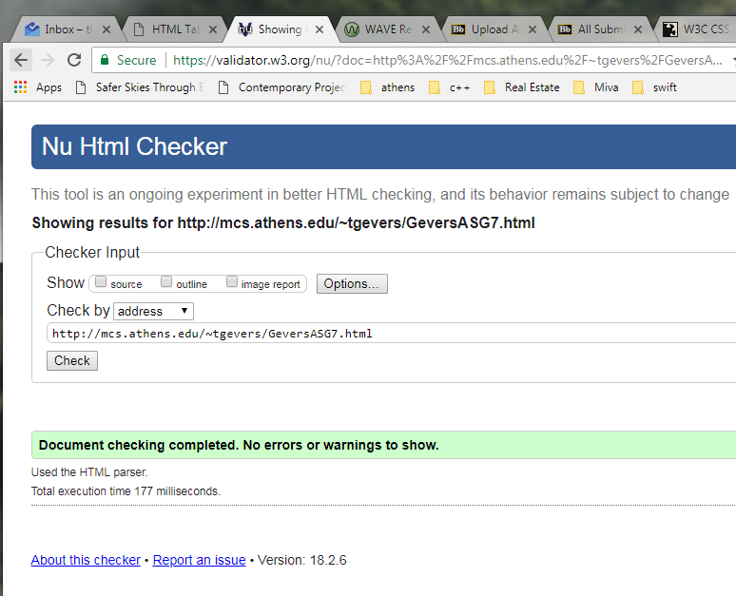

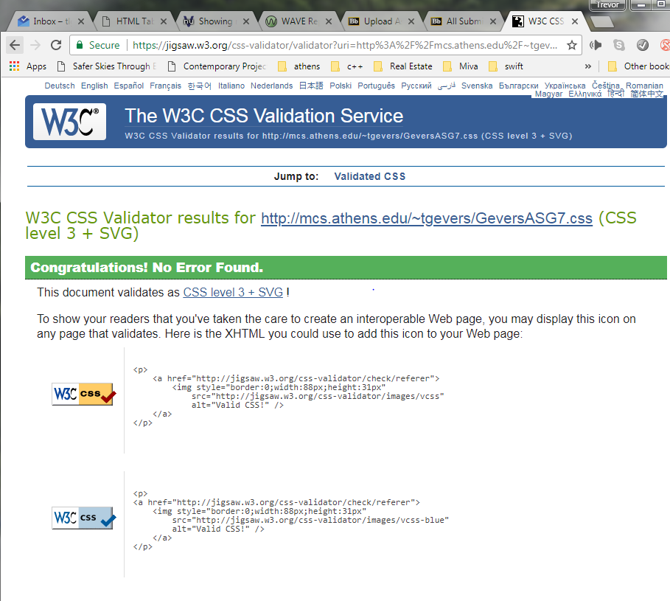

The results from the Wave Evaluation tool were: 0 Errors. 0 Alerts, 0 Features, 1 Structural Elements including a heading level 1.