Trevor Gevers

A00071337

Assignment 8

<http://mcs.athens.edu/~tgevers/GeversASG8.html>



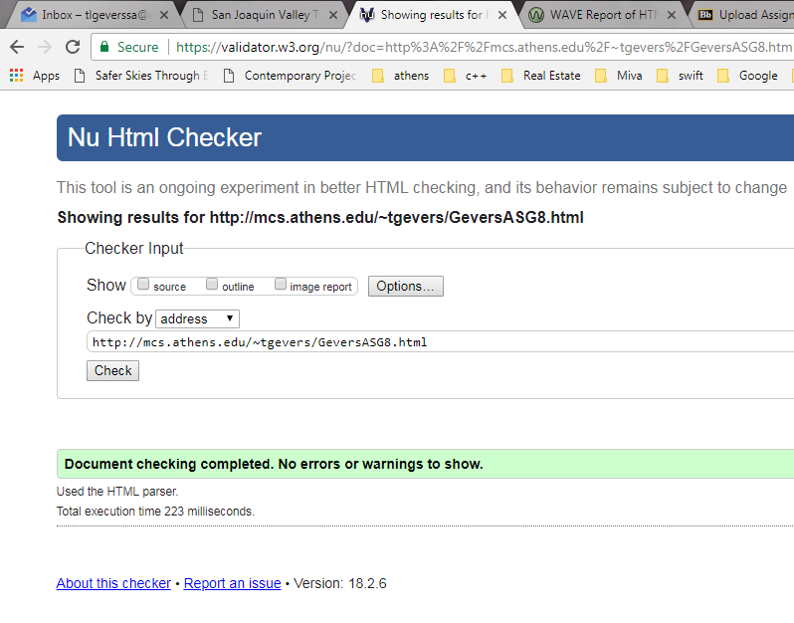

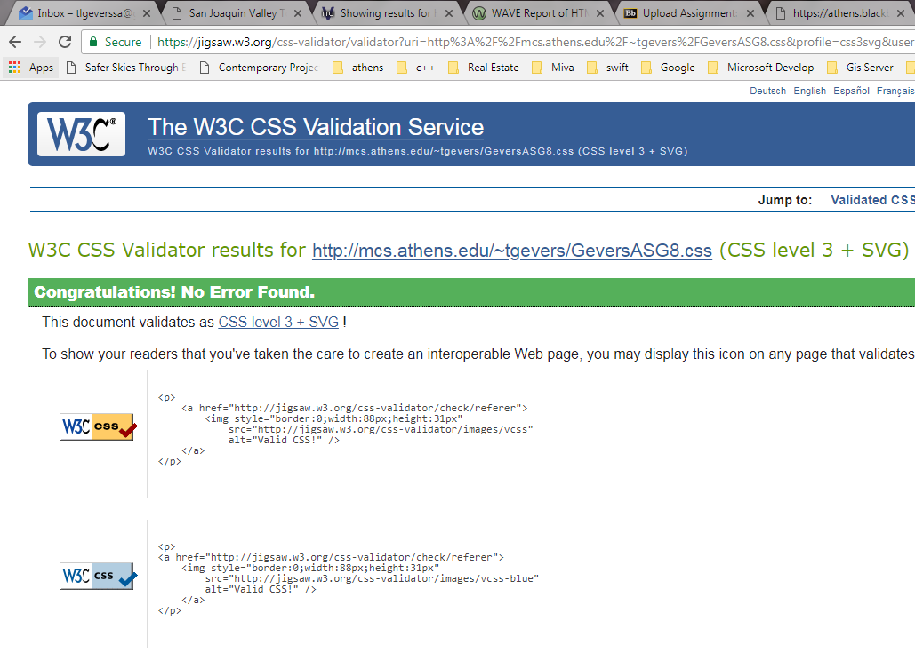

The results from the Wave Evaluation tool were: 0 Errors. 1 Alert that states there is a skipped heading level, 1 Features including an alt text, 5 Structural Elements including a heading level 1, 1 heading level 2, 1 heading level 3 and an unordered list.

HTML5 and ARIA (2) included 1 main content and 1 footer.