Trevor Gevers

A00071337

Assignment 9

<http://mcs.athens.edu/~tgevers/GeversASG9.html>

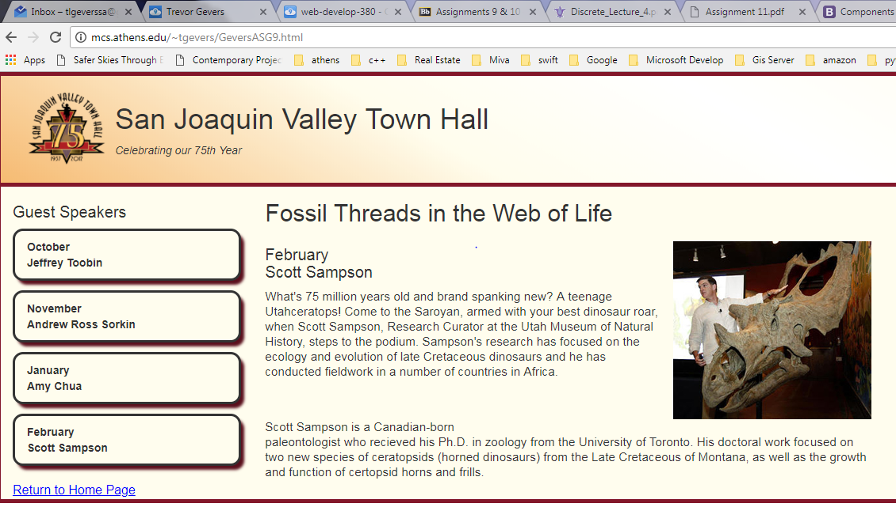

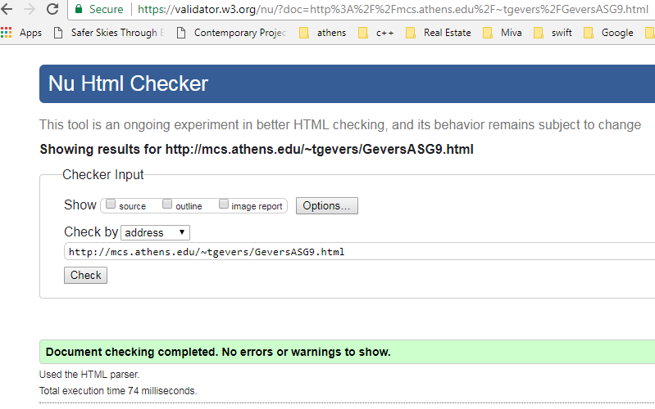

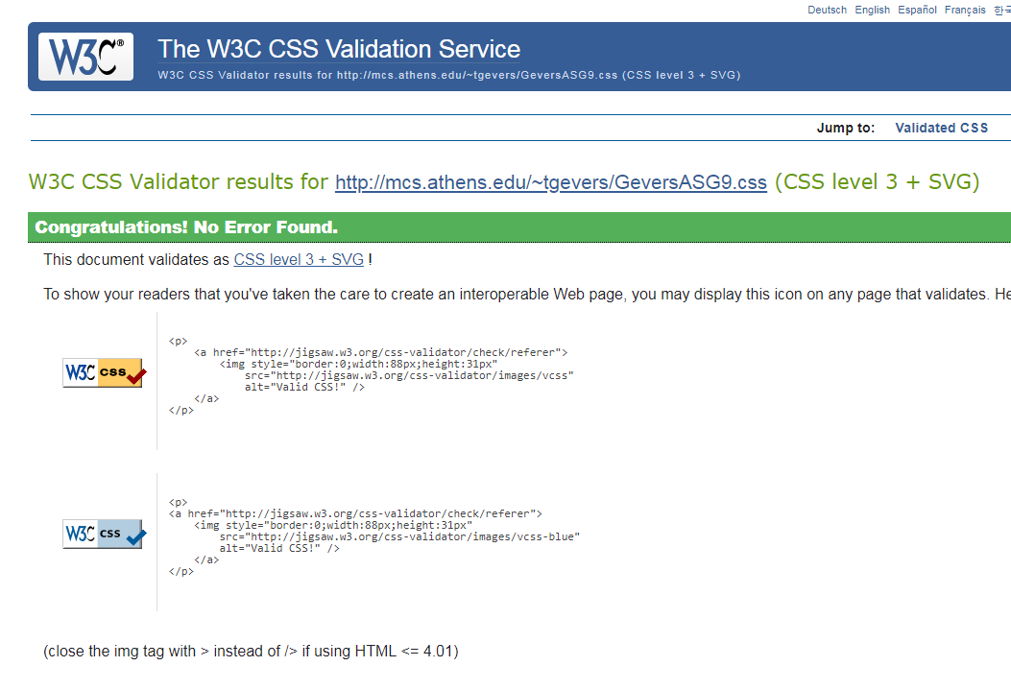

The results from the Wave Evaluation tool were: 0 Errors. 1 Alert that states there is a skipped heading level, the heading level h2 is inline with the h3. Features 2 linked images with alternative text, there too were 5 structural elements, a heading level 1, heading level 2, 2 heading level 3 and one unordered list, HTML5 and ARIA(1) 1 x Main Content.