AO-Bergamo two-photon microscope Operating Procedure

Purpose: This documents the standard procedures for operating the AO-Bergamo in 2C.357 for imaging live cranial windowed mice.

- Preparation
  - At least 45 minutes before imaging, turn the laser (Coherent Discovery TPC) from standby to enable using the key switch on the laser power supply (below the table as you enter the room)
    - Verify using the Coherent Discovery GUI app (ScanImage computer; icon on the desktop)
    - If the laser doesn’t start warming up, or isn’t connected, you will need to turn it off (switch on the back right of the black laser power supply below the optical table), wait a few minutes, and turn it back on.
      - It will make a loud noise, the red lights on the front of the power supply will blink, and the GUI app should work.
      - The chiller (below the laser power supply) and MRU (hidden above the table) should never be turned off.
        - Desiccant in the the MRU may eventually need to be replaced.
- System checks – make sure everything is working before you anesthetize your subject.
  - Laser: make sure the laser is connected (as above) and operating with a reasonable power
    - > 1.8W 900-1000nm, > 1.5W 1000-1100nm, > 1.3w 1100-1300nm
  - AO: On the laptop, open a terminal (if one is not opened) and type shwfs (‘shack-hartmann wavefront sensor’). This will open a window where you can see the wavefront, as represented by the lenslet centroids.
    - Make sure the mirror moves when you check ‘test deformable mirror’. Uncheck when done.
      - If it does not, go to ‘Debugging the deformable mirror’, below.
    - Check and un-check ‘zero DM command’. This should flatten (to some approximation) the mirror.
    - Check ‘closed loop control of DM’, and select a wavefront calibration. Verify that the wavefront changes then is stable.
    - Close shwfs.
      - Only one program open at a time! (It conflicts with the leveling optics / camera)
  - Anesthesia: check there is oxygen in the tank outside the door, and isoflurane in the vaporizer
    - The vaporizer has a sight glass with two white lines for upper and lower limits; refill if it’s too low.
      - There are more iso bottles by the west entrance to the vivarium.
  - Headbar orientation: if the headbar is in the front for the mouse, the aluminum tube that holds the mouse needs to be moved to the back position.
    - Likewise, if the headbar is to the back of the head, the tube should be in the forward position.
    - You can move it by unscrewing the two Phillips screws at the bottom of the aluminum tube – long handle screwdriver should be in the rig – and switching the holes that the screws go into.
  - Heat: if the mouse will be fully anesthetized, turn on the aluminum tube heater. The controller should be set for 38C. Make sure it’s heating up by touching it.
    - If the mouse is awake, do not turn the heater on, it will only irritate the rodent.
  - Nose cone: Take the nose cone off the surgical rig beside the sink, store the scavenge hose adapter and set-screw, and plug the inlet / scavenge tubes into the small and large polyethylene tubes by the microscope.
    - Small polyethylene tube = isoflurane; large = scavenge.
    - Plug the other ends of the PE tubes into the vaporizer, via the angle adapter, and into the wall vacuum by sliding one tube inside the other.
    - Mount the nose-cone on the leveling goniometer using the Thorlabs thumb-screw.
      - This jig is adjustable for different mice.
    - In this way, you can route anesthesia + oxygen to the microscope & nose-cone.
  - Stimulus: If the experiment requires visual stimulus, roll Filip's PsychToolbox rig into the room, plug it in, turn it on, and launch Matlab 2020.
    - Connect the stimulus monitor to the HDMI port on the back of the computer.
    - Connect the trigger output BNC cable to 'User1' input on the top rack of the Ni-DAQ BNC panel in the Scanimage computer rack below the optical table.
    - Mount the stimulus monitor on the microscope table using a pedestal clamp, if it's not already there.
    - Edit Matlab file "XXXXX" to change the parameters of the stimulus, if needed.
    - At the command prompt, run command XXXXX to start the stimulus presentation. Verify that gratings are displayed.
  - Matlab: start up Matlab 2019, and run scanimage at the command prompt.
    - If the laser isn't pulsing / mode-locked, it will complain about the FPGA sample clock. Check the laser and restart ScanImage.
    - If ScanImage can't find the motor controller or flipper mirror controller or some National Instruments thing, close Matlab and try again.
      - If this doesn't work, restart the computer and try again.
- Procedure
  - Anesthetize the subject using the induction box.
    - Use 4% - 5% isoflurane in 0.7-0.8 lpm oxygen flow. Be sure to check the outlet valves of the vaporizer to route the anesthetic correctly.
    - When the subject is breathing slowly -- usually not to the point of gasping (but that's ok too):
      - Switch the vaporizer valve to route the iso to the microscope & nosepiece
      - Change the dial on the vaporizer to 2%
      - Move the mouse to the microscope.
    - Putting the headbars in the holder can be tricky; I use one thumb to hold one side in while securing the other side. Once one arm of the headbar is in place, move the nosepiece so the animal remains anesthetized.
      - If the animal wakes up, put back in the induction chamber and try again.
    - Gently clean the cranial window with a little bit of ethanol and a cotton swab, or a Kimwipe, or whatever works.
  - Level the cranial window.
    - Make sure that Scanimage is set to 'Epi' not PMT (lower right corner of the control window).
    - Make sure the longpass dichroic, which blocks all light except the excitation laser, is not in place just above the objective on the microscope. It is mounted in a small 3D printed plastic mount which slides forward-back.
    - Place the collimating lens, which is usually stored on top of the PMT arm, in the holder just above the second tube lens (which is in turn above the dichroic mentioned above).
      - Be sure to push it all the way down so it is properly aligned with the optical axis.
    - Use the collimated reference laser light emitted from the objective to center the cranial window, by sliding the mouse mount / goniometer on the microscope table.
      - It is advisable to make sure the X and Y axes of the microscope are approximately centered before doing this -- you can get close by looking at the linear stages, which are stainless steel (hence a different color -- not anodized black) behind and below the bulk of the optical assembly.
        - If this drifts or is not centered periodically, you may run into the limits of the X or Y travel, or experience excess mechanical noise, which could affect imaging.
      - Lock the mouse goniometer in place on the microscope table with a pedestal clamp.
      - Move the Z-axis down (counter-clockwise on the wheel controller) to ~3mm above the mouse & cranial window.
      - Use a transfer pipette to apply the immersion water (DI water, get it from outside the vivarium)
    - At the laptop, in the terminal run the command pylonviewer.
      - This will launch the viewing application for the leveling camera.
      - The leveling camera is Basler aca2500-60um; double click on it in the list, then click the video icon to start the live preview. You should see some white circular interference patterns, which are the back reflections off surfaces in the objective.
        - If the image is too dark or too light (unlikely), use the “Acquisition Control” tab on the left side of pylonviewer to adjust the exposure time. A good default is 5000.
    - Adjust the two micrometers on the mouse goniometer to move the back-reflection off the cranial window.
      - Which circle this will be is obvious once you start turning the knobs.
      - The leveling doesn't need to be perfect, but generally go not from the center-of-mass, but rather from the outline.
      - If you run out of travel on either of the micrometers, there are coarse-thread screws below them that can be adjusted to allow more travel.
    - Close pylonviewer when you are satisfied with the alignment.
    - Remove the collimating lens from the mount on the microscope, and return it to the PMT arm.
  - Locate the area of interest (e.g. viral expression) using epifluorescene.
    - At the terminal, launch guvcview
      - This usually defaults to the epi camera, but sometimes it switches to the webcam built into the laptop. It it's not correct, use 'Video Controls' tab to select DMK 33UX249
      - Fullscreen the video display, if so desired.
    - Turn on the blue LED with the controller mounted near the XYZ wheel controller.
      - Usually you don't need full power; no need to bleach the animal prematurely!
    - Change the speed of the XYZ wheel controller to about half (center smaller knob) for greater precision.
    - Adust the Z-height carefully, while looking at the mouse, to bring the projected blue circle into focus on the brain.
    - Now use the video display to bring the surface of the brain into tight focus.
    - Move in X and Y to locate the area(s) of interest.
      - Take care that you may bump into the edges of the cranial window or into the dental acrylic; if this happens, don't push too hard to avoid injuring the mouse.
    - Zero X and Y on the motor controller in Scanimage to 'mark' your region. (not necessary but helpful).
    - Turn off the blue epi LED.
    - Close guvcview.
  - Place the 1" silver mirror so the mouse can see the stimulus screen.
    - It is helpful to use a cell-phone flashlight as a guide light in ~the middle of the screen for mirror alignment.
    - Some adjustment is usually required; be careful that the mirror does not accidentally bump into or get close to the objective.
  - 2P imaging!
    - At the terminal, run shwfs to start up the AO controller.
      - Check, as before, that things are working.
      - Enable closed-loop control, and select a calibration (960nm PS beads SVD is usually the best).
      - Visually check that the wavefront is stable.
    - Slide the longpass dicroic back over the objective hole to block the reference laser from reaching the mouse & PMTs.
    - In scanimage, load wHalocamp configuration; verify that external triggering is enabled (green).
    - Check the mouse respiration & heat again, adjust the iso to 1.75 - 1.5 or lower, if visual perception is needed.
    - Lower the black front curtain and turn off the lights.
    - Turn on the PMTs, switch the flipper mirror from 'Epi' to 'PMT'.
    - Adjust the power of the laser, via the Coherent Discovery GUI, to ~4% @ 950nm (if you have GFP). Open the shutter on the laser.
    - Click 'Focus' in scanimage.
      - Make sure zoom = 1.
      - Adjust the Z-axis to locate the dura; zero the Z-axis motor counter so you know subsequent imaging depth.
      - Adust the scaling on the PMTs and frame averaging to get a good image (if possible).
    - Change wavelength and laser power according to experimental needs.
      - Generally don't exceed ~30% power at GFP excitation wavelengths; ~60% power at RFP wavelengths. You can use full power for jf669 (1225nm).
        - This depends on zoom (higher = less power) and depth (deeper = more power).
      - Laser power can be measured in mW after the experiment with the Melles Girot bolometer, which is on a shelf behind the rack of remnants of the old 2p microscope.
        - It is helpful to record in your notes laser output power and percentage of the AOM; at-sample powers can be reconstructed afterward from this and a few measurements on the microscope, since it's optical throughput will not change much (if at all) with time.
    - If you need a Z-stack, click the checkbox 'Stack' on the main Scanimage window, then set the parameters of the stack in it's UI window. Stacks are acquired from deep to shallow.
      - External triggering needs to be disabled.
    - If a timeseries is required, determine the number of frames at the current framerate, enter that into the main Scanimage window, enable external triggering, and make sure the PsychToolbox computer is ready.
      - Do record both red and green channels.
        - Stimulus bleed-through is on the green channel, great for synchronization.
      - When you click 'grab' in scanimage, it will wait for the trigger from PsychToolbox. Wait until you can hear the resonant mirror scanning & Matlab / Scanimage is idle. (~2-3sec).
      - Hit enter on that computer to start the stimulus and capture.
        - This doesn't always work; if it gets messed up, Filip had a way of resetting the PsychToolbox computer. Scanimage just needs to be 'Aborted' and tried again.
      - Good practice to immediately check the images in Fiji.
  - Cleaning up
    - Turn off the PMTs, close the shutter on the laser.
    - Max out the speed of the XYZ wheels, raise the objective to its maximum +Z.
    - Reset the mouse goniometer to be approximately level with the microscope table surface.
    - Unfasten the pedestal holding the mouse goniometer, move forward for better access.
    - Turn off the iso, move the nose-cone out of the way, loosen the headbar thumb-screws and take the animal out.
    - Turn off oxygen flow at the vaporizer and close the valve on the oxygen tank
      - Don't forget this last one!!!
    - Clean the bottom of the objective with a Kimwipe (don't want anything drying on there)
    - Unplug the heater
    - Put the laser in standby
    - Close shwfs
    - Backup your data to \\nrsv\ or wherever and celebrate!

Appendix A:
Debugging the deformable mirror.
If, when you open shwfs, “test deformable mirror” does nothing, do the following:
- Turn off, wait a moment or two, and turn back on the DM control box, which is above the optical table labeled “ALPAO”
  - The switch has a dim blue light on it, and when you turn the control box back on, the also dim yellow light above this switch should blink for a while then stop blinking.
- At the laptop, go to the terminal and type “sudo ip a”. Enter the password “cupcake” when prompted. This lists all the network interfaces on the laptop. It should result in the following (or similar):
- sudo ip a
[sudo] password for tlh24:
1: lo: <LOOPBACK,UP,LOWER_UP> mtu 65536 qdisc noqueue state UNKNOWN group default qlen 1000
link/loopback 00:00:00:00:00:00 brd 00:00:00:00:00:00
inet 127.0.0.1/8 scope host lo
valid_lft forever preferred_lft forever
inet6 ::1/128 scope host
valid_lft forever preferred_lft forever
2: enp0s31f6: <BROADCAST,MULTICAST,UP,LOWER_UP> mtu 1500 qdisc pfifo_fast state UP group defau
lt qlen 1000
link/ether 48:2a:e3:86:3d:a0 brd ff:ff:ff:ff:ff:ff
inet 10.123.1.152/20 brd 10.123.15.255 scope global dynamic enp0s31f6
valid_lft 421880sec preferred_lft 421880sec
3: wlp82s0: <BROADCAST,MULTICAST> mtu 1500 qdisc noqueue state DOWN group default qlen 1000
link/ether 02:15:ab:e5:6c:6a brd ff:ff:ff:ff:ff:ff permaddr b8:9a:2a:fe:13:93
7: enxe415f6f3c785: <BROADCAST,MULTICAST,UP,LOWER_UP> mtu 1500 qdisc pfifo_fast state UP group
default qlen 1000
link/ether e4:15:f6:f3:c7:85 brd ff:ff:ff:ff:ff:ff
inet 192.168.7.1/30 brd 192.168.7.3 scope global dynamic noprefixroute enxe415f6f3c785
valid_lft 863954sec preferred_lft 863954sec
inet6 fe80::e615:f6ff:fef3:c785/64 scope link noprefixroute
valid_lft forever preferred_lft forever
- In the output above are highlighted the DM interface, here “enxe415f6f3c785”. This name is assigned by Linux, and it doesn’t really matter what it is.
  - Sometimes (infrequently) it will show up as “usb0” (since the DM controller is plugged into a USB port).
  - It is never ‘lo’ (the loopback interface) or anything starting with “wlp” (that’s wifi) or “enp” (that’s ethernet).
- The important thing for this named interface is that it has an IP address, so shwfs can communicate with it. Below enxe… there needs to be a line saying “inet 192.168.7.1/30”
  - If it says this, then the DM should be properly connected, and try running shwfs again.
  - If it does not have an ip address (unlikely), then at the command line run: sudo dhclient enxe415f6f3c785
    - You will need to copy the name of the DM controller interface from “sudo ip a”
      - Note on Linux, all you need to do to copy some text is highlight it. Then, when the cursor is over the terminal, press the middle mouse button to paste it. (This is a separate paste buffer from Control-C / Control-V. Indeed, Control-C doesn’t work at the terminal, as this command is used to close a program. )
    - This should complete quickly.
    - Run sudo ip a again to make sure that the DM controller (“enex…”) has an IP address.
      - Whenever a command is preceded by “sudo”, you’ll need to enter the password (unless it has been cached).

Appendix B:
Photos of relevant parts of the rig.
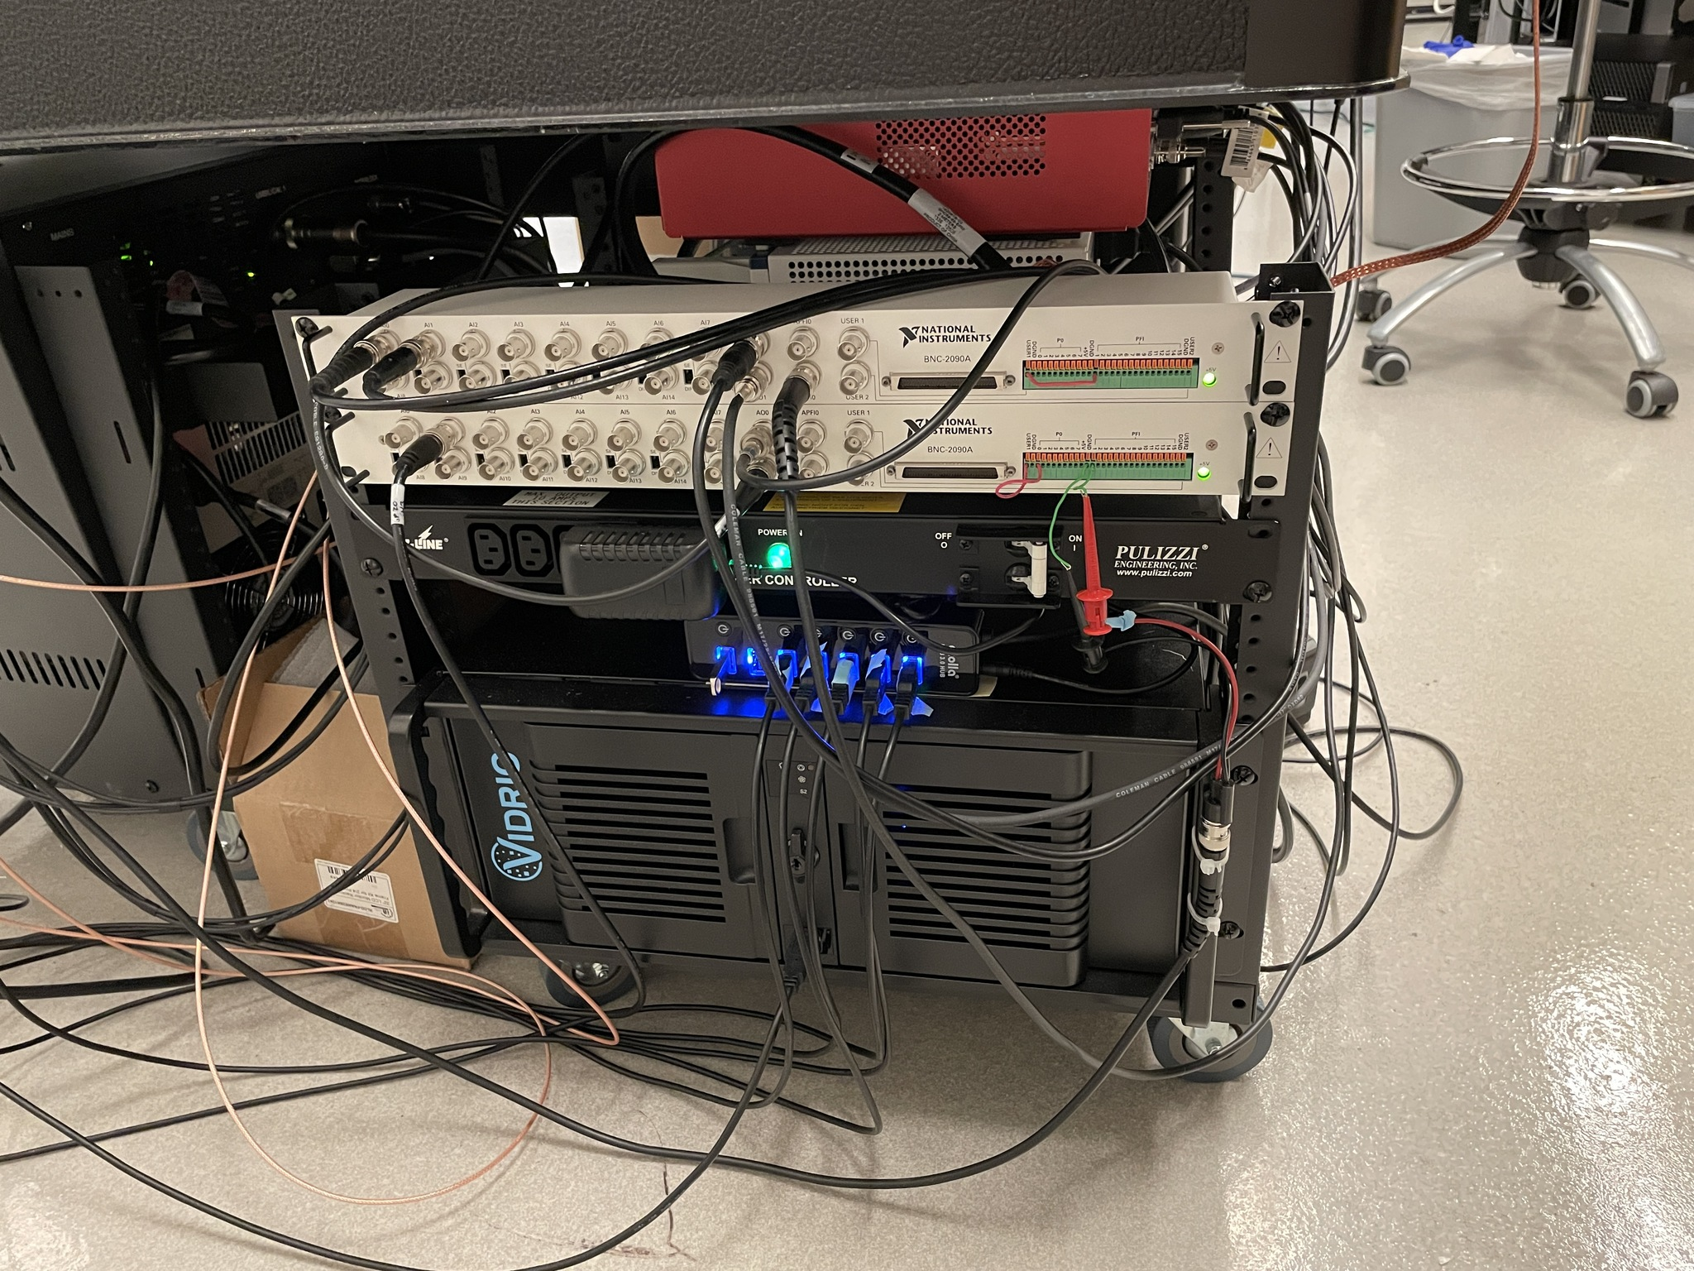
ScanImage computer (featuring the Vidrio logo), NI BNC breakout panels (top one accepts external trigger on User1) & USB inputs / outputs.
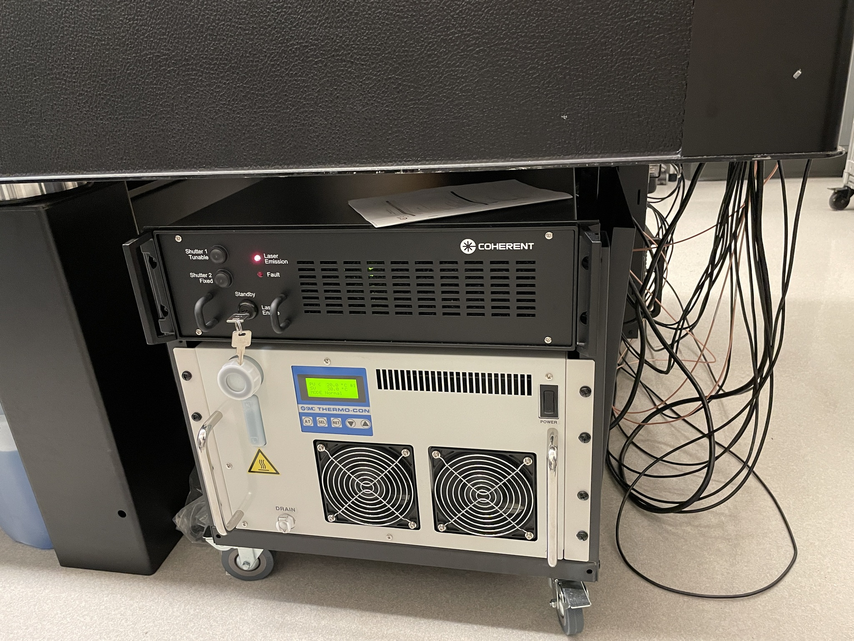
Coherent Discovery power supply (top, black), with key switch; laser chiller (white, bottom). Lrave the chiller on at all times.
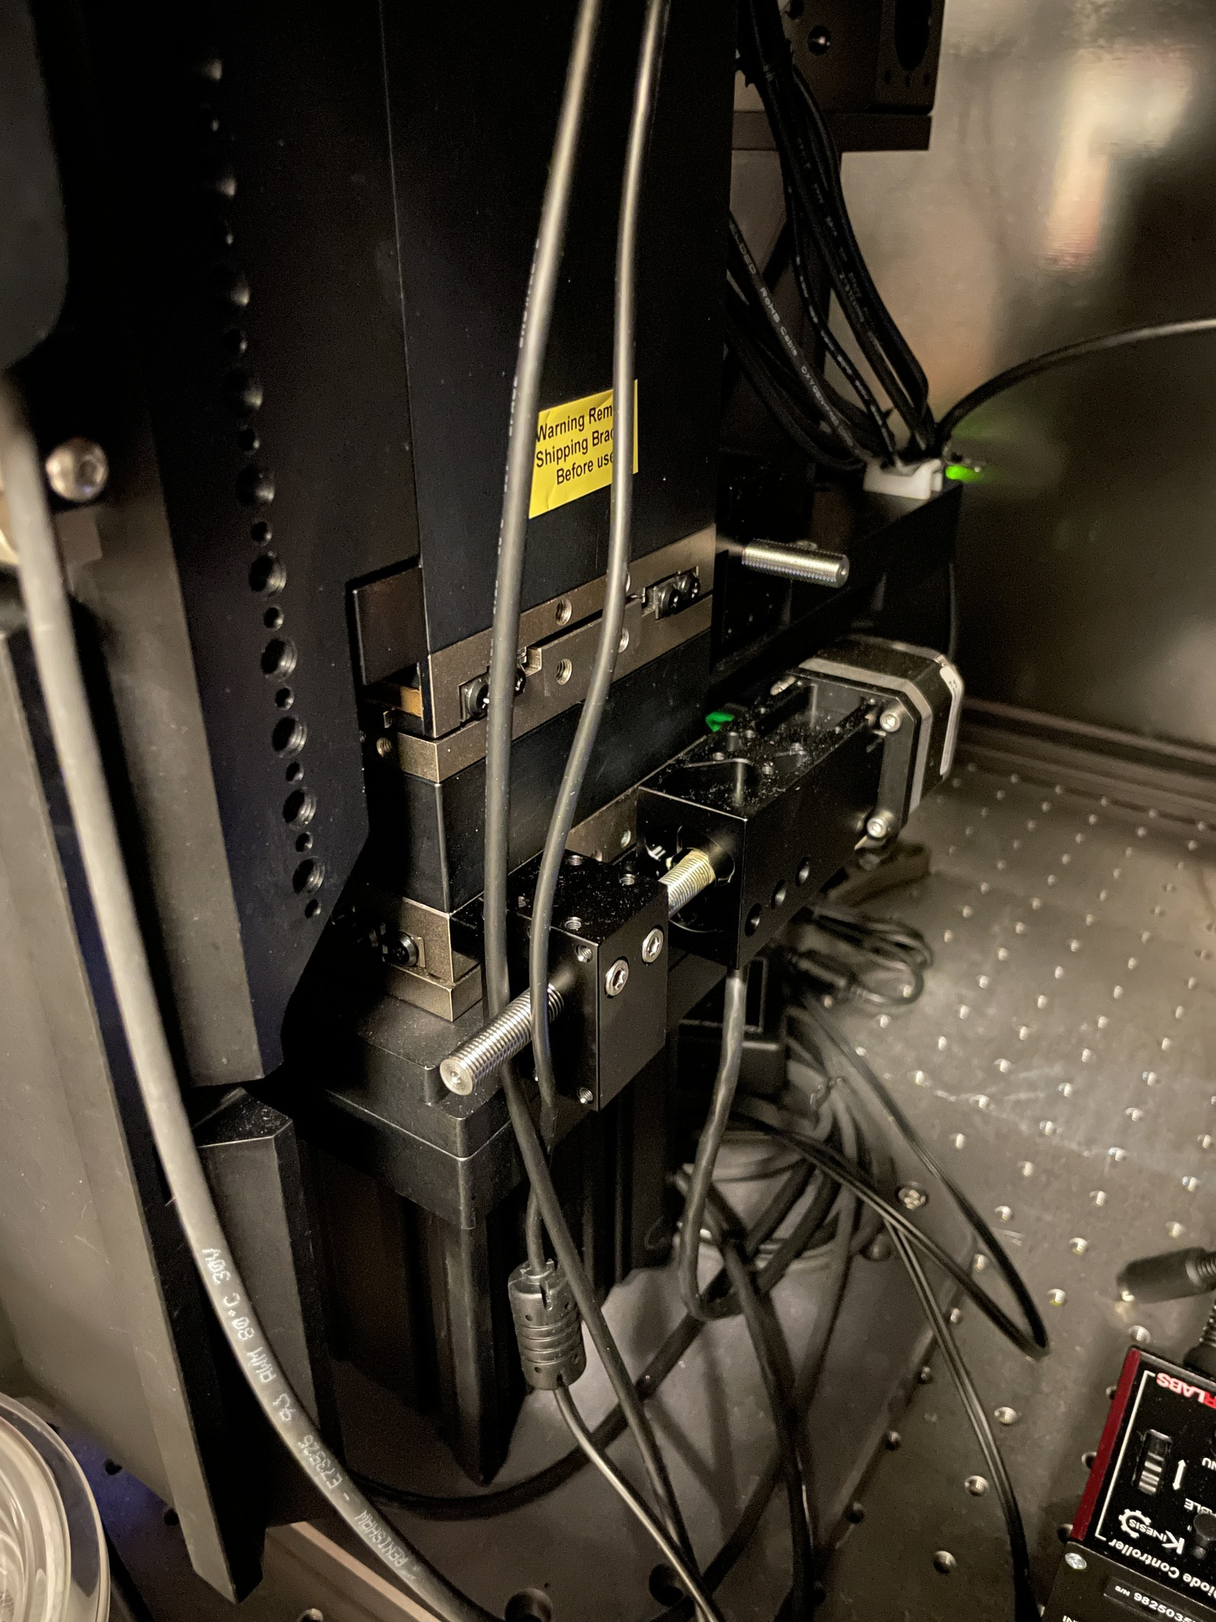

Image of the X and Y microscope movement stages (stainless-steel; rest of structure is black anodized aluminum). These should be aligned before securing the mouse goniometer.

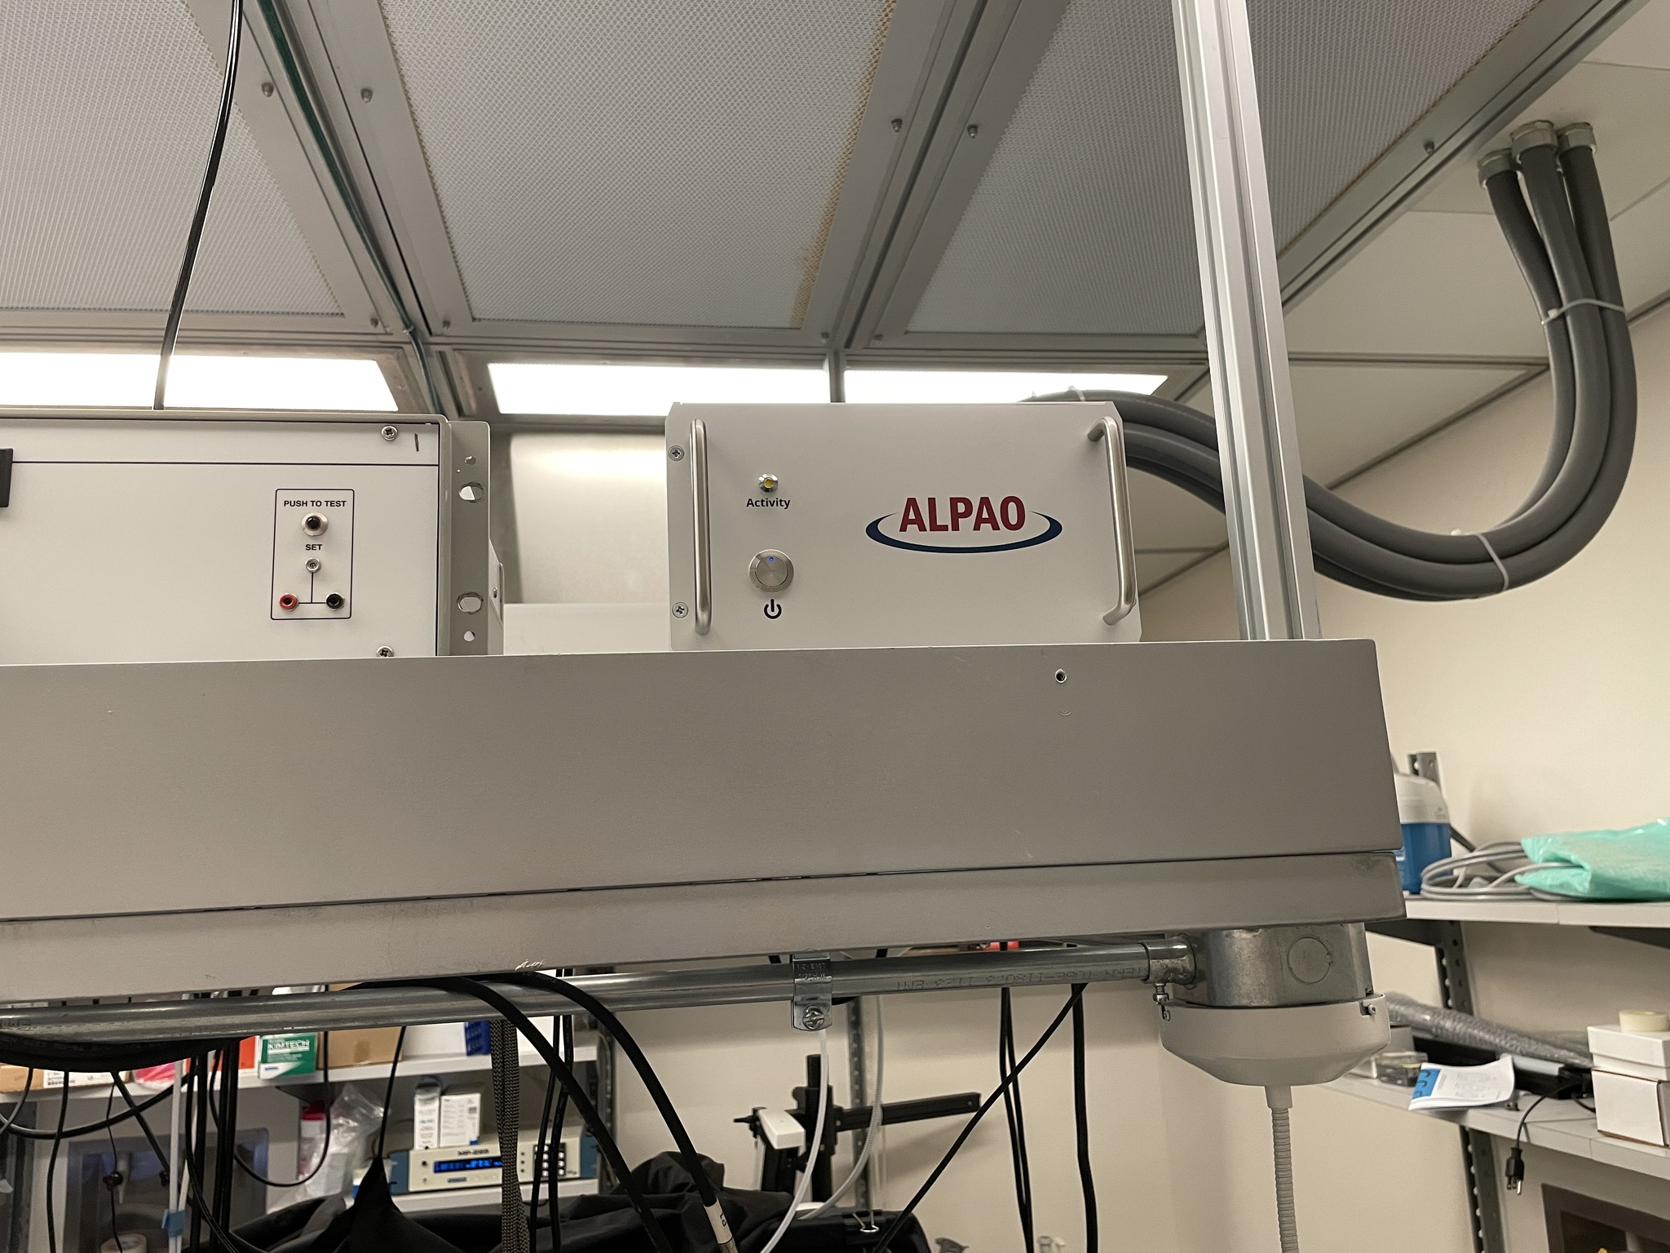
Alpao deformable mirror control box. Above the table & the laser power supply and chiller.

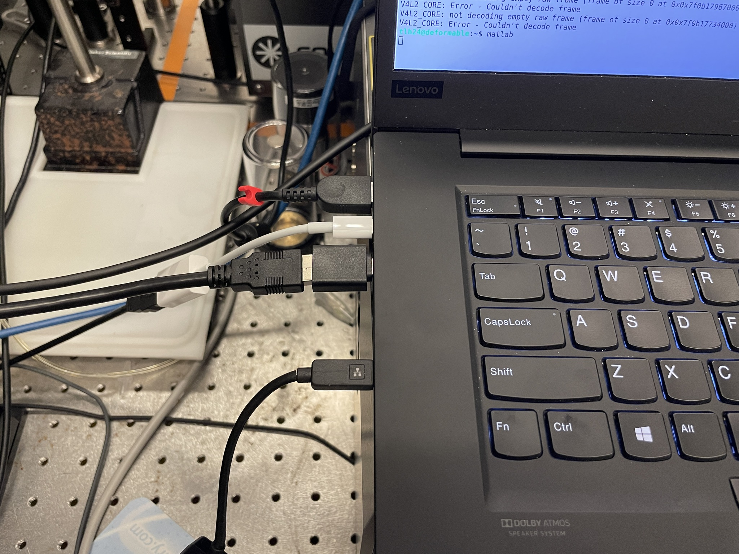
Left side of the DM control laptop. From top to bottom:
- Power cord
- USB-C to USB-A to Alpao DM controller
- USB-C to USB-A to Basler leveling camera
- Ethernet adapter

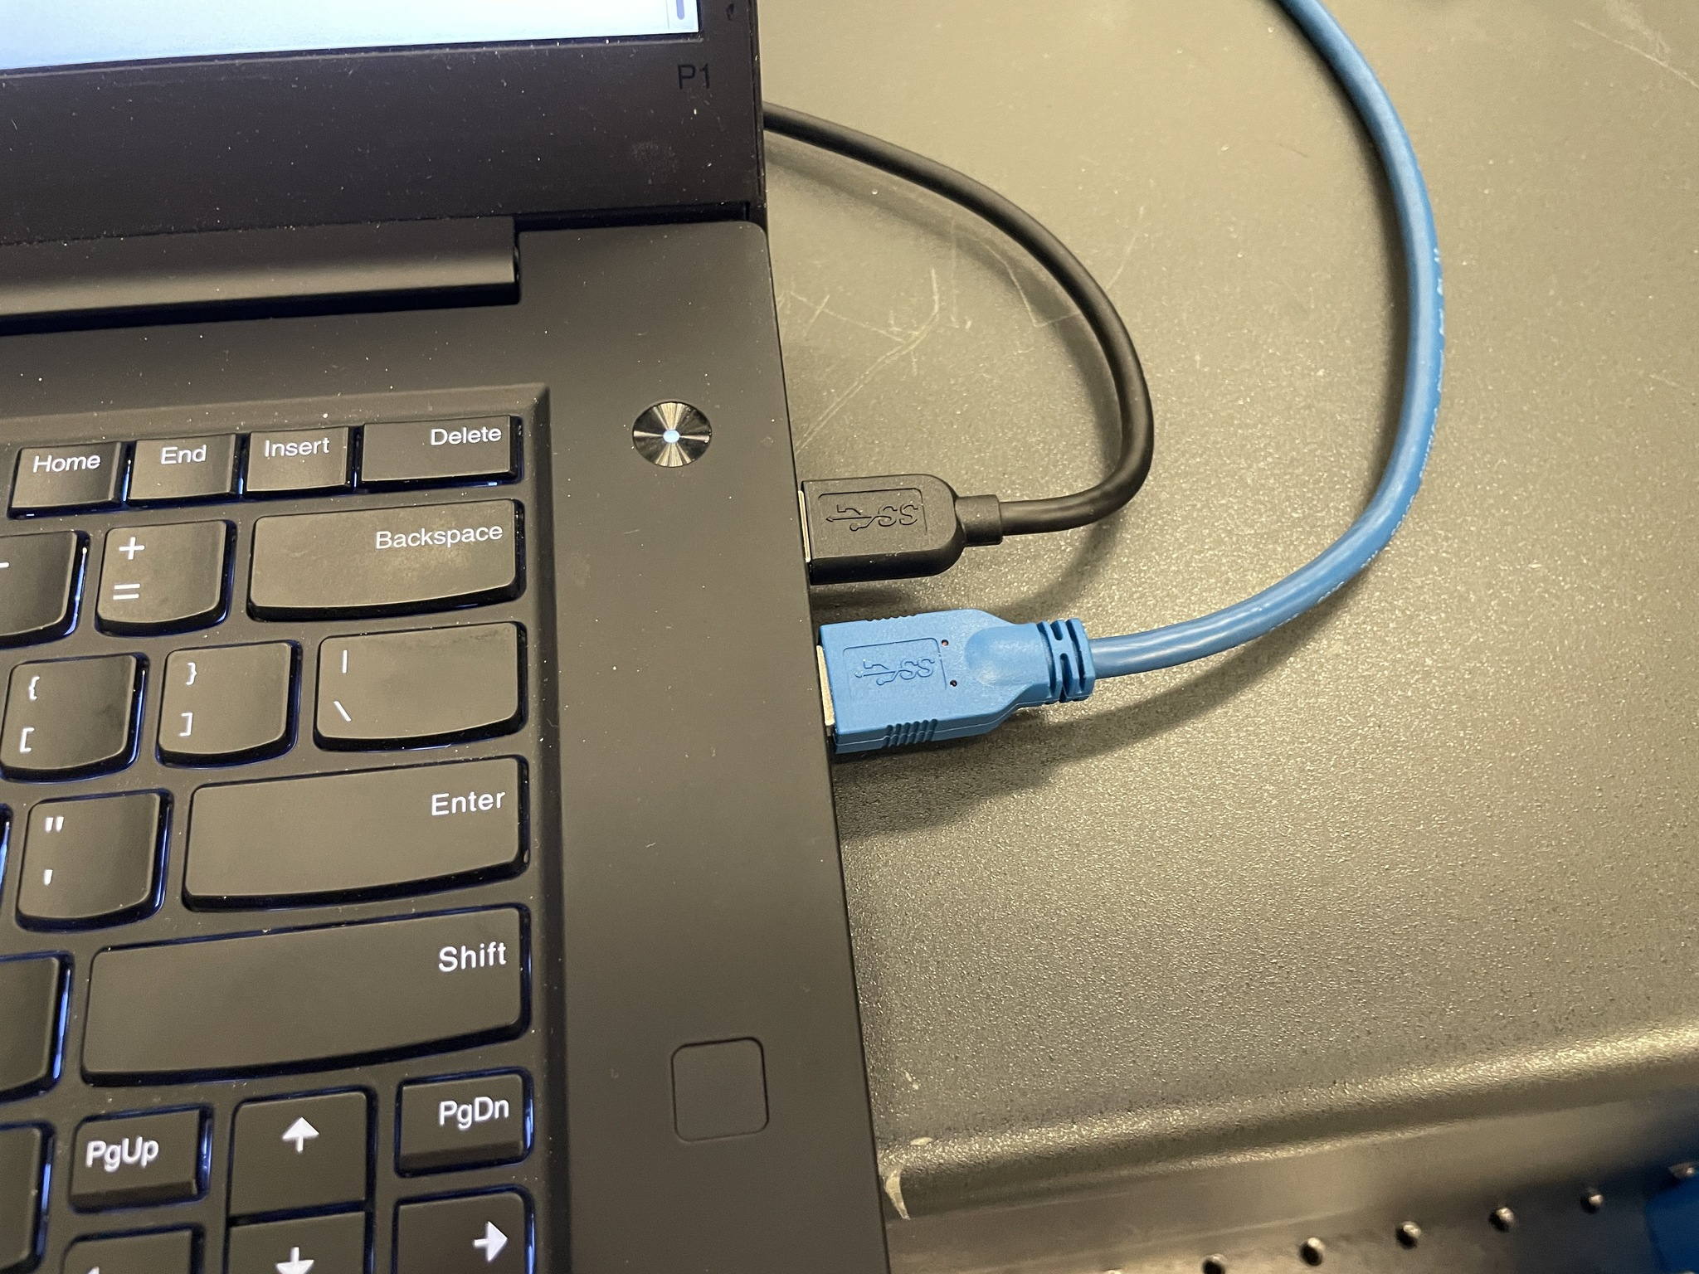
Right side of DM control laptop. Black: Wavefront sensor camera, to Basler aca2040-90um. Blue: epifluorescence camera, to ImagingSource DMK 33UX249.

