The Grasps (see following pages for animation):

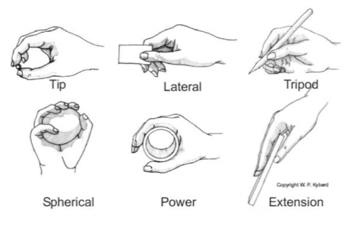

The Problems (see following pages for examples):

* The animated thumb is not as long as an actual thumb
* No control over Palm Arch
* When the thumb rotates, naturally your palm arches, however, in the animated version of a human arm, you the thumb rotates in place, without arching the palm

The Potential Fixes:

* In the 3D model of the thumb, minutely increase the length of each of the sections
* Add a Palm_Arch function to the list of functions in MiniV.m to allow for use in animation
* In the Thumb_Rot function, adjust the movement so that the palm arches as the thumb rotates by some proportional degree

Tip Grasp:

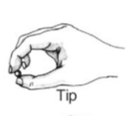

Option1 Option2

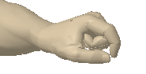 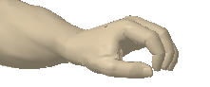

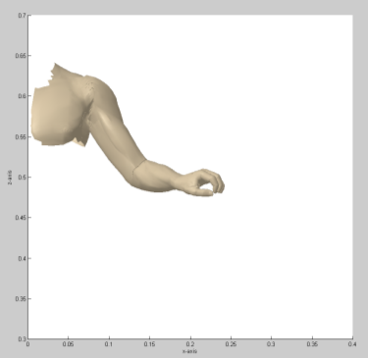

The index finger should be able to extend more, but the thumb is not long enough so the index finger has to bend more to compensate

The thumb should be rotated in slightly more which would be achieved by palm arch

Lateral Grasp:

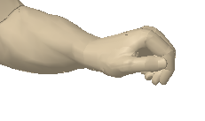 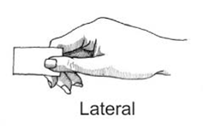

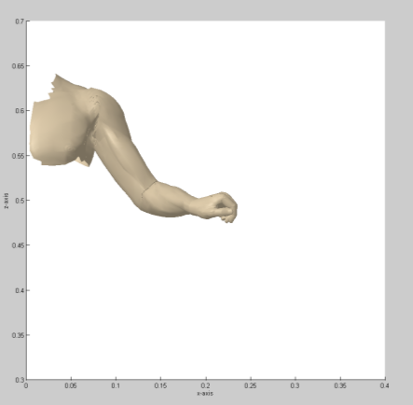

The thumb should be able to extend to the far edge of the index finger, yet it doesn’t even though the index finger is curved tighter than it should be.

Tripod Grasp:

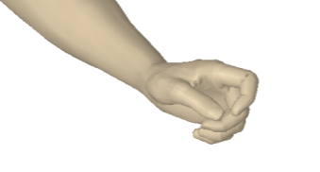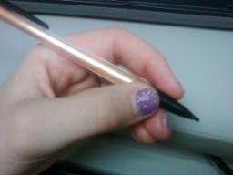 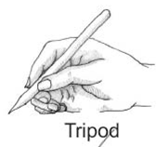

The thumb should extend over the middle finger, but it is too short, and doesn’t even extend over the middle finger when the middle finger is curled in too much.

The thumb should be slightly more rotated inwards, which would be achieved by Palm Arch.

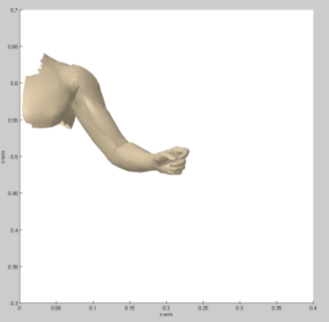

Spherical Grasp:

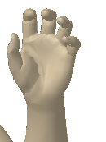 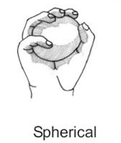

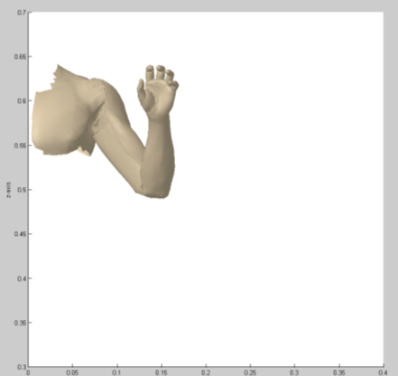

The thumb should extend up higher, closer towards the index finger, but there isn’t really a noticeable problem with the thumb in this grip.

Power Grasp:

**Without a palm arch function, this grasp cannot be completed:**

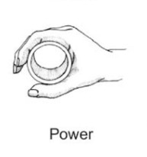

Thumb Index, Middle, Ring, and Pinky Fingers

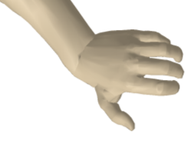 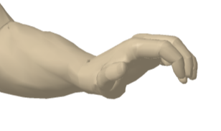

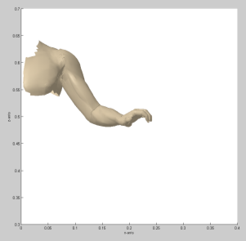

There is no way to make the thumb rotate to create a circle with the index finger, the rotate function rotates the thumb in place but doesn’t arch the palm.

Extension Grasp:

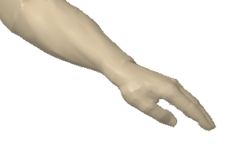 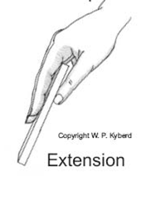

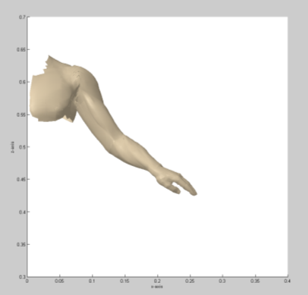

The thumb should extend halfway between the Proximal Interphalangeal (PIP) joint and the Distal Interphalangeal (DIP) joint if it was the correct length.

In an extension grasp in which one is picking up a wide flat object, in order to balance the object in one’s hand, the user will use Palm Arch to line their thumb up with their middle finger so as to hold the wide object closer to its center point, keeping it from tipping. But this action cannot be performed in the demonstration currently.