FAQs Working w/ MiniVIE Code

**I changed folders so that my current folder is C:/svn/myopen/MiniVIE, but I am getting the this error message. What am I doing wrong?**

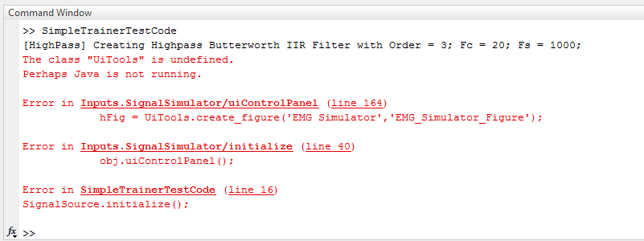

The key error in this message is the circled line. This lets you know that even though you might be under the MiniVIE directory, you are not connected with the *Utilities* folder. The *Utilities* folder contains tools that you need to run your software and must be accessible in order for your program to run. If you are receiving that error *Shortcuts* message it is because your *Current Folder* box looks like the image on the left. Go to *Shortcuts* and click on *goto MiniVIE.* This is will access the *Utilities* folder so that your *Current Folder* looks like the correct image on the right.

