AI2002: ARTIFICIAL INTELLIGENCE
Semester Project, Fall 2026 - Path A (Software-Based)
MUHAFIZ.SOL
Smart Contract Vulnerability Detector
Final Project Report

Table 1: Project summary
Item | Details
Group | 39
Members | Sohaib (24I-3108), Shaiman (24I-3074), Talha Sami (24I-3118)
Path | A - software (hardware not applicable)
Phase owners | Phase 1 data: Talha Sami - Phase 2 models: Sohaib - Phase 3 app and delivery: Shaiman
Datasets | Slither Audited Smart Contracts (training); SmartBugs Curated (external test)
Deliverables | Source code, Streamlit app (streamlit run app/app.py), this report, slides

Abstract
Smart contracts hold real money and cannot be patched after deployment, yet professional audits are slow and expensive. Muhafiz.sol is a machine-learning triage tool that reads the Solidity source of an Ethereum contract and returns, within seconds, a probability for each of 7 weakness families, an overall risk level, the lines that drive the prediction and the most similar known contracts. Models are trained on 65,058 unique contracts from the Slither Audited Smart Contracts dataset after exact and near-duplicate (MinHash) grouping and a clone-aware split, and are tested independently on the human-annotated SmartBugs Curated benchmark. Six model families are compared. The selected MLP neural network reaches a macro PR-AUC of 0.862 (95 % CI [0.855, 0.871]) on the held-out test split and flags 62.6% of the SmartBugs contracts in the three categories with a confirmed label mapping. We show how much clone leakage would inflate the scores, measure whether the highlighted lines hit the annotated vulnerable lines, and state the limits plainly: the model learns tool-generated labels, cannot see weakness types that have no training label, and is not a substitute for an audit.

Contents
1. Introduction
1.1 Problem statement
1.2 Real-world justification
1.3 Why machine learning?
1.4 Selected path
1.5 Objectives and how they were met
1.6 Scope, users, inputs and outputs
2. Methodology and System Architecture
2.1 Components
2.2 Interface contract between the phases
2.3 Experimental protocol
3. Dataset Description
3.1 Dataset A: Slither Audited Smart Contracts (training)
3.2 Label semantics: what does label 4 mean?
3.3 Dataset B: SmartBugs Curated (external test only)
3.4 Preprocessing
3.5 De-duplication and group-aware splits
3.6 Data limitations
4. Algorithm Description and Justification
4.1 Task formulation
4.2 Models compared and why
4.3 How the MLP learns (forward pass, loss, backpropagation)
4.4 Training protocol
4.5 Decision thresholds, calibration and risk level
5. Experiments, Results and Interpretation
5.1 E1 - Model comparison on the cluster-aware test split
5.2 E2 - How much does clone leakage inflate scores?
5.3 E3 - Independent test on SmartBugs Curated
5.4 E4 - Ablations
6. Implementation Details
6.1 Code structure
6.2 Preprocessing implementation
6.3 Explanation module (occlusion)
6.4 Streamlit application
7. Testing and Evaluation Evidence
7.1 Automated tests
7.2 Acceptance tests (blueprint 13.2, 14.2, 15.2)
7.3 The ten fixed test inputs (C2)
7.4 E3b - Do the highlighted lines point at the real bug?
7.5 E5 - Latency and error analysis
8. Limitations and Ethics
8.1 Technical limitations
8.2 Ethics and safety
9. Conclusion and Future Work
Future work
Team contributions
References
Appendix A - Compliance checklist (blueprint Part B)
Appendix B - User guide
(Page numbers appear when Word updates the field: right-click the list and choose Update Field.)

1. Introduction

1.1 Problem statement
A smart contract is a small program stored on a blockchain such as Ethereum. It holds and moves digital money according to fixed rules and, once deployed, generally cannot be changed. A coding mistake therefore cannot be quietly fixed afterwards: if an attacker finds it, the funds the contract holds can be drained. Security audits exist to find such flaws before deployment, but they are slow and costly, so many students and small teams deploy with little or no review. They need a fast way to find the most common weakness patterns and to see where in the code they occur.
A classic example is the refund mistake. A shopkeeper checks the ledger (the customer is owed 100 rupees), hands over the money, and only then writes zero in the ledger. A customer who repeats the request between the second and third steps is paid again and again. In smart contracts this ordering mistake is called reentrancy. Muhafiz.sol should flag such a contract and highlight the lines where money is sent before the balance is updated.

1.2 Real-world justification
Chainalysis reports more than US$3.4 billion in cryptocurrency stolen between January and early December 2025, and CertiK's Hack3d report for 2025 records US$3.35 billion lost to hacks, scams and exploits across 310 incidents, about US$1.70 billion of it on Ethereum. An honest qualification matters: most of the 2025 dollar value came from a few infrastructure and key-compromise attacks, not from contract-code bugs. TRM Labs figures, as summarised by a secondary source, attribute about 12 % of stolen value (52 incidents) to code exploits. Contract-code flaws are therefore a smaller share of the money lost, but a recurring and preventable one - exactly the category a pre-deployment check addresses. (The secondary figures must be re-checked against the primary reports before submission; risk R11.)
Pakistan's Parliament passed the Virtual Assets Act 2026 on 6 March 2026, establishing the Pakistan Virtual Assets Regulatory Authority (PVARA) to license virtual-asset service providers and give regulatory clarity for token launches and DeFi protocols; the same report places Pakistan third in Chainalysis's 2025 adoption index. A newly licensed sector creates demand from small local teams for low-cost screening. Muhafiz.sol is a student research tool: we do not claim that PVARA requires contract scanning, and it is not a compliance product.

1.3 Why machine learning?
Rule-based analysers such as Slither need code that compiles with the right compiler version and apply hand-written detectors. A trained model reads raw source text, needs no compiler, returns a ranked probability for every class within a second and can score code that does not compile. Because our training labels were produced by Slither, the model largely learns to approximate Slither - which is why we position it as a triage aid and test it on an independently annotated benchmark.

1.4 Selected path
The project follows Path A (software only). No hardware, sensors or actuators are used and the project is never presented as a hybrid. The core functionality depends entirely on trained models: without them the application produces no output, and no static-analysis rule runs at prediction time.

1.5 Objectives and how they were met
Table 2: Measurable objectives (blueprint 4.1) and their evidence
ID | Objective | Evidence
O1 | Clean, leak-free pipeline from two public datasets | Automatic tests A1 (no annotation text) and A2 (no clone group in two splits) pass
O2 | Train and fairly compare at least four model families | Six families compared on the same split (chapter 5, E1)
O3 | Evaluate on an independent annotated benchmark | Per-class recall with bootstrap intervals on SmartBugs (E3)
O4 | Show how much clone leakage inflates scores | Random vs cluster-aware split for all models (E2)
O5 | Highlight risky lines and measure correctness | Line hit-rate@1/@3 against annotated lines (E3b)
O6 | Working Streamlit app with the full flow | streamlit run app/app.py; ten fixed inputs tested (chapter 7)
O7 | Honest reporting including limitations | Chapter 8, model card, data card and in-app disclaimer

1.6 Scope, users, inputs and outputs
- In scope: Solidity source pasted or uploaded as one file; multi-label weakness prediction; risk level; line highlighting; similar contracts; batch ranking of several files.
- Out of scope: hardware; exploit generation or automatic fixing; scanning deployed addresses; bytecode; non-Ethereum chains; running Slither or a compiler in the app; any claim of certification.
- Users: student and freelance Solidity developers, small Web3 / token-launch teams, auditors deciding what to review first, launchpad review staff.
- Input -> output: one .sol file -> per-class probabilities, flags, low/medium/high risk, top-k risky lines, three similar training contracts and a downloadable report.
- Decision supported: deploy, fix specific functions first, or send for a full manual audit.

2. Methodology and System Architecture
Figure 1 shows the complete workflow. The left block is the offline pipeline that builds the data and trains, freezes and evaluates the models; the right block is what runs when a user presses Scan. The app reuses exactly the same cleaning and feature code as training, so a contract is represented identically in both places.
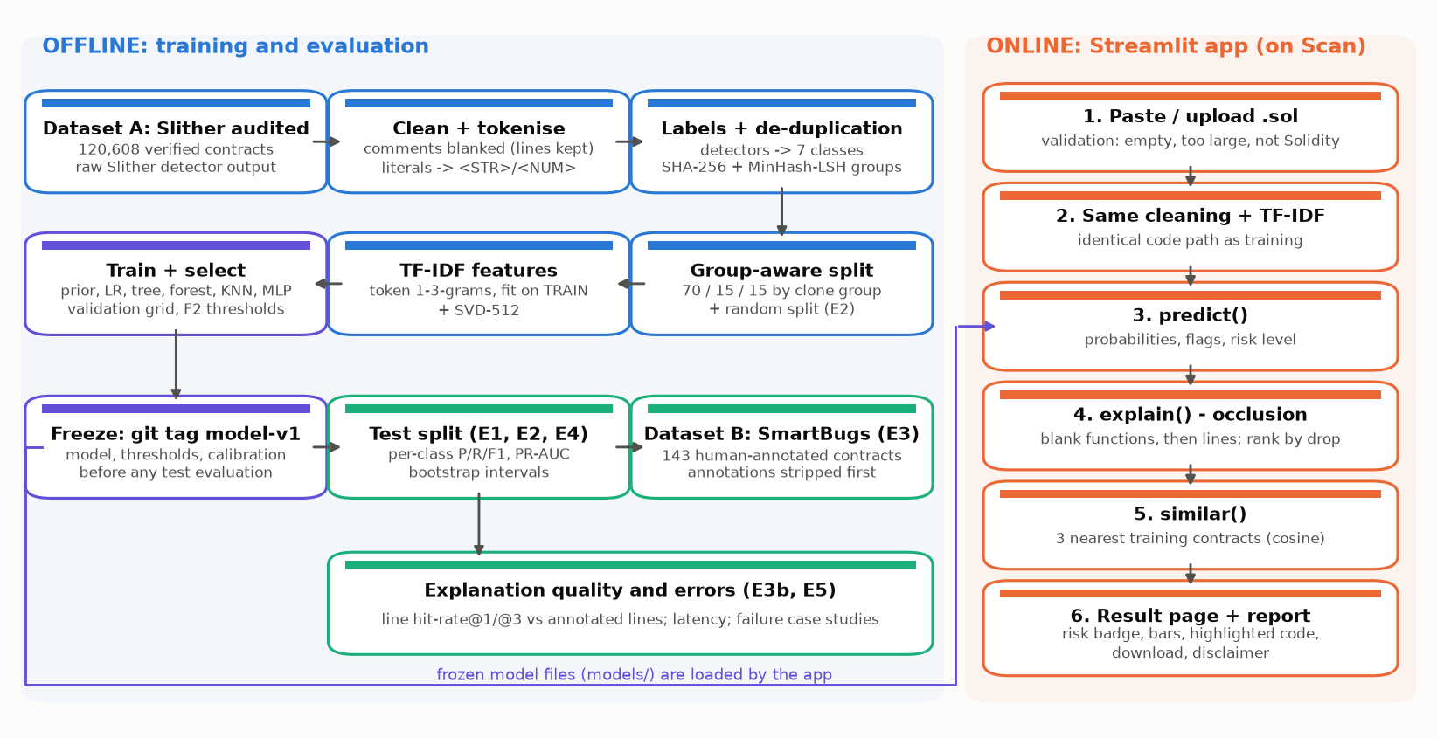
Figure 1: Muhafiz.sol pipeline (training, evaluation and application)

2.1 Components
Table 3: System components
Component | Responsibility | Code (src/ unless stated)
Data loader | Dataset A column-range download from the Hub; Dataset B cloned at a pinned commit | ingest_slither.py, build_gold.py
Preprocessor | Line-preserving comment removal, literal normalisation, tokenisation | preprocess.py
Labels | Detector -> family mapping, rare-class rule, SmartBugs mapping | labels.py
Splitter | SHA-256 exact groups, MinHash-LSH near-duplicate groups, stratified group split, random split | splits.py
Feature builder | TF-IDF 1-3-grams fitted on train only; SVD-512 | features.py
Models | Prior, logistic regression, decision tree, random forest, KNN, MLP (PyTorch) | models.py, train.py
Evaluator | Metrics, bootstrap intervals, thresholds, calibration, experiments E1-E5 | evaluate.py, run_experiments.py, eval_explain.py
Predictor | predict() and similar() used by the app | predict.py
Explainer | Two-stage occlusion: functions, then lines | explain.py
Application | Input, scan, result page, metrics tab, batch scan, disclaimer | app/app.py, app/components.py

2.2 Interface contract between the phases
The interfaces of blueprint section 7.4 were fixed first so the three phases could proceed in parallel; the app was developed against a MockPredictor with the same output schema.
Table 4: Interface contract
Function | Input | Output
clean_source(text) | raw Solidity | same text with comments blanked, identical line count
tokenize(text) | cleaned text | list of tokens
predict(source) | raw Solidity | probability and flag per class, risk_level, latency_ms (+ warnings, truncation flag)
explain(source, class, top_k) | raw Solidity, class, k | list of {line, score, text, function}
similar(source, k) | raw Solidity, k | training contracts with labels, similarity and Etherscan link

2.3 Experimental protocol
- Build the data pack once (python -m src.build_data); the TF-IDF vocabulary, IDF weights and SVD are fitted on the training split only.
- Tune every model family on the validation split only (python -m src.train).
- Choose per-class thresholds (F2 with a precision guard) and the calibration on validation data.
- Freeze the model, thresholds and calibration and mark the freeze with the git tag model-v1.
- Only then evaluate on the test split and on SmartBugs; python -m src.run_experiments refuses to run otherwise.

3. Dataset Description

3.1 Dataset A: Slither Audited Smart Contracts (training)
Table 5: Dataset A
Item | Details
Source | huggingface.co/datasets/mwritescode/slither-audited-smart-contracts (raw shards and split files)
Creator | Rossini, M. (2022), University of Bologna course project
Construction | Verified Ethereum contracts (Smart Contract Sanctuary / Etherscan), flattened and analysed with Slither (38 detectors)
Licence | MIT for the repository; contracts keep their original licences; academic, non-commercial use
Features used | source_code (input); raw Slither detector list (target). Bytecode is not downloaded.
Size | 120,608 contracts; 65,058 unique after exact de-duplication
Target | multi-label, 7 families: access-control, arithmetic, bad-randomness, locked-ether, other, reentrancy, unchecked-calls

Acquisition. The Hub repository uses a loading script that recent versions of the datasets library no longer execute, and its automatic parquet export is marked partial. We therefore read the nine raw shards directly, fetching only the byte ranges of the address, source and Slither-result columns (the unused bytecode column is 44 % of every shard). Keeping the raw Slither JSON let us re-derive every label instead of trusting the pre-collapsed integer ids.

3.2 Label semantics: what does label 4 mean?
Table 6: Upstream integer ids re-created from the raw Slither output (label-4 audit)
config | contracts | id4_name | id4_share | id4_with_other_ids_share | max_id_seen | safe_id
big | 106,474 | safe | 0.339 | 0.000 | 5 | 4
small | 14,134 | safe | 0.212 | 0.000 | 8 | 4
all | 120,608 | divide-before-multiply | 0.166 | 0.137 | 38 | 38

The loading script uses a different list of class names for each configuration. In big and small, id 4 is safe and never appears together with another id. In all - the configuration the dataset viewer shows by default - id 4 is the divide-before-multiply detector and safe is id 38. The blueprint's two observations ("4 means safe" and "4 appears with other ids up to 38") are therefore both true, but about different configurations. Safe is not used as a class: a contract has no flagged weakness when every class is below its threshold. We also checked for failed Slither runs, which the loader would silently label safe: none of the 120,608 runs failed.
The audit also showed that every contract with a locked-ether, bad-randomness or double-spending finding is in the small configuration and none is in big. Training on big alone would have made the SmartBugs Bad Randomness category impossible to evaluate, so all contracts are used with our own split. One upstream mapping was corrected: unchecked-send (an ignored send() result, SWC-104) is moved from locked-ether to unchecked-calls. Full reasoning is in docs/label_decision.md.
Table 7: Label families in the de-duplicated pool; rare-class rule: >= 1 % prevalence and >= 300 training positives
family | positives | prevalence | kept_as_class
unchecked-calls | 31,144 | 0.4787 | yes
other | 22,446 | 0.3450 | yes
reentrancy | 18,710 | 0.2876 | yes
safe | 17,900 | 0.2751 | no
arithmetic | 12,453 | 0.1914 | yes
access-control | 9,654 | 0.1484 | yes
locked-ether | 3,287 | 0.0505 | yes
bad-randomness | 2,503 | 0.0385 | yes
double-spending | 368 | 0.0057 | no

3.3 Dataset B: SmartBugs Curated (external test only)
SmartBugs Curated (github.com/smartbugs/smartbugs-curated, pinned at commit 230e649, Apache-2.0) groups vulnerable contracts by the DASP taxonomy and annotates each vulnerable line. Our own count is 143 contracts, 207 annotated vulnerabilities and 222 distinct annotated lines. It is used only for testing. All comments - including the @vulnerable_at_lines header and the // <yes> <report> markers - are removed with the line-preserving cleaner before any model sees a contract, and the build fails if any marker survives.
Table 8: SmartBugs Curated - our counts per category
category | contracts | annotated_vulnerabilities | annotated_lines
access_control | 18 | 21 | 24
arithmetic | 15 | 23 | 23
bad_randomness | 8 | 31 | 34
denial_of_service | 6 | 7 | 14
front_running | 4 | 7 | 7
other | 3 | 3 | 5
reentrancy | 31 | 32 | 32
short_addresses | 1 | 1 | 1
time_manipulation | 5 | 7 | 7
unchecked_low_level_calls | 52 | 75 | 75
TOTAL | 143 | 207 | 222

Table 9: Class mapping between the datasets (only confirmed pairs are headline results)
SmartBugs category | Our class | Status | Reason
reentrancy | reentrancy | confirmed | Slither reentrancy-eth / reentrancy-no-eth detect the same pattern.
unchecked_low_level_calls | unchecked-calls | confirmed | unchecked-lowlevel and unchecked-send detect ignored call/send results.
bad_randomness | bad-randomness | confirmed | weak-prng flags randomness derived from block variables.
access_control | access-control | partial | suicidal / tx-origin / arbitrary-send cover only part of SmartBugs access control (e.g. wrong constructor names are not detected by any training label).
arithmetic | - | not evaluated | Training label 'arithmetic' is divide-before-multiply only; SmartBugs means integer overflow.
denial_of_service | - | not evaluated | No Slither label in the dataset detects DoS.
front_running | - | not evaluated | No Slither label in the dataset detects front running.
time_manipulation | - | not evaluated | Slither's 'timestamp' detector is not among the 38 dataset labels.
short_addresses | - | not evaluated | No corresponding label.
other | - | not evaluated | Heterogeneous category.

3.4 Preprocessing
- Line-preserving comment removal: a state machine (normal, string, line comment, block comment) replaces comment characters by spaces and keeps every newline, so line numbers stay valid for highlighting and the SmartBugs annotations disappear without moving the annotated lines.
- Literal normalisation: strings become <STR>, numbers and hex literals <NUM>. User identifiers are kept for the model; replacing them by <ID> is tested as an ablation (E4) and used for clone detection.
- Tokenisation with a regular expression that keeps keywords, operators and identifiers and treats msg.sender, tx.origin, block.timestamp and similar globals as single tokens.
- Long-file policy: at most 20,000 tokens; longer flattened files keep their first quarter and the end, where the main contract sits; the app warns when this happens.
- Exact and near-duplicate grouping and a group-aware split (section 3.5).
- TF-IDF over token 1-3-grams with a vocabulary of 20,000 n-grams chosen on a seeded subset of training contracts; IDF and SVD fitted on the training split only.
367 contracts (0.6%) exceed the token budget and are truncated.
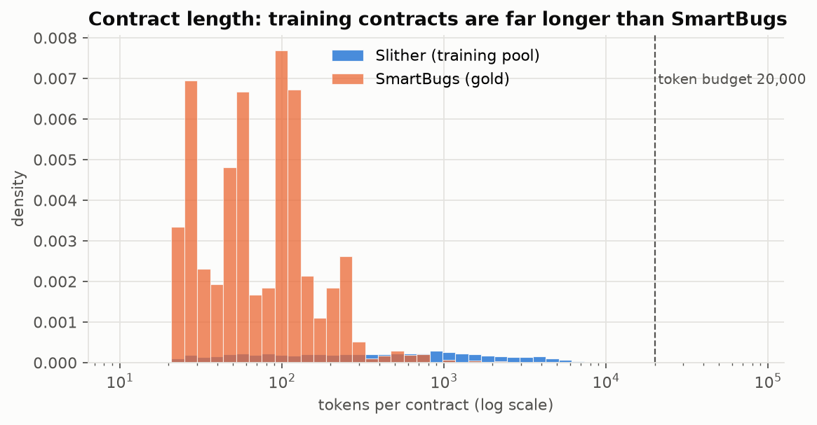
Figure 2: Contract length in tokens: training contracts are far longer than SmartBugs

3.5 De-duplication and group-aware splits
Etherscan contains many copies of the same token and library code. Hashing the normalised token string (identifiers anonymised) removed 55,452 exact or renamed duplicates (46.0 %). MinHash signatures of token 5-gram shingles with locality-sensitive hashing found 1,192,678 near-duplicate pairs (estimated Jaccard similarity >= 0.8) among the remaining contracts; their connected components form 31,186 clone groups (largest: 5,319 contracts). Whole groups were assigned to train / validation / test (45,540 / 9,759 / 9,759) with greedy multi-label stratification so that every class has positives in every split. Under a random split of the same sizes, 58.5% of validation and test contracts would have a clone in the training data; under our split the figure is 0.0%.
A by-product is a direct measurement of label noise: 56 groups of identical (normalised) code carry different Slither labels.
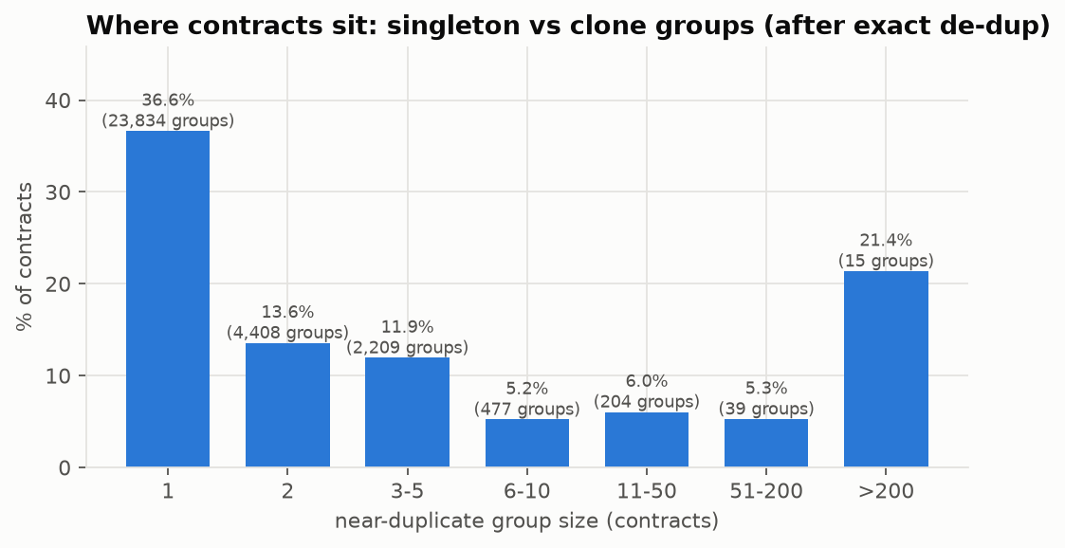
Figure 3: Contracts by clone-group size after exact de-duplication
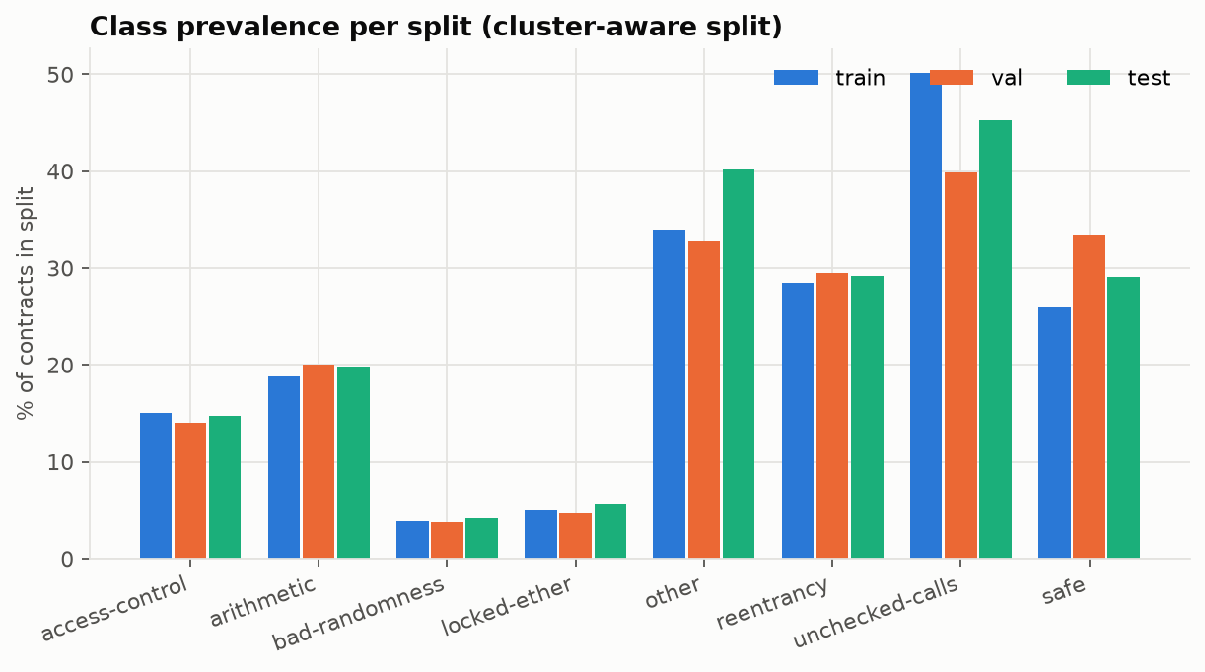
Figure 4: Class prevalence per split (cluster-aware split)
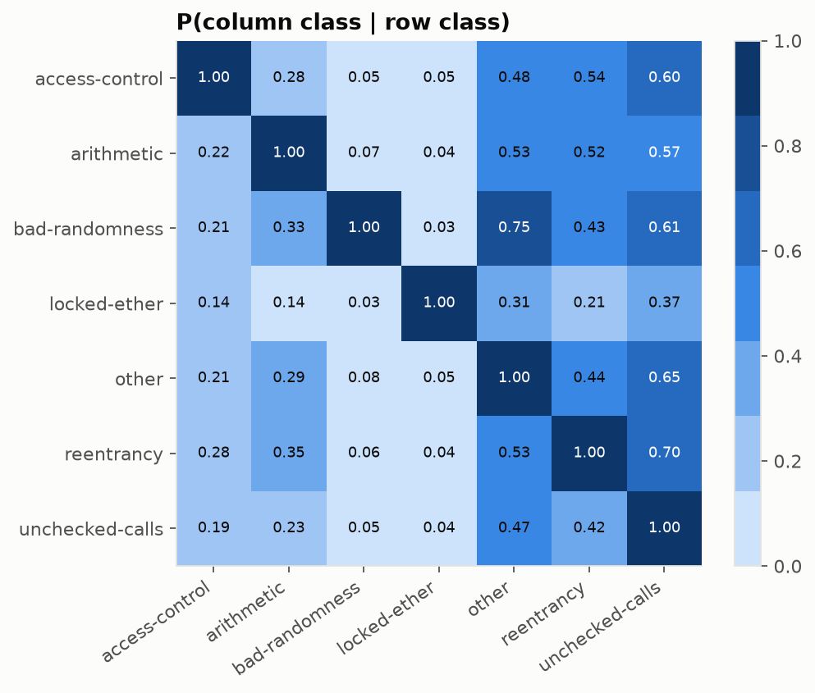
Figure 5: Label co-occurrence: probability of the column class given the row class
Weakness families often occur together: most reentrancy contracts also carry an unchecked-calls finding (Figure 5). This is why the task is multi-label, with one independent probability per class, rather than picking a single class per contract.
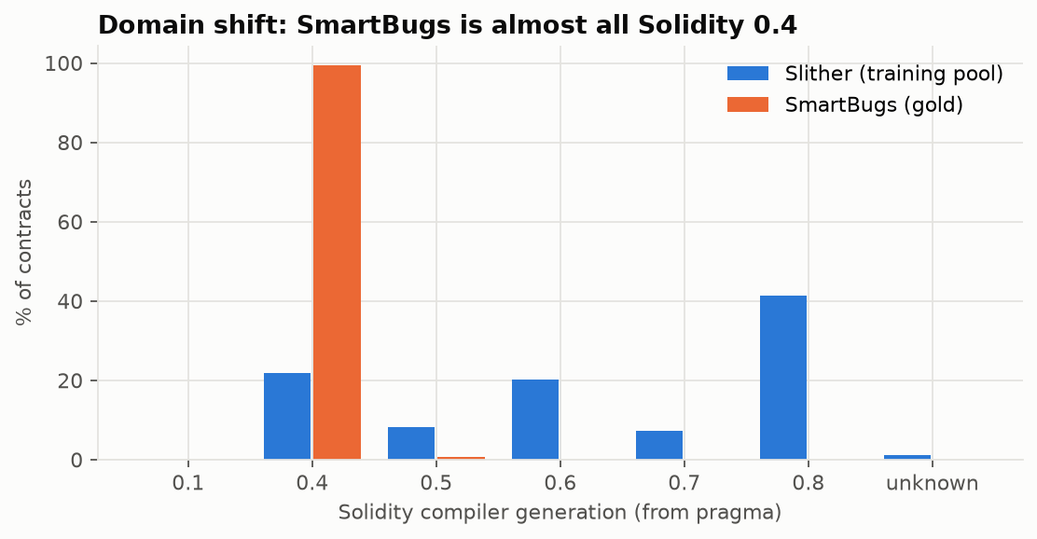
Figure 6: Compiler generation: training pool vs SmartBugs (domain shift)

3.6 Data limitations
- Weak labels: targets are Slither findings, not expert judgements; in-distribution scores measure agreement with Slither.
- Clone leakage: handled by grouping and measured explicitly (E2).
- Domain shift: SmartBugs contracts are small and almost all Solidity 0.4; training contracts are long, real deployments.
- No clean SmartBugs contracts: only recall can be measured there; false-positive rates come from the test split.
- Unmapped categories: Arithmetic (overflow), DoS, Front Running, Time Manipulation and Short Addresses have no training label.

4. Algorithm Description and Justification

4.1 Task formulation
The task is multi-label classification: a contract can contain several weaknesses at once, so the model outputs one probability per class (access-control, arithmetic, bad-randomness, locked-ether, other, reentrancy, unchecked-calls). Input x is the TF-IDF vector of the cleaned contract's token 1-3-grams; output is p(class | x) for every class; a per-class threshold turns probabilities into flags, and an overall risk level is derived from the same outputs. This directly supports the user's decision: deploy, fix the flagged functions first, or send the contract for a full audit.

4.2 Models compared and why
Table 10: Model families
Model | How it works here | Why it is appropriate
Majority / prior baseline | predicts each class's training prevalence | shows what scores mean under imbalance (floor)
Logistic regression (one-vs-rest) | linear model per class on TF-IDF, balanced class weights | strong, fast text baseline; coefficients are interpretable
Decision tree | multi-output tree, class-weighted | course model; captures keyword combinations
Random forest | bagged trees, balanced_subsample weights | course model; non-linear, robust
K-nearest neighbours | cosine similarity on SVD-512, similarity-weighted votes | course model; also powers 'similar contracts'
MLP neural network | TF-IDF -> 512 -> 128 -> 7, ReLU, dropout 0.3, sigmoid outputs | learns non-linear token interactions and shared structure across classes

4.3 How the MLP learns (forward pass, loss, backpropagation)
Forward pass. The TF-IDF vector x (20,000 numbers) is multiplied by a weight matrix W1 and shifted by a bias b1, giving 512 numbers; the ReLU activation keeps the positive ones (h1 = max(0, W1x + b1)). During training, dropout randomly switches off 30 % of these units so the network cannot rely on any single token pattern. A second layer produces 128 numbers the same way, and the output layer produces 7 scores z; the sigmoid function turns each score into a probability p = 1 / (1 + e^-z). Because each class has its own sigmoid (not one softmax), several classes can be likely at once.
Loss. For each contract and class the binary cross-entropy is -[y log p + (1 - y) log(1 - p)]: small when the probability agrees with the label, large when it confidently disagrees. Rare classes would be ignored if every mistake cost the same, so the loss on positive examples of class c is multiplied by (negatives / positives) for that class, capped at 50.
Backpropagation and optimisation. Automatic differentiation applies the chain rule from the loss back through the output layer, the ReLUs and the hidden layers, giving the gradient of the loss with respect to every weight. Adam (learning rate 0.001, weight decay 1e-05) moves each weight a small step against its gradient, using running averages of past gradients to adapt the step size per weight. One epoch is one pass over the 45,540 training contracts in mini-batches of 256. After each epoch the validation macro PR-AUC is measured; training stops when it has not improved for 4 epochs and the best weights are restored (early stopping). The network is trained with three seeds to show how much the result depends on random initialisation.
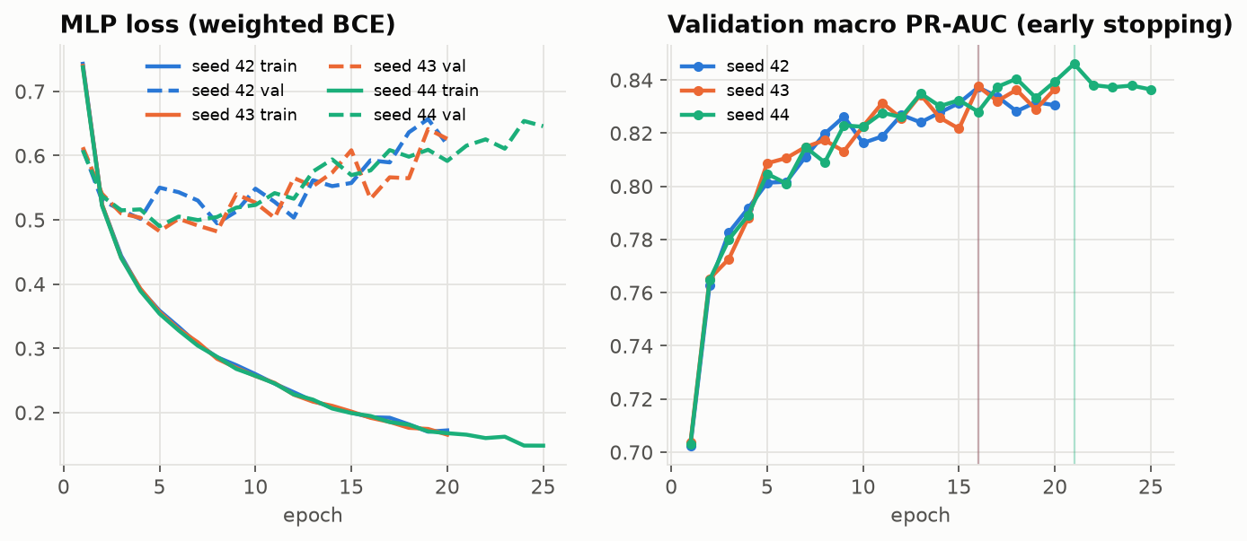
Figure 7: MLP learning curves (loss and validation macro PR-AUC per epoch)

4.4 Training protocol
- Imbalance: balanced class weights (LR, tree, forest) and per-class positive weights in the MLP loss.
- Tuning: a small grid per family scored by macro PR-AUC on the validation split only (reports/tables/validation_grid.csv). The test split and SmartBugs were never used for tuning. The first full run crashed while saving (out of memory) after every model had been fitted; the saved winning logistic regression and decision tree were reused and the scores of their losing grid settings come from that run's log (column 'source'); every other model was re-fitted with checkpoints, so a crash can no longer lose finished work.
- MLP input: sparse TF-IDF and the SVD-512 representation were compared on validation; the better one was kept.
- Seeds: seed 42 everywhere; the MLP is trained with seeds 42, 43 and 44 and the spread is reported.
- Freeze: model, thresholds and calibration are written to models/ and tagged model-v1 in git before any test or SmartBugs evaluation; the evaluation script refuses to run otherwise.
Table 11: Model selection on the validation split (primary = highest validation macro PR-AUC; fit times are wall-clock on one laptop CPU shared by several jobs)
model | val_macro_pr_auc | val_macro_f2 | ece_before | ece_after | calibrated | fit_minutes | size_mb
MLP neural network | 0.846 | 0.816 | 0.047 | 0.047 | no | 134.7 | 18.3
Logistic regression | 0.812 | 0.812 | 0.073 | 0.013 | yes | 2.4 | 0.9
Random forest | 0.771 | 0.762 | 0.056 | 0.012 | yes | 89.6 | 215.1
K-nearest neighbours | 0.615 | 0.651 | 0.041 | 0.041 | no | 0.0 | 87.2
Decision tree | 0.514 | 0.644 | 0.153 | 0.032 | yes | 20.2 | 0.3
Majority / prior baseline | 0.207 | 0.503 | 0.021 | 0.021 | no | 0.0 | 0.0

The MLP neural network has the highest validation macro PR-AUC (0.846) and is the primary model. Logistic regression is also shipped in the app so users can compare a simple, interpretable model with the primary one (feature F12).

4.5 Decision thresholds, calibration and risk level
A missed vulnerability costs more than an extra warning, so each class's threshold maximises F2 on the validation split (recall counts four times as much as precision), subject to a minimum precision of 0.2 so the tool does not flag almost everything. Reliability curves showed that class-weighted training inflates probabilities, so Platt scaling (a one-feature logistic regression on the model's log-odds, fitted per class on the validation split) was applied whenever the expected calibration error exceeded 0.05; it changes the displayed probabilities but not the ranking.
Risk level (shown in the app with its rule): low if no class reaches its threshold; medium if at least one does; high if at least one class reaches the stricter level t + 0.25 x (1 - t), i.e. a quarter of the way from its threshold to certainty.
Table 12: Frozen thresholds of the primary model (validation values)
class | threshold | precision | recall | F2 (val) | guard_met
access-control | 0.419 | 0.599 | 0.772 | 0.730 | yes
arithmetic | 0.311 | 0.691 | 0.860 | 0.820 | yes
bad-randomness | 0.276 | 0.761 | 0.870 | 0.846 | yes
locked-ether | 0.306 | 0.511 | 0.779 | 0.705 | yes
other | 0.092 | 0.627 | 0.915 | 0.838 | yes
reentrancy | 0.248 | 0.653 | 0.936 | 0.862 | yes
unchecked-calls | 0.107 | 0.776 | 0.949 | 0.908 | yes

5. Experiments, Results and Interpretation
All numbers in this chapter were produced after the model-v1 freeze by python -m src.run_experiments and python -m src.eval_explain; the CSV files in reports/tables are the single source for this report, the slides and the app. Intervals are 95 % percentile bootstrap intervals over contracts.

5.1 E1 - Model comparison on the cluster-aware test split
Table 13: E1: all models on the held-out test split (frozen thresholds)
model | macro PR-AUC | 95% CI | macro F1 | F1 95% CI | macro recall | macro precision | micro F1 | Hamming loss | label accuracy
Majority / prior baseline | 0.227 | [0.222, 0.231] | 0.346 | [0.340, 0.350] | 1.000 | 0.227 | 0.370 | 0.773 | 0.227
Logistic regression | 0.837 | [0.828, 0.847] | 0.737 | [0.729, 0.744] | 0.905 | 0.630 | 0.757 | 0.136 | 0.864
Decision tree | 0.584 | [0.570, 0.597] | 0.509 | [0.500, 0.519] | 0.838 | 0.371 | 0.568 | 0.315 | 0.685
Random forest | 0.820 | [0.811, 0.828] | 0.680 | [0.671, 0.688] | 0.870 | 0.566 | 0.720 | 0.162 | 0.838
K-nearest neighbours | 0.697 | [0.685, 0.707] | 0.587 | [0.578, 0.594] | 0.788 | 0.469 | 0.644 | 0.216 | 0.784
MLP neural network | 0.862 | [0.855, 0.871] | 0.758 | [0.750, 0.765] | 0.880 | 0.669 | 0.776 | 0.119 | 0.881

Interpretation. The MLP neural network ranks first on macro PR-AUC (0.862, [0.855, 0.871]), followed by the logistic regression (0.837). The prior baseline scores 0.227 - simply the average class prevalence - yet its label accuracy is 0.227, which shows why accuracy is not our headline metric: predicting nothing already looks good when most labels are 0. The MLP beats logistic regression by 0.026 macro PR-AUC, so non-linear combinations of token patterns carry extra signal. What the table does not show: these labels are Slither's, so a high score means close agreement with Slither, not proof of security - that is what E3 tests.
Table 14: E1: per-class results of the primary model (MLP neural network) on the test split
class | precision | recall | f1 | f2 | pr_auc | support | fpr | threshold
access-control | 0.621 | 0.813 | 0.704 | 0.765 | 0.756 | 1,437 | 0.086 | 0.419
arithmetic | 0.689 | 0.859 | 0.765 | 0.819 | 0.854 | 1,938 | 0.096 | 0.311
bad-randomness | 0.761 | 0.823 | 0.791 | 0.810 | 0.860 | 402 | 0.011 | 0.277
locked-ether | 0.575 | 0.859 | 0.689 | 0.782 | 0.827 | 553 | 0.038 | 0.306
other | 0.658 | 0.937 | 0.773 | 0.864 | 0.915 | 3,916 | 0.326 | 0.092
reentrancy | 0.592 | 0.915 | 0.719 | 0.825 | 0.862 | 2,853 | 0.260 | 0.248
unchecked-calls | 0.785 | 0.957 | 0.863 | 0.917 | 0.962 | 4,417 | 0.217 | 0.107

Per class, unchecked-calls is easiest (PR-AUC 0.962) and access-control hardest (0.756). Classes defined by a few distinctive tokens (e.g. block variables for bad randomness, low-level call syntax) are learned well; heterogeneous groups such as 'other' mix many unrelated detectors and are harder.
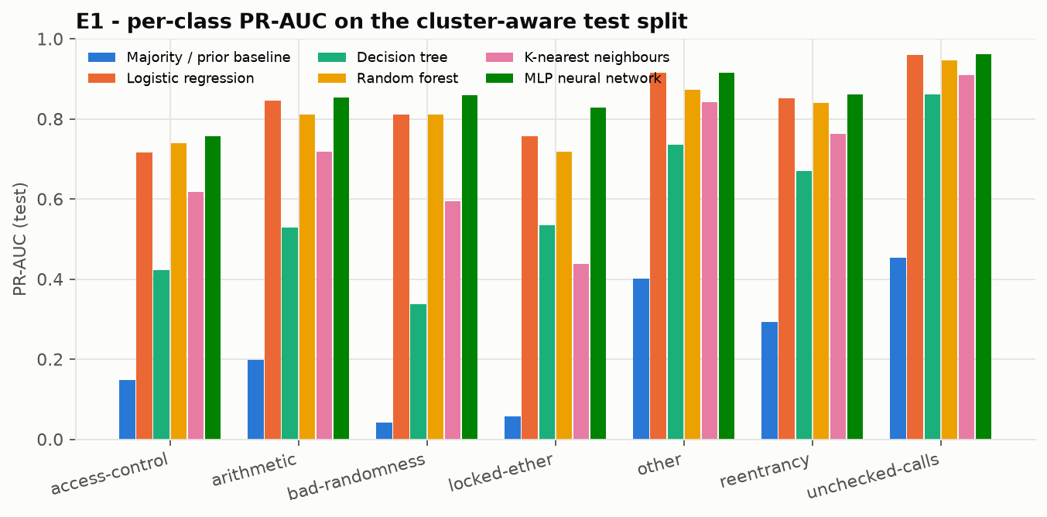
Figure 8: E1: per-class PR-AUC of every model on the test split
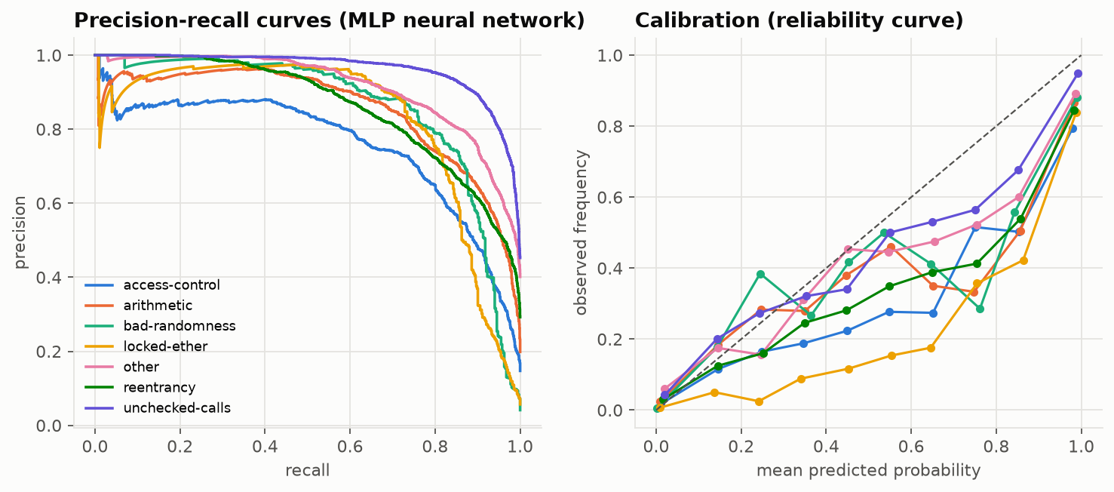
Figure 9: Primary model: precision-recall curves and calibration on the test split
Table 15: MLP seed stability on the test split (acceptance test B5)
seed | input | test_macro_pr_auc | test_macro_f1 | test_macro_f2
42 | tfidf | 0.858 | 0.746 | 0.831
43 | tfidf | 0.858 | 0.742 | 0.830
44 | tfidf | 0.862 | 0.758 | 0.826
mean | - | 0.860 | 0.749 | 0.829
std | - | 0.002 | 0.006 | 0.002

The standard deviation across seeds is 0.0019 macro PR-AUC, far smaller than the gaps between model families, so the ranking does not depend on the seed.

5.2 E2 - How much does clone leakage inflate scores?
Table 16: E2: the same configurations on a random split vs the cluster-aware split
model | cluster_test_macro_pr_auc | random_test_macro_pr_auc | pr_auc_inflation | cluster_test_macro_f1 | random_test_macro_f1 | f1_inflation
Majority / prior baseline | 0.227 | 0.221 | -0.006 | 0.346 | 0.338 | -0.009
Logistic regression | 0.837 | 0.871 | 0.034 | 0.737 | 0.777 | 0.040
Decision tree | 0.584 | 0.686 | 0.102 | 0.509 | 0.598 | 0.088
Random forest | 0.820 | 0.909 | 0.090 | 0.680 | 0.784 | 0.105
K-nearest neighbours | 0.697 | 0.766 | 0.068 | 0.587 | 0.643 | 0.057
MLP neural network | 0.862 | 0.908 | 0.046 | 0.758 | 0.813 | 0.056

Interpretation. Under a random split 58.5% of test contracts have a near-duplicate in training. Every learned model scores higher there - on average +0.068 macro PR-AUC - and the nearest-neighbour model, which can simply look up the clone, gains most (+0.068). A random split would therefore have overstated how well the tool generalises to genuinely new contracts. Note that exact duplicates were removed from both pools, so this is a lower bound on the inflation of a completely naive pipeline.
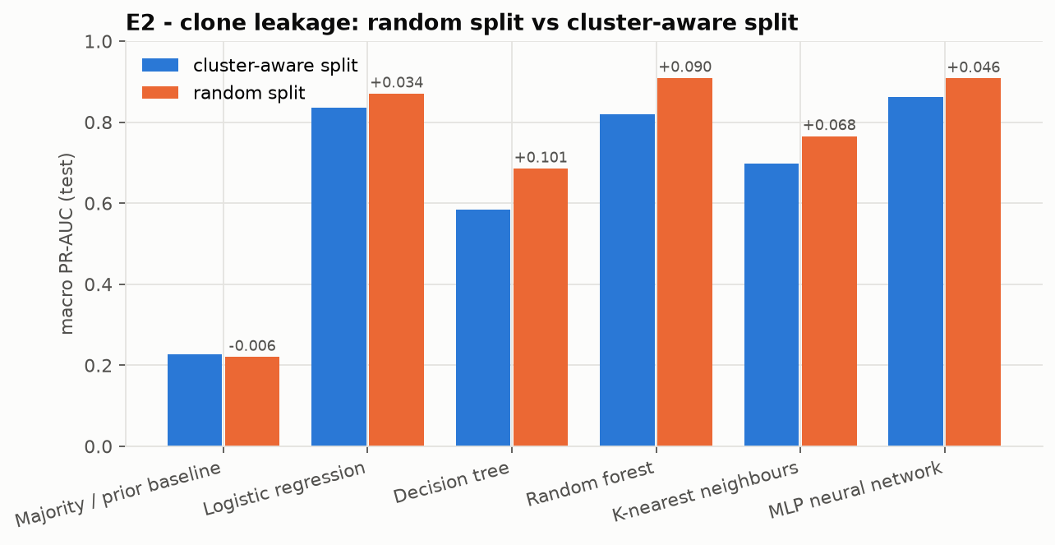
Figure 10: E2: macro PR-AUC on random vs cluster-aware test splits

5.3 E3 - Independent test on SmartBugs Curated
Table 17: E3: recall of the primary model per SmartBugs category (95 % bootstrap CI)
smartbugs_category | mapped_class | status | contracts | recall | ci_low | ci_high | mean_probability
unchecked_low_level_calls | unchecked-calls | confirmed | 52 | 0.481 | 0.346 | 0.615 | 0.349
reentrancy | reentrancy | confirmed | 31 | 0.871 | 0.742 | 0.968 | 0.824
bad_randomness | bad-randomness | confirmed | 8 | 0.625 | 0.372 | 0.875 | 0.536
access_control | access-control | partial | 18 | 0.611 | 0.389 | 0.833 | 0.561
arithmetic | - | not evaluated | 15 | - | - | - | -
denial_of_service | - | not evaluated | 6 | - | - | - | -
time_manipulation | - | not evaluated | 5 | - | - | - | -
front_running | - | not evaluated | 4 | - | - | - | -
other | - | not evaluated | 3 | - | - | - | -
short_addresses | - | not evaluated | 1 | - | - | - | -

Interpretation. SmartBugs contracts were annotated by people, not by Slither, so this is the honest test of usefulness. Over the confirmed categories the primary model flags 62.6% of the vulnerable contracts. unchecked low level calls: 48.1% [35%-62%] of 52. reentrancy: 87.1% [74%-97%] of 31. bad randomness: 62.5% [37%-88%] of 8. The intervals are wide because the categories are small (blueprint risk R3). Recall is lower than on the in-distribution test split because SmartBugs contracts are tiny Solidity 0.4 teaching examples, very unlike the long deployed contracts the model learned from (domain shift), and because Slither itself - the source of our labels - misses some of these bugs. Categories without a training label are listed as not evaluated rather than forced into a mapping.
Table 18: E3: SmartBugs recall (confirmed categories, pooled) and false alarms on clean test contracts
model | smartbugs_pooled_recall_confirmed | false_alarm_rate_on_clean_test | macro_fpr_test
Majority / prior baseline | 1.000 | 1.000 | 1.000
Logistic regression | 0.516 | 0.320 | 0.173
Decision tree | 0.593 | 0.720 | 0.421
Random forest | 0.429 | 0.373 | 0.206
K-nearest neighbours | 0.648 | 0.690 | 0.271
MLP neural network | 0.626 | 0.288 | 0.148

SmartBugs has no clean contracts, so false alarms are measured on the 2,834 test contracts in which Slither found nothing: the primary model raises at least one flag on 28.8% of them. This is the cost of recall-favouring (F2) thresholds; the sensitivity slider in the app lets a user trade some recall for fewer alarms.

5.4 E4 - Ablations
Table 19: E4: ablations with logistic regression (retrained per setting; thresholds from validation)
ablation | setting | test_macro_pr_auc | test_macro_f1 | smartbugs_recall_confirmed
reference | comments stripped, identifiers kept, n-grams 1-3 | 0.837 | 0.737 | 0.516
comments | comments KEPT on SmartBugs (annotations visible) | 0.837 | 0.737 | 0.560
identifiers | user identifiers -> <ID> | 0.859 | 0.751 | 0.494
ngrams | n-grams 1-2 | 0.843 | 0.736 | 0.692
ngrams | n-grams 1-1 (bag of tokens) | 0.818 | 0.699 | 0.604

Interpretation. (a) Keeping comments on SmartBugs changes recall from 51.6% to 56.0%: the annotation words are mostly outside the training vocabulary, so the leak is small here, but stripping them is still required - a model trained with comments could learn them. (b) Replacing user identifiers by <ID> gives test macro PR-AUC 0.859 vs 0.837 and SmartBugs recall 49.5%: anonymised identifiers generalise at least as well. (c) Shorter n-grams score n-grams 1-2: 0.843, n-grams 1-1 (bag of tokens): 0.818 vs 1-3-grams 0.837, so short token sequences (e.g. '. call . value') add information beyond single tokens.

6. Implementation Details

6.1 Code structure
The repository follows blueprint section 7.3. Every script reads its paths, seeds and hyper-parameters from config.yaml, so nothing is hard-coded. Large data files are rebuilt by one command and are not committed; the frozen model files are committed so the app runs from a fresh clone.
Table 20: One-command entry points
Command | What it does
python -m src.build_data | Phase 1: download, gold set, tokens, de-duplication, splits, TF-IDF, EDA
python -m src.train | Phase 2: validation grid, thresholds, calibration, freeze to models/
git tag model-v1 | freeze marker checked by the evaluation scripts
python -m src.run_experiments | E1-E4 tables and figures
python -m src.eval_explain | E3b and E5
python -m src.make_report | this report, the slides and the model / data cards
streamlit run app/app.py | the application
pytest | unit, acceptance and integration tests

6.2 Preprocessing implementation
clean_source is a state machine with four states (normal, string, line comment, block comment). Instead of stepping through one character at a time in Python it jumps between the characters that can change state using pre-compiled regular expressions, which made it about fifty times faster on the million-character flattened contracts of Dataset A while keeping exactly the same semantics. Comment characters become spaces and every newline is kept, so both line and column positions survive. Edge cases covered by unit tests include comment markers inside strings, escaped quotes, unterminated strings and comments, Windows and old-Mac line endings, unicode and binary junk.

6.3 Explanation module (occlusion)
The explanation answers "which lines does this score depend on?". It is computed in two stages so it stays fast: (1) function-like blocks (function, modifier, constructor, fallback, receive) are found by brace matching on the cleaned code, and each block (up to 200) is removed in turn; (2) the single lines inside the 3 blocks with the largest probability drop - plus top-level lines - are removed one at a time (up to 120 lines). The score of a line is the drop in the class probability when that line is blanked; the top-k lines are highlighted.
Re-vectorising the whole contract for every removed line would be slow for long files. Because TF-IDF only counts n-grams of at most three tokens, removing a span S changes only the n-grams that touch S. With L and R the two tokens on either side of S, the counts without S are exactly counts(full) - counts(L+S+R) + counts(L+R). Only these tiny windows are vectorised, which is mathematically identical to re-vectorising (verified by an integration test) and makes line-level occlusion take well under a second. The module only needs the predictor's probability function, so it works with any of the models.

6.4 Streamlit application
The app (app/app.py) implements the layout of blueprint section 9.1 with four tabs. The sidebar holds the sample-contract selector, the model selector (the recommended model and logistic regression for comparison), the sensitivity slider and the model card. The scan tab takes pasted code or a .sol upload, validates it (empty, larger than 2 MB, too short, or not Solidity), and shows: a risk badge with an icon, a word and the rule in plain language (never colour alone); a probability bar per weakness type with its alert level marked; a plain-language explanation and typical fix for the selected type; the source code with line numbers and the top-k lines highlighted; a function-level view; three similar training contracts with Etherscan links; and Markdown / JSON report downloads. Further tabs show the evaluation tables (read from the same CSV files as this report), a batch scan that ranks several files by risk, and the limitations. The model loads once (st.cache_resource) and results survive interaction (st.session_state). The footer always shows the audit disclaimer.
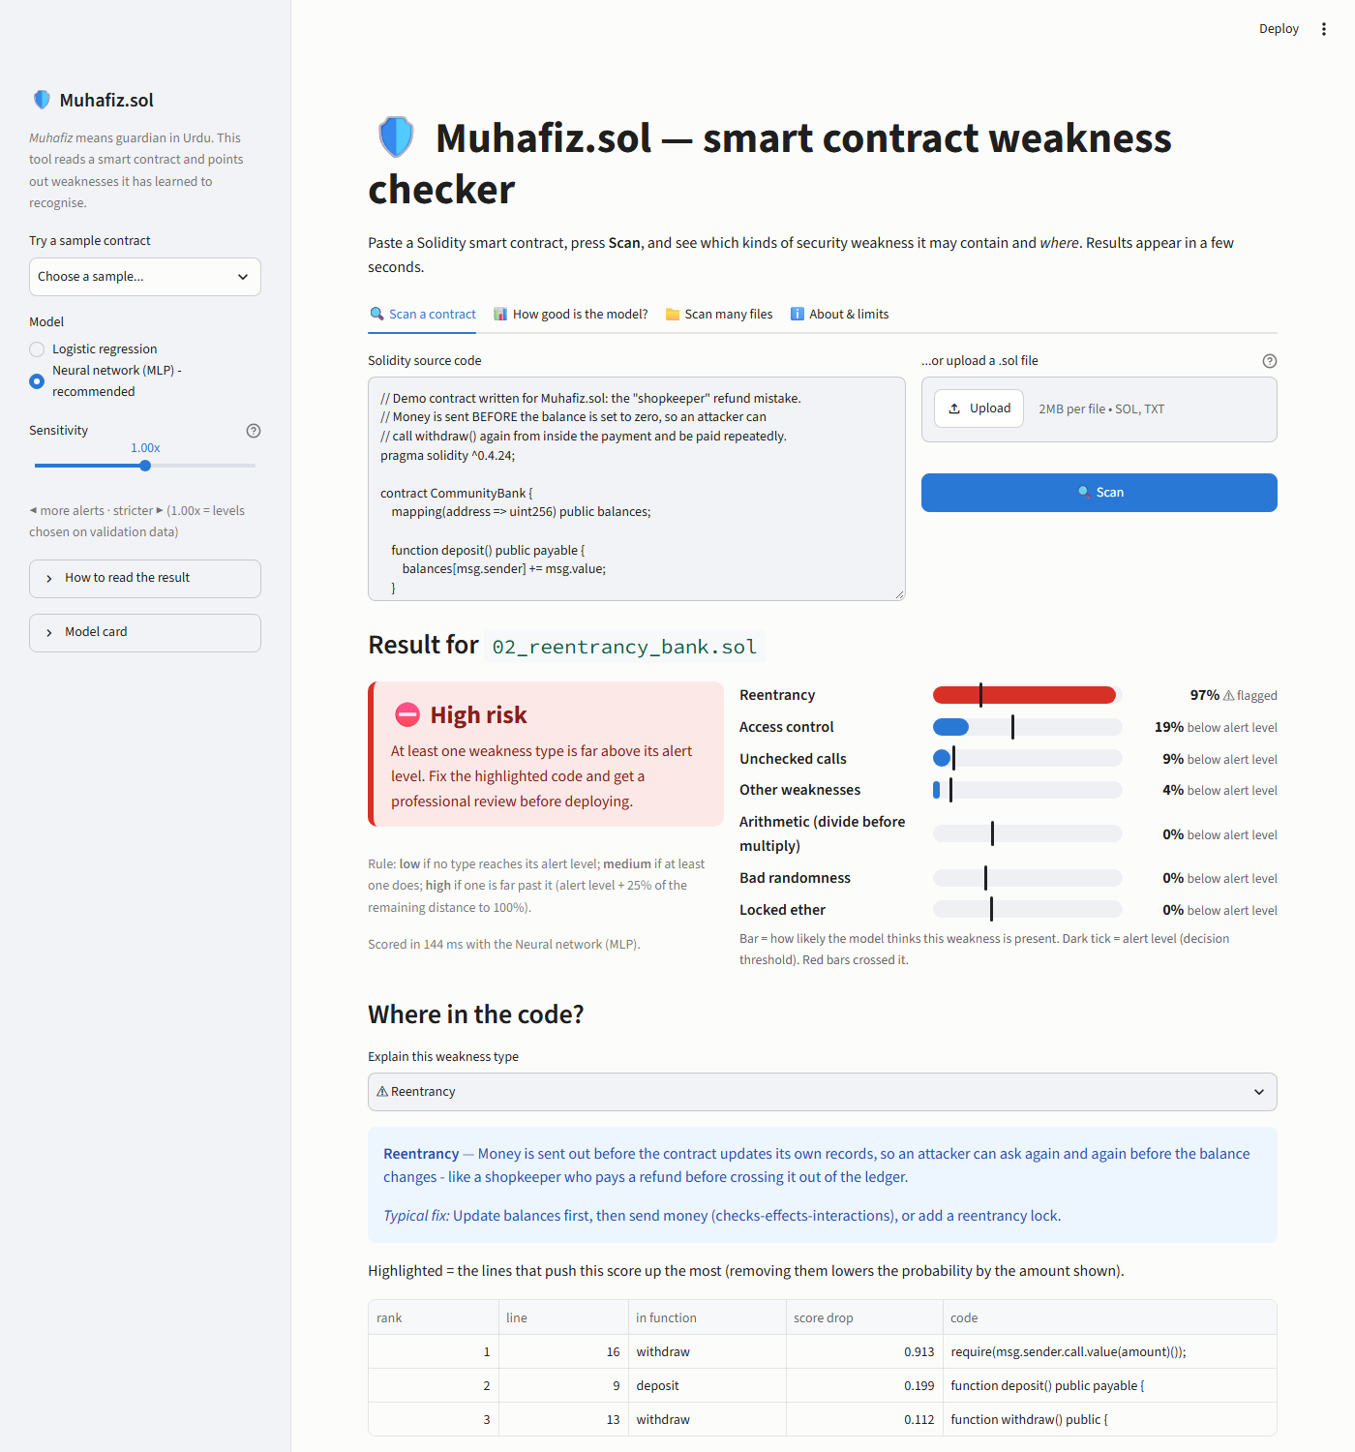
Figure 11: App screenshot: 1 reentrancy result
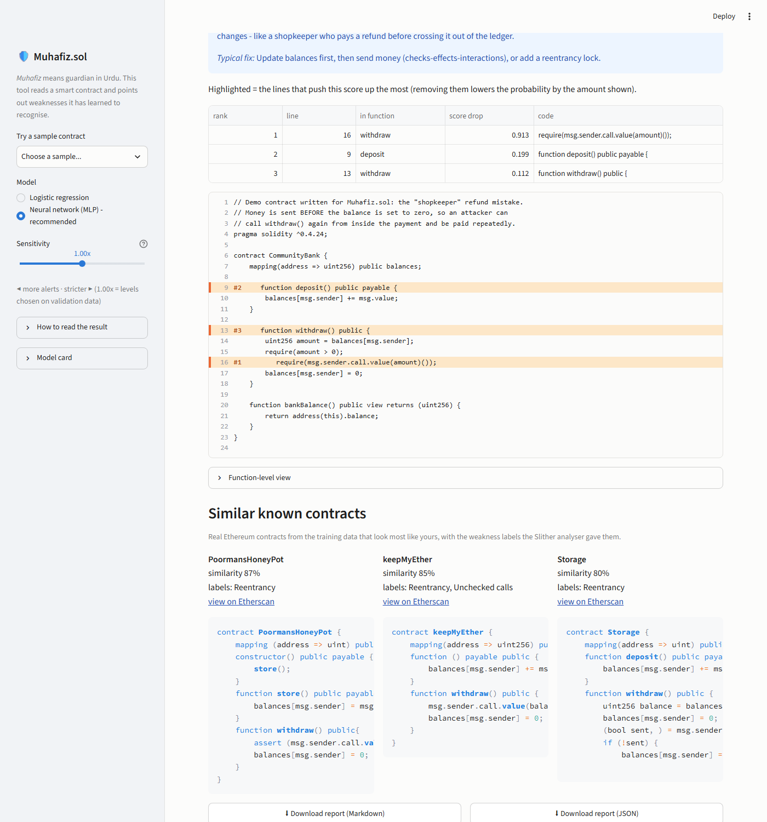
Figure 12: App screenshot: 2 highlighted code
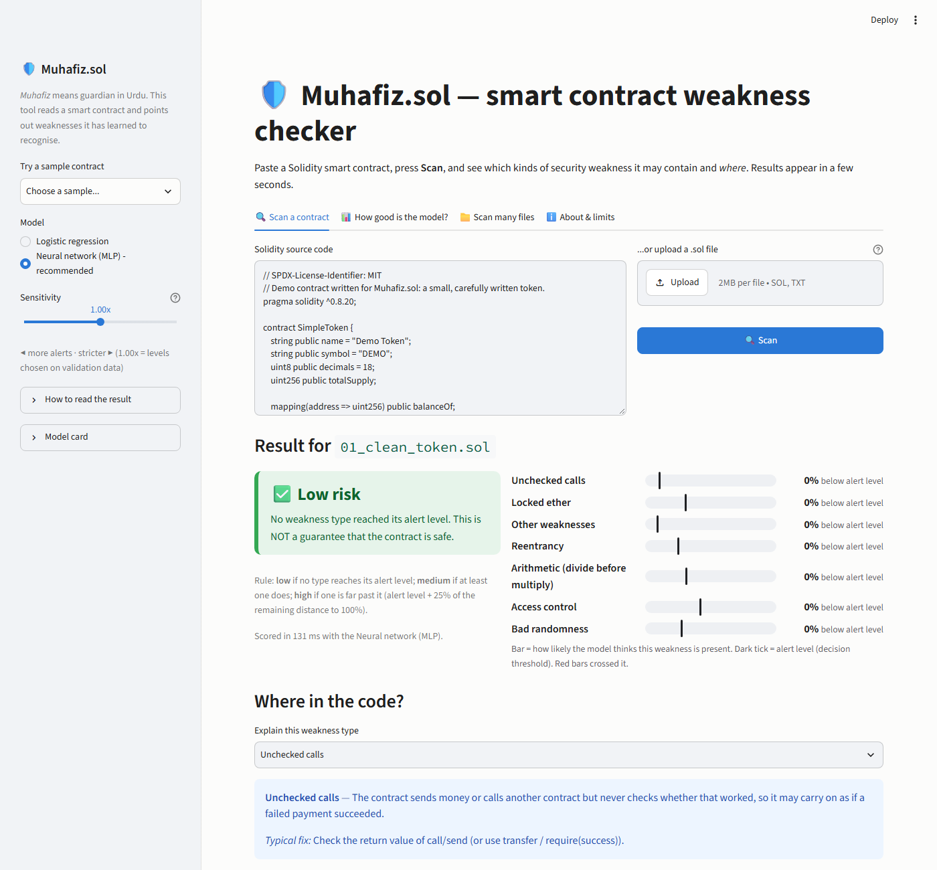
Figure 13: App screenshot: 3 clean token
Table 21: MoSCoW feature status
ID | Feature | Priority | Status
F1 | Paste or upload | Must | done
F2 | Six sample contracts | Must | done
F3 | Input validation | Must | done (fuzz-tested)
F4 | Class probabilities with threshold | Must | done
F5 | Risk level with rule | Must | done
F6 | Highlighted lines | Must | done
F7 | Metrics and limitations panel | Must | done (reads report tables)
F8 | One-command run | Must | done on the development laptop; other two laptops pending
F9 | Similar known contracts | Should | done
F10 | Sensitivity slider | Should | done (monotone, tested)
F11 | Download scan report | Should | done (Markdown and JSON)
F12 | Model comparison toggle | Should | done
F13 | Batch scan | Could | done
F14 | Function-level view | Could | done
F15 | Cloud deployment | Could | not done (needs the team's Streamlit Cloud account)
F16 | Exploits, auto-fix, address scanning, bytecode, Slither at runtime | Won't | excluded

7. Testing and Evaluation Evidence

7.1 Automated tests
The test suite (pytest) contains 101 tests: 101 passed, 0 failed, 0 skipped (run on 2026-11-08 13:31, 168 s). It covers unit tests of every module, the acceptance tests of all three phases on the real data and model, and integration tests of the app.
Table 22: Test files and results
file | passed | failed | covers
tests/test_build_helpers.py | 4 | 0 | test_main_contract_is_the_last_declared_contract, test_snippet_regex_is_linear_on_long_blank_runs, test_solidity_minor_parsing, test_split_hash_is_order_independent
tests/test_data_pack.py | 8 | 0 | test_a1_no_annotation_text_reaches_any_model_input, test_a2_no_group_in_two_splits, test_a3_line_count_preserved_on_1000_dataset_a_contracts, test_a4_split_is_reproducible ...
tests/test_environment.py | 3 | 0 | test_config_loads_with_required_sections, test_repository_structure_exists, test_requirements_are_pinned
tests/test_evaluate.py | 9 | 0 | test_confusion_counts_known_values, test_per_class_precision_recall_f1_f2, test_pr_auc_matches_hand_computation, test_summary_macro_micro_hamming ...
tests/test_explain.py | 3 | 0 | test_find_blocks_ignores_comments_and_bodiless_declarations, test_explain_points_at_the_call_line, test_explain_never_raises_on_odd_input
tests/test_features.py | 6 | 0 | test_analyzer_ngrams_and_ids, test_vocabulary_comes_from_train_only, test_transform_is_deterministic_and_l2_normalised, test_max_df_removes_ubiquitous_tokens ...
tests/test_freeze.py | 5 | 0 | test_b2_training_code_cannot_read_test_or_gold, test_b2_evaluation_refuses_without_tag, test_b2_tag_exists_and_thresholds_unchanged_since_freeze, test_b6_baselines_in_every_table ...
tests/test_gold.py | 4 | 0 | test_gold_counts_match_vulnerabilities_json, test_gold_required_columns, test_a1_no_annotation_leakage, test_annotated_lines_are_valid_and_line_count_preserved
tests/test_integration.py | 14 | 0 | test_six_real_contracts_give_sensible_output, test_edge_cases_give_clear_messages[-empty], test_edge_cases_give_clear_messages[ \n\t -empty], test_edge_cases_give_clear_messages[bad2-too large] ...
tests/test_models.py | 6 | 0 | test_models_learn_signal[model0], test_models_learn_signal[model1], test_models_learn_signal[model2], test_prior_baseline_is_constant ...
tests/test_preprocess.py | 31 | 0 | test_empty_input, test_line_comment_blanked_and_layout_kept, test_block_comment_blanked_and_layout_kept, test_comment_markers_inside_double_quoted_string_are_kept ...
tests/test_splits.py | 8 | 0 | test_union_find_components, test_shingles_short_and_long, test_renamed_copy_is_exact_duplicate, test_cluster_groups_exact_and_near_duplicates ...

7.2 Acceptance tests (blueprint 13.2, 14.2, 15.2)
Table 23: Acceptance tests and evidence
test | check | status | evidence
A1 | No annotation leakage | passed | test_data_pack::test_a1_no_annotation_text_reaches_any_model_input, test_gold::test_a1_no_annotation_leakage
A2 | No group leakage | passed | test_data_pack::test_a2_no_group_in_two_splits
A3 | Line preservation (1,000 random contracts) | passed | test_data_pack::test_a3_line_count_preserved_on_1000_dataset_a_contracts, test_preprocess::test_a3_line_count_invariant_on_random_inputs
A4 | Determinism (identical split hashes) | passed | test_data_pack::test_a4_split_is_reproducible
A5 | Class coverage in every split | passed | test_data_pack::test_a5_every_class_has_positives_in_every_split
A6 | One-command rebuild | passed | test_data_pack::test_a6_one_command_build_entry_point_exists (+ full run of python -m src.build_data)
B1 | Metric correctness on hand-made arrays | passed | test_evaluate (9 tests)
B2 | No test-set use in selection | see evidence | src/train.py refuses test/gold; run_experiments checks tag model-v1 (test_freeze::*)
B3 | Reproducibility | see evidence | fixed seeds; split hashes; test_freeze::test_logreg_retrain_reproduces_frozen_validation_score
B4 | Interface schema | passed | test_integration::test_six_real_contracts_give_sensible_output
B5 | Seed stability | see evidence | reports/tables/e1_mlp_seeds_test.csv (spread reported)
B6 | Honest baselines | passed | prior and logistic regression present in every result table (test_freeze::test_baselines_in_every_table)
C1 | One-command run | partly (team) | streamlit run app/app.py on the development laptop; other two laptops pending (team)
C2 | Ten fixed inputs | passed | test_integration (six contracts + four edge cases), table below
C3 | App output equals predict() | passed | test_integration::test_app_shows_exactly_the_predict_output
C4 | Explanation quality | see evidence | E3b hit-rate with intervals (reports/tables/e3b_hit_rate.csv)
C5 | Latency | see evidence | test_integration::test_latency_is_a_few_seconds; reports/tables/e5_latency.csv
C6 | Package runs on a clean machine | partly (team) | fresh venv install from requirements.txt + pytest (pending: zip on a second machine)

7.3 The ten fixed test inputs (C2)
Table 24: Ten fixed inputs: expected vs observed behaviour
input | expected | risk | flagged | highest
01_clean_token.sol | low risk or few flags (clean token) | low | - | unchecked-calls 0.00
02_reentrancy_bank.sol | reentrancy flagged | high | reentrancy | reentrancy 0.97
03_unchecked_send.sol | unchecked-calls flagged | high | access-control, reentrancy, unchecked-calls | unchecked-calls 1.00
04_weak_randomness_lottery.sol | bad-randomness flagged | high | access-control, bad-randomness, other | bad-randomness 1.00
05_tricky_safe_with_keywords.sol | lower reentrancy score than 02 (correct use of call) | low | - | reentrancy 0.01
06_tricky_renamed_reentrancy.sol | reentrancy flagged despite odd names | high | access-control, reentrancy | reentrancy 0.95
empty | clear message | - | - | message: The input is empty. Paste a Solidity contract or upload a .s
not Solidity | warning, no crash | low | - | warning: This does not look like Solidity (no 'contract', 'pragma' or
oversized | clear message | - | - | message: The input is too large (2,600,000 characters; limit 1,500,00
very short | clear message | - | - | message: The input is too short to analyse (fewer than 5 code tokens

7.4 E3b - Do the highlighted lines point at the real bug?
Table 25: E3b: line hit-rate on SmartBugs (primary model) vs a random-line baseline
category | contracts | strict@1 | strict@3 | strict@3_ci | relaxed@3 | random@1 | random@3
ALL evaluated | 109 | 0.743 | 0.826 | [0.75, 0.89] | 0.890 | 0.049 | 0.141
access_control (partial) | 18 | 0.333 | 0.389 | [0.17, 0.61] | 0.667 | 0.068 | 0.191
bad_randomness (confirmed) | 8 | 0.750 | 0.875 | [0.62, 1.00] | 0.875 | 0.081 | 0.202
reentrancy (confirmed) | 31 | 0.903 | 0.903 | [0.77, 1.00] | 0.935 | 0.029 | 0.089
unchecked_low_level_calls (confirmed) | 52 | 0.788 | 0.923 | [0.85, 0.98] | 0.942 | 0.049 | 0.147

Interpretation. For 109 SmartBugs contracts in mapped categories, an annotated vulnerable line is the single top-ranked line in 74.3% of cases and among the top three in 82.6% ([0.75, 0.89]); picking three code lines at random would hit 14.1%. Counting a hit when a top-3 line is in the same function as the annotated line raises this to 89.0%. The highlights are therefore clearly better than chance and usually land in the right function, but they explain what the model reacts to - e.g. the external call rather than the later balance update - so they guide a reviewer rather than pinpoint the bug.

7.5 E5 - Latency and error analysis
Table 26: E5: latency (milliseconds) on the development laptop (CPU only)
input | lines | first_predict_ms | warm_predict_ms_median | explain_ms | similar_ms
01_clean_token.sol | 49 | 59.819 | 77.314 | 177.129 | 257.003
02_reentrancy_bank.sol | 24 | 90.368 | 77.044 | 137.379 | 101.867
03_unchecked_send.sol | 36 | 58.163 | 60.134 | 135.840 | 102.032
04_weak_randomness_lottery.sol | 26 | 58.411 | 60.621 | 155.433 | 104.277
05_tricky_safe_with_keywords.sol | 33 | 60.588 | 59.686 | 134.243 | 129.491
06_tricky_renamed_reentrancy.sol | 20 | 68.591 | 58.520 | 132.469 | 100.831
smartbugs longest (unchecked_low_level_calls/0x663e4229142a27f00bafb5d087e1e730648314c3.sol) | 2,470 | 99.511 | 99.511 | 435.743 | -
synthetic 10x long file | 24,700 | 400.275 | 400.275 | 1282.360 | -
cold start: load all model files | - | 473.012 | - | - | -

Table 27: E5: test-split recall / precision of the primary model by contract length and compiler generation
slice | value | contracts | label_positives | micro_recall | micro_precision
len_bucket | shortest 25% | 2,443 | 1,572 | 0.786 | 0.579
len_bucket | short-mid | 2,438 | 1,990 | 0.797 | 0.521
len_bucket | mid-long | 2,438 | 4,967 | 0.937 | 0.666
len_bucket | longest 25% | 2,440 | 6,987 | 0.955 | 0.762
solidity | 0.4 | 2,057 | 2,487 | 0.838 | 0.613
solidity | 0.5 | 1,144 | 1,494 | 0.910 | 0.634
solidity | 0.6 | 1,977 | 3,069 | 0.924 | 0.714
solidity | 0.7 | 775 | 984 | 0.892 | 0.593
solidity | 0.8 | 3,683 | 7,349 | 0.936 | 0.707
solidity | unknown | 123 | 133 | 0.850 | 0.557

Table 28: E5: ten case studies (five successes, five failures)
kind | SmartBugs contract | class | p | flagged | top lines | annotated lines
success | bad_randomness/random_number_generator.sol | bad-randomness | 1.00 | yes | 24, 22, 12 | 12, 18, 20, 22
success | unchecked_low_level_calls/lotto.sol | unchecked-calls | 1.00 | yes | 20, 27, 11 | 20, 27
success | reentrancy/0x7541b76c...f615.sol | reentrancy | 1.00 | yes | 29, 38, 25 | 29
success | reentrancy/0x7b368c4e...2cf3.sol | reentrancy | 1.00 | yes | 29, 38, 25 | 29
success | reentrancy/0xf015c356...ad68.sol | reentrancy | 1.00 | yes | 29, 38, 25 | 29
failure | bad_randomness/old_blockhash.sol | bad-randomness | 0.00 | no | 35, 24, 20 | 35
failure | unchecked_low_level_calls/0x0cbe050f...acc9.sol | unchecked-calls | 0.00 | no | 12 | 12
failure | bad_randomness/lottery.sol | bad-randomness | 0.00 | no | 38, 55, 42 | 38, 42
failure | reentrancy/spank_chain_payment.sol | reentrancy | 1.00 | yes | 244, 223, 180 | 426, 430
failure | unchecked_low_level_calls/0x19cf8481...ab10.sol | unchecked-calls | 0.39 | yes | 374, 346, 326 | 439, 465

Success - bad_randomness/random_number_generator.sol (bad-randomness): flagged with p = 1.00; the top line `return uint256((h / x)) % max + 1;` matches the annotated vulnerable line. The pattern is the textbook form the model saw many times in training.
Success - unchecked_low_level_calls/lotto.sol (unchecked-calls): flagged with p = 1.00; the top line `winner.send(winAmount);` matches the annotated vulnerable line. The pattern is the textbook form the model saw many times in training.
Success - reentrancy/0x7541b76cb60f4c60af330c208b0623b7f54bf615.sol (reentrancy): flagged with p = 1.00; the top line `if(msg.sender.call.value(_am)())` matches the annotated vulnerable line. The pattern is the textbook form the model saw many times in training.
Success - reentrancy/0x7b368c4e805c3870b6c49a3f1f49f69af8662cf3.sol (reentrancy): flagged with p = 1.00; the top line `if(msg.sender.call.value(_am)())` matches the annotated vulnerable line. The pattern is the textbook form the model saw many times in training.
Success - reentrancy/0xf015c35649c82f5467c9c74b7f28ee67665aad68.sol (reentrancy): flagged with p = 1.00; the top line `if(msg.sender.call.value(_am)())` matches the annotated vulnerable line. The pattern is the textbook form the model saw many times in training.
Failure - bad_randomness/old_blockhash.sol (bad-randomness): not flagged (p = 0.00). Annotated line: `bytes32 answer = blockhash(guesses[msg.sender].block);`. Typical causes: very short or unusual code that shares few n-grams with the training contracts, old syntax, or a bug that Slither itself does not report, so the model never learned it.
Failure - unchecked_low_level_calls/0x0cbe050f75bc8f8c2d6c0d249fea125fd6e1acc9.sol (unchecked-calls): not flagged (p = 0.00). Annotated line: `a.call();`. Typical causes: very short or unusual code that shares few n-grams with the training contracts, old syntax, or a bug that Slither itself does not report, so the model never learned it.
Failure - bad_randomness/lottery.sol (bad-randomness): not flagged (p = 0.00). Annotated line: `bool won = (block.number % 2) == 0;`. Typical causes: very short or unusual code that shares few n-grams with the training contracts, old syntax, or a bug that Slither itself does not report, so the model never learned it.
Failure - reentrancy/spank_chain_payment.sol (reentrancy): flagged, but the highlights miss the annotated line (p = 1.00). Annotated line: `Channels[_lcID].partyAddresses[0].transfer(Channels[_lcID].ethBalances[0]);`. Typical causes: very short or unusual code that shares few n-grams with the training contracts, old syntax, or a bug that Slither itself does not report, so the model never learned it.
Failure - unchecked_low_level_calls/0x19cf8481ea15427a98ba3cdd6d9e14690011ab10.sol (unchecked-calls): flagged, but the highlights miss the annotated line (p = 0.39). Annotated line: `owner.send(this.balance - SubX);`. Typical causes: very short or unusual code that shares few n-grams with the training contracts, old syntax, or a bug that Slither itself does not report, so the model never learned it.

8. Limitations and Ethics

8.1 Technical limitations
- Weak labels. Training targets are Slither findings. The model learns to imitate Slither, including its false positives and blind spots; in-distribution scores measure agreement with a tool, not with experts.
- Missing weakness types. Integer overflow, denial of service, front running, timestamp dependence and short addresses have no training label, so the model cannot flag them at all, however obvious.
- Domain shift. The training data is long, real, mostly modern Solidity; SmartBugs and many teaching examples are short Solidity 0.4 snippets. Recall on such code is lower (E3, E5).
- No semantic understanding. TF-IDF over token n-grams sees which tokens appear near each other, not control or data flow. Code that uses suspicious keywords correctly can be flagged, and unusual vulnerable code can be missed.
- Small gold set. SmartBugs has 143 contracts; per-class intervals are wide and only recall can be measured.
- Explanations explain the model. Occlusion shows which lines move the score, which can be correlated code rather than the bug itself (hit-rates in E3b quantify this).
- Long files. Very long flattened files are truncated to a token budget (head and tail kept); lines in the middle of such files are not analysed and the app says so.

8.2 Ethics and safety
- The project is defensive only: it detects and explains weaknesses and never generates exploits or attack code.
- False negatives are the main risk. The interface and this report say clearly that the tool does not replace a professional audit and never certifies safety; the risk badge for 'low' says so explicitly.
- Labels come from a tool, so its errors propagate; this is disclosed and tested against an independent benchmark.
- Contracts are public and contain no personal data; each source keeps its original licence and both datasets are cited.
- The tool is not presented as meeting any regulatory requirement and is not affiliated with PVARA.
- Misuse: attackers can already run public analysers; a triage score does not give them new capability.

9. Conclusion and Future Work
Muhafiz.sol meets the Path A requirements: its core output comes from trained models, the full pipeline is implemented and evaluated with metrics suited to imbalanced multi-label data, and a Streamlit app shows the complete flow from pasted code to an explained, downloadable result. The work that made the numbers trustworthy is as important as the models: re-deriving the labels from raw Slither output (which resolved the label-4 question and recovered the bad-randomness class), removing 46 % exact duplicates, keeping clone groups and giant template families out of the evaluation splits, stripping annotations, and freezing the model before any test evaluation.
The primary MLP neural network reaches a macro PR-AUC of 0.862 on unseen contract families and flags 62.6% of the human-annotated SmartBugs contracts in the categories where a fair comparison is possible. The random-split ablation shows how much a careless split would have flattered these numbers, and the hit-rate study shows that the highlighted lines are useful pointers but not proof.

Future work
- Function-level chunking with a pretrained code model (e.g. CodeBERT-style embeddings) to capture semantics beyond token n-grams.
- Human-verified labels for more weakness types (overflow, DoS, front running, timestamp dependence) so they can be learned and evaluated.
- Augmenting training with small Solidity 0.4-style snippets to reduce the domain gap to teaching examples.
- Batch scanning connected to a review queue for auditors, and a public deployment on Streamlit Community Cloud.

Team contributions
Table 29: Responsibilities as planned in the blueprint
Member | Responsibility (per blueprint)
Talha Sami (24I-3118) | Phase 1: data acquisition, label audit, preprocessing, de-duplication, splits, features, data card; chapters 1-3
Sohaib (24I-3108) | Phase 2: evaluation harness, models, MLP, thresholds, calibration, experiments E1-E4, model card; chapters 4-5
Shaiman (24I-3074) | Phase 3: explanation module, Streamlit app, integration tests, E3b/E5, report and slide assembly; chapters 6-9

References
- Rossini, M. (2022). Slither Audited Smart Contracts Dataset. Hugging Face: huggingface.co/datasets/mwritescode/slither-audited-smart-contracts; GitHub: github.com/mwritescode/slither-audited-smart-contracts.
- SmartBugs Curated dataset. GitHub: github.com/smartbugs/smartbugs-curated (README, vulnerabilities.json, ICSE2020_curated_69.txt), commit 230e649.
- Durieux, T., Ferreira, J. F., Abreu, R., Cruz, P. (2020). Empirical review of automated analysis tools on 47,587 Ethereum smart contracts. ICSE 2020.
- Ferreira, J. F., Cruz, P., Durieux, T., Abreu, R. (2020). SmartBugs: A Framework to Analyze Solidity Smart Contracts. arXiv:2007.04771.
- NCC Group. DASP Top 10 (dasp.co); Smart Contract Weakness Classification Registry (swcregistry.io).
- Feist, J., Grieco, G., Groce, A. (2019). Slither: a static analysis framework for smart contracts. github.com/crytic/slither.
- Chainalysis (2026). Crypto hacking and stolen funds, 2025. chainalysis.com/blog/crypto-hacking-stolen-funds-2026/.
- CertiK. Hack3d: The Web3 Security Report 2025. certik.com/blog/hack3d-the-web3-security-report-2025.
- Smart Contract Security Statistics 2026 (secondary summary citing TRM Labs). spacedev.io/blog/smart-contract-security-statistics-2026.
- CoinEdition via CryptoRank (7 March 2026). Pakistan Passes Virtual Assets Act 2026 to Catalyze Crypto Adoption.
- Tang, X. et al. (2023). Lightning Cat: Deep learning-based solution for smart contract vulnerabilities detection. Scientific Reports 13, 20106.
- FTSmartAudit (2024). On the importance of balanced training data for vulnerability detection. arXiv:2410.13918.
- Broder, A. Z. (1997). On the resemblance and containment of documents. Compression and Complexity of Sequences (MinHash).
- Sechidis, K., Tsoumakas, G., Vlahavas, I. (2011). On the stratification of multi-label data. ECML PKDD (iterative stratification).
- Zeiler, M. D., Fergus, R. (2014). Visualizing and understanding convolutional networks. ECCV (occlusion sensitivity).
- Platt, J. (1999). Probabilistic outputs for support vector machines (Platt scaling).
- Pedregosa, F. et al. (2011). Scikit-learn: Machine learning in Python. JMLR 12; scikit-learn.org. PyTorch (pytorch.org); Streamlit (docs.streamlit.io); datasketch (ekzhu.com/datasketch).
- National University of Computer and Emerging Sciences, Islamabad. AI2002 Artificial Intelligence, Semester Project Statement, Fall 2026.

Appendix A - Compliance checklist (blueprint Part B)
Table 30: Compliance with the project statement
Requirement | Evidence | Status
Exactly one path; no A/B mixture | Path A only; no hardware | met
Group of 2-3 members | 3 members (Group 39) | met
Core functionality depends on ML | every output comes from trained models; no rules at prediction time | met
Not a CRUD / rule-based system | Slither only produced training labels; retraining changes outputs | met
Algorithm justified for the use case | chapters 1.3 and 4 | met
Dataset documented (source, features, target, preprocessing, limitations) | chapter 3, docs/data_card.md | met
Pipeline evaluated with appropriate metrics and interpreted | chapter 5 (E1-E4), chapter 7 (E3b, E5) | met
Streamlit deployment with the complete flow | app/app.py: input -> model -> explained result | met
Tested with representative inputs | test split, SmartBugs, ten fixed inputs, fuzzing, pytest | met
Report chapters required by the statement | chapters 1-9 of this report | met
Presentation slides | reports/Muhafiz_sol_Slides.pptx (20 slides) | met
Live demonstration | rehearsal on the demo laptop | pending (team)
Every member can explain every part | mock viva | pending (team)
One-command run on all three laptops | verified on the development laptop | pending (two laptops)
Single zip submitted on GCR | - | pending (team, 6 Dec)

Appendix B - User guide
- Install once: python -m venv .venv, activate it, pip install -r requirements.txt.
- Start: streamlit run app/app.py - the browser opens at http://localhost:8501.
- Paste a contract into the text box, upload a .sol file, or pick a sample in the sidebar; press Scan.
- Read the risk badge and the bars: a bar that crosses its dark tick is flagged.
- Choose a weakness type under 'Where in the code?' to see its plain-language meaning and the highlighted lines.
- Optionally move the sensitivity slider (left = more alerts), switch to logistic regression, or download the report.
- Use 'Scan many files' to rank several contracts by risk. Remember: a low score is not a safety certificate.
The model card (docs/model_card.md) and data card (docs/data_card.md) are part of the submission and are regenerated from the same tables as this report.

