Lab Report

OOP Lab

Lab 03

Student name: Trần Lê Hạ Đan

Student ID: 20235483

1. **Method overloading**

* Try to add method addDigitalVideoDisc which allows to pass an arbitrary number of arguments for dvd. Compare to an array parameter. What do you prefer in this case?

* Comparison:
  + The addDigitalVideoDisc(DigitalVideoDisc [] dvdList) method takes one array parameter
  + The addDigitalVideoDisc(DigitalVideoDisc... dvdList) method takes an arbitray number of DigitalVideoDisc parameters which will be in the dvdList array
* In this case, I prefer the second method, because we don’t have to declare an array before calling the method.

1. **Passing parameter**

* Is JAVA a Pass by Value or a Pass by Reference programming language?
* Java is a pass by value programming language.
* After the call of swap(jungleDVD, cinderellaDVD) why does the title of these two objects still remain?
* The parameter passed into the method is only the value of jungleDVD and cinderellaDVD, not the reference to the objects themselves, so they are not modified.
* After the call of changeTitle(jungleDVD, cinderellaDVD.getTitle()) why is the title of the JungleDVD changed?
* Because when we call the changeTitle method, we call setTitle(title), which directly modifies the object.
* Please write a swap() method that can correctly swap the two objects

1. **Debug run**

* Investigate value of variables

* Change value of variables

* Output of correct swap method

1. **Print cart**

* Write a toString() method for the DigitalVideoDisc class. What should be the return type of this method?
* The return type should be String.

1. **Updated diagrams**

* Use Case Diagram

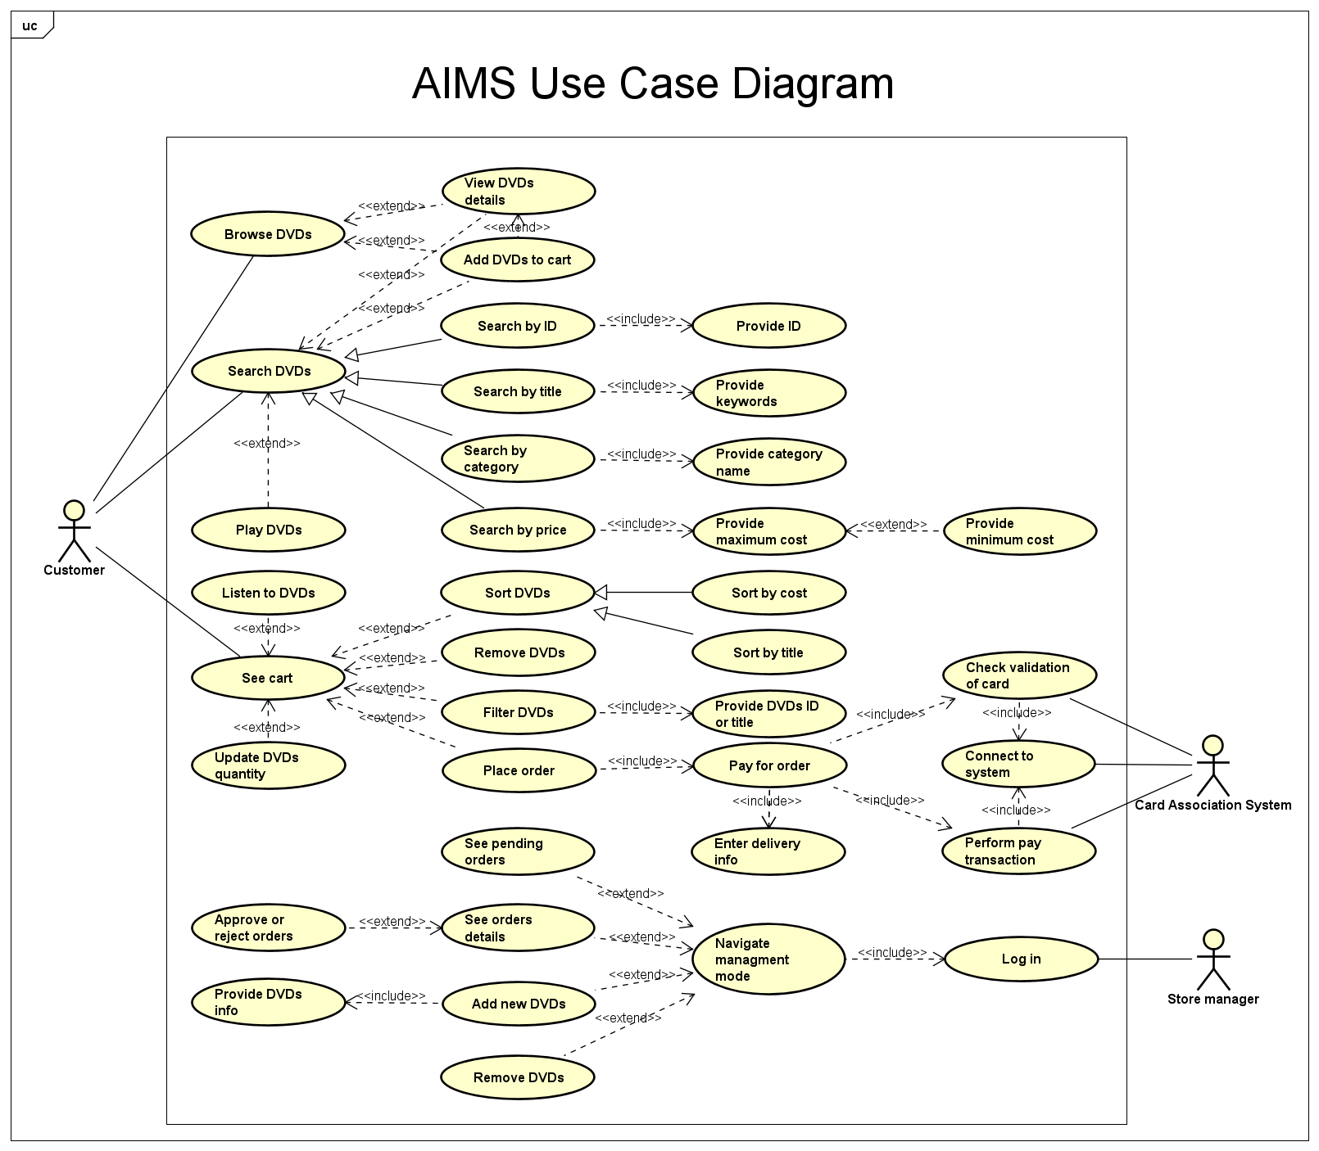

* Class Diagram

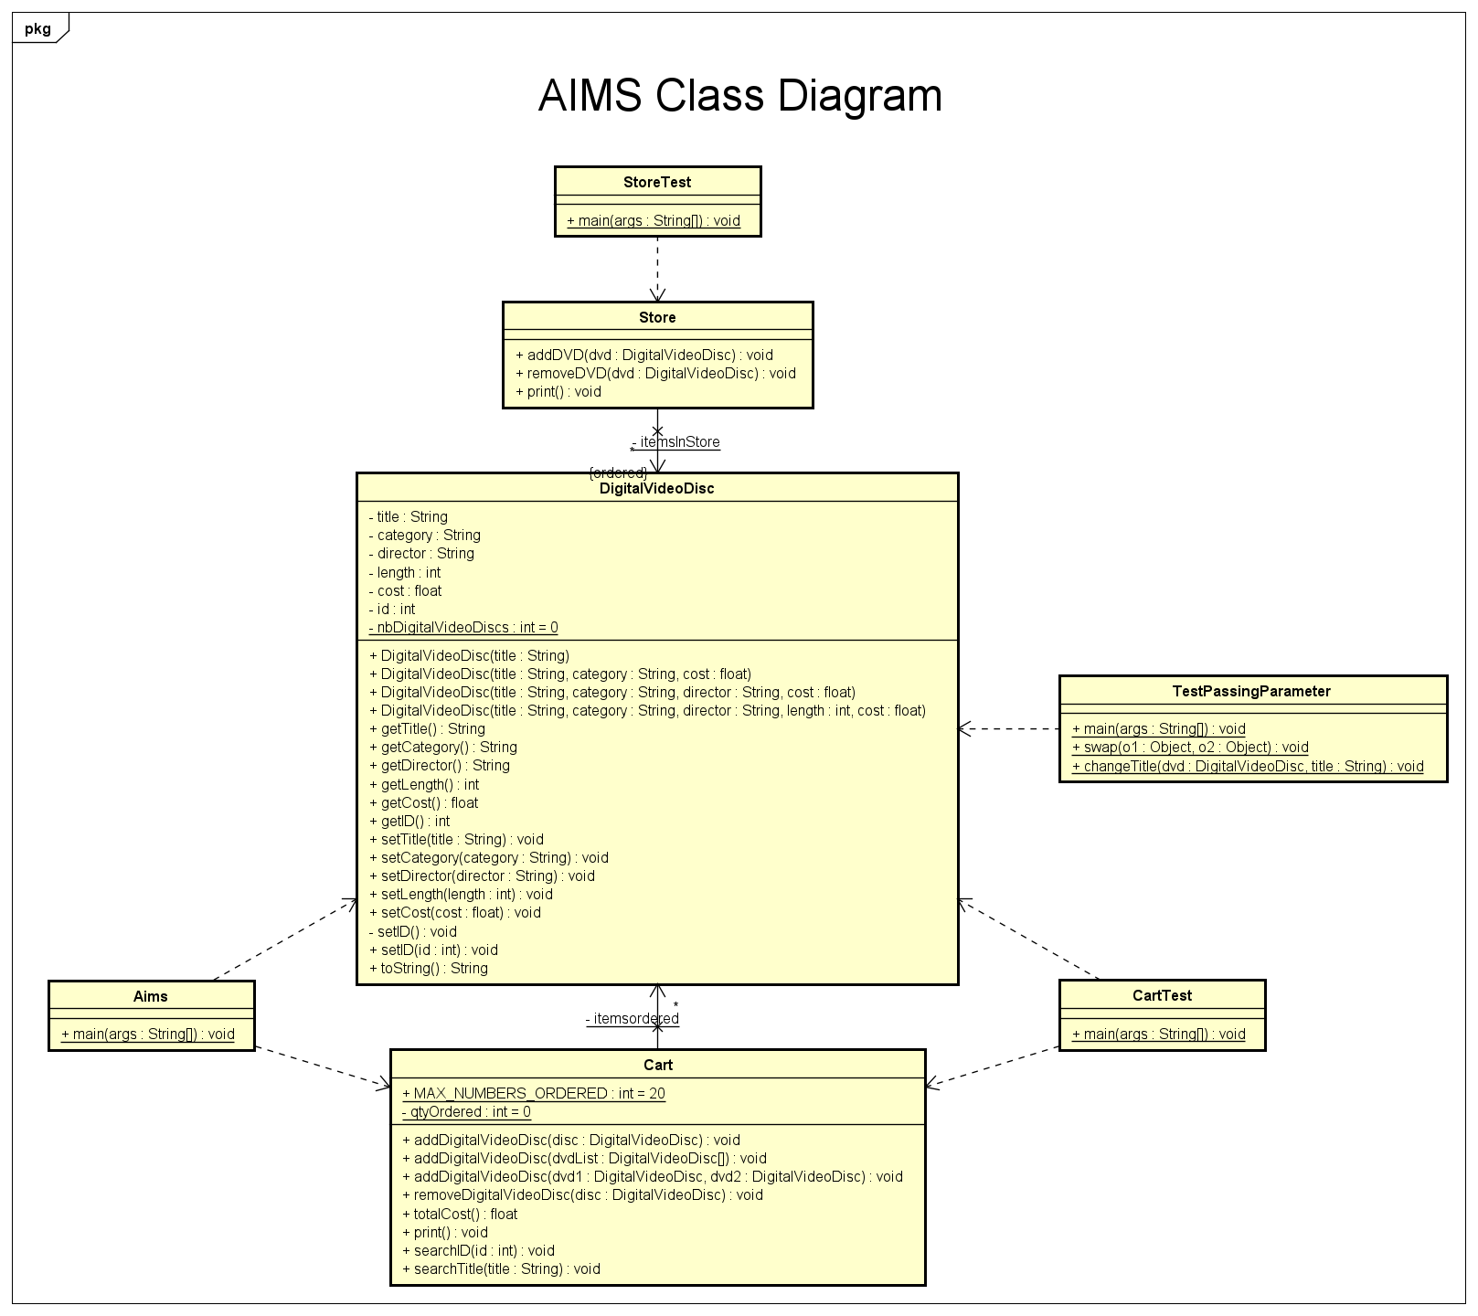

1. **String, StringBuilder, and StringBuffer**

* GarbageCreator has been running for over 10 minutes.

1. **Apply Release Flow**

Unfortunately, I read the instructions to apply release flow after I was done with other sections. I am very sorry for this mistake.