Mapping and Navigation
Thomas Lillis
Lauren Mitchell
Emily Randall
Jordan Peters
Mario Alanis
Jesus Ortiz

1. Provide a brief write-up on your mapping approach and the differences you observe when moving from line-following to an approach that does not depend on environmental features. Include a picture of the maps you obtained.

We implemented a line-following mapping method and a lawn-mowing mapping method. The line-following mapping created a much better map than the lawn-mowing method. We believe this is because the when line-following Sparki is always reading the line while while lawn-mowing the sensors didn't always pick of the line. We could have significantly improved the lawn-mowing algorithm by decreasing the distance traveled before checking the sensors. That would have allowed us more precision in detecting the lines.
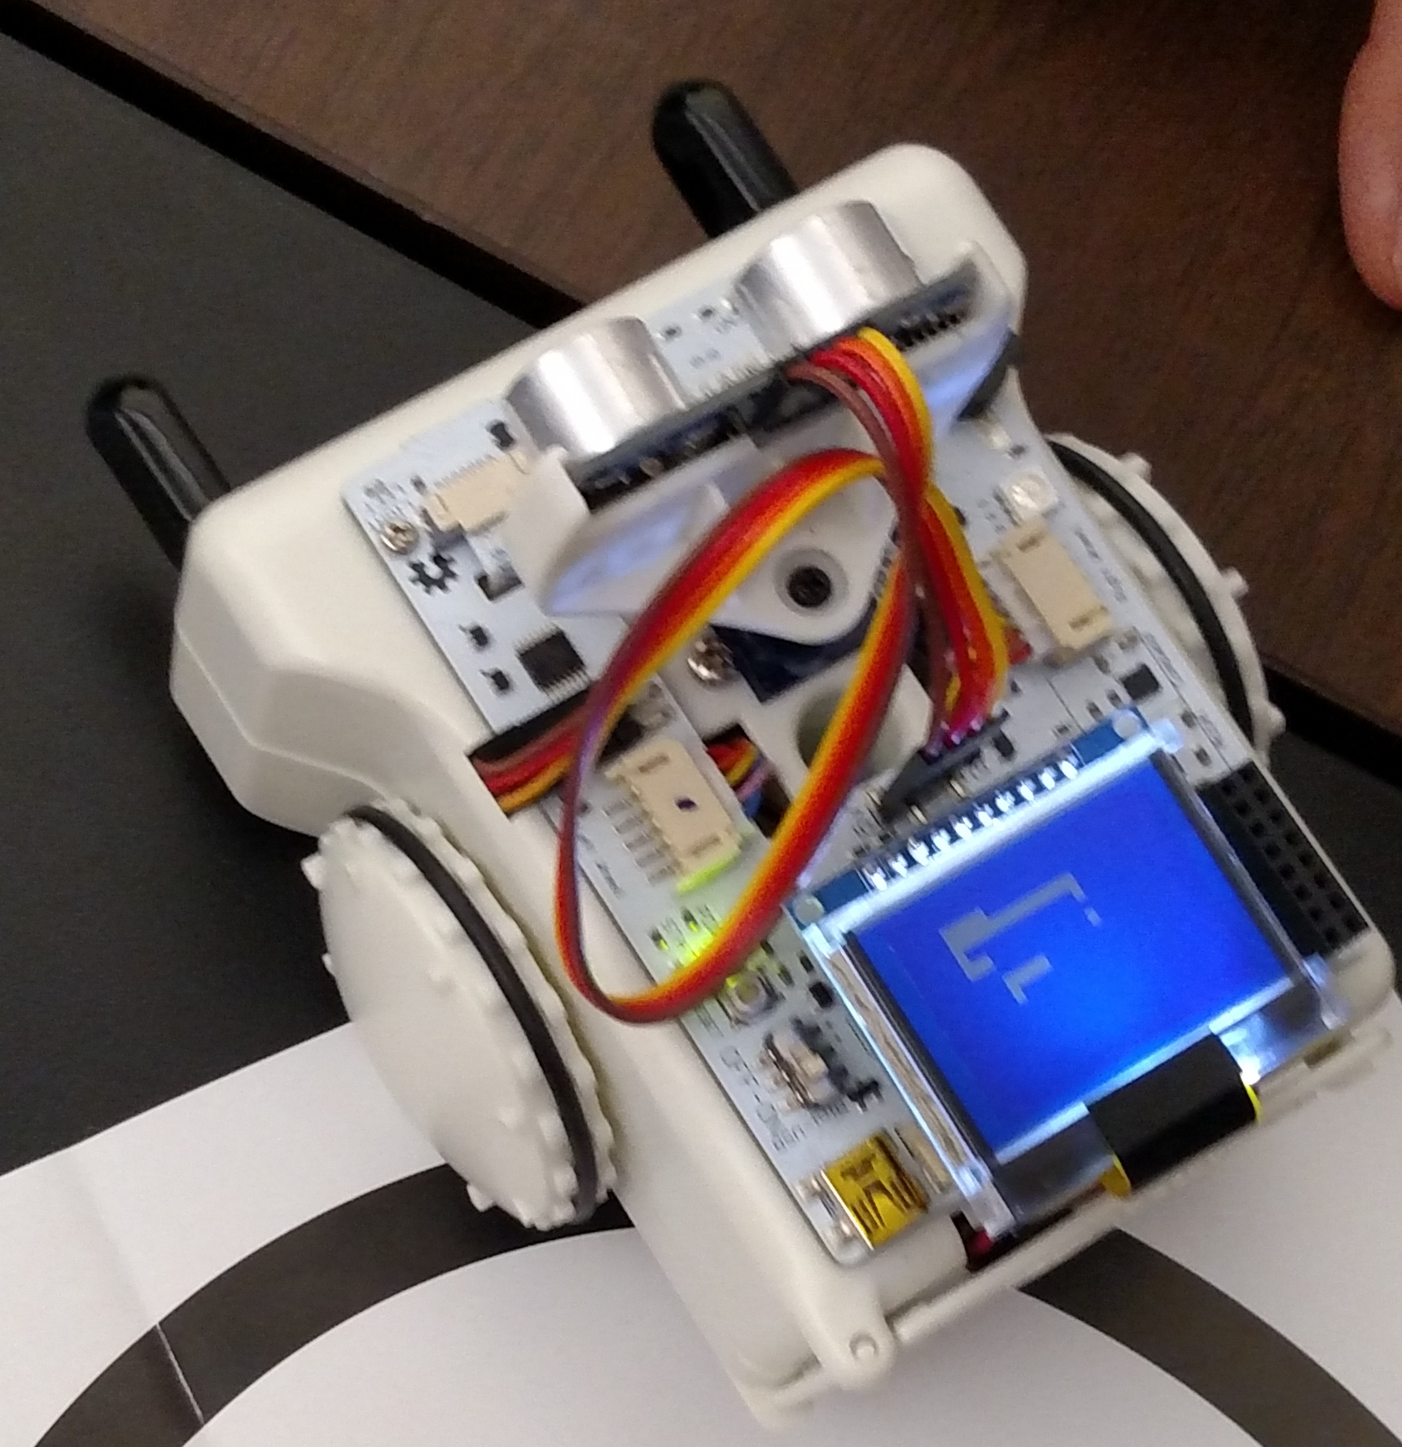
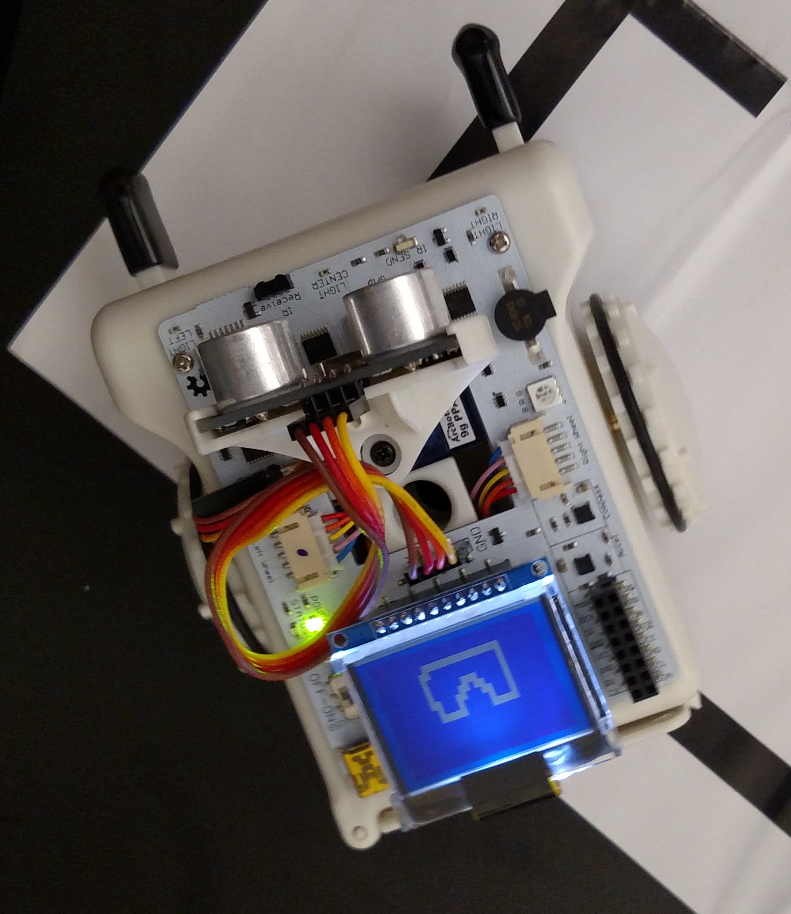

Line Following Mapping Lawn-Mowing Mapping
2. Provide a brief write-up explaining your path planning approach, and answer the following questions: How long does it take to find a shortest path on Sparki? What would you need to do to deal with dynamic obstacles? What would you need to do in order to plan also for the desired orientation of the robot?
To handle dynamic obstacles, after every step recalculate Dijkstra's algorithm. If there was a way to get a notification every time the environment changes you would recalculate it then to prevent having to recalculate at every step. To plan for the orientation of the robot, we would need to include a variable that described its current orientation and know which direction the next action took it.

