|  |
| --- |
| **Setup contributor to repository** |
| [NOTE] To set the contributor name and email for all repository, type  git config –global user.name “name” instead and  git config – global user.email “email”. |
| 1. Go to the root of the repository. |
| 1. Open-up the command-line window through pressing   SHIFT + RIGHT-CLICK  in the repository. |
| 1. Type in   git config user.name  to see the current username set for the repository. |
| 1. If none exist, type in   git config user.name “Firstname Lastname”. |
| 1. Type in   git config user.email  to see the current Github account set for the repository. |
| 1. If none exist, type in   git config user.email “email” to set it. |

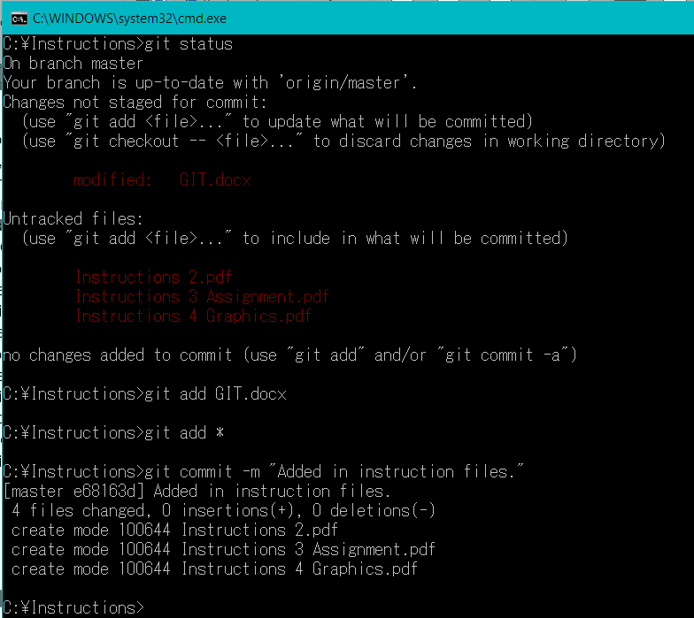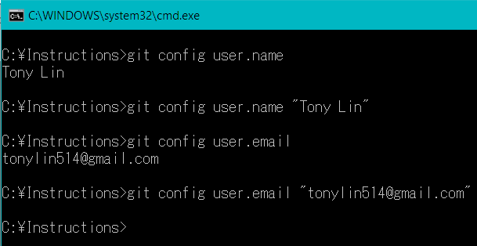

|  |
| --- |
| **Adding, Updating, and removing files from repository.** |
| 1. Add, remove, or update files in the repository. |
| 1. Open-up the command-line window through pressing SHIFT + RIGHT-CLICK in the repository. |
| 1. Type in git status to see the modified files in your repository. |
| 1. Type in git add [FILENAME]   to add changed files to be placed on a stage. Type git add * to add all modified files. |
| 1. Type in   git commit -m “comments”  to “set” the files on the stage and to add a comment about these changed files. |
|  |
|  |

**Adding, updating, removing files from repository**

1. A
2. O
3. Type in

git add [FILENAME]

to add changed files to be placed on a stage. Type

git add *

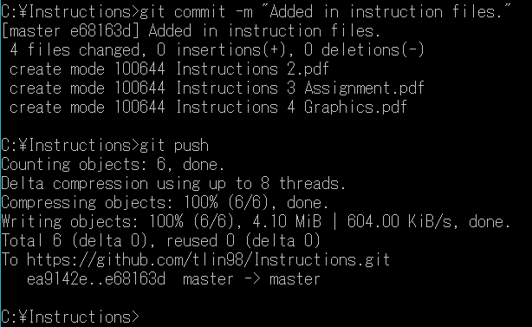to add all changed files.

1. Type in

git push

to push the “set” files to the online repository.

**Updating/Downloading files from master repository**

1. Go to the root of the repository.
2. Open-up the command-line window through pressing SHIFT + RIGHT-CLICK in the repository.
3. Type in