## Setup contributor to repository

You will learn how to learn to set your Github account to the repository. This allows you to use your Github account to commit changes to the repository, and helps identified which user made a commit.

[NOTE] To set the contributor name and email for all repository, type git config –global user.name “name” instead and git config – global user.email “email”.

1. Go to the root folder of the repository.

2. Open-up the command-line window through pressing SHIFT + RIGHT-CLICK in the repository.

3. Type in git config user.name to see the current username set for the repository.

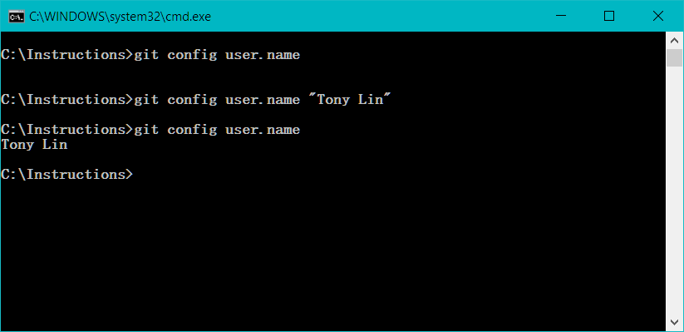

4. If none exist, type in git config user.name “Firstname Lastname”.

5. Type in git config user.email to see the current Github account set for the repository.

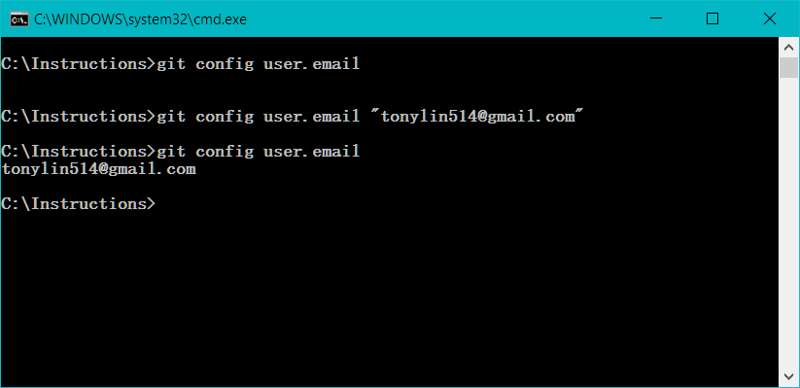

6. If none exist, type in git config user.email “email” to set it.

## Adding, Updating, and Removing files from Repository

You can modify your master repository on Github through synchronizing your local computer’s repository. This will change the online master repository’s files by adding, removing, or replacing the files.

1. Add, remove, or update files in the repository.

2. Open-up the command-line window through pressing SHIFT + RIGHT-CLICK in the repository.

3. Type in git status to see the modified files in your repository.

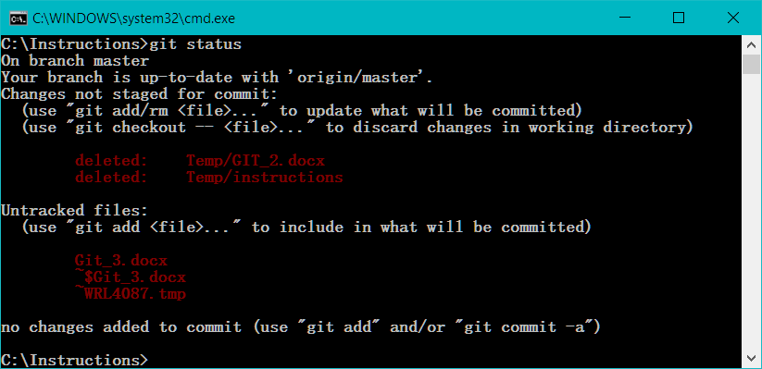

4. Type in git add [FILENAME] to add changed files to be placed on a stage. Type git add * to add all modified files.

5. Type in git commit -m “comments” to “set” the files on the stage and to add a comment about these changed files.

6. Type in git push and wait a few seconds for files to upload to online repository.