## Setup contributor to repository

[NOTE] To set the contributor name and email for all repository, type

git config –global user.name “name” instead and

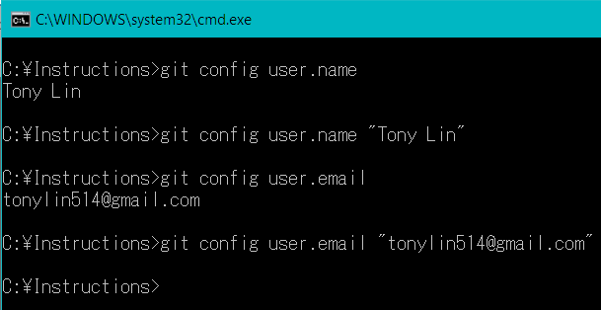git config – global user.email “email”.

Figure 1 Steps 3 to 6

|  |
| --- |
| 1. Go to the root of the repository. |
| 1. Open-up the command-line window through pressing   SHIFT + RIGHT-CLICK  in the repository. |
| 1. Type in   git config user.name  to see the current username set for the repository. |
| 1. If none exist, type in   git config user.name “Firstname Lastname”. |
| 1. Type in   git config user.email  to see the current Github account set for the repository. |
| 1. If none exist, type in   git config user.email “email” to set it. |

## Adding, Updating, and Removing files from repository

|  |
| --- |
| 1. Add, remove, or update files in the repository. |
| 1. Open-up the command-line window through pressing SHIFT + RIGHT-CLICK in the repository. |
| 1. Type in git status to see the modified files in your repository. |
| 1. Type in git add [FILENAME]   to add changed files to be placed on a stage. Type git add * to add all modified files. |
| 1. Type in   git commit -m “comments”  to “set” the files on the stage and to add a comment about these changed files. |
|  |
|  |
|  |

