Assignment 1: Filtering and Smoothing

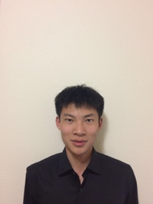

Name : Suozhi Qi

Dept: Computer Science

Part I

Exercise 1:

Original tiger image downloaded:

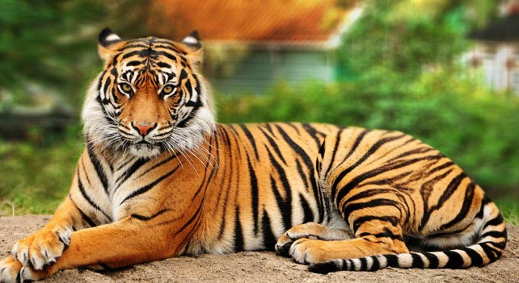

Crop image: I use imcrop() function, and the user need to manually selection out the head of the provide tiger image. The user can finish the selection process by double clicking the selected region. Here is the cropped image:

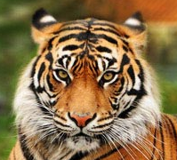

Display red components: basically just set the matrixes associated with green and blue to zero, and save the results to a new image object. Here is the red image:

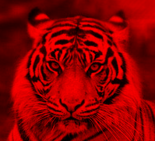

Change the order of color: just assign different matrixes associated with R, G or B colors to the new order provided. Here is the color changed image:

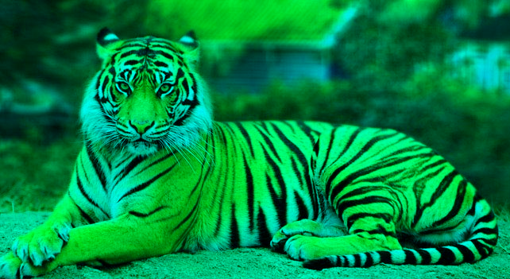

Exercise 2:

Convert to gray scale: first read the image and then use rgb2gray function. Here is the grayscale image:

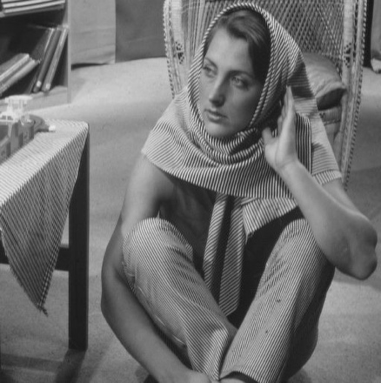

Blur the image using Gaussian filter: first I created a Gaussian filter using fspecial function. Then I use imfilter function to blur the image. Here is the image:

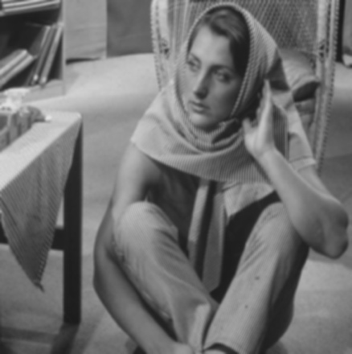

Subtract image: I use imsubtract function. Here is the image:

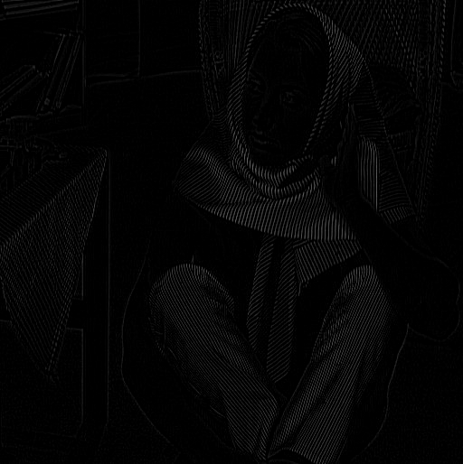

Threshold image and display the image: I use max(max()) function to get the largest pixel value, and times the result by 0.05 to get the threshold. I use the find() function to get the indexes of all the locations that have pixels lower than the threshold. I set those locations to 0 in pixel value, and get the resultant image shown below.

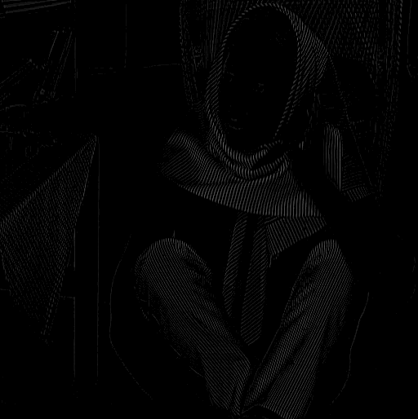

You can clearly see that the final image looks like a total darkness with some dim white bands in it.

Part II:

Filtering:

Filter manually the matrices I1 and I2: I manually input I1 and I2, and input the three filters as instructed. Then I use imfilter function and provides I1 in combination with each of the three filters, and repeat the same with I2. Results are attached:

disp(filt11);

85.0000 125.0000 120.0000 93.3333 53.3333

90.0000 133.3333 106.6667 75.0000 31.6667

78.3333 95.0000 65.0000 35.0000 18.3333

40.0000 53.3333 33.3333 23.3333 10.0000

21.6667 28.3333 18.3333 10.0000 3.3333

disp(filt12);

88.3333 86.6667 83.3333 56.6667 28.3333

130.0000 123.3333 100.0000 68.3333 35.0000

115.0000 93.3333 73.3333 38.3333 21.6667

80.0000 60.0000 36.6667 20.0000 11.6667

38.3333 23.3333 20.0000 8.3333 5.0000

disp(filt13);

58.3333 86.1111 75.5556 56.1111 28.3333

84.4444 117.7778 97.2222 67.7778 34.4444

69.4444 93.8889 68.3333 44.4444 20.0000

46.6667 58.8889 38.8889 22.7778 10.5556

20.5556 27.2222 17.2222 11.1111 4.4444

disp(filt21);

85.0000 125.0000 120.0000 118.3333 78.3333

90.0000 133.3333 120.0000 116.6667 73.3333

41.6667 60.0000 55.0000 48.3333 30.0000

21.6667 35.0000 30.0000 23.3333 10.0000

8.3333 15.0000 11.6667 10.0000 3.3333

disp(filt22);

88.3333 86.6667 83.3333 70.0000 81.6667

110.0000 106.6667 101.6667 86.6667 95.0000

80.0000 73.3333 75.0000 56.6667 56.6667

38.3333 33.3333 38.3333 25.0000 18.3333

16.6667 13.3333 20.0000 8.3333 5.0000

disp(filt23);

58.3333 86.1111 80.0000 78.3333 50.5556

72.2222 106.1111 98.3333 94.4444 60.5556

51.1111 76.1111 68.3333 62.7778 37.7778

23.8889 36.6667 32.2222 27.2222 14.4444

10.0000 16.6667 13.8889 11.1111 4.4444

Apply following filters on the gray scale image of Barbara:

1. Central difference gradient filter: I create a X-axis filter [-1, 0, 1], and Y-axis filter [-1;0;1]. I then filtered the image using both filters. Next I square both of the images, add them up, and then get the square root value. Here are the images, left to right, x-axis filter, y-axis filter, x and y added up:

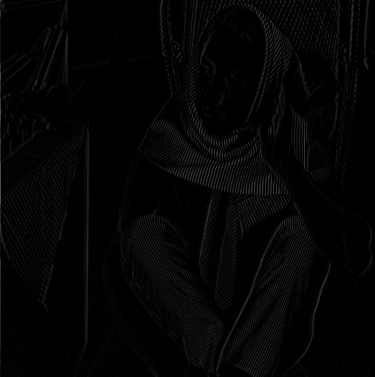 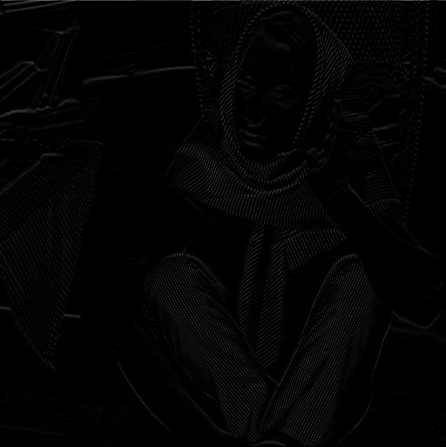 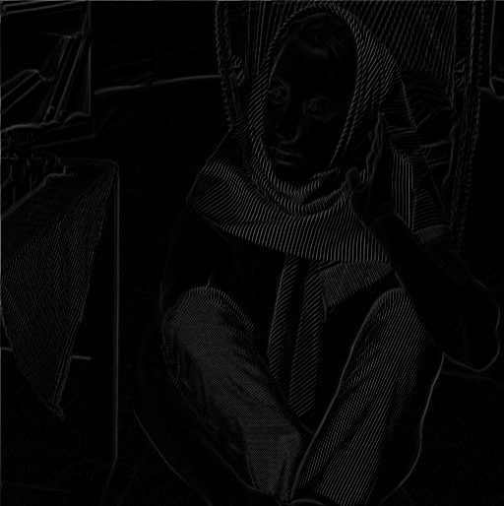

2. Sobel filter: I use fspecial function to create a sobel filter, and apply this filter to the image using imfilter function. Here is the image:

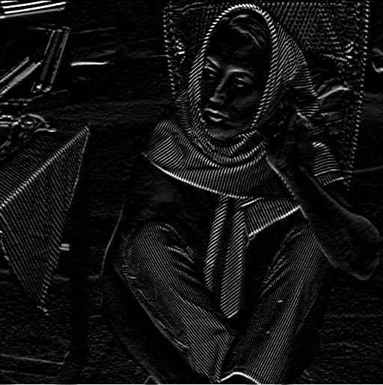

3. Mean filter: I repeat the same process as in sobel filter but change the parameter to average to generate the filter. Here is the image:

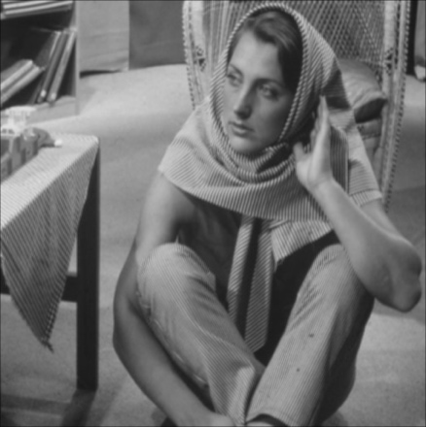

4. Median filter: I directly use the medfilt2 function to generate the resultant image. Here is the image:

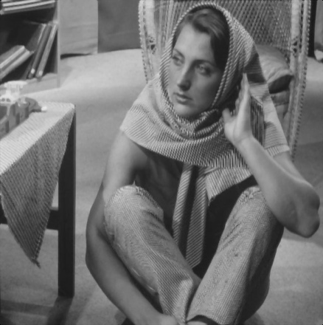

Smoothing:

Read the image: I use imread() function

Box filters of different sizes: I use fspecial function to create boxfilters and the type is “average”. Here are the filterd image. Left to right, top to bottom: size 2, 4, 8, 16

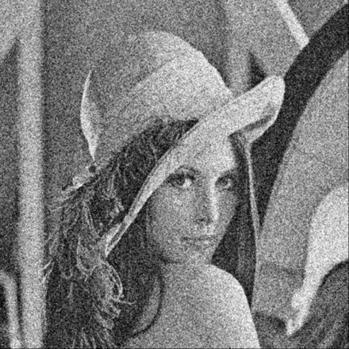 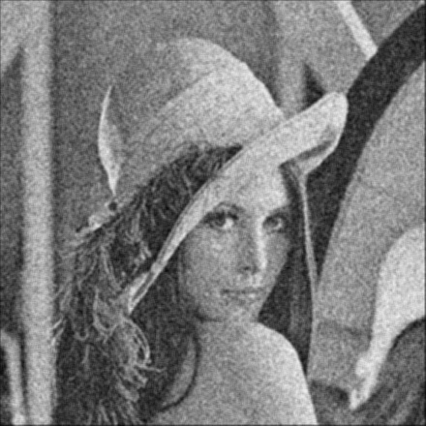

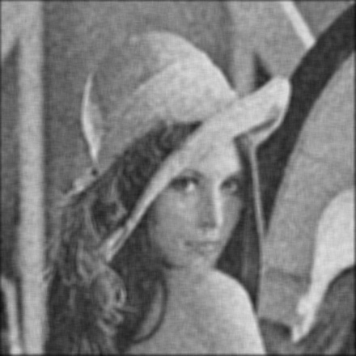 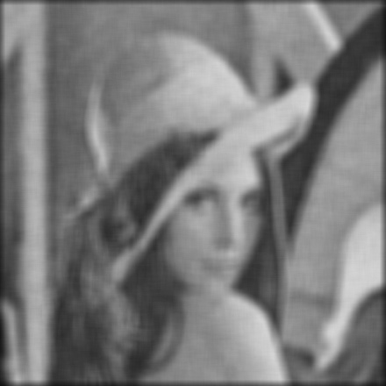

Gaussian filter of standard deviations of 2, 4, 8, 16:

According to the instructions, the size should be 4 times the SD. So the size of the each filters should be 8, 16, 32, 64. Here are the images. Left to right, top to bottom: SD 2, 4, 8, 16:

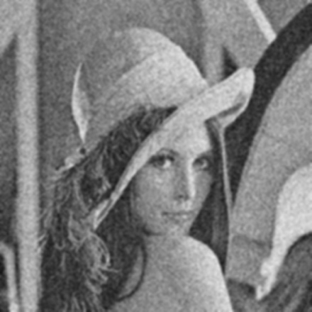 

 

It looks like the Gaussian filter has a stronger effect compared with the box filter. In both the box filters and the Gaussian filters, with the increase of box filter size in box filters, or increase of SD in Gaussian filters, the image become more and more blurry.

Grad credits:

I first use imread() function to read the image and transform it to double precision in order for the bilateral filter to work.

Then I introduce the AWGN as instructed by the run demo.

Next I use the same parameters as the demo, but adjust the intensity standard deviation. For the “large” one I change it to 1000, and the “small” one I change it to 0.001. Then I apply the filter to each image and save the resulting file. Here are the images, left to right, original, large intensity SD, small intensity SD:

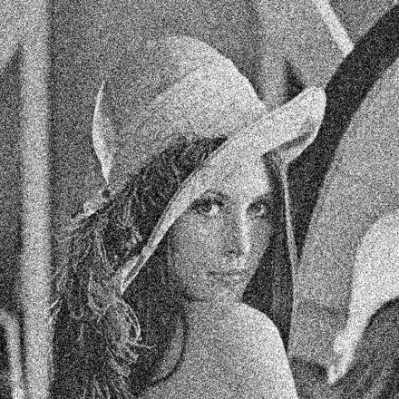  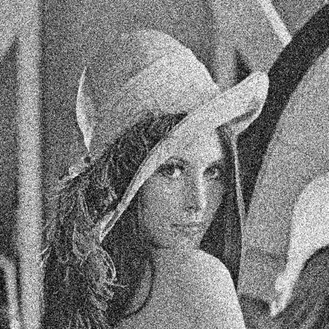

Clearly, we can see that when intensity SD gets large, the noise is getting small. I also tested other values of intensity SD. The results showed that when SD goes above 1, the noise level stays almost the same as it continues to increase. On the other hand, when SD becomes smaller, close to 0, the noise background increases. Here are the images, left to right, top to bottom, intensity SD 0.01, 0.1, 1, 10, 100:

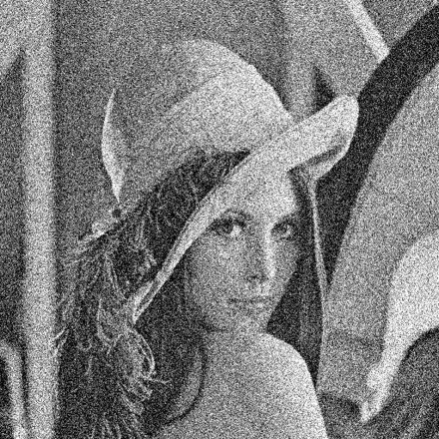 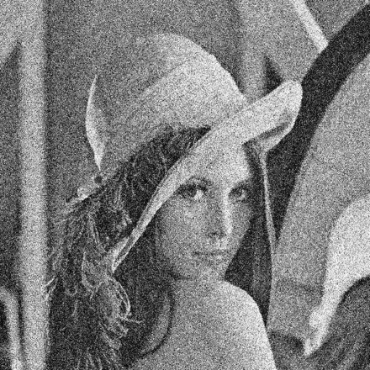 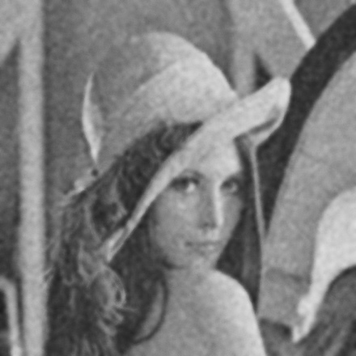

 

Looks like an intensity SD = 1 is optimal according to my eyes.

Compared with Gaussian filter. Here are the images, left to right, Gaussian filter sd = 4, sd = 8, bilateral intensity sd = 1:

  

I would say Gaussian filter seems to work better in denoising compared with the bilateral filter according to the above pics.

As to the optimal choice of intensity standard deviation related to the noise standard deviation, I found the data from a paper by Zhang et al. [1], showing that optimal intensity SD increases with the noise standard SD. Below is the data from the paper, x-axis is noise SD and y-axis is optimal intensity SD:

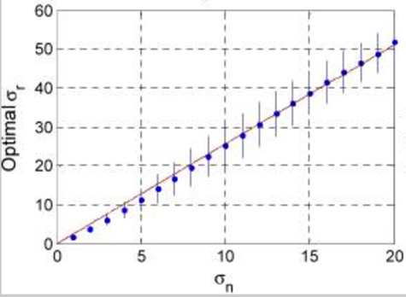

Reference:

# [1] M. Zhang and B. K. Gunturk (2008). “Multiresolution Bilateral Filtering for Image Denoising”

I[EEE Trans Image Process. 2008 Dec; 17(12): 2324–2333.](https://www.ncbi.nlm.nih.gov/entrez/eutils/elink.fcgi?dbfrom=pubmed&retmode=ref&cmd=prlinks&id=19004705)