Assignment 2: Filtering and Smoothing

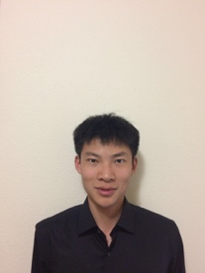

Name : Suozhi Qi

Dept: Computer Science

1. In this paper, the author defined three criteria for detecting edges and proved the validity of these criteria via mathematical forms. These criteria include low error rate detection, good edge localization, as well as having only one response to a single edge.

The author first considered one-dimensional formulation to facilitate the analysis to generate the three major criteria as mentioned above. In an optimal detector, the edge is marked at maxima in the gradient magnitude of a Gaussian-smoothed image. Then they determined that intermaximum spacing scales with the operator width, which could be used to fix noise maxima.

In doing so, they first demonstrated that they can find optimal detectors by numerical optimization. This idea is then implemented in designing a detector for step edges, and the results are proved by mathematical forms. This operator is further approximated using the first derivative of Gaussian. Before this point, these steps were quite similar to the methods proposed by Marr-Hildreth. Next, the author proposed hysteresis thresholding that upgraded the above method. He proposed the use of two thresholds, one as the low threshold, and the other as the high threshold. They proved that using a single threshold makes edge detectors susceptible to streaking, which could lead to broken edge contours.

Last, they applied the above criteria to two dimensions by adding edge direction to the formulas. They also showed that locally straight edge contours combined with highly directional operators yield good results than operators with a circular support. These methods combined, form an efficient way in generating efficient directional masks at several orientations, and thus, good edge detectors.

2. Implementation:

(a) Noise Reduction

I just use the filter and get the image.

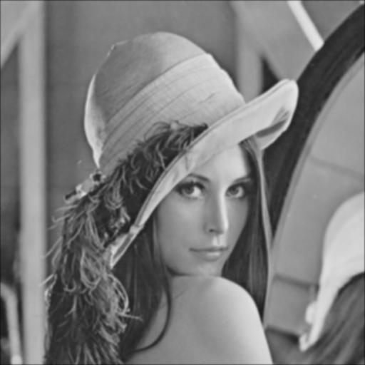

(b) Gradient magnitude and angle

filt using Dx(x,y):

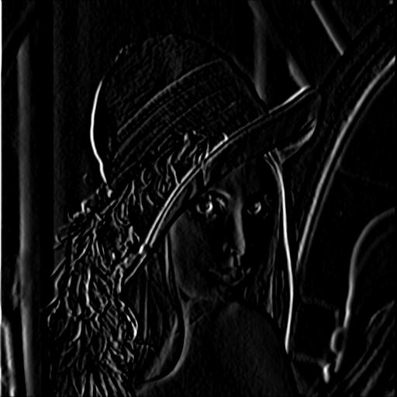

filt using Dy(x,y)

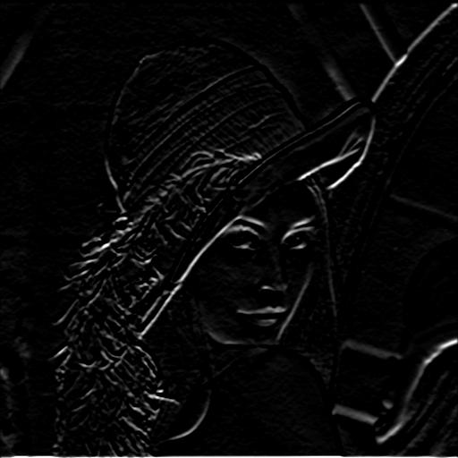

gradient image:

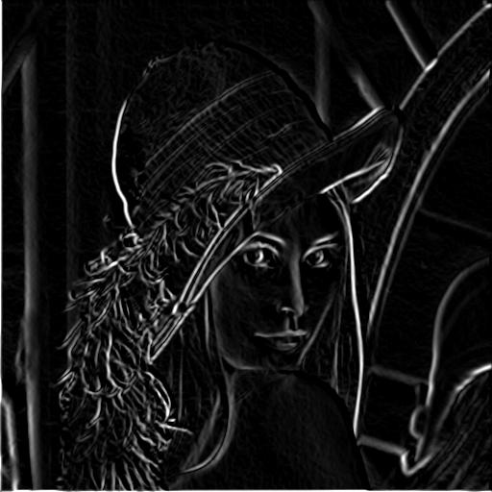

I also calculated the angle. Please refer to the code.

(c) Non-maximum suppression

I got the image below:

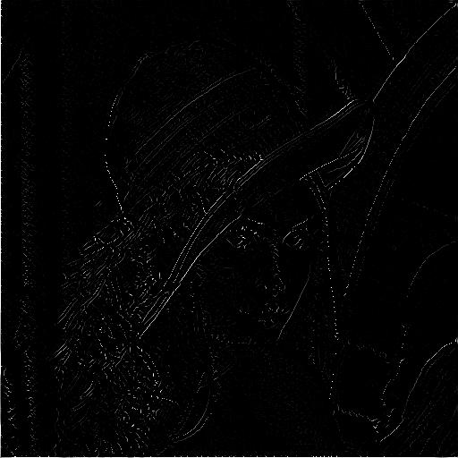

(d) Hysteresis thresholding

Please refer to the code. I set high threshold to 0.3, and low threshold to 0.1. I got the image below:

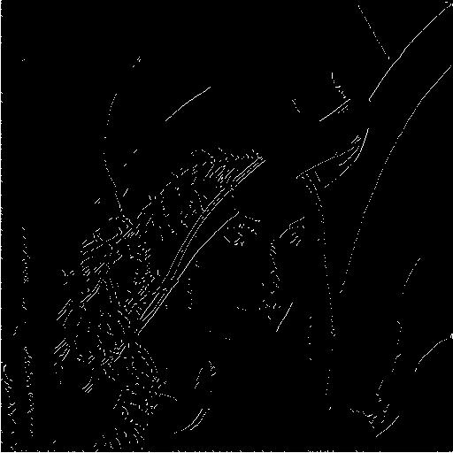

**Grad credits: hybrid image**

This paper describes how to create hybrid images in detail. Generally speaking, a hybrid image is composed of low spatial frequency of one image and high spatial frequency of another image. This generated hybrid image will display image contents that are a function of view distance. If people view the image from a long distance away, they will see the image with low spatial frequency. On the other hand, people will see image with high spatial frequency if they view the image closely.

This beautiful design of hybrid image takes advantage of the perceptual mechanisms of human vision system. Human’s vision analysis tends to unfold from global to local perception. Basically, people tend to see low spatial frequency components of an image when they view the image for a short time. While if they see the image for a long time, they will then see the fine details with high spatial frequency. That’s the reason why low spatial frequency components could dominate early visual processing, while high spatial frequency components dominates late visual processing. According to this principle, when we stand far from the image, our eyes tend to receive information from low spatial frequency components because they are the ones that take a shorter time for our vision system to process. As we stand closer to the image, now we have more time for our vision system to process information, hence we see the fine details, which are the high spatial frequency components.

In order to generate a hybrid image composed of high and low spatial frequency components, we can utilize different image filters. We can use a low pass filter to generate a low spatial frequency image, and a high pass filter for a high spatial frequency image. For example, a Gaussian filter can be used for generating a low spatial frequency image, while a Laplacian filter is fit for generating a high spatial frequency image.

Based on these principles, I generated my own hybrid image. I use a Gaussian filter with size of 11 and sigma of 8.5 as the low pass filter to generate low pass filtered image of my selfie. For the high pass image, I first filtered the image with a Gaussian filter with size of 80 and sigma of 45, and then I subtract this image from an impulse to generate a high pass filtered image of my girlfriend’s selfie. Here are the low pass image, high pass image and the hybrid image:

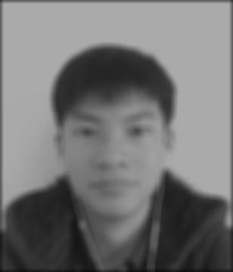 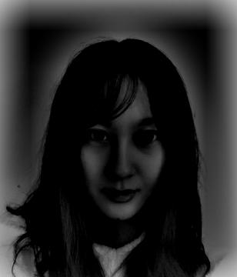 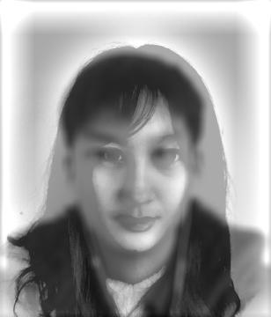

Though not very impressive, I have tried my best….

Besides the frequency issues, this paper also claims that other factors could impact image understanding. For example, if a viewer receives a task of identifying one particular component from an image, he/she will interpret that image regardless of the spatial frequency of that particular component. More interestingly, this viewer tends not to be aware of other frequencies when he/she selects that particular spatial frequency.

This design of hybrid image has the potential to be utilized in a lot of applications. For example, it can be used to design private fonts that require some extent of user privacy. It can also be used to show changing faces with differences in viewing distances. Still, a lot of great potentials of hybrid images have not been fully defined, and these things will definitely benefit the development of the whole computer vision field.