Assignment 7: Face Recognition using PCA and LDA



Name: Suozhi Qi

NetId: sq6

**1 Using PCA**

1. I use the function reshape to vectorize each image and save them in a struct called trainingVector
2. I calculated S according to the instructions. Please refer to my matlab code
3. I use the eig function to get the eigenvectors and eigenvalues.
4. I pick the eigenvectors with the top K eigenvalues and store them in matrix U
5. I extracted the PCA features according to the instructions. Please refer to my matlab code
   1. Training Phase

The PCA features are stored in a struct named PCAfeatureY

* 1. Testing Phase

I use the same procedure to get the PCA feature, and calculate their corresponding distances with the training data set’s PCA features. I then use that distances to predict, and if correctly predicted, I increment the correctPredict by 1. Using that I finally get the percentage of identity prediction.

* 1. Tasks 1

1. Shown below are the first 20 eigenfaces:

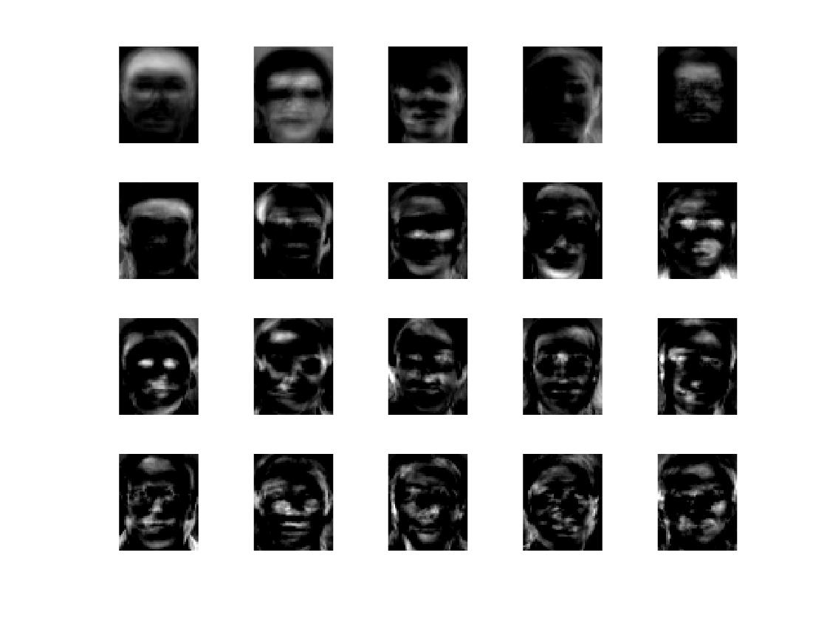

1. Shown below is the plot:

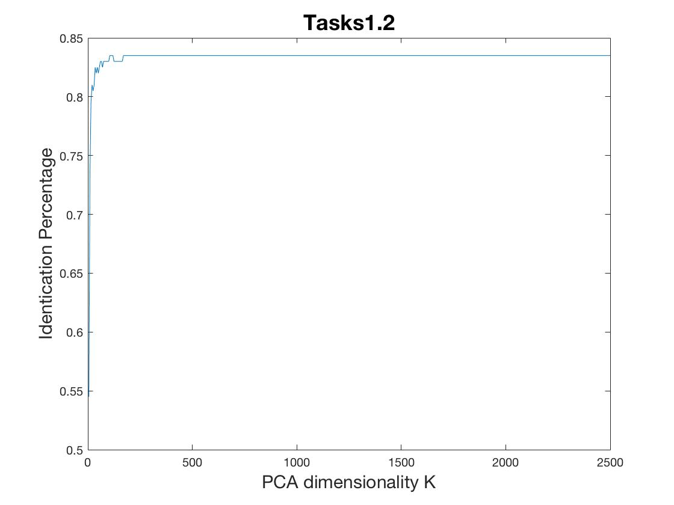

1. Shown below is the table:

|  |  |  |
| --- | --- | --- |
| K | Total Variance Explained | Identification Percentage |
| 5 | 0.523447536 | 0.545 |
| 10 | 0.654791303 | 0.735 |
| 20 | 0.767350011 | 0.81 |
| 40 | 0.864557013 | 0.82 |
| 60 | 0.912821177 | 0.83 |
| 100 | 0.960982462 | 0.83 |
| 150 | 0.9885565 | 0.83 |
| 200 | 1 | 0.835 |
| 400 | 1 | 0.835 |
| 1000 | 1 | 0.835 |
| 2000 | 1 | 0.835 |

1. **Using LDA**
2. I Use the same strategy as in PCA to vectorize the images.
3. I first calculated the mean of each subject vector, and then use that to calculate within-class matrix Sw.
4. I calculated the mean of all of the images and use the mean subject vector to get the between-class matrix Sb.
5. To calculate the eigenvectors, piv(Sw) * Sb is used instead of a single scatter matrix in PCA method.
6. The same as PCA
7. The same as PCA
   1. Tasks2
8. Please refer to the code and the answers above
9. The first 20 Eigenfaces are shown below

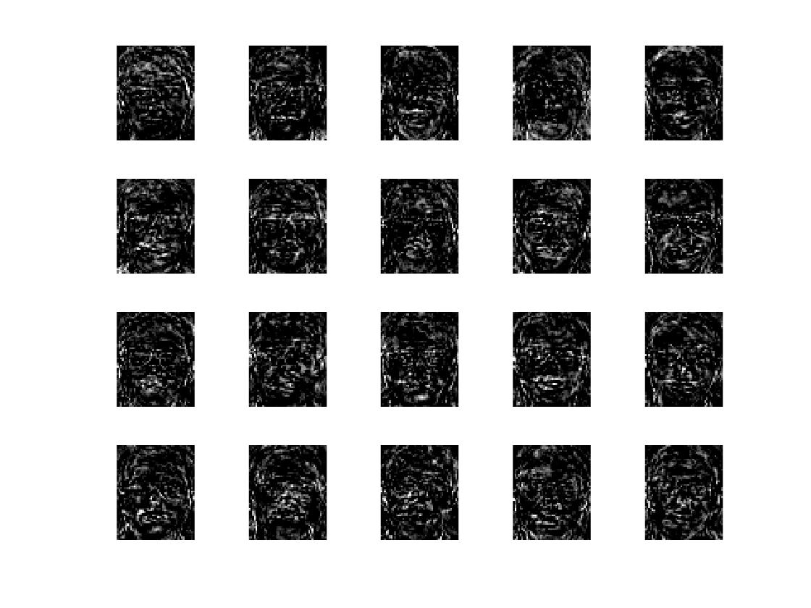

1. The plot is shown below

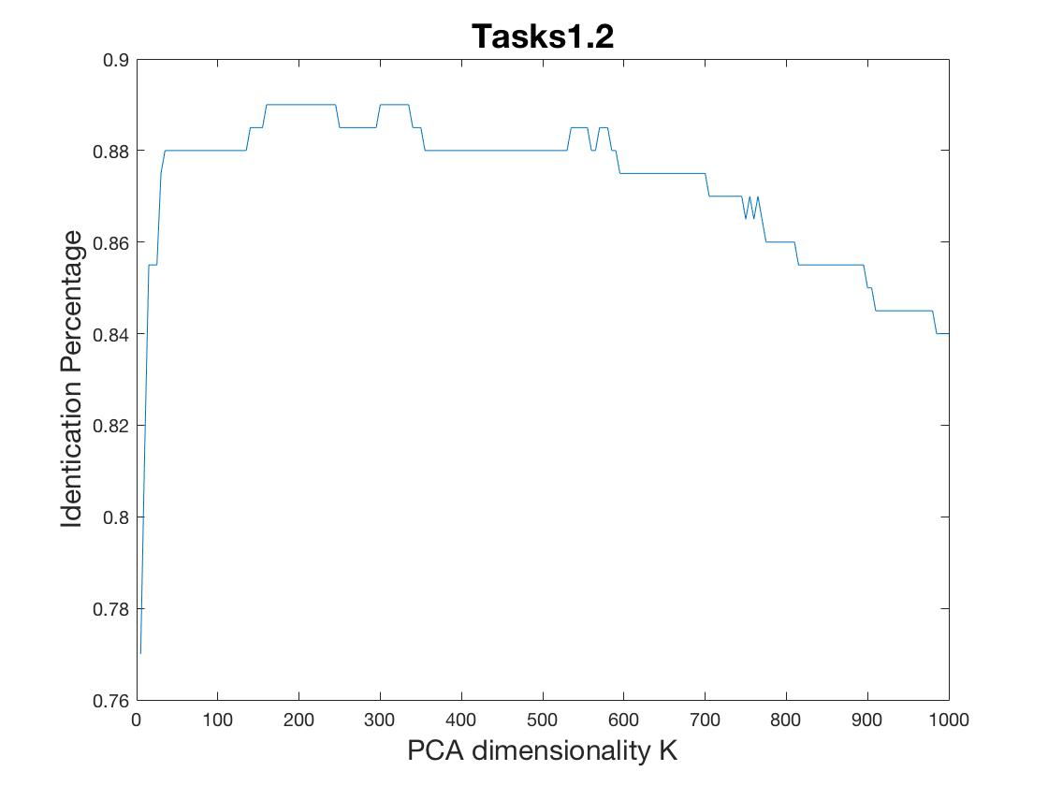

1. The table is shown below

|  |  |  |
| --- | --- | --- |
| K | Total Variance Explained | Identification Percentage |
| 5 | 0.5477 | 0.77 |
| 10 | 0.7340 | 0.8150 |
| 20 | 0.9007 | 0.8550 |
| 40 | 1 | 0.8800 |
| 60 | 1 | 0.8800 |
| 100 | 1 | 0.8800 |
| 150 | 1 | 0.8850 |
| 200 | 1 | 0.8900 |
| 400 | 1 | 0.88800 |
| 1000 | 1 | 0.8400 |
| 2000 | 1 | 0.6750 |

1. **Task 3**
2. From the plot we can see that PCA method makes the identification percentage rise in a very fast way with the increase of K, and then it stays at the same value (0.835). On the other hand, LDA methods tend to give a fluctuating result, and in most cases has higher identification percentage compared with PCA. PCA uses a general scatter matrix S, while LDA uses the combination of in class scatter matrix Sw and between class scatter matrix Sb. The performance of LDA versus PCA generally varies from case by case.
3. One can use the PCA method instead of the LDA method to avoid the singular matrix problem.
4. This method first uses PCA to provide high quality features. But because of the use of the entire face image, it cannot just whether the changing face images comes from the change of illumination or various facial expression. To compensate for this, it uses LDA to enhance the separation between classes. These two methods are combined in this way for data pre-processing. In the recognition part, a P-RBF NNs based on the fuzzy inference mechanism is used. The overall result works well [1].
5. **Grad Credits: Head Pose Estimation**

**Appearance template methods:** This method compares a new image of a head to a set of exemplars to find the most similar view. It has advantages including expansion of templates to a larger data set at any time, greatly increasing adaptability. Also the templates do not require negative training examples or facial feature points. Its disadvantages include that they are only capable of estimating discrete pose locations without the use of some interpolation method. Also this method may suffer from efficiency concerns due to more templates being added to the exemplar set. The most significant problem lies in that they operate under the faulty assumption that pairwise similarity is the same as similarity in pose.

**Detector array methods:** This method trains a series of head detectors each attuned to a specific pose and assign a discrete pose to the detector with the greatest support. This method also directly operates on an image patch. The image is evaluated by a detector trained on many images with a supervised learning algorithm. One advantage is that a separate head detection and localization step is not required. Another advantage includes that detector arrays employ training algorithms that learn to ignore the appearance variation that does not correspond to pose change, which is well-suited for high and low-resolution images. Disadvantages include large amount of workload in training detectors for each discrete pose and potential systematic problems that arise as the number of detectors increases.

**Nonlinear regression methods:** This method uses nonlinear regression tools to develop a functional mapping from the image or feature data to a head pose measurement. One potential problem of this method is that it is not clear how well a specific regression tool will be able to learn the proper mapping. This method is similar to detector arrays and appearance templates in that it provides a coarse estimate of pose at discrete locations. One advantage of this approach includes fast speed, low workload and great stability. Disadvantages include that they are to prone to error from poor head localization.

**Manifold embedding methods:** This method seeks low-dimensional manifolds that model the continuous variation in head pose. It applies PCA and KPCA to generate a separate projection matrix for each group. In this way, head pose will be estimated by normalizing the image and projecting it into each of the pose-eigenspaces, thus finding the pose with the highest projection energy. This method has one disadvantage that both LDA and KLDA has the tendency to ignore the pose labels that might be available during training.

**Tracking methods:** This method recovers the global pose change of the head from the observed movement between video games. It operates by following the relative movement of the head between consecutive frames of a video sequence. In this method, temporal continuity and smooth motion constraints are utilized to provide a visually appealing estimate of pose over time. It has a great advantage of showing high level of accuracy, though requiring a known head position beforehand. And this causes its major disadvantage, which is that it relies on manual initialization such that the subject’s neutral head pose is forward-looking and easily reinitialized.

1. **References:**

[1] http://www.sciencedirect.com/science/article/pii/S095741741201007X