**WeRateDogs**

WeRateDogs is an user from Twitter that rate dogs. User tweet an image of a dog and WeRateDogs would give a rating to the dog.

Here, we look at the dog’s data since the beginning (Nov2015) up to Jul2017.

We use Udacity awesome image prediction neutral network to identify the type of dogs from the image.

Date range: Nov2015 to Jul2017

**Distribution of rating**

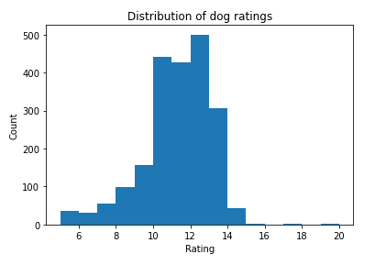

WeRateDogs rate dogs using 10-point system. However, due to cuteness of dogs, they always give out rating beyond 10 points, commonly around 11-14 points.

**Does ratings vary overtime?**

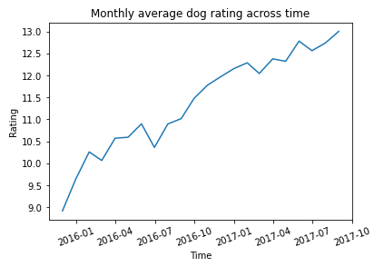

We can clearly see the monthly average ratings is increasing, indicating dogs become cuter.

**Which type of dogs get the most retweet/likes?**

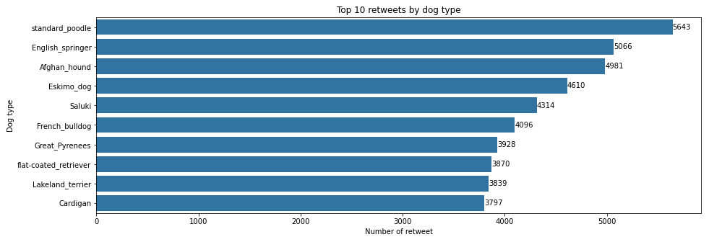

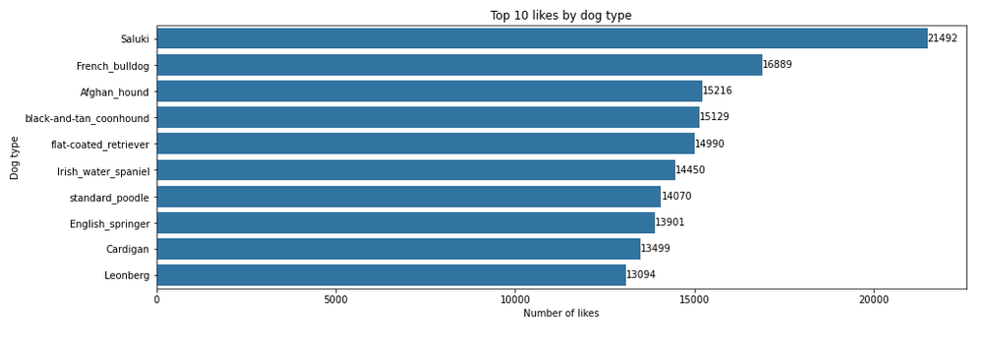

Standard poodle had the most retweet while Saluki get the most likes!

