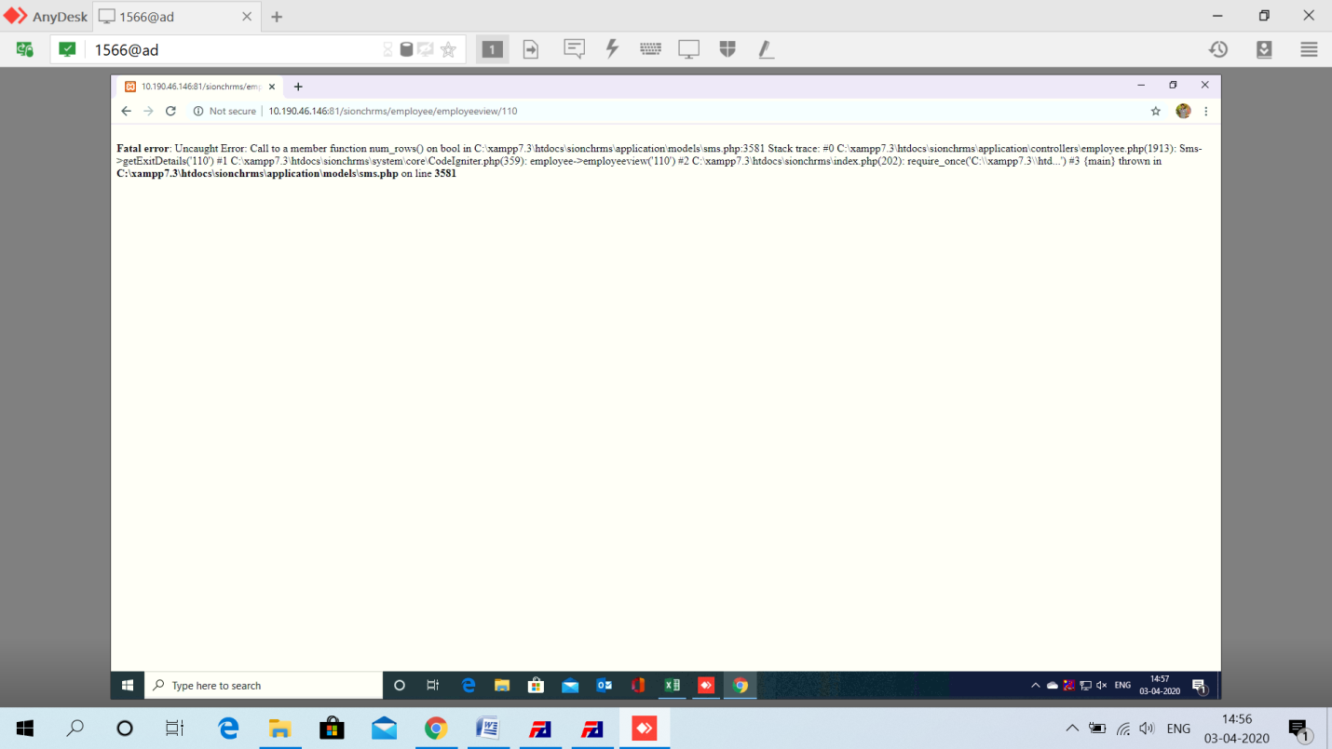

Employee view option – fatal error.

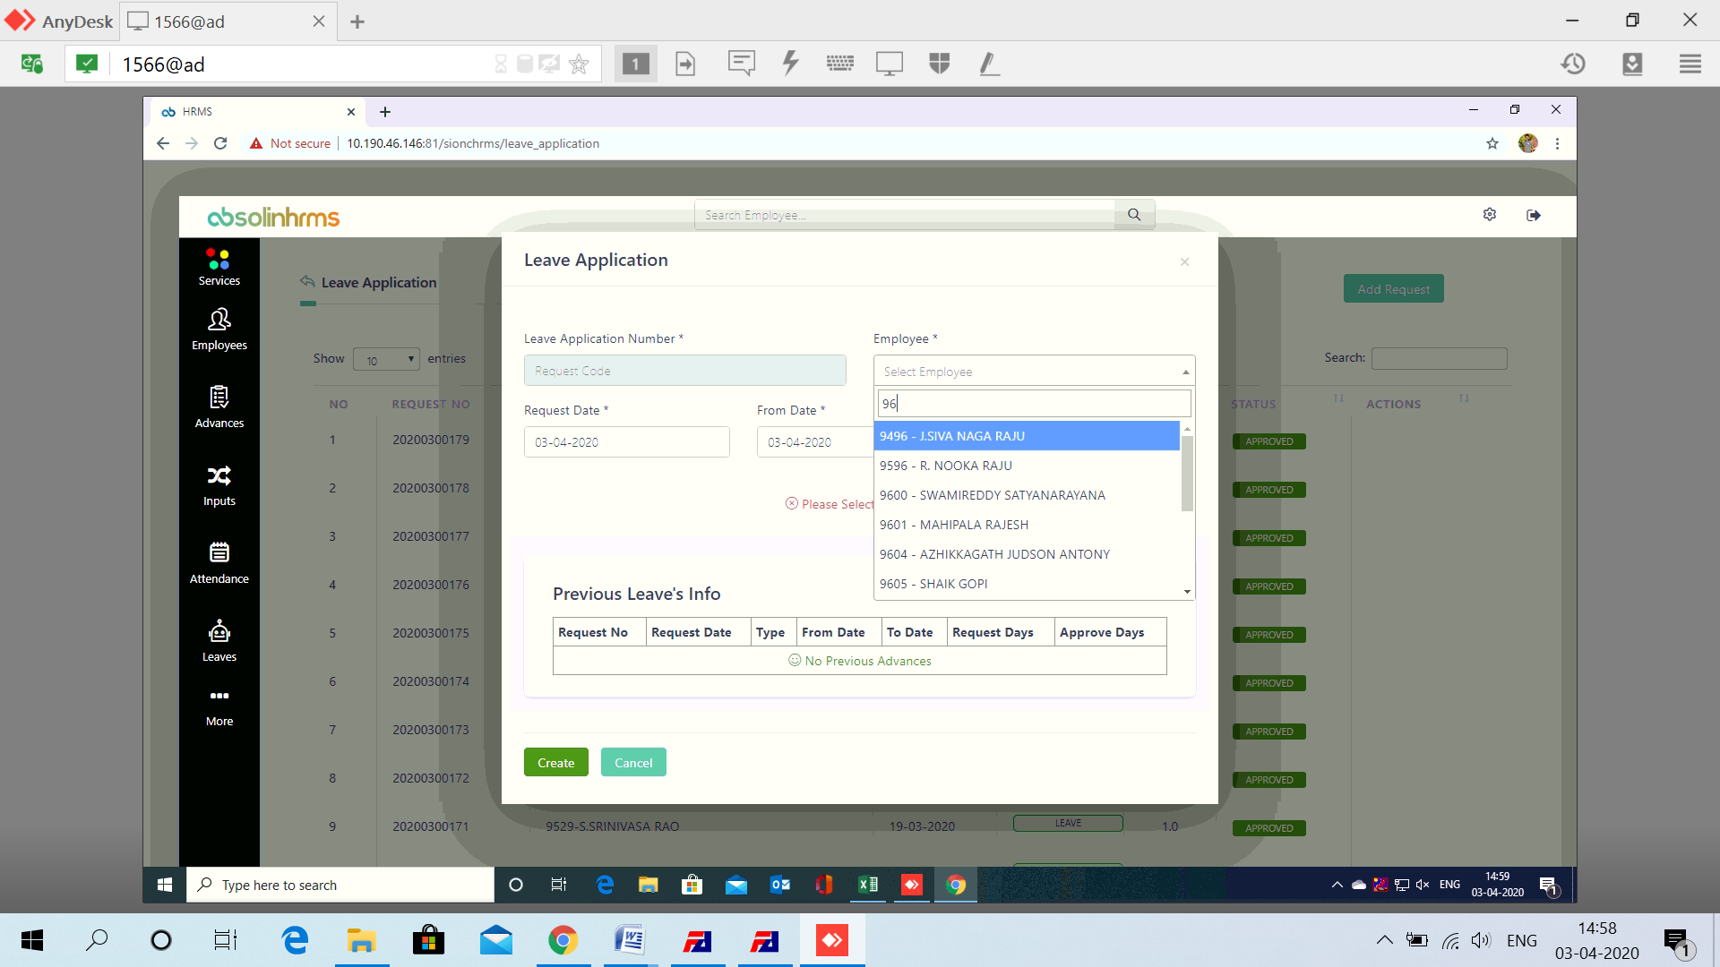

Reference number auto generation not happening

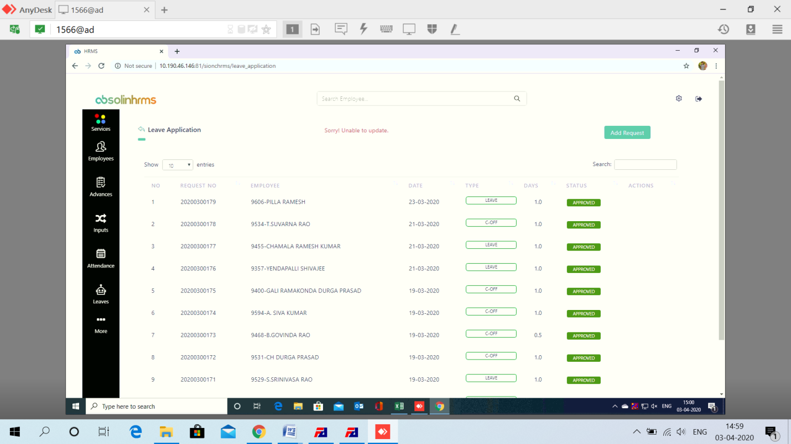

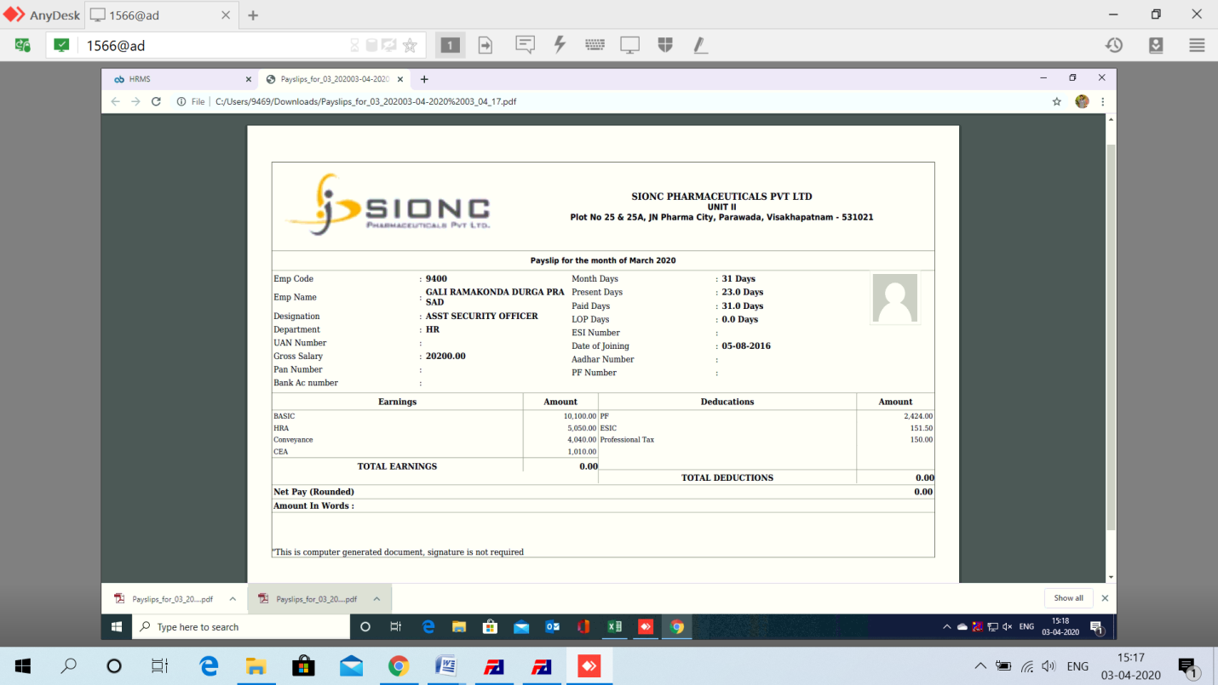

Total earnings and deductions not getting reflected either at monthly deduction screen 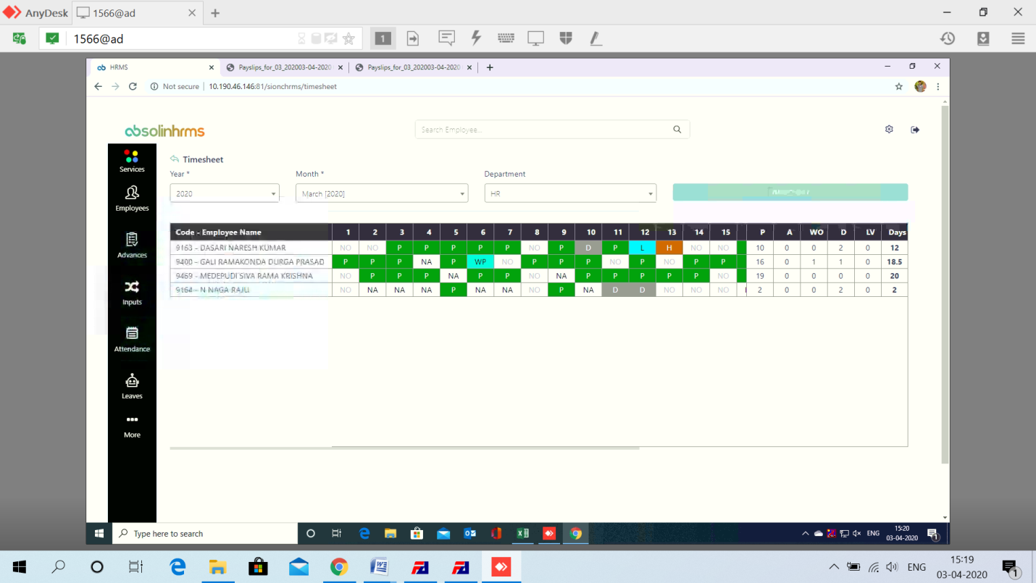

Attendance not getting updated properly.



Attendance not getting mapped properly.