Zelda: Tears of the Kingdom
Offline AI Guide — Architecture Overview
Version 1.0 | March 2026
On-device RAG — fully offline after install
Llama 3.2 1B | sqlite-vec | Core ML | AltStore
Free distribution — no Apple Developer account required

1. Purpose and goals
The Zelda TotK Guide is a personal iOS app that answers questions about The Legend of Zelda: Tears of the Kingdom using entirely on-device AI. The key property is that it works with no internet connection — useful on a plane, in a dungeon (literally), or anywhere with no signal. There is no server, no API key, no subscription, and no data leaving the device.

Core goals
- Answer natural language questions about TotK: item locations, shrine solutions, enemy weaknesses, quest steps, lore
- Fully offline after installation — zero network calls at runtime
- Free to install via AltStore sideloading — no Apple Developer account
- Configurable model: 1B (default, any iPhone) or 3B (better quality, paid account upgrade path)
- Answers grounded in real wiki content — not hallucinated by the LLM

Non-goals for v1
- Multi-user or cloud sync — this is a single-device personal app
- Real-time wiki updates — the knowledge base is built once and bundled
- Voice input or image recognition
- App Store distribution — AltStore sideloading is sufficient for personal use

2. System overview
The system has two distinct environments that never overlap at runtime. Everything complex happens before the app reaches the phone.

Environment | What runs there | When
Windows PC | Python data pipeline: scrape, clean, chunk, embed, build SQLite DB | Once, before first install
GitHub Actions (macOS) | Core ML model conversion, .ipa build | Once per model change or app update
iPhone (runtime) | Vector search, LLM inference, SwiftUI chat UI | Every time the user opens the app

System architecture diagram
The diagram below shows how data flows from three public sources through the build pipeline, through GitHub Actions CI, and ends up bundled inside the iPhone app.

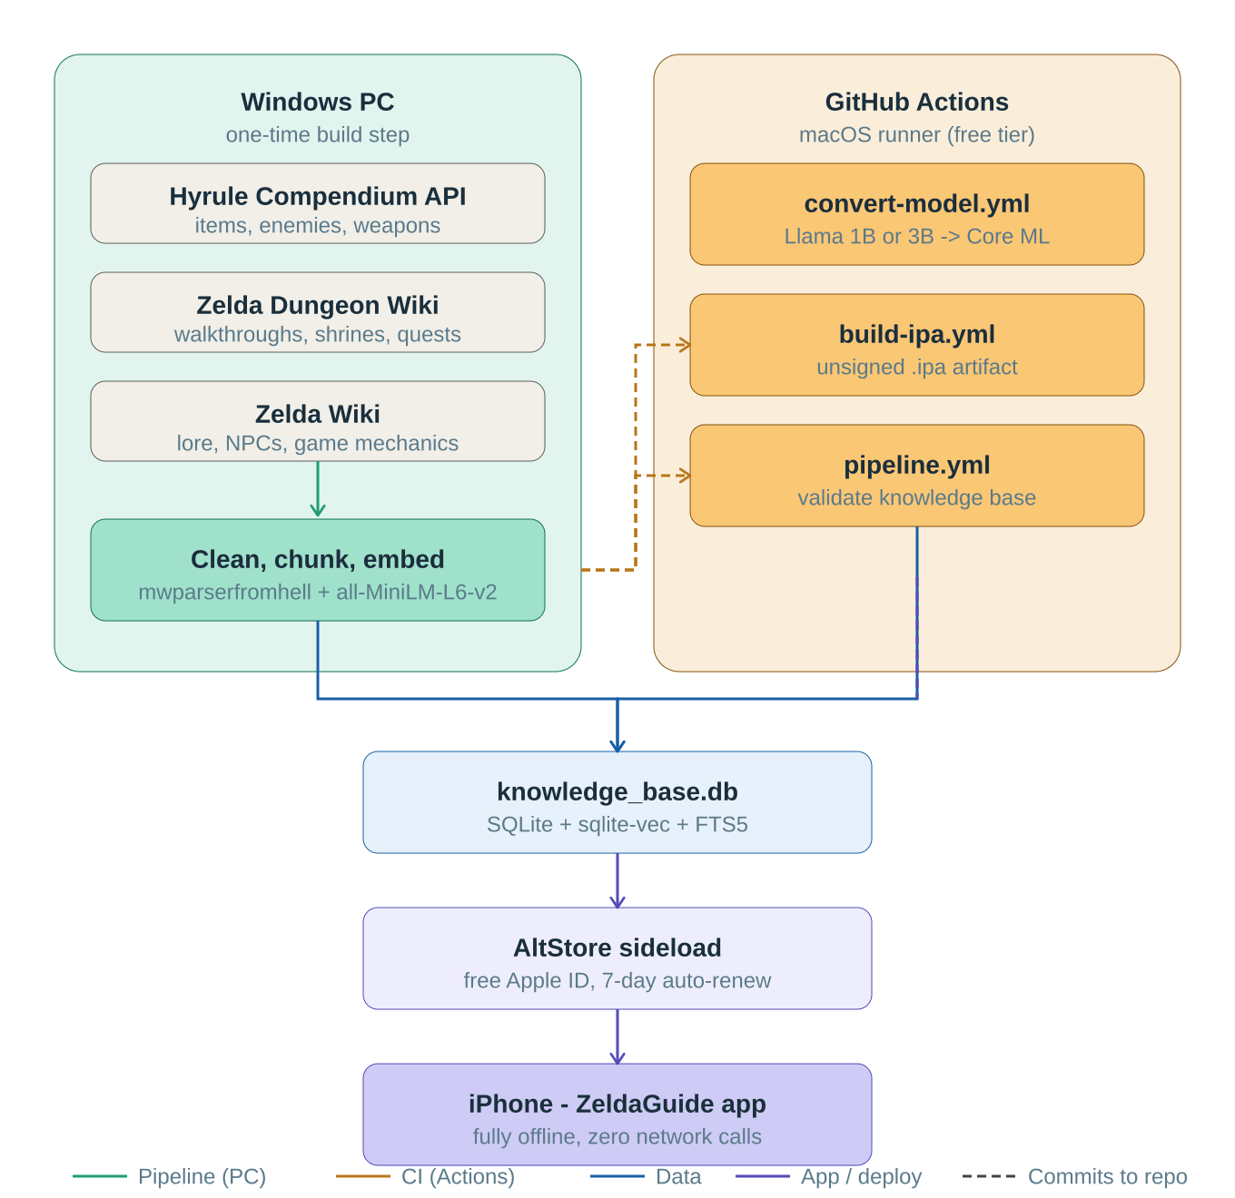

The key insight: build time vs runtime
All the expensive work — scraping 50,000+ wiki pages, generating embeddings, downloading and converting a 1B parameter model — happens exactly once on your PC and in CI. By the time the app lands on your iPhone it contains a pre-built SQLite database and a pre-compiled Core ML model. The app itself is dumb: it just does vector search and token generation, both of which are fast and cheap on modern iPhone silicon.

DESIGN DECISION The knowledge base does not update at runtime. Re-running the pipeline and rebuilding the app is the update mechanism. This keeps the iPhone app simple, fully offline, and free of any background sync logic.

3. Data pipeline
The pipeline runs on your Windows PC once before the first install, and again whenever you want to refresh the knowledge base with updated wiki content. It produces a single file: knowledge_base.db.

Data sources
Source | Method | Content | Licence
Hyrule Compendium API | REST JSON (no key) | All items, enemies, weapons, regions | Fan-compiled, free to use
Zelda Dungeon Wiki | MediaWiki API | Walkthroughs, shrines, side quests | GFDL — attribute in app
Zelda Wiki (zeldawiki.wiki) | MediaWiki API | Lore, NPCs, timeline, mechanics | GFDL — attribute in app

SCRAPING RULES Minimum 1.5 second delay between all wiki API requests. User-Agent identifies the scraper as ZeldaTotKGuide/1.0. Only TotK-related pages are fetched (filtered by category). Tests always use mock HTTP — the live wikis are never hit during testing.

Pipeline stages
- Scrape — fetch raw wikitext and JSON from all three sources, save to data/raw/
- Clean — strip MediaWiki markup using mwparserfromhell, discard stub pages under 100 tokens
- Chunk — split cleaned text into 400-600 token segments with 50-token overlap; format compendium entries as readable paragraphs
- Embed — generate 384-dimension float32 embeddings for every chunk using all-MiniLM-L6-v2
- Store — write chunks and embeddings into SQLite with sqlite-vec virtual table and FTS5 full-text index
- Validate — quality checks: chunk count, source coverage, sample queries, copy to ios/ZeldaGuide/Resources/

Knowledge base structure
The output is a single SQLite file with two tables working together:

Table | Purpose | Key columns
chunks_vec (sqlite-vec) | Vector similarity search | embedding BLOB (float32, 384 dims), rowid
chunks (FTS5) | Full-text keyword search fallback | chunk_text, source, page_title, chunk_index

Expected output: 5,000-50,000 chunks, under 150MB total. A query for 'Where is the Hylian Shield' should return relevant Hyrule Castle content in the top 5 results.

4. Model configuration
The app supports two model variants controlled by a single constant in ModelConfig.swift. Switching models requires changing one line of code and re-running the CI conversion job — nothing else changes.

Property | 1B (default) | 3B (upgrade)
Model | Llama 3.2 1B Instruct | Llama 3.2 3B Instruct
Quantized size | ~600 MB | ~1.8 GB
Total app size | ~750 MB | ~2.5 GB
Min device | Any iPhone (iOS 17) | Any iPhone (iOS 17)
Speed on A15 | ~15 tokens/sec | ~8 tokens/sec
Speed on A17 Pro | ~25 tokens/sec | ~20 tokens/sec
Answer quality | Good for factual Q&A | Better for complex questions
Distribution | AltStore (free Apple ID) | Paid Apple Developer account needed

ARCHITECTURE RULE ModelConfig.swift is the single source of truth for the model variant. No other Swift file may reference a model filename or hardcode generation parameters. This is enforced in code review. The model filename, context length, max output tokens, RAG top-K, and system prompt all live in this one file.

Model conversion (GitHub Actions)
Model conversion runs on a macOS-14 GitHub Actions runner — free tier is sufficient. The process:
- Download Llama 3.2 1B or 3B Instruct weights from Hugging Face (HF_TOKEN secret required)
- Convert to Core ML stateful .mlpackage using coremltools
- Apply 4-bit palettization quantization to reduce size
- Upload as a GitHub Actions artifact — not committed to git (too large)
- Download manually and place in ios/ZeldaGuide/Resources/ before building the .ipa

The embedding model (all-MiniLM-L6-v2) is also converted to Core ML separately so the app can generate query embeddings on-device without any Python runtime.

5. On-device RAG pipeline
This is the core of the app — what happens every time a user submits a question. All five steps run entirely on the iPhone with no network involvement.

RAG pipeline diagram
The diagram below shows the question-to-answer flow inside the app.

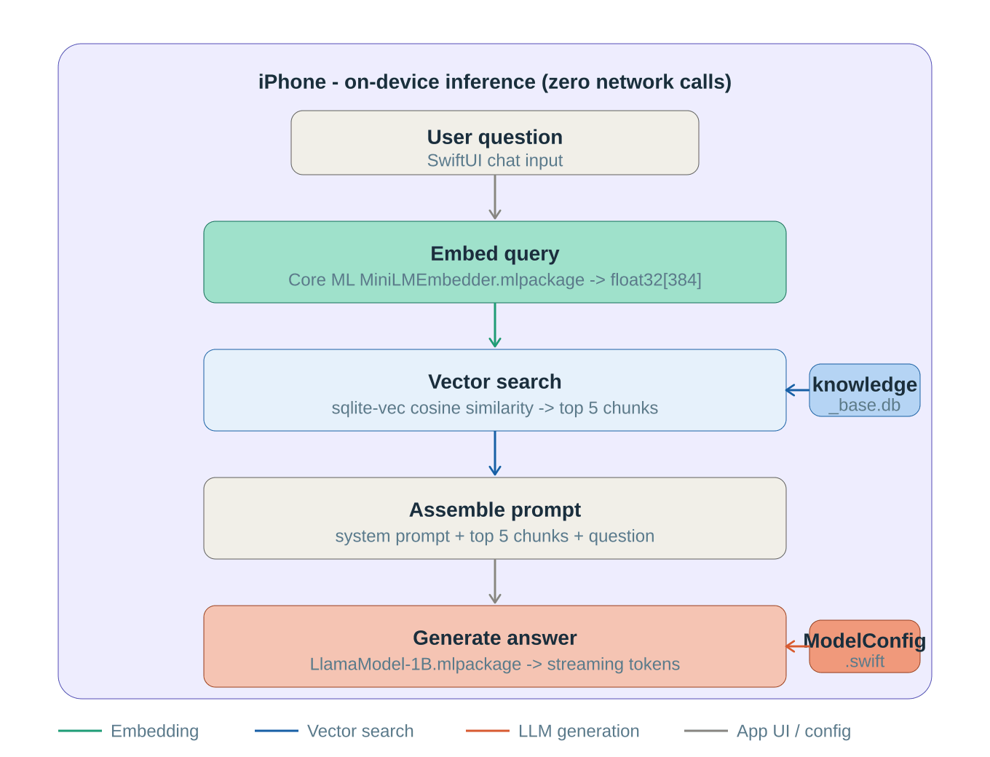

Step by step
- User types a question in the SwiftUI chat interface and taps send
- The query is passed to the Core ML MiniLMEmbedder model, which produces a float32 vector of 384 dimensions
- VectorSearchService queries knowledge_base.db using sqlite-vec cosine similarity, returning the top 5 most relevant chunks
- If vector search returns 0 results, it falls back to FTS5 full-text keyword search
- RAGEngine assembles a prompt: ModelConfig.systemPrompt + the 5 retrieved chunks + the original question
- The prompt is fed to LLMService, which runs the Core ML Llama model and streams tokens back as they are generated
- The SwiftUI view displays tokens as they arrive, word by word
- The source chunks are exposed alongside the answer so the attribution view can show which wiki pages were used

The system prompt
The system prompt is defined in ModelConfig.swift and is the primary guardrail against hallucination:

You are a helpful guide for The Legend of Zelda: Tears of the Kingdom.
Answer questions using only the context provided below.
If the answer is not in the context, say you do not have that information.
Be concise and specific.

WHY THIS MATTERS Without this constraint, the LLM would draw on its training data and potentially invent plausible-sounding but incorrect game information. By restricting it to the retrieved context, wrong answers manifest as 'I don't have that information' rather than confident fabrications.

6. iOS app architecture

Project layout
ios/ZeldaGuide/
Views/ SwiftUI views (ContentView, MessageBubble, SourcesView)
Models/ Swift data models (Message, KnowledgeChunk)
Services/
ModelConfig.swift THE single file to change when switching model variant
VectorSearchService.swift Opens DB, runs cosine similarity search
LLMService.swift Loads Core ML model, streams tokens
RAGEngine.swift Orchestrates: embed -> search -> prompt -> generate
Resources/
knowledge_base.db Built by pipeline, committed to repo
MiniLMEmbedder.mlpackage Built by CI, added manually
LlamaModel-1B.mlpackage Built by CI, added manually

Service responsibilities
Service | Public API | Depends on
VectorSearchService | search(query: [Float], topK: Int) -> [KnowledgeChunk] | knowledge_base.db, ModelConfig.embeddingDimensions
LLMService | generate(prompt: String) -> AsyncStream<String> | ModelConfig.modelFilename, ModelConfig.maxOutputTokens
RAGEngine | answer(question: String) -> AsyncStream<String> | VectorSearchService, LLMService, ModelConfig.systemPrompt

Key design rules
- ModelConfig.swift is the only file that references model filenames or generation parameters — enforced in review
- LLMService loads the model asynchronously at app startup, not on first query — avoids a cold-start delay when the user first asks something
- Generation can be cancelled mid-stream via Swift structured concurrency task cancellation
- The app makes zero network requests at runtime — verified by running in airplane mode
- Source attribution is always shown below each answer for GFDL compliance

7. Distribution via AltStore
AltStore is a free iOS app sideloader that signs apps using your free Apple ID. No paid Apple Developer account is required.

How it works
- GitHub Actions build-ipa.yml produces an unsigned .ipa artifact
- You download the .ipa from the completed Actions run
- AltStore on your iPhone re-signs it with your free Apple ID and installs it
- AltStore Daemon runs on your PC in the background and automatically re-signs the app every 7 days when your phone is on the same Wi-Fi network

Constraints of a free Apple ID
Constraint | Detail | Impact
3-app limit | Maximum 3 sideloaded apps at once from a free Apple ID | Low — you can remove other AltStore apps if needed
7-day expiry | App signature expires every 7 days | None in practice — AltStore Daemon auto-renews
Memory entitlements | Large Core ML models need entitlements only paid accounts can request | 1B model works fine; 3B requires paid account

Upgrade path to 3B model
When you want better answer quality and have a paid Apple Developer account:
- Change activeVariant to .llama3B in ModelConfig.swift
- Trigger convert-model.yml with MODEL_VARIANT=3B in GitHub Actions
- Download the LlamaModel-3B.mlpackage artifact
- Replace LlamaModel-1B.mlpackage in ios/ZeldaGuide/Resources/
- Rebuild via Xcode direct install or configure signing in build-ipa.yml

No other code changes are required. ModelConfig.swift drives all differences.

8. CI workflows
Workflow | Runner | Trigger | Output
pipeline.yml | ubuntu-latest | workflow_dispatch | Validates pipeline runs end-to-end on sample data, runs pytest
convert-model.yml | macos-14 | workflow_dispatch (MODEL_VARIANT input) | Core ML .mlpackage artifact (1B or 3B)
build-ipa.yml | macos-14 | workflow_dispatch | Unsigned .ipa artifact ready for AltStore

FREE TIER NOTE All three workflows run on GitHub Actions free tier. The macOS runner minutes are more limited than Linux but conversion and build jobs run infrequently — typically once when you first set up and once per model upgrade. Normal development does not require the macOS runners.

Secrets required
Secret | Used by | Where to get it
HF_TOKEN | convert-model.yml | https://huggingface.co/settings/tokens (free account, accept Llama licence)

9. Milestones
Milestone | Issues | Key deliverable
1 - Data pipeline | #1-7 | knowledge_base.db built, validated, and committed to repo
2 - Model conversion and CI | #8-10 | Both Core ML models converted, all three CI workflows working
3 - iOS app core | #11-16 | Working chat UI with streaming RAG answers and source attribution
4 - Polish and distribution | #17-18 | AltStore .ipa build documented and tested, performance tuned

Recommended sequence
Milestones 1 and 2 can run in parallel once issue #1 is done — the pipeline and model conversion are independent. Milestone 3 depends on both #7 (knowledge_base.db in Resources/) and the model .mlpackage being in place before the iOS services can be tested end-to-end.

Zelda TotK Guide Architecture Overview | v1.0 | March 2026

