Vehicle Rental System
-Group 12-

1. Functional Requirements

1.1 View and search cars
- The system shows a list of cars. Each car has a name, picture, car type, number of seats, price per day, and status.
- The customer views cars by car type The customer sorts the car list by price (low to high, high to low) and by number of rentals.
- The customer searches cars by keyword, and the system shows the cars whose name contains the keyword.
- The customer views the details of a car: code, name, pictures, description, price per day, status, number of views, and car type.

1.2 Choose and rent a car
- The customer adds a car to the rental cart from the car list or from the car detail page.
- The customer views the cars in the cart, removes a car from the cart, and changes the number of rental days.
- The customer chooses the pick-up date and the return date, and the system checks if the car is free. If the car is not free, the system shows a message.
- The customer chooses "Rent now" after choosing all the cars.
- The system asks the customer to log in or register a new account if the customer is not logged in.
- The customer enters the renter information: full name, ID card number, driver license number, phone number, and address. The person who receives the car can be different from the person who pays.
- The customer chooses to pick up the car at the shop or to get delivery to their address.
- The system calculates the total price = price per day × number of days + delivery fee + deposit. The system gives free delivery if the total is from 2,000,000 VND. Otherwise, the delivery fee depends on the area of the address.
- The customer chooses to pay by cash when receiving the car or to pay online. If the customer pays online, the system connects to the online payment service of the company.
- The system saves the order if the rental is successful. The order includes the cars, rental days, unit price, renter information, receiving method, total price, order time, and payment method.
- The system sends a confirmation email with the full order information if the customer gives an email address.

1.3 Register and update account
- The customer registers a new account.
- The system stores customer information: full name, date of birth, gender, address, phone number, password, and email. The email is the username and is also used to send order information or reset the password.
- The customer updates all of their information except the email.
- The system creates a new random password and sends it to the customer's email if the customer forgets the password.

1.4 View rented orders
- The customer views the list of their orders and the status of each order (New, Confirmed, Car delivered, Returned, Cancelled).
- The customer cancels an order only if its status is "New".

1.5 System administration
- The administrator manages cars: adds, edits, and deletes a car, changes its status (available, rented, under maintenance), and manages car types.
- The administrator manages users: views the user list and locks or unlocks an account.
- The administrator manages orders: views all orders, confirms an order, updates the order status, and cancels an order.
- (Optional) The administrator views a simple revenue report by month.

2. Non-functional Requirements

Usability
- The website is simple, so a new customer rents a car in 5 steps or fewer.
- The system shows clear messages when an error happens.
- The system checks the user input before saving it.

Reliability
- The system does not allow two orders for the same car in the same time period.
- The system cancels the saving of an order if an error happens, so no half-saved data remains.
- The system runs without crashing during a 30-minute demo.

Performance
- Each page loads in 3 seconds or less with about 100 cars in the database.
- The system works well with at least 20 users at the same time.

Supportability
- The website works on the latest versions of Chrome, Edge, and CocCoc
- The website is responsive, so users can use it on a phone, tablet, and computer.
- The project has a README file with the installation guide.

Security
- The system stores passwords in hashed form (for example: bcrypt).
- The system checks the user role, so a customer cannot open the admin pages and can only see their own orders.
- The system uses prepared statements to prevent SQL Injection.

Development requirements
- The team builds the system as a web application with 3 layers: interface, business logic, and data.
- The team uses HTML/CSS/JavaScript, one back-end language (PHP, Java, or Python), and MySQL.
- The team manages the source code on GitHub.
- Data Flow Diagram
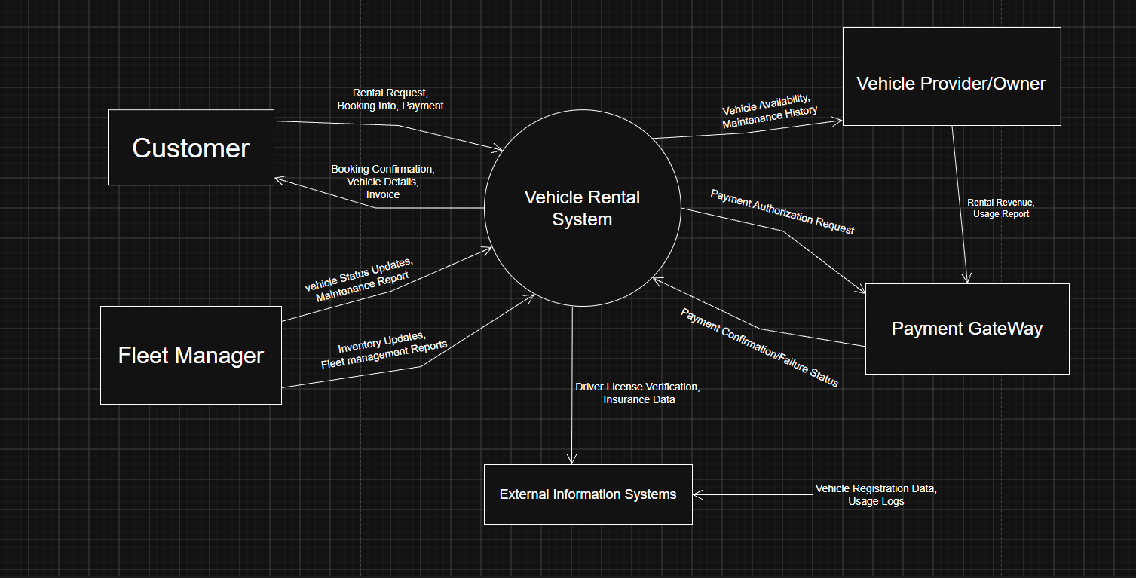
Level 1
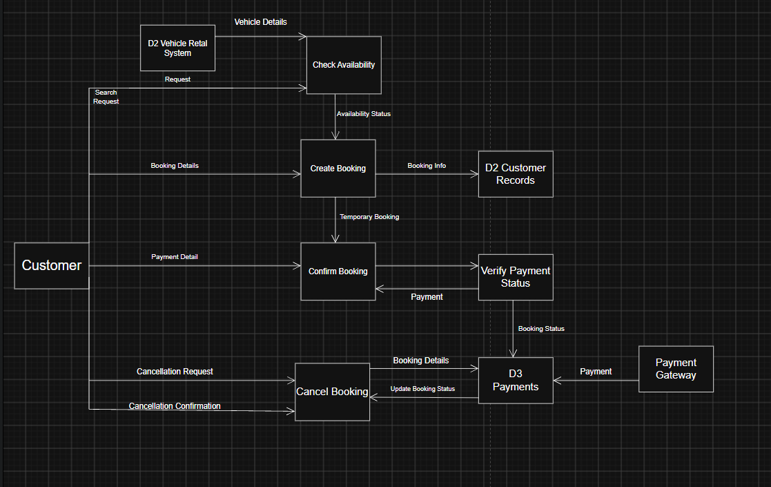
Level 0
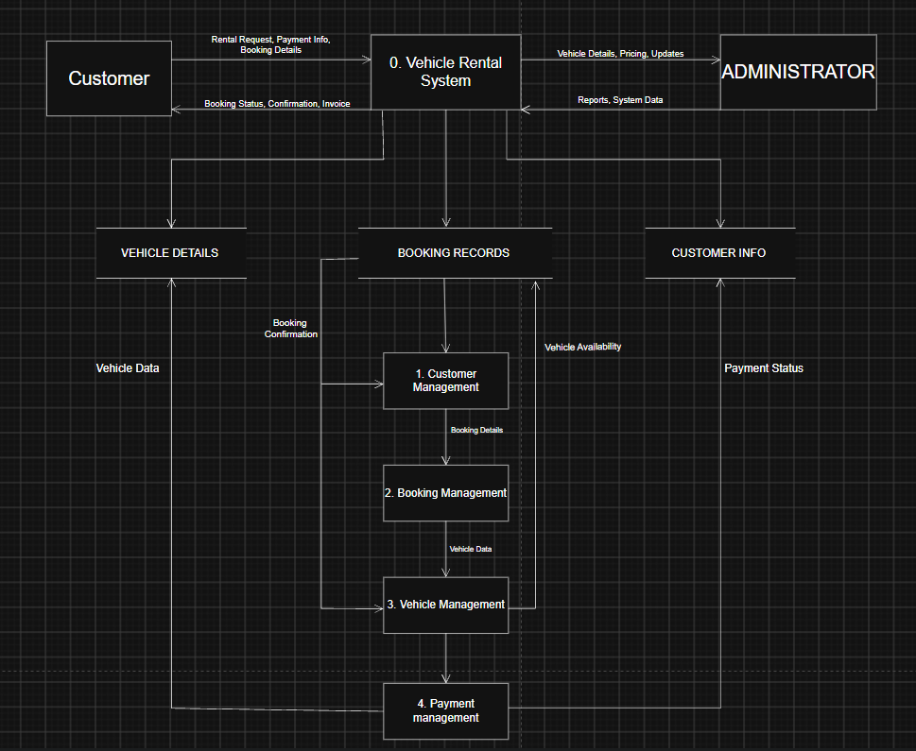
4. Use case Diagram

