# D2.4: Community-building App for Erith Park

Contents

Community-building App for Erith Park 1

Rationale 1

App Design 1

Technical Overview 3

Outcomes 4

APPENDIX A: Ethics form for Erith park app 5

APPENDIX B: Information sheet accompanying app 11

APPENDIX C: Hoarding surrounding the App 12

## Rationale

Orbit is in the process regenerating an unpopular estate that suffered from crime and antisocial behaviour: Larner Road. The regeneration involves demolition of old tower blocks and the creation of a new development: Erith Park[1]. Orbit ‘s ambition is to not only prevent Erith from following the path of its predecessor, but to create a place that people aspire to live in, where residents feel invested in community management.

Our fieldwork identified the impact of coherent communities on the health of a residential development; our interviews with Barbican residents illustrated the importance that residents place on the wider community; Management Companies stated an unequivocal preference to manage residential developments with stronger communities. There is believed to be a direct relationship between the costs of managing a community and the strength of the ties between them (put simply, the more that residents care about the environment that they live in, the better they will take care of it).

Orbit housing subscribes strongly to this view; Erith Park employs a full time community officer whose job is to encourage and develop the new community through events, meetings and general community support. The development has commissioned poets, artists and even archaeologists to work with its residents to help to establish a sense of pride in the development and its local area.

## 

## App Design

Orbit housing were keen for us to work with them build a technology probe that would help encourage community building. In particular, given that many new residents were not necessarily going to participate in Erith’s community building events, a goal of any supporting technology was to support residents in getting to know each other. The aim was to deploy ‘situated’ technology to reduce the barriers to participation as low as possible (i.e. no requirement for users to have mobile phones / laptops / broadband etc). Erith Park is composed of a mix of high and low-rise, mixed tenure properties. Given that the site is under development, there is no central community-focused environment; each of the high-rises have communal spaces next to the lifts and post-boxes that offered semi-secure environment; all residents living in the block would pass through here on a daily basis.

Nottingham University has had experience deploying urban screens[2]; large interactive screens placed in urban areas in various cities in the UK. Each of the screens cycles through various ‘experiences’: live links with other networked screens, public displays of Instagram photos, games and so on. Their most popular experience was one of the simplest: a photo booth, where passersby take photos of themselves, which are then displayed on the screen. Given its simplicity and popularity, we used this as a starting point for our design. Our goal was to allow residents to take pictures of themselves and to tag them (from a list of words e.g. happy, tired, angry etc). The display would show a set number of the most recent photos, and display a live video feed to capture interest.

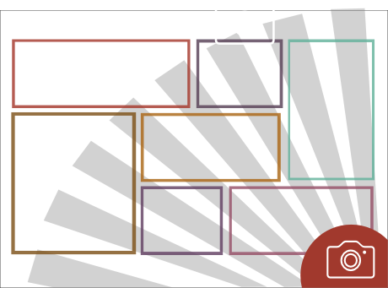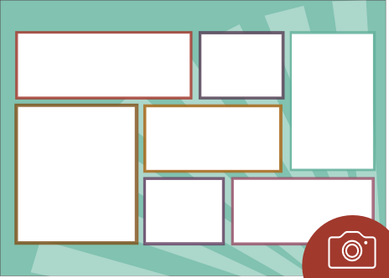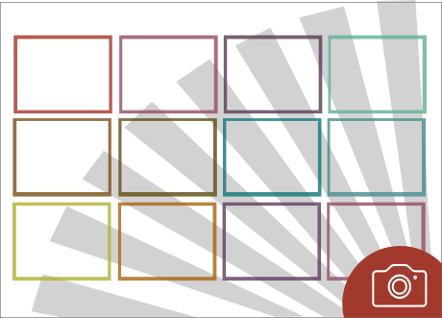

Figure Version 1 mockups

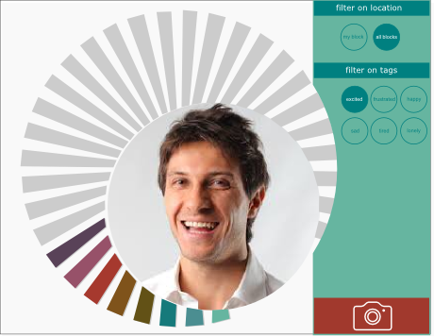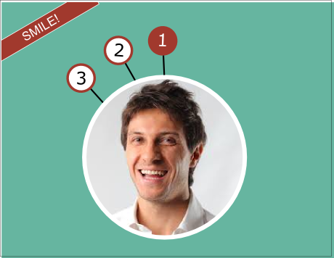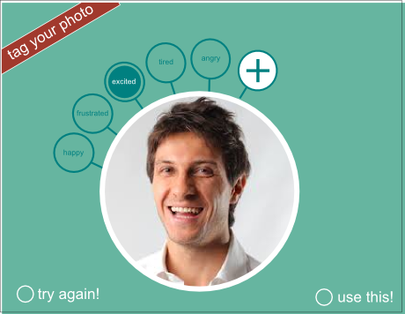

Figure version 2 mockups

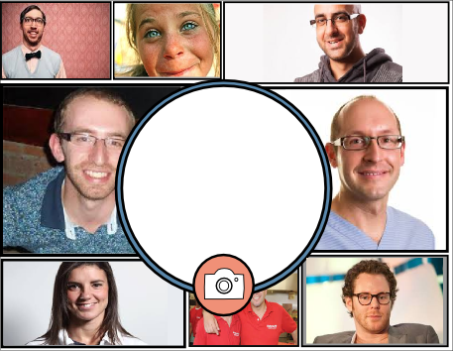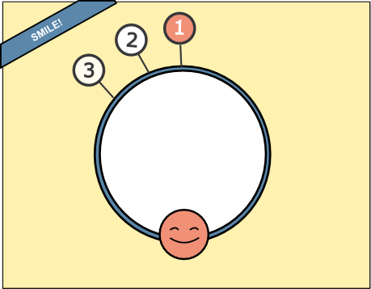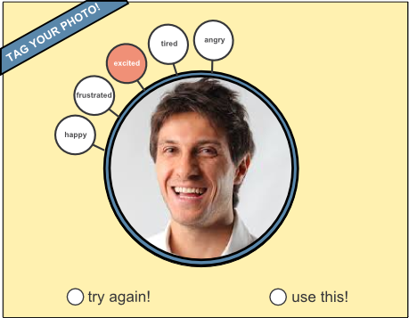

Figure Version 3 mockups

Figures 1 to 3 show the progression of the design of the app. Figure three shows the final template that was settles on. The screen on the left is the default view. The white circle in the middle is a live view. The rectangles around the live shot will are older photos that have been taken by residents. Clicking on the older photos shot will display the photo temporarily in the middle with tags overlaid (after a few seconds it’ll go back to the live view). To take a picture the user presses the camera button and will be taken to the middle screen. There will be a countdown, and the picture is taken and displayed in the central circle (right-most screen). In the final screen the user is invited to tag the photo and use the picture or to try again.

Several final requirements were added by the Erith Park management team. They were concerned about content moderation; there were obvious sensitivities with the display running in a semi-public space; they wanted to be able to view all images as they arrived on the screen, and to be able to delete them if they were inappropriate. They also wanted to be able to have full control of the list of tags that residents could tag a photo with, and they wanted to be able to broadcast messages to the screen in order to be able to advertise events.

## Technical Overview

As a prototype we were keen to develop a probe that could be easily (and remotely) updated, refined and improved as the deployment progressed. The app needed to be able to run continuously, on a tablet, with very patchy Internet connectivity. It was also essential that it was ‘tamper proof’, i.e. it had to be impossible for users to be able to break out of the app to get to the main screen of the device. Given the requirement that the app could be monitored and moderated by management (and display messages) it could not be fully isolated from the network (but what use it does make of it has to be minimal). In addition it needed to be able to operate in a privileged mode to allow Erith Park management to delete photos. Figure 4 presents an overview of the system:

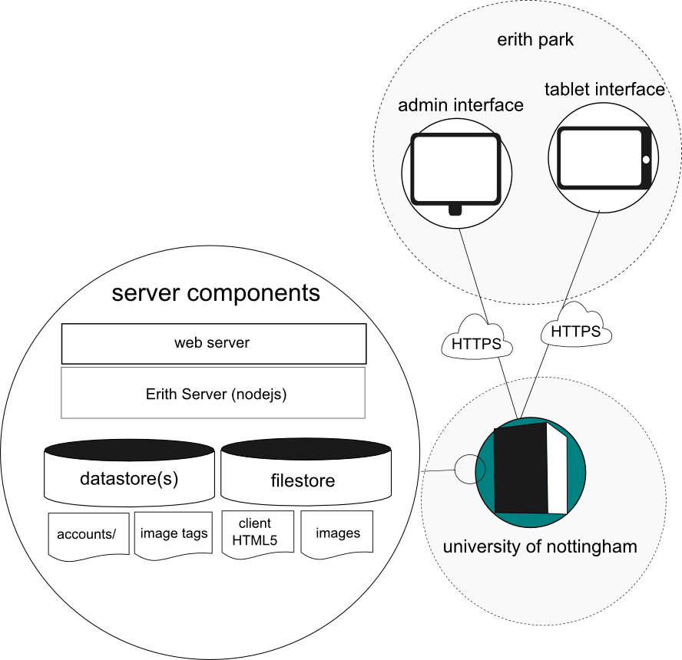

Figure Systems Diagram

The tablet running the photo interface is running android, which does not allow webapps to run full screen. We wrote a simple native android wrapper to get around this limitation. Given the patchiness of the internet connectivity (running over 3G), all images are compressed on the client before being sent to the server. All traffic is encrypted (https) in order to satisfy the ethics requirements (see APPENDIX A). The app was written using d3 (for the animated countdown on the camera) and React[3]/Flux[4]. Full source code can be found at: <https://github.com/tlodge/erith-react>

## Outcomes

The app has been installed on a wall in a communal foyer alongside an ethics statement (see Appendix C) and has been running for several months, though sporadically. The communications infrastructure in Erith is in a state of flux; new mobile phone masts are being installed which are expected to improve the currently very post internet connectivity. In addition there have been some issues getting power to the app, which has meant that it is often turned off over night. In spite of these constraints, the app has run with no issues and has collected over a hundred photos. Though we have not yet had time to do a formal follow up evaluation (we have had to delay this until the problems with power and connectivity are sorted out), our discussions with the Community Support officer suggest that it has been positively received by residents; Orbit now want to deploy more screens in their other high-rise blocks. The app was deployed in accordance with a Nottingham University’s research ethics (see Appendix A for relevant wording, Appendix B for information sheet), which mean that we are unfortunately unable to publish the pictures that have been taken by residents.

The app has also received attention from the Minister of State for Culture, Communications and Creative Industries and was featured as a news story on gov.uk as an approach for supporting digital inclusion. Most importantly we view the installation of the app as an important first step for developing our relationship with Orbit Housing and Erith Park residents in order that we can develop our research further.

## APPENDIX A: Ethics form for Erith park app

|  |
| --- |
| 4. Description of Project, including aims and objectives. *Please include any information which may affect the consideration of the ethics involved, eg location of study, unusual circumstances, age range of participants:*  This project is a collaboration with Orbit housing association (<http://www.orbit.org.uk>) around the deployment of interactive screens into the Erith Park housing estate, London. Erith Park is managed by Orbit housing association. Screens will be installed to explore their potential to support the developing community as it emerges during the completion of Erith Park (on-going). The project involves the development of screen applications, the deployment of screens, the observation of their use, iterations of design and feedback to community members.  **Installation basics:**  Interactive screens (e.g. tablets running custom applications) will be installed in semi-public places at Erith Park, for example in a building’s foyer near the lift. Orbit is managing the site and provides the install locations. Therefore, a lot of the people coming into contact with the installation (but not all, e.g. visitors) would be known to Orbit. Tablets will be networked and can show a variety of applications in principle (see for an example application below). Orbit takes responsibility for the hardware installation on a suitable wall, providing power and networking to the tablet.  **Initial example application:**  The initial example application is a photo booth, using the forward facing camera of a standard tablet computer. The photo booth will allow people to take photos and tag those photos from a selection of pre-set tags. Once photos are taken, people can decide to upload the photo to the display or delete the photo. The photo booth does not record anything, unless a person takes and then uploads a photo. Approximately the last 6 photographs are visible on the screen at any one point.  Using a remote interface, Orbit and MRL can leave messages on the screen, which would for example publicise events or request certain actions from residents. Using a remote interface, Orbit and MRL can delete images from the screen, and Orbit will manage regular checks of the photo feed. Residents will have clear guidance near the installation of how to request the removal of images but cannot remove them themselves. |
| 4. Will personal data or biological materials be collected, recorded and/or analysed?  **Yes** (delete as appropriate)  *If Yes, please give details of the data or materials and the methods to be used and describe how safe storage will be maintained according to the Data Protection Act:* |
| **We are aiming to collect the following data:**   * The photographs taken as part of the use of the photo booth * The tags selected to go with photographs * Sets of tags edited by Orbit * Observations on site that include notes * Interview and focus group feedback (consent form and information sheet required) with residents and Orbit staff   **Data protection:**  The interactive screen is secured to the wall. Photos are uploaded securely over https to a server hosted in CS at Nottingham. The access to the management interface (photographs and tags) will be password protected (Access to the management interface might be distributed to invited residents / community buddies who are part of community groups to lower the burden of image management to Orbit). The interface only shows the images that are currently on screen not the entire back catalogue, which is stored in its entirety but only available to researchers at Nottingham. Data will be deleted when it is no longer required and it is accessible only to those involved in the research.  **Informed consent for using the installation:**  Orbit will clearly communicate the installation to residents of the particular block in advance. Installations do not record anything until a resident interacts with the installation. A sign next to the installation will make clear what interaction with the installation means in terms of data recording. The same sign will also explain how to request the removal of personal data that appear on screen (see attached draft to this application).  **Informed consent for interview and focus groups:**  Specific, signed consent will be sought for participation in interviews and focus groups (see attached forms) |

|  |  |
| --- | --- |
| **SECTION III: Research Ethics Checklist (Part 1)** | |
| **Please answer all questions:** | **Yes/No** |
| 1. Does the study involve participants who are particularly vulnerable or unable to give informed consent (e.g., children, people with learning disabilities, prisoners, your own students)? | No |
| 1. Will the study require the co-operation of a gatekeeper for the initial access to the groups of individuals to be recruited (e.g., students at school, members of a self-help group, residents of a nursing home)? | Yes |
| 1. Will it be necessary for participants to take part in the study without their knowledge and consent at the time (e.g., covert observation of people in non-public places)? | No |
| 1. Will the study involve the discussion of sensitive topics (e.g., sexual activity, drug use)? | No |
| 1. Will participants be asked to discuss anything or partake in any activity that they may find embarrassing or traumatic? | No |
| 1. Is it likely that the study will cause offence to participants for reasons of ethnicity, religion, gender, sexual orientation or culture? | No |
| 1. Are drugs, placebos or other substances (e.g., food substances, vitamins) to be administered to the study participants or will the study involve invasive, intrusive or potentially harmful procedures of any kind? | No |
| 1. Will body fluids or biological material samples be obtained from participants? (e.g., blood, tissue etc) | No |
| 1. Is pain or more than mild discomfort likely to result from the study? | No |
| 1. Could the study induce psychological stress or anxiety or cause harm or negative consequences beyond the risks encountered in normal life? | No |
| 1. Will the study involve prolonged or repetitive testing for each participant? | No |
| 1. Will financial inducement (other than reasonable expenses and compensation for time) be offered to participants? | No |
| 1. Will the study involve the recruitment of patients, staff, tissue sample, records or other data through the NHS or involve NHS sites and other property? If Yes, NHS REC and R&D approvals from the relevant Trusts must be sought prior to the research being undertaken. | No |

|  |  |
| --- | --- |
| **SECTION III: Research Ethics Checklist (Part 2)** | |
| **Please answer all questions:** | **Yes/No/NA** |
| 1. For research conducted in public, non-governmental and private organisations and institutions (such as schools, charities, companies and offices), will approval be gained in advance from the appropriate authorities? | Yes |
| 1. If the research uses human participants, personal data or the use of biological material, will written consent be gained? | No/Yes |
| 1. Will participants be informed of their right to withdraw from the study at any time, without giving explanation? | Yes |
| 1. If data is being collected, will this data be anonymised? | No |
| 1. Will participants be assured of the confidentiality of any data? | Yes |
| 1. Will all data be stored in accordance with the Data Protection Act 1998 | Yes |
| 1. Will participants be informed about who will have access to the data? | Yes |
| 1. If quotations from participants will be used, will participants be asked for consent? | Yes |
| 1. If audio-visual media (voice recording, video, photographs etc) will be used, will participants be asked for consent? | Yes |
| 1. If digital media (eg computer records, http traffic, location logs etc) will be used, will participants be asked for consent? | Yes |
| 1. If the research involves contact with children, will the researchers have appropriate CRB checks? | NA |

* If you have answered ‘No’ to all questions in SECTION III Part 1 and ‘Yes’ to all relevant questions in SECTION III Part 2 the project is deemed to involve **minimal risk** - go to the signature page.
* If you have answered ‘Yes’ to any of the questions in Part 1 or ‘No’ to any of the questions in Part 2 the project is deemed to involve **more than minimal risk**. Please explain in SECTION IV why this is necessary and how you plan to deal with the ethical issues raised.

|  |
| --- |
| **SECTION IV: If the project involves more than minimal risk, please explain why this is necessary and how you plan to deal with the ethical issues raised** |
| **Checklist Part 1**  **2. Gatekeeper**  All access to our study participants will be through Orbit housing association at Erith Park.  **Checklist Part 2**  **2. Written consent**  *General use*  For general use of the application, obtaining written consent is impractical as any passer-by could potentially use the application (even though we anticipate that we know the majority of all users). The interactive screen will only collect personal data when a user pro-actively interacts with it. The fact that data is being collected (e.g. photos, selection of pre-scribed tags) will be made clear on a sign next to the screen. The screen will also provide details about who to contact about the withdrawal of data.  *Interviews and focus groups*  For the planned interviews and focus groups, written consent will be sought (see attached set of forms).  **4. Anonymised data**  The photographs will be stored in non-anonymised form. They will only be published in anonymised form, unless specific written consent has been obtained (e.g. during the interviews or focus groups) |

## APPENDIX B: Information sheet accompanying app

**Screens at Erith Park**

*Screens at Erith park investigates the value of interactive screens for communities as they grow and develop in new housing estates. The project is a collaboration between Orbit housing association and the Mixed Reality Lab, University of Nottingham (*[*www.mrl.nott.ac.uk*](http://www.mrl.nott.ac.uk)*). The project involves the development of screen applications, the deployment of screens, the observation of their use, iterations of design and feedback to community members.*

Interactive screens (e.g. tablets running custom applications) will be installed in semi-public places at Erith Park, for example in a building’s foyer near the lift. Screens will be networked and can show a variety of applications in principle (see for an example application below).

The initial example application is a photo booth, using the forward facing camera of a standard tablet computer. The photo booth will allow people to take photos and tag those photos from a selection of pre-set tags. Once photos are taken, people can decide to upload the photo to the display or delete the photo. The photo booth does not record anything, unless a person takes and then uploads a photo. Approximately the last 6 photographs are visible on the screen at any one point.

We (a team of researchers from the Mixed Reality Lab, School of Computer Science, University of Nottingham) are studying the value of interactive screens for the emerging communities at Erith Park housing estate.

We will collect and analyse video, audio and usage data to build up a picture of the use of the interactive screens through interview and focus groups. We will also analyse observations directly taken on site in form of notes. Finally we will analyse data collected as part of interactions with the screen, for example the photos taken in the photo booth application.

Your data will be stored in accordance with the Data Protection Act 1998, namely on a password protected computer in a secure facility and only for the duration for which it is required, after which it will be destroyed. It will only be accessible by those directly involved in the research project.

All data will be anonymised before dissemination (e.g. publication of research papers or presentation of research at conferences), unless you have given specific consent for data to be included that could identify you (e.g. photographs or video clips). Publishing data will result in information becoming available through the Internet to anyone who wishes to access it.

You are free to withdraw from the study at any time, without giving a reason and without consequence by contacting the researcher (details below). Should you withdraw your consent, all data collected from you will be excluded from the study and records of your contributions will be deleted immediately where it is possible to separate your data from that of other participants (e.g. your comments removed from transcripts). It will not be possible to withdraw that specific data which has already been published.

Please feel free to contact the researcher at any time for further information about the research or in relation to your consent:

Dr Tom Lodge

Research Fellow, Mixed Reality Lab, School of Computer Science

University of Nottingham

[Thomas.Lodge@nottingham.ac.uk](mailto:Thomas.Lodge@nottingham.ac.uk)

This research study has received ethical approval from the School of Computer Science, University of Nottingham.

## APPENDIX C: Hoarding surrounding the App

Screens at Erith Park Research Project

Screens at Erith Park is a research project funded and conducted by the University of Nottingham. *We would like to understand what impact interactive screens like this one have on your community.*

*When you interact with this screen, information about you will be recorded to allow us to monitor and evaluate your interaction. No recording will be made if you do not interact with the screen.*

The recordings are kept securely, according to the Data Protection Act 1998, and will only be used for the purposes of the research project. Only members of the research team and Orbit staff at Erith Park will have access to the data. All data will be anonymised before publication (online and in print media) and all data will be deleted when it is no long required for research purposes.

If you are concerned about what is on screen, please alert Erith Park staff either in person or on tel.: [TBC]

If you have any further questions or would like your personal record deleted for any reason, please contact: Screens at Erith Park, Mixed Reality Laboratory, CS, Jubilee Campus, University of Nottingham, Nottingham NG8 1BB, sitw@cs.nott.ac.uk

1. http://www.erithpark.co.uk/
2. http://screensinthewild.org/
3. <https://facebook.github.io/react/>
4. <https://facebook.github.io/flux/>