## Introduction

Ice-contact lakes influence ice dynamics near the terminus (Baurley; Kirkbride; Sugiyama; Pronk), and this influence can propagate up-glacier (Holt et al., 2024)

Observed increase in prevalence of ice-contact lakes over the satellite era (Carrivick and Quincey, 2014; Shugar et al, 2020; How et al, 2021; Rick et al, 2022).

Estimates of subglacial bed topography (Morlighem et al., 2017) suggest that there are many over-deepenings (Patton et al., 2016) which are liable to fill with meltwater during margin recession, further increasing [the number] the influence of ice-contact lakes on ice sheet mass balance (Carrivick et al., 2022).

There is a fundamental difference between bedrock dammed ice-contact lakes at the terminus of a topographically confined outlet glacier (hereafter proglacial lakes), and ice-dammed lakes oblique to main ice-flow (hereafter ice-marginal lakes). Whilst it has been shown that ice surface velocity proximate to (all types of) ice-contact lakes are enhanced (by ~25% (Carrivick et al., 2022)), it is contended that due to the long-term stability of bedrock dammed lakes (versus the transient nature of valley-side ice-dammed lakes), they are likely to be of greater importance in controlling ice sheet mass balance (Holt et al., 2024).

The force balance at the terminus dictates whether or not the lake has a material impact on dynamics (O’Neel et al., 2005; Pronk et al., 2021), with lake depth and ice thickness being key. Additionally

* Determining lake depth from satellite imagery is tricky
* *Likely* that many of the lakes in the ice marginal lake inventory (How et al., 2021) – which are in turn used by Carrivick et al., (2022) are not deep enough to have any significant influence on force balance.
* *And* (from my reading of their methods and SI) the 25% quoted by Carrivick et al., comes from 2014-2019 average velocity mosaic taken at points along the margin (i.e. point sampled at terminus, not upglacier), *and*, they do not consider the *direction* of the velocity at these points (i.e. is the flux even directed into the lake at that point?)

Recent work (Holt et al., 2024) at Isortuarsuup Sermia illustrated the potential for terminus thinning to drive ice flow acceleration at lake-terminating outlet glaciers.

*Need* to:

* ascertain the whether the observed behaviour at Isortuarsuup Sermia is typical at other lake-terminating outlets across Greenland
  + This would be the *new contribution*
  + Carrivick et al., 2022 only looked at velocity at the margin (from 2014-2019 mosaic)
  + Mallalieu et al., 2021 only looked at margin position
  + Neither looked at surface elevation change.
* Is there a latitudinal (/climate) control on lake-terminating dynamics?
* Something about lake depth – can we do *anything* to estimate bathymetry?

The potential of ice-contact lakes to have a substantial influence on ice sheet mass balance is context dependent. This paper aims to illustrate this sensitivity to ‘context’ (topographic setting, present-day dynamics, climate).

## Method

### Study sites

We are interested ice-contact lakes that are bedrock controlled, not those that reside in a tributary valley dammed by ice in the main trunk (Figure 1).

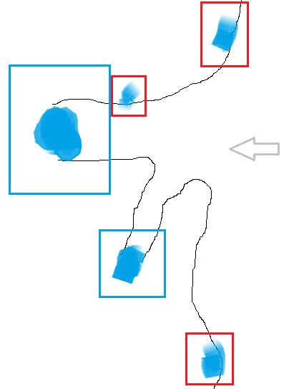

Figure : Lakes of interest (in blue boxes) at the end of topographically confined outlet glaciers; and lakes that are not of interest (red boxes) sited along the margins (oblique) to flow/ on interfluves. Grey arrow shows direction of Ice flow direction shown. Ice margin in black.

Using the inventory of ice marginal lakes (IIML) (How et al., 2021) (which has a nominal date of 2017), lakes were manually selected if the lake is sited at the end of a topographically confined outlet-glacier, and lakes were excluded if it is likely to be ice-dammed, or of if it is a small distributary of a larger fast-flowing marine-terminating outlet.

The selection process is largely subjective.

For example, Inderhytten, despite being the 2nd largest lake in the IIML, it’s catchment is small, and

### Ice velocity

### Surface elevation change

For each glacier a centreline was drawn with reference to satellite imagery and the ice velocity data generated above. Individual ArcticDEM (v.4.1) strips were selected where (a) the acquisition date was between April and October (inclusive) and (b) the if the strips intersected a 5 km buffer around each centreline. The identified DEMs were all clipped to same extent and, using the supplied bit-mask, grid-squares marked as cloud, water and edges were set to null. The DEM with the greatest number of valid measurements was chosen to as the reference DEM to which all other DEMs at that site were coregistered. To identify regions where no elevation change should be detected (i.e., exposed bedrock) a stable terrain mask was generated from all Sentinel-2 scenes that intersect the DEM with acquisition dates in July and August, and with cloud coverage < 10%. For each scene the normalized difference water index (NDWI) was calculated and grid-squares where the median NDWI over time was less than zero, are taken to be stable terrain. These binary masks were reprojected to the same resolution as the DEM prior to coregistration. Coregistration was done using the XDEM python package in two steps: first the method of Nuth & Kaab (2011) for sub-pixel accuracy, followed by a 2d plane tilt correction. The quality of the coregistration was assessed by differencing the newly coregistered DEM with the reference and computing both the normalized median absolute deviation (NMAD), which provides a measure of dispersion, and the median difference over stable terrain (MDOST). The coregistration process aims to bring both of these values close to zero.

$$\text{NMAD}\left(x\right) = 1.4826 × \text{median}({|x}_{i}-\text{median}(x)|)$$

The coregistered DEMs at each site were filtered to ensure only those with high precision were included in subsequent analyses. A threshold of 1 m was set for MDOST, and 2 m for NMAD.

Rates of surface elevation change were computed from the stack of coregistered DEMs using the Theil-Sen slope estimator, as this is robust to outliers. 95% confidence intervals were computed about this estimate.

Note: when plotting SEC against elevation, the median elevation is used.

## Results

