Programming Exercise

The Bohr model of the atom postulates that electrons can move between different energy levels in discrete steps. When the electron is stimulated and subsequently moves back to its original energy level a photon is emitted of a particular frequency. The picture below gives all possible transitions for six energy levels.

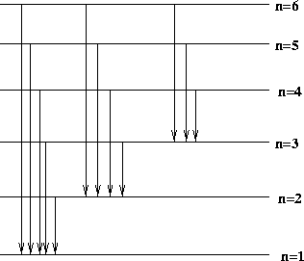
The set of all transitions is as follows: [6,1; 5,1; 4,1; 3,1; 2,1; 6,2; 5,2; 4,2; 3,2; 6,3; 5,3; 4,3] where the first value is the higher energy level and the second value is the lower level.

Of the 12 possible photons emitted, the probabilities for level transitions are as follows:

1 level – 60% (that is, the set [2,1; 3,2; 4,3] of photons)
2 levels – 21%
3 levels – 12 %
4 levels – 6 %
5 levels – 1 %

We would like to use these photon emissions to give directions to a unique jumping robot. The robot starts near center of a 20 X 20 grid denoted by x,y coordinates starting at 0 (i.e. x and y coords are between 0-19). We'll say the starting location is position (9,9) and the robot is facing North (positive y direction) and the location (0,0) is at the lower left.

The robot moves in the following manner, by the type of photon emitted, the robot will rotate clockwise 90 degrees for each energy level of the lower energy state, then move forward one space for each energy level of the higher energy state. For example, if the photon corresponds to energy transition (5,3), the robot rotates 270 degrees clockwise then jumps forward 5 spaces.

Challenge
Write a system using the probability distribution and movement characteristics described above and produce a sequence of photons that ends when the robot leaves the grid.

Run this program 10,000 times. Produce a report that has the number of photons emitted until the robot leaves the grid, and the count for each occurrence. (i.e. 20 photons emitted occurs 12 times, 21 photons emitted occurs 42 times, etc.)

Use your best programming practices. It should take between 2-3 hours to complete.

