Question 1: (4.0 Point)
Design the form might look something like fingue below
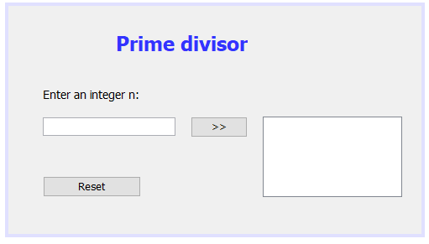
a. Click RESET button, set value of TextField and TextArea is empty.
b. Check input n is integer (n<15). If input fail, TextBox “Enter an integer n” is set empty and show error message.
c. When input an integer number (1-15)
Click button >>: The composite divisor of n will be added to the TextArea.

Question 2: (4.0 Point)

Make a search username frame:
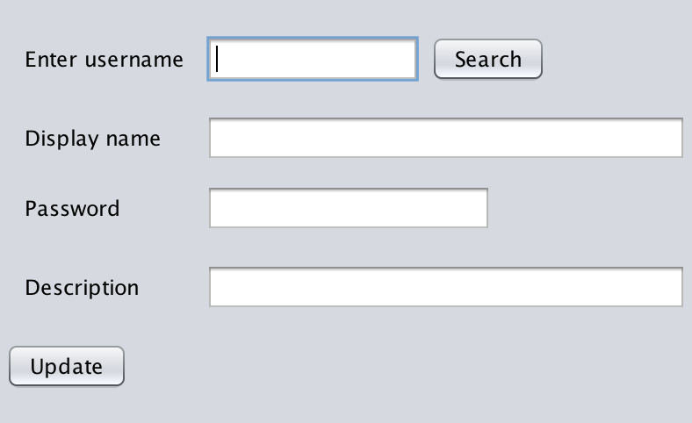
When users enter username, do the searching and output information of entered username.
Users can update the value for entered username, please note that username is not allowed to updated.
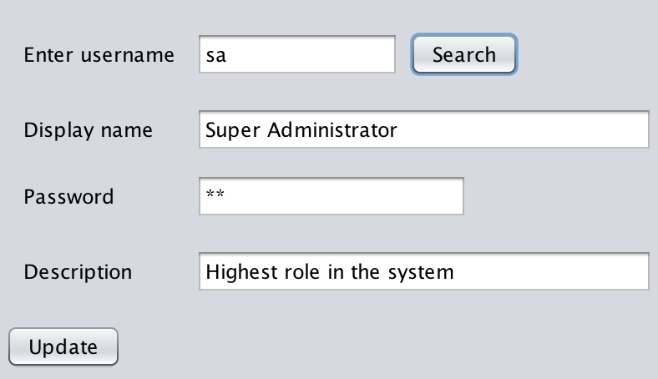

create database BookDB
GO
USE [BookDB]
GO
create table Users
(
UserName nvarchar(255) primary key,
DisplayName nvarchar(max) not null,
Password nvarchar(255) not null,
Description nvarchar(max)
)
go
insert into Users(UserName,DisplayName,Password,Description)
values('sa','Super Administrator','sa','Highest role in the system')
insert into Users(UserName,DisplayName,Password,Description)
values('an','Manager','an','Managers in the system')
insert into Users(UserName,DisplayName,Password,Description)
values('nam','User','nam','Users in the system')

Question 3: (2.0 Point)

Design the form might look something like fingue below, named java file is AColor.java
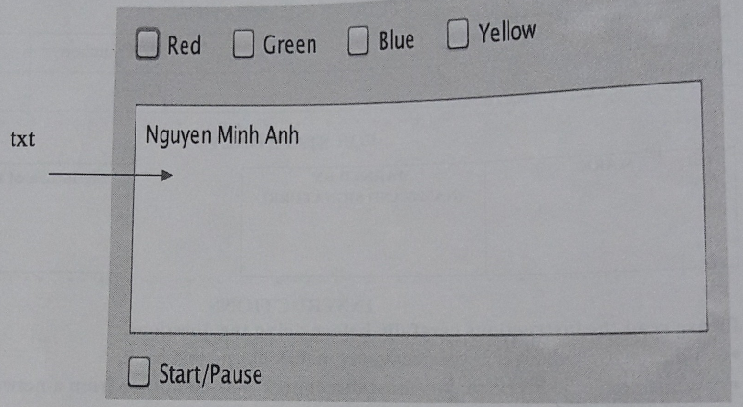
The frame including 5 checkboxes and a textarea (txt). At the running time:
- Output your full name to txt
- When users select/check on checkbox of colors:
  - If checkbox “Start/Pause” is checked then change the background (or text color) txt every second a mong selected colors (which are selected from checkboxes)
  - Stop changing background color (or text color) of txt if checkbox “Start/Pause” unchecked
See the below figures for more detail
