**Japanese Restaurant in Toronto**

**Lorenzo Stocchi**

**January 25, 2021**

This project aims to utilize all Data Science Concepts learned in the IBM Data Science Professional Course. We define a Business Problem, the data that will be utilized and using that data, we are able to analyze it using Machine Learning tools. In this project, we will go through all the processes in a step by step manner from problem designing, data preparation to final analysis and finally will provide a conclusion that can be leveraged by the business stakeholders to make their decisions.

# Table of Contents

1. Introduction
2. Target Audience
3. Data Overview
4. Methodology
5. Discussion
6. Conclusion

# 1. Introduction (Identifying the Business Problem)

Toronto is one of the most densely populated areas in Canada.

Multiculturalism is seen through the various neighbourhoods including; Chinatown, Corso Italia, Little India, Kensington Market, Little Italy, Koreatown and many more.

Being the land of opportunity, it brings in a variety of people from different ethnic backgrounds to the core city of Canada, Toronto. Being the largest city in Canada with an estimated population of over 6 million, there is no doubt about the diversity of the population.

Downtown Toronto being the hub of interactions between ethnicities brings many opportunities for entrepreneurs to start or grow their business.

The objective of this project is to use Foursquare location data and regional clustering of venue information to determine what might be the ‘best’ neighbourhood in Toronto to open a Japanese Restaurant.

It is a place where people can try the best of each culture, either while they work or just passing through. Toronto is well known for its great food.

Toronto has a population of Japanese Canadians and also one of Japanese nationals. As **of 2010** there are about **20,000 Japanese** Canadians in Toronto. Adam McDowell of the National Post stated that Toronto's Japanese community was "never very large compared to, say, the Chinese or Italian communities".

Despite there being a lot of Japanese themed restaurants. Through this project, we will find the most suitable location for an entrepreneur to open a new Japanese restaurant in Toronto, Canada.

# 2. Target Audience

This project is aimed towards Entrepreneurs or Business owners who want to open a new Japanese Restaurant or grow their current business. The analysis will provide vital information that can be used by the target audience.

# 3. Data Overview

The data that will be required will be a combination of CSV files that have been prepared for the purposes of the analysis from multiple sources which will provide the list of neighbourhoods in Toronto (via Wikipedia), the Geographical location of the neighbourhoods (via Geocoder package) and Venue data pertaining to Japanese Restaurants (via Foursquare). The Venue data will help find which neighbourhood is best suitable to open a Japanese Restaurant.

2.1 — Data acquisition:

*Source 1: Toronto Neighborhoods via Wikipedia*

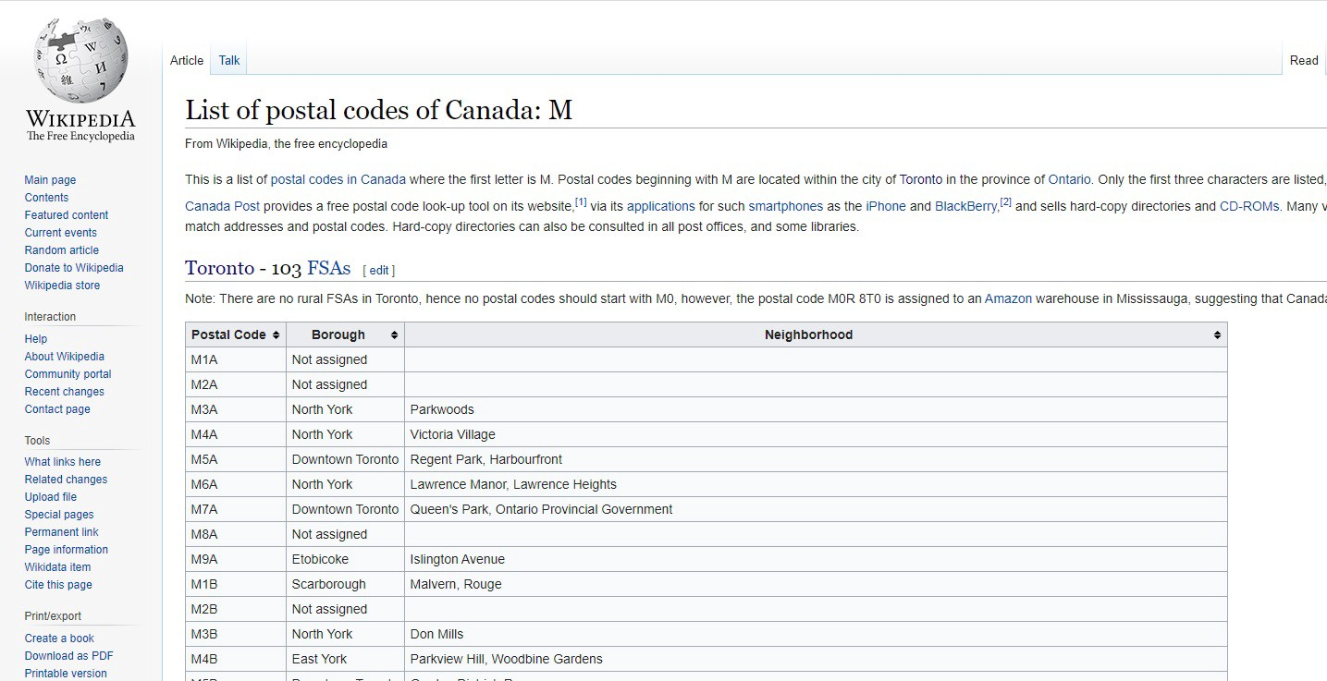

The Wikipedia site shown above provided almost all the information about the neighbourhoods. It included the postal code, borough and the name of the neighbourhoods present in Toronto. Since the data is not in a format that is suitable for analysis, scraping of the data was done from this site.

1. <https://en.wikipedia.org/wiki/List_of_postal_codes_of_Canada:_M>

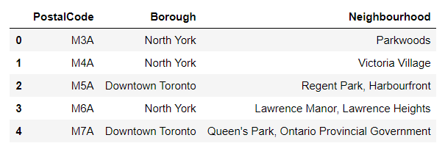

*Source 2: Geographical Location data using Geocoder Package*

The second source of data provided us with the Geographical coordinates of the neighbourhoods with the respective Postal Codes. The file was in CSV format, so we had to attach it to a Pandas data frame.

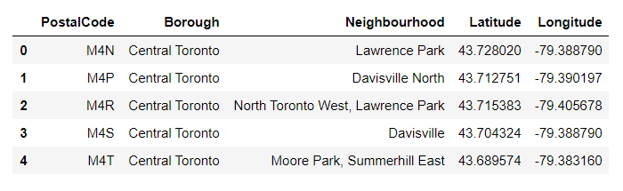

*Source 3: Venue Data using Foursquare*

We performed a bit of data cleansing. Then the neighbourhoods are grouped by the name of the neighbourhood, so data clustering is made easier later on.

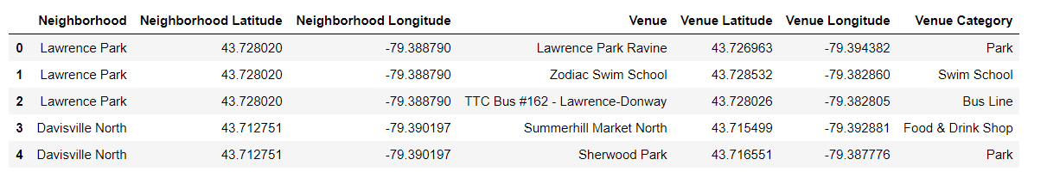

# 4. Methodology

4.1 — Data Cleansing

After all the data was collected and put into data frames, cleansing and merging of the data was required to start the process of analysis. When getting the data from Wikipedia, there were Boroughs that were not assigned to any neighbourhood therefore, the following assumptions were made:

1. Only the cells that have an assigned borough will be processed. Borough’s that were not assigned get ignored.

2. More than one neighbourhood can exist in one postal code area. For example, in the table on the Wikipedia page, you will notice that M5A is listed twice and has two neighbourhoods: Harbourfront and Regent Park. These two rows will be combined into one row with the neighbourhoods separated with a comma.

3. If a cell has a borough but a Not assigned neighbourhood, then the neighbourhood will be the same as the borough.

After the implementation of the following assumptions, the rows were grouped based on the borough.

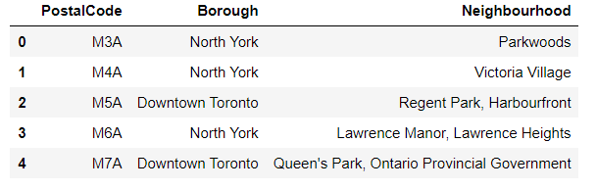

Using the Latitude and Longitude collected from the Geocoder package, we merged the two tables together based on Postal Code.

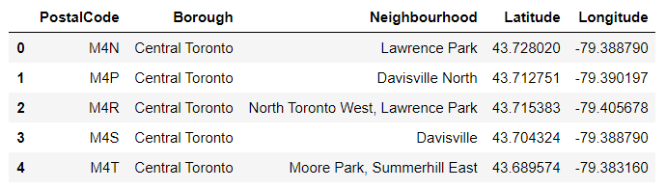

After, the venue data pulled from the Foursquare API was merged with the table above providing us with the local venue within a 500-meter radius.

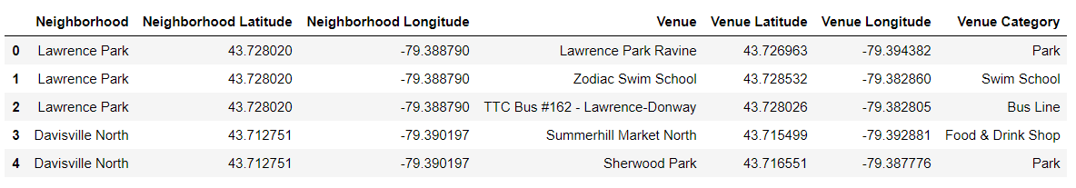

4.2 — Data Exploration

Now after cleansing the data, the next step was to analyze it. We then created a map using Folium and colour-coded each Neighborhood depending on what Borough it was located in.

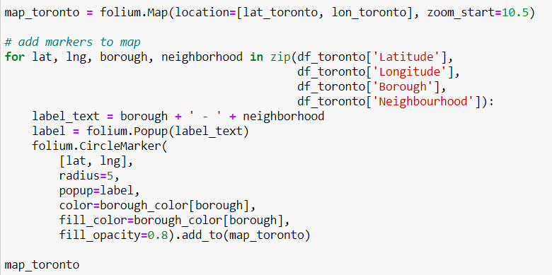

This snippet of code provided us with the map below:

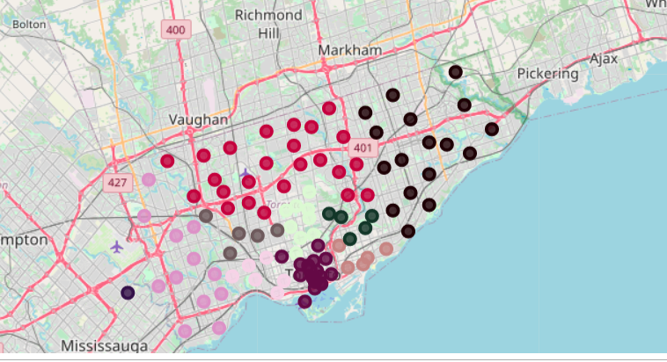

Next, we used the Foursquare API to get a list of all the Venues in Toronto which included Parks, Schools, Café Shops, Asian Restaurants etc. Getting this data was crucial to analyzing the number of Japanese Restaurants all over Toronto. There was a total of 41 Japanese Restaurants in Toronto. We then merged the Foursquare Venue data with the Neighborhood data which then gave us the nearest Venue for each of the Neighborhoods.

4.3 — Machine Learning

Then to analyze the data we performed a technique in which Categorical Data is transformed into Numerical Data for Machine Learning algorithms. This technique is called **One hot encoding**. For each of the neighbourhoods, individual venues were turned into the frequency at how many of those Venues were located in each neighbourhood.

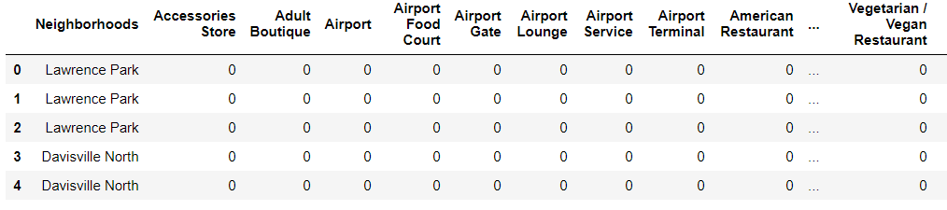

Then we grouped those rows by Neighborhood and by taking the **average** of the frequency of occurrence of each Venue Category.

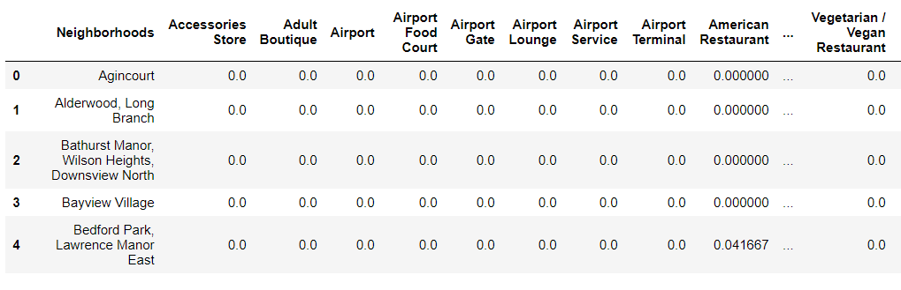

After, we created a new data frame that only stored the Neighborhood names as well as the mean frequency of Japanese Restaurants in that Neighborhood. This allowed the data to be summarized based on each individual Neighborhood and made the data much simpler to analyze.

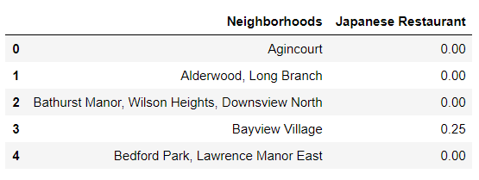

**K-Means Clustering**

To make the analysis more interesting, we wanted to cluster the neighbourhoods based on the neighbourhoods that had similar averages of Japanese Restaurants in that Neighborhood. To do this we used **K-Means**clustering. To get our optimum K value that was neither overfitting or underfitting the model, we used the **Elbow Point** Technique. In this technique, we ran a test with different number of K values and measured the accuracy and then chose the best K value. The best K value is chosen at the point in which the line has the sharpest turn. In our case, we had the Elbow Point at K = 4. That means we will have a total of 4 clusters.

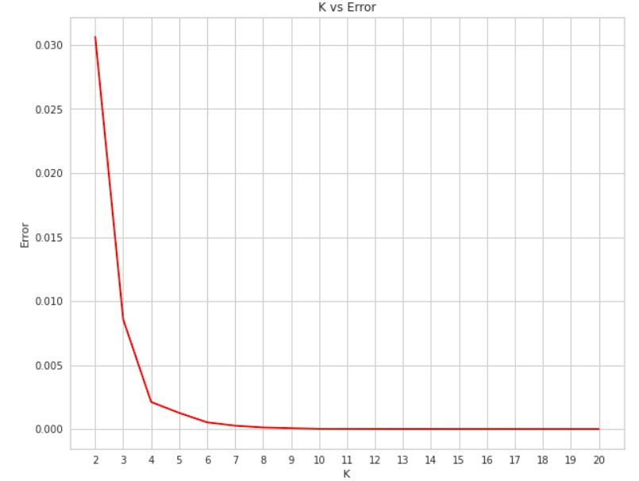

Moreover, in K-Means clustering, objects that are similar based on a certain variable are put into the same cluster. Neighbourhoods that had a similar mean frequency of Japanese Restaurants were divided into 4 clusters. Each of these clusters was labelled from 0 to 3 as the indexing of labels begins with 0 instead of 1.

After, we merged the venue data with the table above creating a new table which would be the basis for analyzing new opportunities for opening a new Japanese Restaurant in Toronto. Then we created a map using the Folium package in Python and each neighbourhood was coloured based on the cluster label.

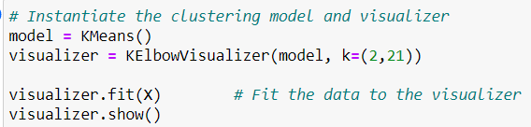

This gave the model below:

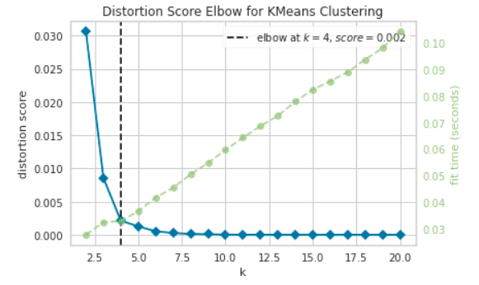

We just integrated a model that would fit the error and calculate the distortion score. From the dotted line, we see that the Elbow is at K=4. Moreover, in K-Means clustering, objects that are similar based on a certain variable are put into the same cluster. Neighbourhoods that had a similar mean frequency of Japanese Restaurants were divided into 4 clusters. Each of these clusters was labelled from 0 to 3 as the indexing of labels begins with 0 instead of 1.

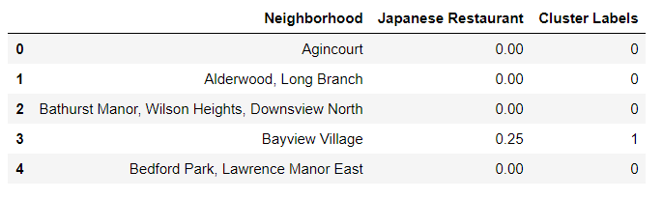

After, we merged the venue data with the table above creating a new table which would be the basis for analyzing new opportunities for opening a new Japanese Restaurant in Toronto. Then we created a map using the Folium package in Python and each neighbourhood was coloured based on the cluster label.

* Cluster 1 — Red
* Cluster 2 — Purple
* Cluster 3 — Turquoise
* Cluster 4 — Dark Khaki

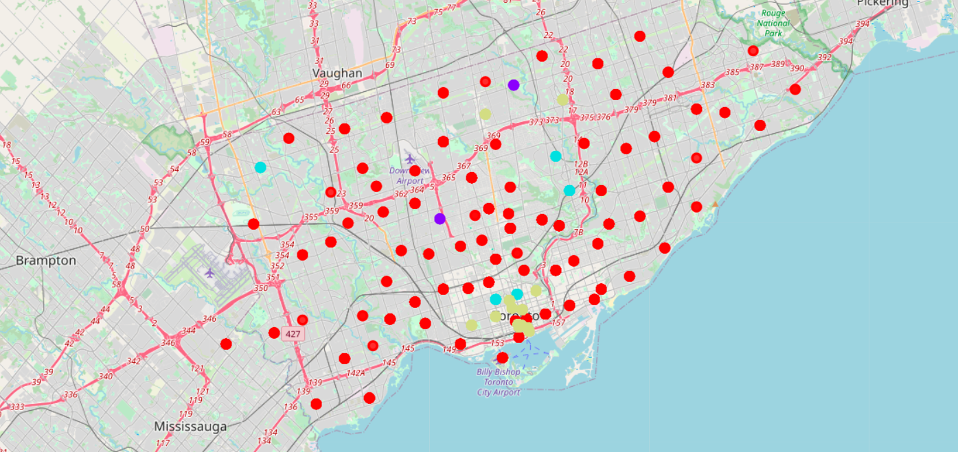

The map above shows the different clusters that had a similar mean frequency of Japanese restaurants.

4.4 - Data Analysis

We have a total of 4 clusters (0,1,2,3). Before we analyze them one by one let's check the total amount of neighbourhoods in each cluster and the average Japanese Restaurants in that cluster. From the bar graph that was made using Matplotlib, we can compare the number of Neighborhoods per Cluster. We see that Cluster 1 has the most neighbourhoods (77) while cluster 2 has the least (2). Cluster 3 has 4 neighbourhoods and cluster 4 has only 13.

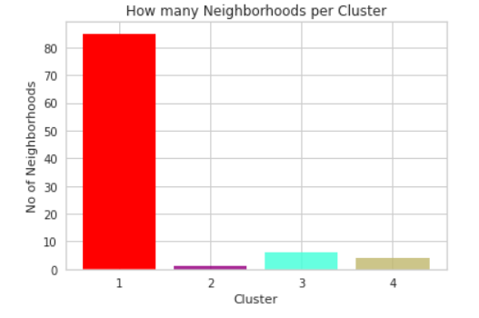

Then we compared the average Japanese Restaurants per cluster.

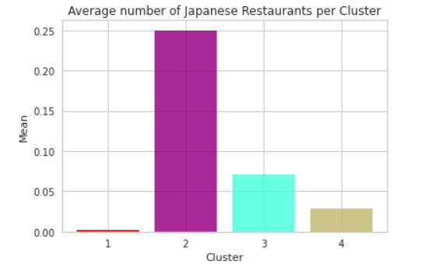

**Cluster Analysis**

This information is crucial as we can see that even though there is only 2 neighbourhood in Cluster 2, it has the highest number of Japanese Restaurants (0.25) while Cluster 1 has the most neighbourhoods but has the least average of Japanese Restaurants (0.0027).

Now let’s analyze the Clusters individually (Note: these are just snippets of the data).

***Cluster 1(Red):***

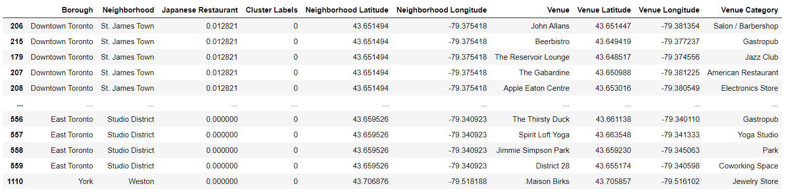

In the map, we can see that nodes of Cluster 1 are dispersed all throughout Toronto making it one of the most sparsely populated clusters.

There was a total of 77 neighbourhoods, 234 different venues and only 3 Japanese Restaurants.

Therefore, the average amount of Japanese Restaurants that were near the venues in Cluster 2 is the lowest being 0.0027.

***Cluster 2 (Purple):***

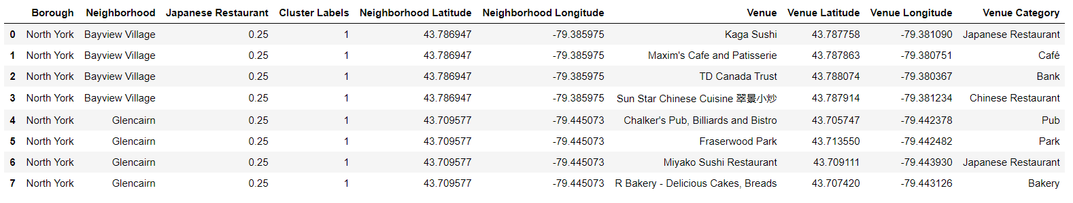

Cluster 2 is in the North York area. Bayview Village and Glencairn are the two Neighborhoods that are in that cluster. Cluster 2 has 7 unique Venue locations and out of those only 2 are Japanese Restaurants.

Cluster 2 has the highest average of Japanese Restaurants equating to 0.25. The reason why the average of Japanese Restaurants is the highest is that all these Restaurants are in two neighbourhoods.

***Cluster 3 (Turquoise):***

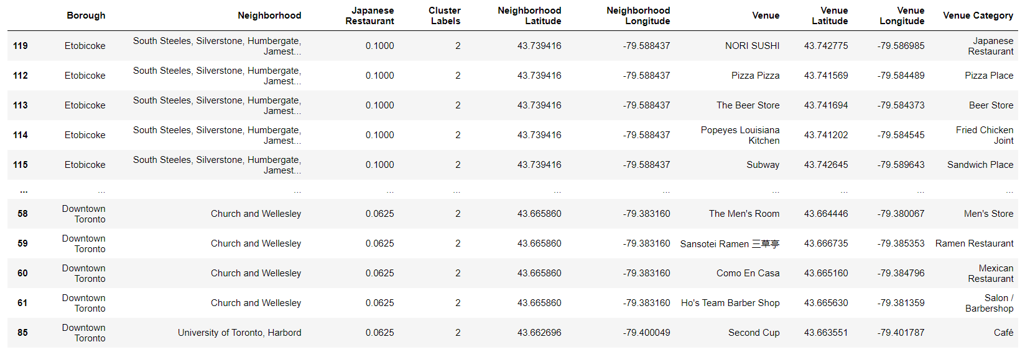

Cluster 3 had the second to lowest average of Japanese Restaurants. Cluster 3 was mainly located in the Downtown area but also had some neighbourhoods in Etobicoke. There are a total of 77 unique venues and out of those 12 are Japanese Restaurants.

***Cluster 4 (Dark Khaki):***

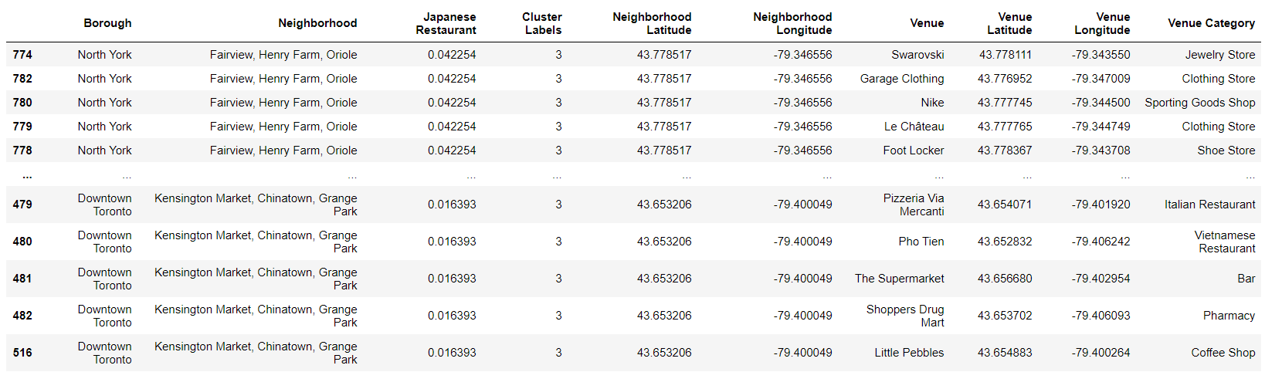

Cluster 4 venues were located in the Downtown, West, East and Central Toronto areas as well as Scarborough. There are a total of 171 unique Venues in Cluster 4 with 26 Japanese Restaurants. This made up the third-highest average of Japanese Restaurants in that cluster which is approximately 0.02901.

Therefore, the ordering of the average Japanese Restaurant in each cluster goes as follows:

1. Cluster 2 (≈0.25)

2. Cluster 3 (≈0.0705)

3. Cluster 4 (≈0.0290)

4. Cluster 1 (≈0.0027)

# 5. Discussion:

Most of the Japanese Restaurants are in cluster 4 represented by the Dark Khaki cluster.

The Neighborhoods located in the North York area that have the highest average of Japanese Restaurants are Bayview Village and Glencairn.

Even though there is a huge number of Neighborhoods in cluster 1, there is little to no Japanese Restaurant.

We see that in the Downtown Toronto area (cluster 4) has the second last average of Japanese Restaurants. Looking at the nearby venues, the optimum place to put a new Japanese Restaurant in Downtown Toronto as there are many Neighborhoods in the area but little to no Japanese Restaurants, therefore, eliminating any competition.

The second-best Neighborhoods that have a great opportunity would be in areas in Cluster 1. Having 77 neighbourhoods in the area with no Japanese Restaurants gives a good opportunity for opening a new restaurant. Some of the drawbacks of this analysis are — the clustering is completely based on data obtained from the Foursquare API. Also, the analysis does not take into consideration of the Japanese population across neighbourhoods as this can play a huge factor while choosing which place to open a new Japanese restaurant. This concludes the optimal findings for this project and recommends the entrepreneur to open an authentic Japanese restaurant in these locations with little to no competition.

# 6. Conclusion

In conclusion, to end off this project, we had an opportunity on a business problem, and it was tackled in a way that it was similar to how a genuine data scientist would do. We utilized numerous Python libraries to fetch the information, control the content and break down and visualize those datasets. We have utilized Foursquare API to investigate the settings in neighbourhoods of Toronto, get a great measure of data from Wikipedia which we scraped with the Beautifulsoup Web scraping Library. We also visualized utilizing different plots present in seaborn and Matplotlib libraries. Similarly, we applied AI strategy to anticipate the error given the information and utilized Folium to picture it on a map.

Places that have room for improvement or certain drawbacks give us that this project can be additionally improved with the assistance of more information and distinctive Machine Learning strategies. Additionally, we can utilize this venture to investigate any situation, for example, opening an alternate cuisine or opening of a Movie Theater and so forth. Ideally, this task acts as an initial direction to tackle more complex real-life problems using data science.