Buildserver-monitor

<image MVP>

Index
Idea and intent 3
ESP-01 4
Extra pins for testing 4
Operating modes 5
More information 6
Programming with USB-programmer (Dutch) 6
Pins and how to connect things 6
Development environment 7
Arduino IDE 7
JSON library - build status parsing 13
NeoPixels library - LEDs 14
Power Circuit 15
NeoPixels – LEDs 16
A word of caution 16
Connection schematic 16
Schematic 17
Soldering 18
Connecting the NeoPixels to the power circuit 19
Programming the NeoPixels 20
WiFi connection 21
Connect to Jenkins 21
Software architecture 23
Assembly 24
BOM – bill of materials 25
NeoPixel strand – 8 LEDs 26
Power Circuit 28

Idea and intent
The buildserver-monitor as presented here was intended to be a fun and functional gadget, a means to learn something new, to tinker with – all the while being useful as it can assist with quality control during the development of software.

The buildserver-monitor can be taught of as a DIY kit, a manual (this manual) which if followed properly will result in a functional electronic device that can read the status of a build server (Jenkins) via WiFi and display this status with some LEDs.

The firmware is written in C/C++, using the Arduino IDE. Configuration is required – but it is kept to a minimum and available via some configuration files (mentioned later in the manual).

ESP-01
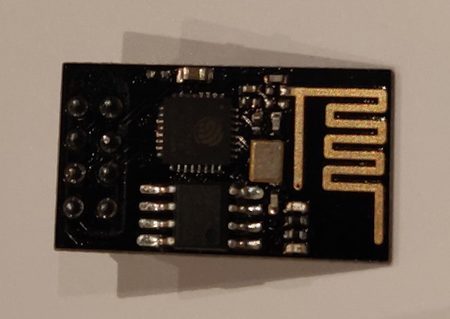
The board used is an ESP-01 module. It features an ESP8266 micro-controller. During programming an USB adapter is used.
The pin-out of both boards is presented here:
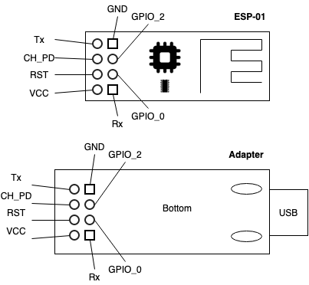
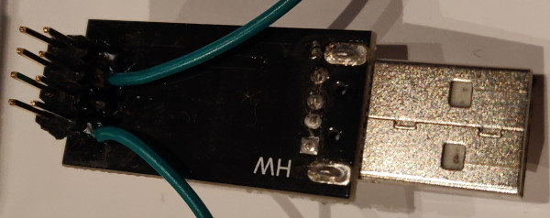
Note: the USB adapter here has a header soldered on the pins for prototyping purpose.
The pin-out for the module and the USB programmer. Note that 1 is top, the other bottom!
The ESP-01 has a limited number of pins which can be used. By default GPIO0 and GPIO2 are used as regular I/O, while Tx/Rx are used for serial communication (the debug console).

If no peripherals (other than the NeoPixels are used, only GPIO2 is used.

Extra pins for testing
To more easily program and test with the ESP-01, a modification is made to the USB Adapter:
- Soldered a 2x4 pin header to be able to connect jumper wires.
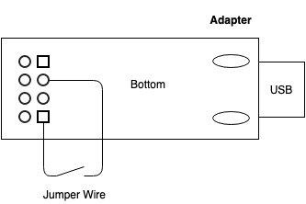
- Soldered a jumper wire which I can disconnect. This will act as programming switch.

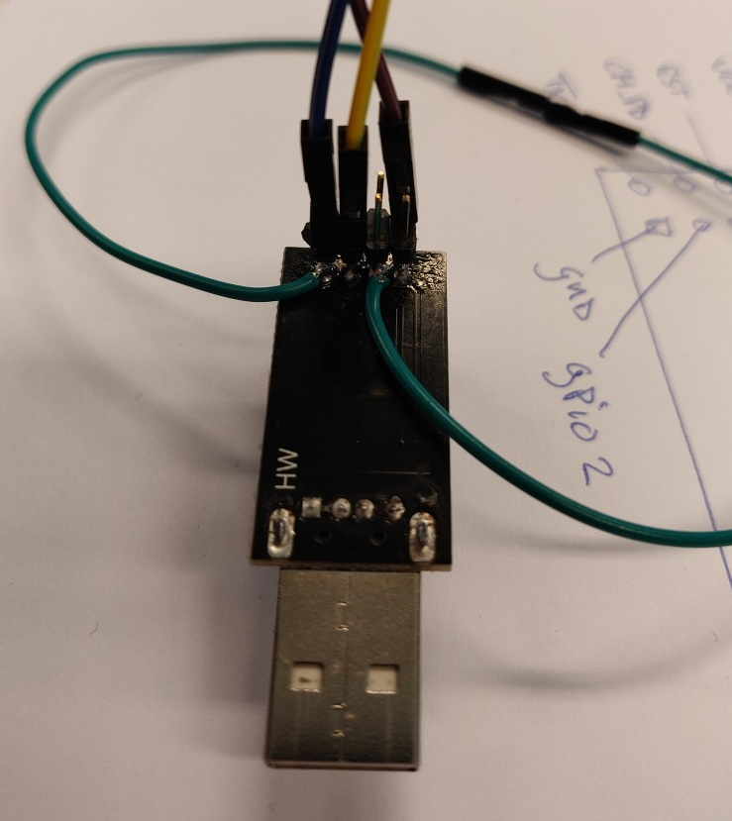
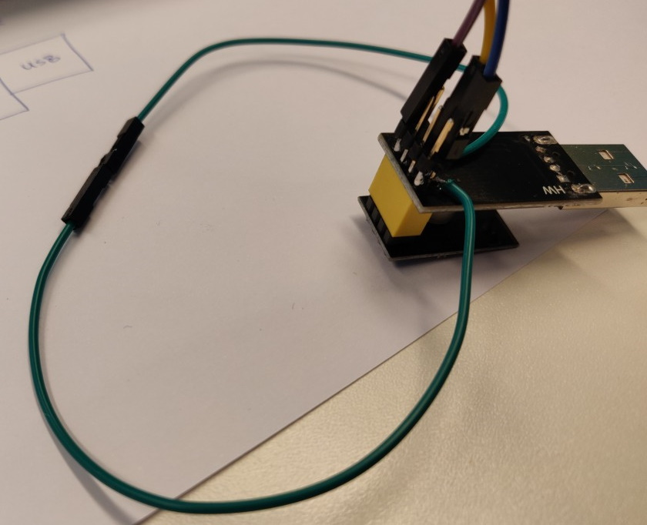

Operating modes
Program mode:
- When the wire is closed (green in the example) when connecting via USB, GPIO_0 is connected to GND and the ESP-01 starts in programming mode.
Normal mode:
- When the wire is open when connecting via USB, GPIO_0 is NOT connected to GND and the ESP-01 will start in normal mode - running the firmware on it.

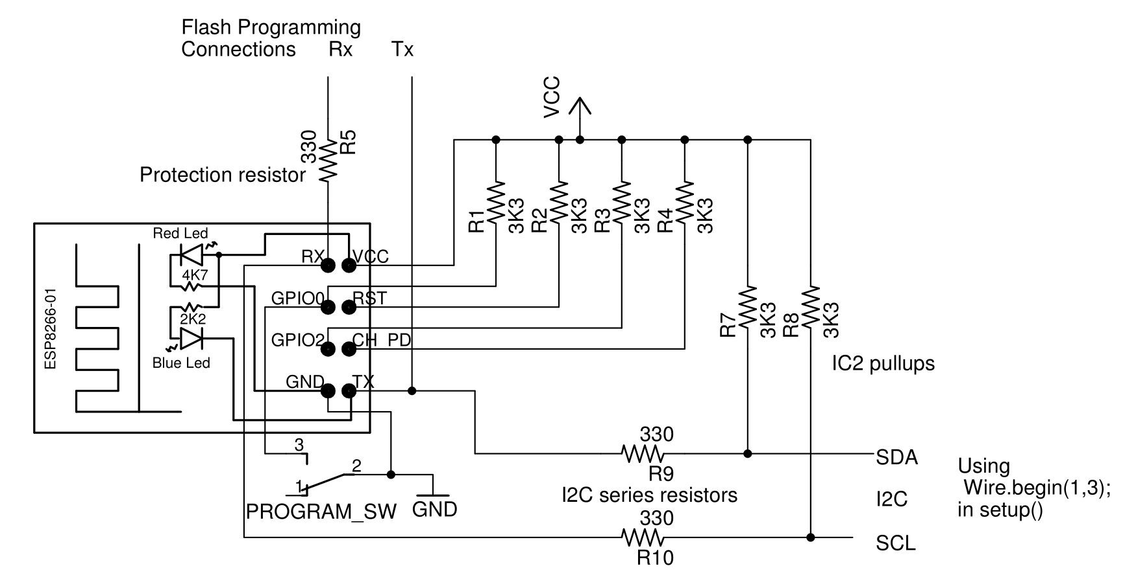
Later versions of this unit will re-configure the Tx/Rx to be I2C pins:

More information
More information about the board can be found here:
https://www.electroschematics.com/the-mighty-esp-01-adapter/
https://medium.com/@aallan/getting-started-with-the-esp8266-270e30feb4d1
https://www.instructables.com/id/Getting-Started-With-the-ESP8266-ESP-01/

Programming with USB-programmer (Dutch)
https://opencircuit.nl/Blog/Simpele-ESP-01-Programmer-hack

Pins and how to connect things
https://www.forward.com.au/pfod/ESP8266/GPIOpins/ESP8266_01_pin_magic.html
https://randomnerdtutorials.com/esp8266-pinout-reference-gpios/

Development environment
The setup of the development manual is described for a Windows 10 PC, note that development is certainly not limited to this.

Arduino IDE
The Arduino IDE is used as default IDE for source code creation. Download the Arduino IDE from the official website: https://www.arduino.cc/en/Main/Software (the windows installer, not the app)

Install the Arduino IDE.

Goto "File->Preferences". Add the following URL to "Additional Boards Manager URL":
https://arduino.esp8266.com/stable/package_esp8266com_index.json

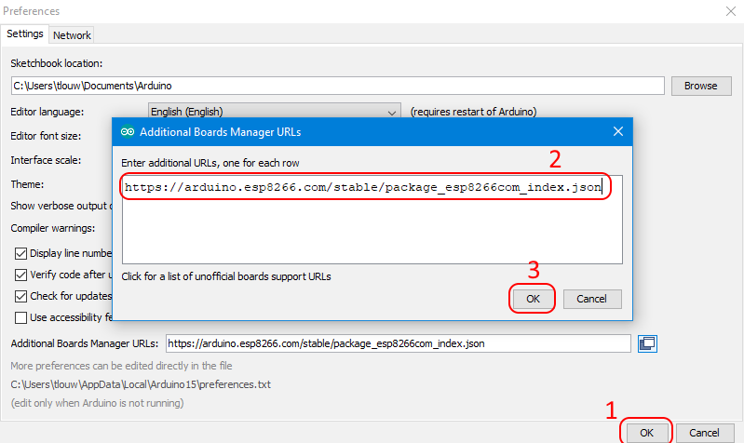
Goto "Tools->Board [...]->Board Manager".
Enter: "esp8266", then select the package and "Install".
This will take some time. Once done click "Close".
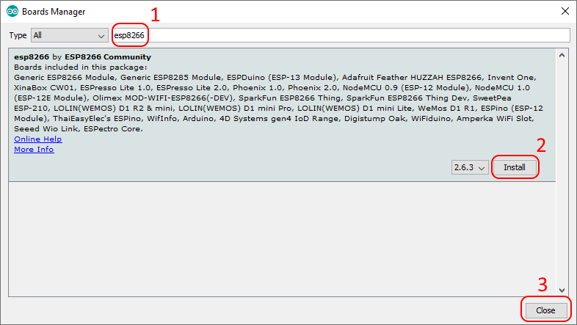
Click "Close".

Select the proper board, goto: "Tools->Board [...]->Generic ESP8266 Module".

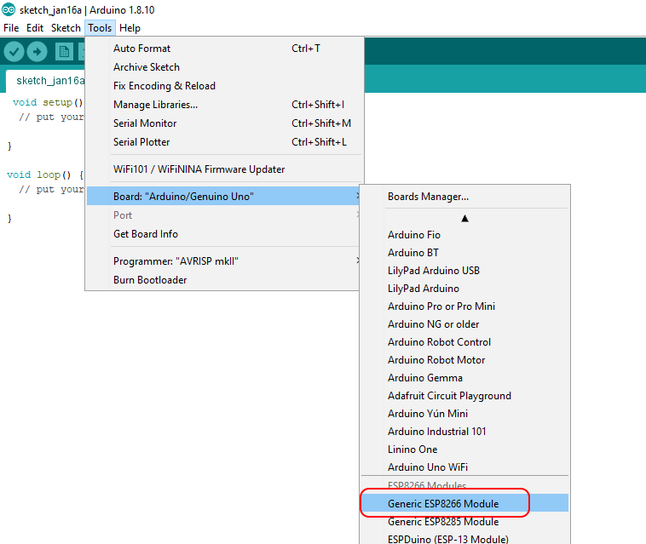
Insert the adapter with ESP-01 module. Make sure it is in "program" mode. (See: <TBD: verwijzing naar – Programming modes>)

Configure relevant Debug settings:

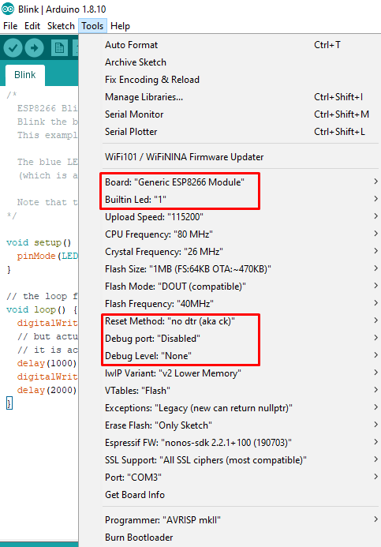
Note: the Build-in Led is at 1, debug is at None and Reset method at "no dtr (aka ck)".

Goto: "File->Examples->ESP8266", select "Blink".
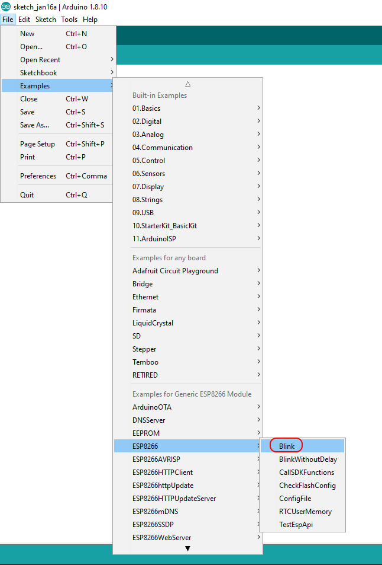

Compile and run the application, it should be downloaded to the ESP-01, after which it will run automatically. At this point the Blue led should be blinking.

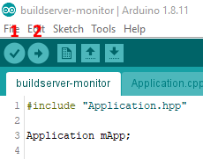
Compile the application by clicking (1), the Verify button. Output of the compilation process is shown in the output windows at the bottom of the screen.

Upload (and run) the application by clicking (2), the Upload button. This will transfer the build application to the ESP-01 – provided it is in Program Mode.

Modify the code slightly by adding the "Serial.begin()" and some print statements. Note the baudrate. Since Tx is also the Blue led, we cannot toggle the led and use Serial.println() at the same time.
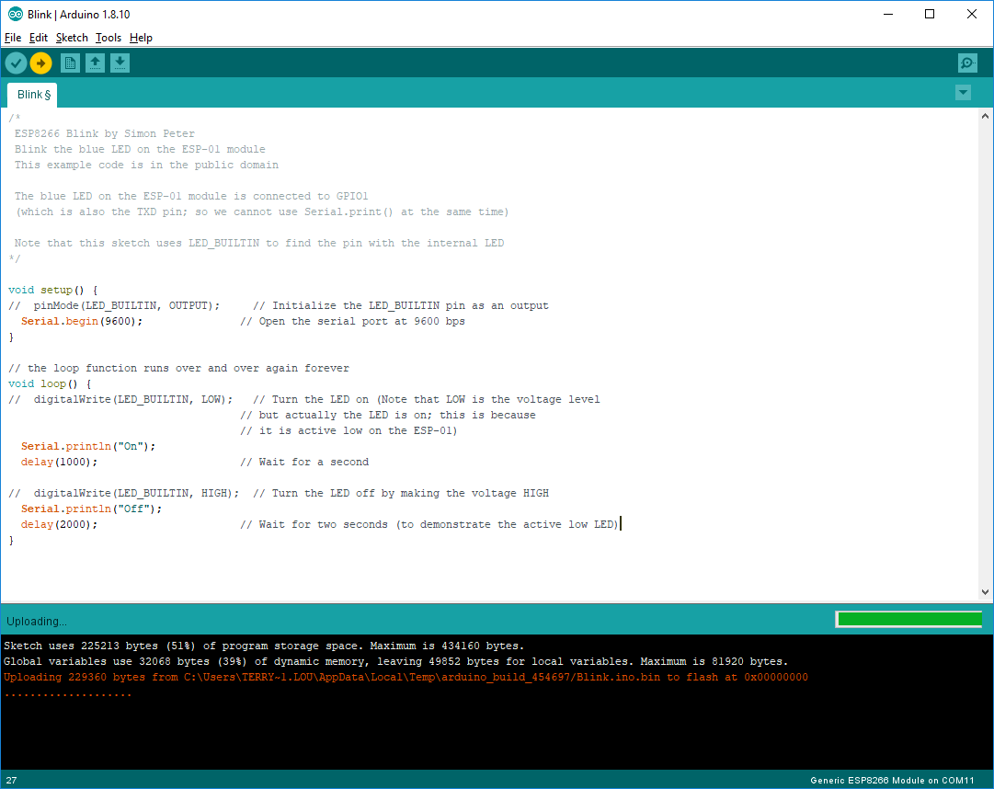
Compile and run the application, it should be downloaded to the ESP-01, after which it will run automatically.

Open the debug window: goto" "Tools->Serial Monitor". Fill the proper baudrate.

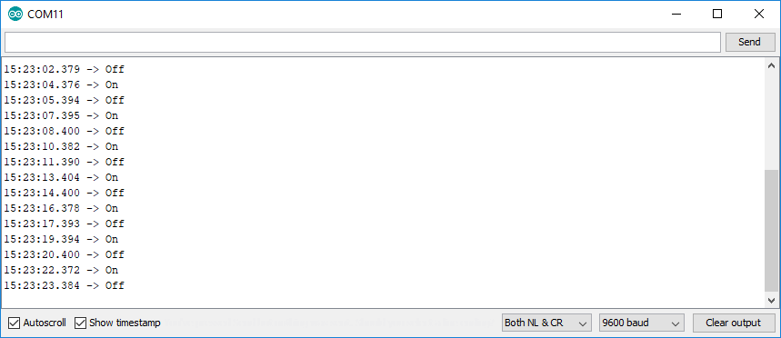
Congratulations, the development environment works!

JSON library - build status parsing
To parse the Jenkins build status we need a JSON library to assist us.
Goto: Tools->Manage Libraries...".
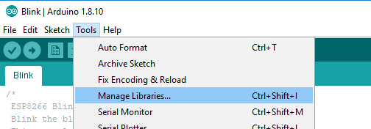
Enter: "json", then select the "ArduinoJSON" library. Click "Install".
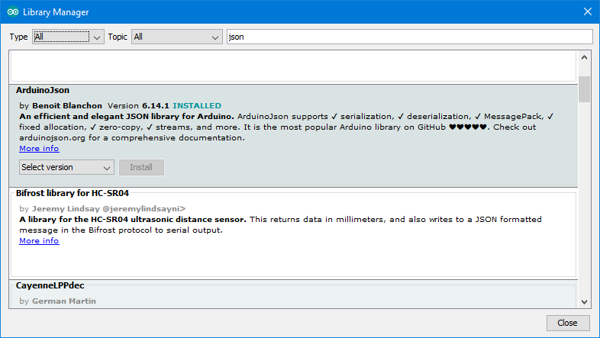
Examples are on its info page: https://arduinojson.org/?utm_source=meta&utm_medium=library.properties

NeoPixels library - LEDs
Goto: Tools->Manage Libraries...".
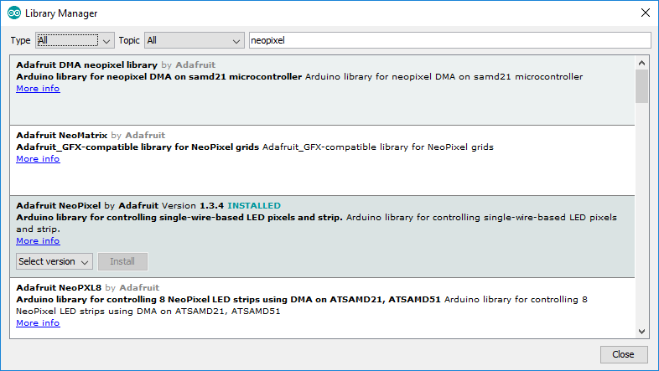
Enter: "neopixel", then select the "Adafruit NeoPixel by Adafruit" library. Click "Install".

Examples are on its info page: https://github.com/adafruit/Adafruit_NeoPixel

Power Circuit
The unit is to be powered via battery, a 18650 LiPo. This battery has an operating voltage of 3.7V. To charge the battery a charging circuit with protection is used, this eases handling the battery and prevents overcharging it. Simply connect a USB cable, as long as this is connected the battery will be charged. Charging voltage is 4.2V.

The microcontroller (ESP-01) has an operating voltage of 3.3V. To overcome this difference a step-down convertor is used. By connecting this to the battery it will provide a stable 3.3V – regardless if the battery is being charged or not.

Schematic:
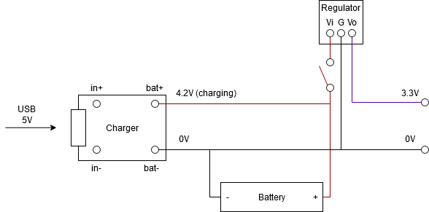
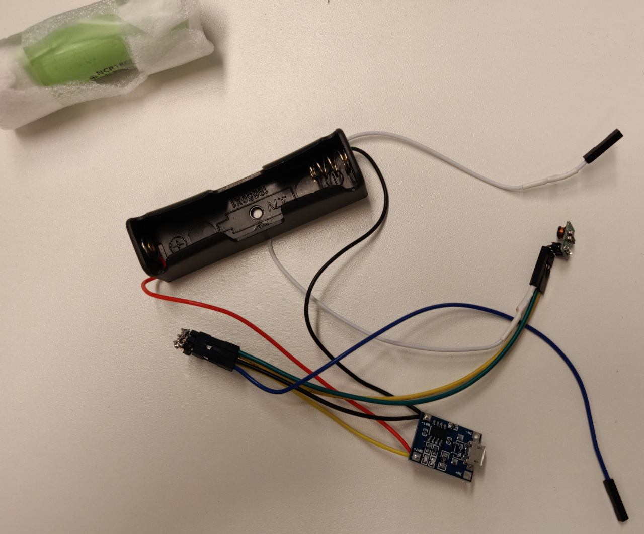
Final result:
Note: the switch is not (yet) assembled in the photo.

NeoPixels – LEDs
NeoPixels are (in short) uniquely addressable RGB LEDs which can be chained together in large strands. Each led can be colored and dimmed individually.
See: https://learn.adafruit.com/adafruit-neopixel-uberguide/the-magic-of-neopixels for more information.
These LEDs are quite handy for this project for 2 reasons:
- They have their own PWM generator inside, meaning they can be dimmed individually.
- The Arduino library for controlling these LEDs is quite mature, meaning we can easily integrate it in the project.
The NeoPixels come in a lot of different shapes and sizes, the ones used in the project are these:
https://www.adafruit.com/product/4356
Note: they are available in different pack sizes, take a look at the BOM where to find them more cheaply.

A word of caution
There are several instances where the user is warned about how to connect the LEDs. To power the LEDs 5V is assumed, we will use power from after the regulator, meaning 3.3V. A resistor close to the LEDs to prevent spikes on the data line and a large capacitor on the power supply are mentioned to prevent damage to the LEDs and an inrush current to cause a brown-out.
The connection schematic is adapted with these remarks in mind.

Connection schematic
The data-sheet tells us that a logic high input will be detected at a minimum voltage of 0.7 * Vcc. We connect directly to the battery, meaning the LEDs will be powered by 3.7V. The logic high input is the data line from the micro-controller, which is 3.3 V. Taking the formula from above: 0.7 * 3.7 = ~3.0V, this means the 3.3 V of the data line is sufficient and will be detected properly by the LEDs.

Schematic
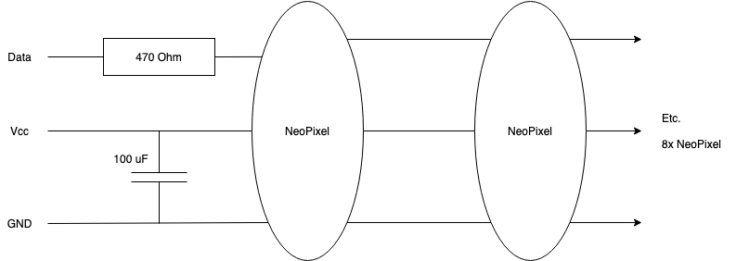
The intend is to have a strand of 8 NeoPixels in total.

Soldering
Soldering the NeoPixels is quite straightforward: with a soldering iron with a small tip, a steady hand and a little patience they are assembled without much trouble.
Each NeoPixel has a direction arrow on the back:
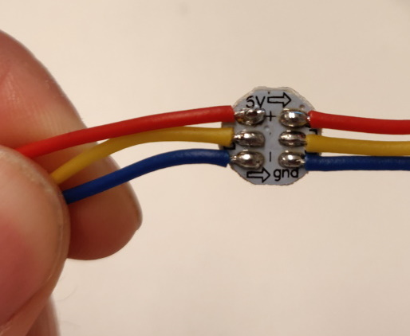
Some tips:
- Make sure the heat of the soldering iron is high.
- Try to avoid heating a soldering pad for too long, this will break the component eventually. As rule of thumb: the shorter the better.
- Put some soldering tin on the pads and wires first, before connecting them. This makes it easier to join the two.
- Do not use to much soldering tin, you really do not need that much.

After the soldering the end result will look somewhat like this:
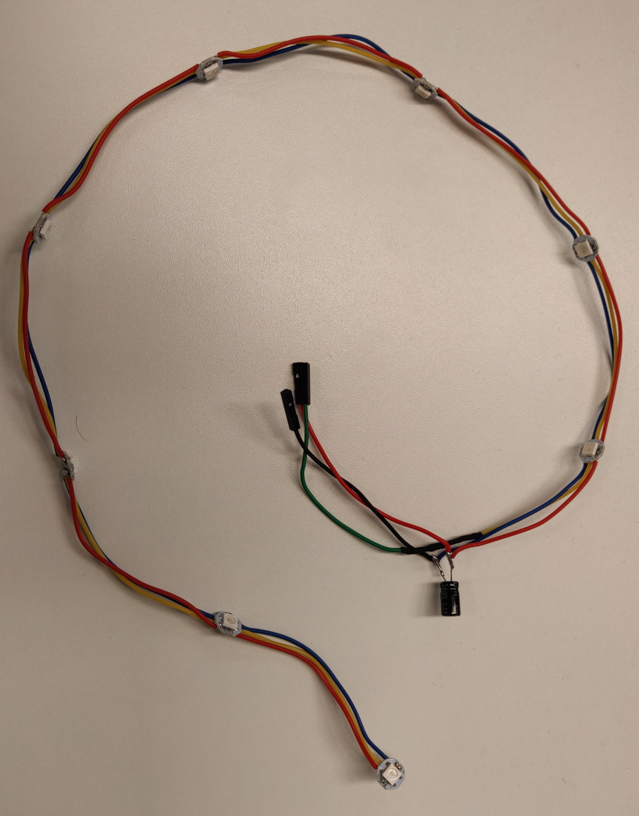
The 470 Ohm resistor is hidden under some shrink tubing in the image.

The wire ends are made of some jumper wire ends, for easier assembly in the unit later.

Some shrink tubing is used to prevent many open pieces of metal/wire.

Note: if a NeoPixel is/gets damaged the entire chain does not work. Best to test the entire strand first in separation, before trying the full application.

Example code for a strand of 5 leds is available here: https://github.com/tlouwers/buildserver-monitor/commit/ac570f306501735aabdafa7b3580a849af753960
If the define “NUMBER_OF_NEOPIXELS” is set to 8 this works for the entire strands (not just the first 5 leds).

Connecting the NeoPixels to the power circuit
To connect the NeoPixels, the ESP-01 and the Power Circuit, the following schematic is used.
The idea is to have the NeoPixels be powered directly from the battery – this would be 4.2V when charging, ~3.7V when operating on battery only. The Data is connected to pin GPIO_2 on the ESP-01, this is at 3.3V.

By connecting things such, the switch allows the buildserver-monitor to be turned off completely (although the battery still can be charged while the unit is off). In case a hard reset is needed, the entire enclosure does not need to be oped to do so.

Schematic:
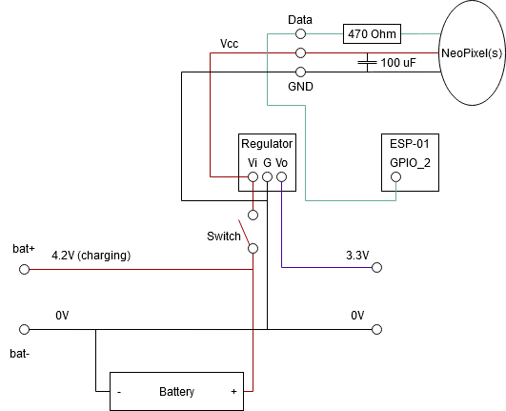

Programming the NeoPixels
The ‘Development Environment’ section describes how to install the NeoPixel library used for controlling the LEDs.

The NeoPixels are controlled via a single data line. Commands are send to each pixel individually or to a range. For this purpose the NeoPixel library needs to be configured to the correct number of NeoPixels in the strand and the GPIO pin to use. Defaults are set in the ‘config.h’ file.

To ease programming, a ‘Led’ class is created which can set a single, or all LEDs to a specified color. Note that much more functionality is available in the library.

WiFi connection
To be able to connect via WiFi to a buildserver (Jenkins is assumed), some configuration must be done.

Connect to Jenkins
The current build assumes:
- A 2.4 GHz WiFi network, secured via WPA2
- A build PC running Jenkins
- Jenkins requires an https connection
- Jenkins requires a login via a user (monitor) account.

In the file ‘wifi_config.h' the connection parameters for connecting to the WiFi network need to be set:
- WIFI_SSID This is the SSID (name) of the network to connect to.
- WIFI_PASSWORD This is the password needed to connect to the network.

In the file ‘http_config.h' the connection parameters for the build PC need to be set.
- USERNAME This is the user (monitor) account to log in to Jenkins – is the name generated with the token.

- BASIC_AUTHENTICATION_TOKEN This is the basic authentication token belonging to the user and is used as alternative to the password to login to Jenkins. This token can be acquired by logging in to Jenkins via the user (monitor) account and generate the token from within Jenkins.
To create a User API Token in Jenkins:
- Log into Jenkins.
- Click on your username (in the top right).
- Click on “Configure” (on the left).
- Under the “API Token” section, click on “Add new Token”, and “Generate” and record the generated token.
- Give the token a name, this is the username (monitor) needed with the token to login to Jenkins.

- JENKINS_API_URL This is the full URL to the Jenkins job to retrieve the build status from. It is expected to have the following format:
https://{server}/{job}/api/json
Where:
username USERNAME
token BASIC_AUTHENTICATION_TOKEN

- SHA1_FINGERPRINT[FINGERPRINT_SIZE] Between the curly brackets ‘{}' the SHA1 hash of the https connection to Jenkis is to be stored.
Example (assuming the Chrome webbrowser is used):
- Login to Jenkins using the USERNAME and initial user password.
- Click the ‘lock’ icon (top left), open the Certificate by clicking on it.
- Goto the ‘Details’ tab.
- Note/write down the expiration date. It is good to write this date in the comments near the SHA1 hash, once this date is reached the SHA1 hash needs to be retrieved/refreshed again.
- Note/write down the ‘Fingerprint’. This is the SHA1 hash that needs to be added between the curly brackets.

Software architecture
The architecture of the buildserver-monitor is kept simple as the main goal of the device is to be a simple to build gadget.

The code works its way through a main application loop, a state machine.
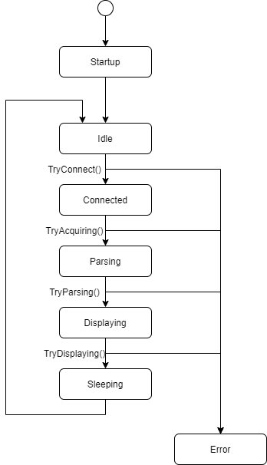

The device will startup, then try to make a WiFi connection to the (Jenkins) build-server. It tries to fetch a build result (*.json file), which is then parsed. If a build result can be found the status of the build is displayed, after which the device goes to sleep to save power. After some time the cycle is repeated.
If anything goes wrong the device enters an error state: here the WiFi connection is closed (if needed) and the device resets itself.

Assembly
For the assembly a 3D printed model of the Tardis is used; this looks similar to an old fashioned phone booth. The model can be retrieved here (from Thingyverse).

Warning: all items are to be printed at 130% of the original size! This to make sure the unit is large enough for all components to fit inside.

The following files need to be 3D printed:
- <TBD> list of files in the package

...

BOM – bill of materials
Described below is the list of components used for the buildserver-monitor.
Note: the URLs in this document are used as example and often show with a picture the component required – most of this is better ordered via AliExpress, or via your local electronics shack. Prices will be better there as well.

NeoPixel strand – 8 LEDs
pieces | details
8 | NeoPixel Button PCB  https://www.adafruit.com/product/1612  note: these can be ordered at different locations and in different pack sizes, for instance:  https://nl.aliexpress.com/item/32966321827.html?spm=a2g0o.productlist.0.0.30c6206aaSIyUB&s=p&algo_pvid=7773d8dd-fb90-427f-bdfd-372e26ecd068&algo_expid=7773d8dd-fb90-427f-bdfd-372e26ecd068-1&btsid=2594c913-d050-4b27-a4c1-55f1e67105bb&ws_ab_test=searchweb0_0,searchweb201602_8,searchweb201603_55
1 | Resistor, 470 Ohm, ¼W, 5%  https://www.kiwi-electronics.nl/Weerstand-470-ohm-1-4-watt-5-procent-10-stuks
1 | Capacitor, 100 uF, 16V  https://www.kiwi-electronics.nl/componenten-onderdelen/componenten/condensatoren/elektrolytische-condensatoren/100uf-16v-condensator  note: the NeoPixelUberGuide uses 1000 uF, but this seems a bit much for the amount of NeoPixels we use.
3 (colors) | Wire, about 50 cm  https://www.kiwi-electronics.nl/componenten-onderdelen/prototyping/draad-kabel/aansluitdraden-set-met-solide-kern-6x7-5m-0-65mm
3 | Jumper wires, 15 cm, female-female  https://www.kiwi-electronics.nl/componenten-onderdelen/prototyping/jumperwires-kabeltjes/jumperwires-10-stuks-15-cm-femafe-female

Optional:
pieces | details
1 | Heat shrink tubing  https://www.kiwi-electronics.nl/krimpkousjes-assortiment?search=krimpkous&description=true  Or: some tape will do as well. The intent is to shield some of the open connections.

Final result:
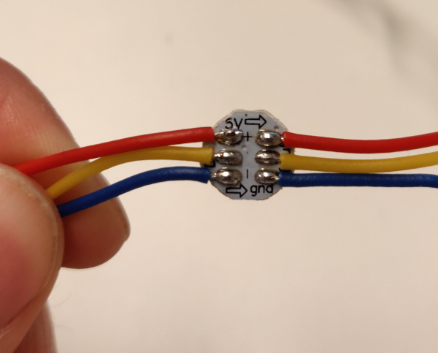
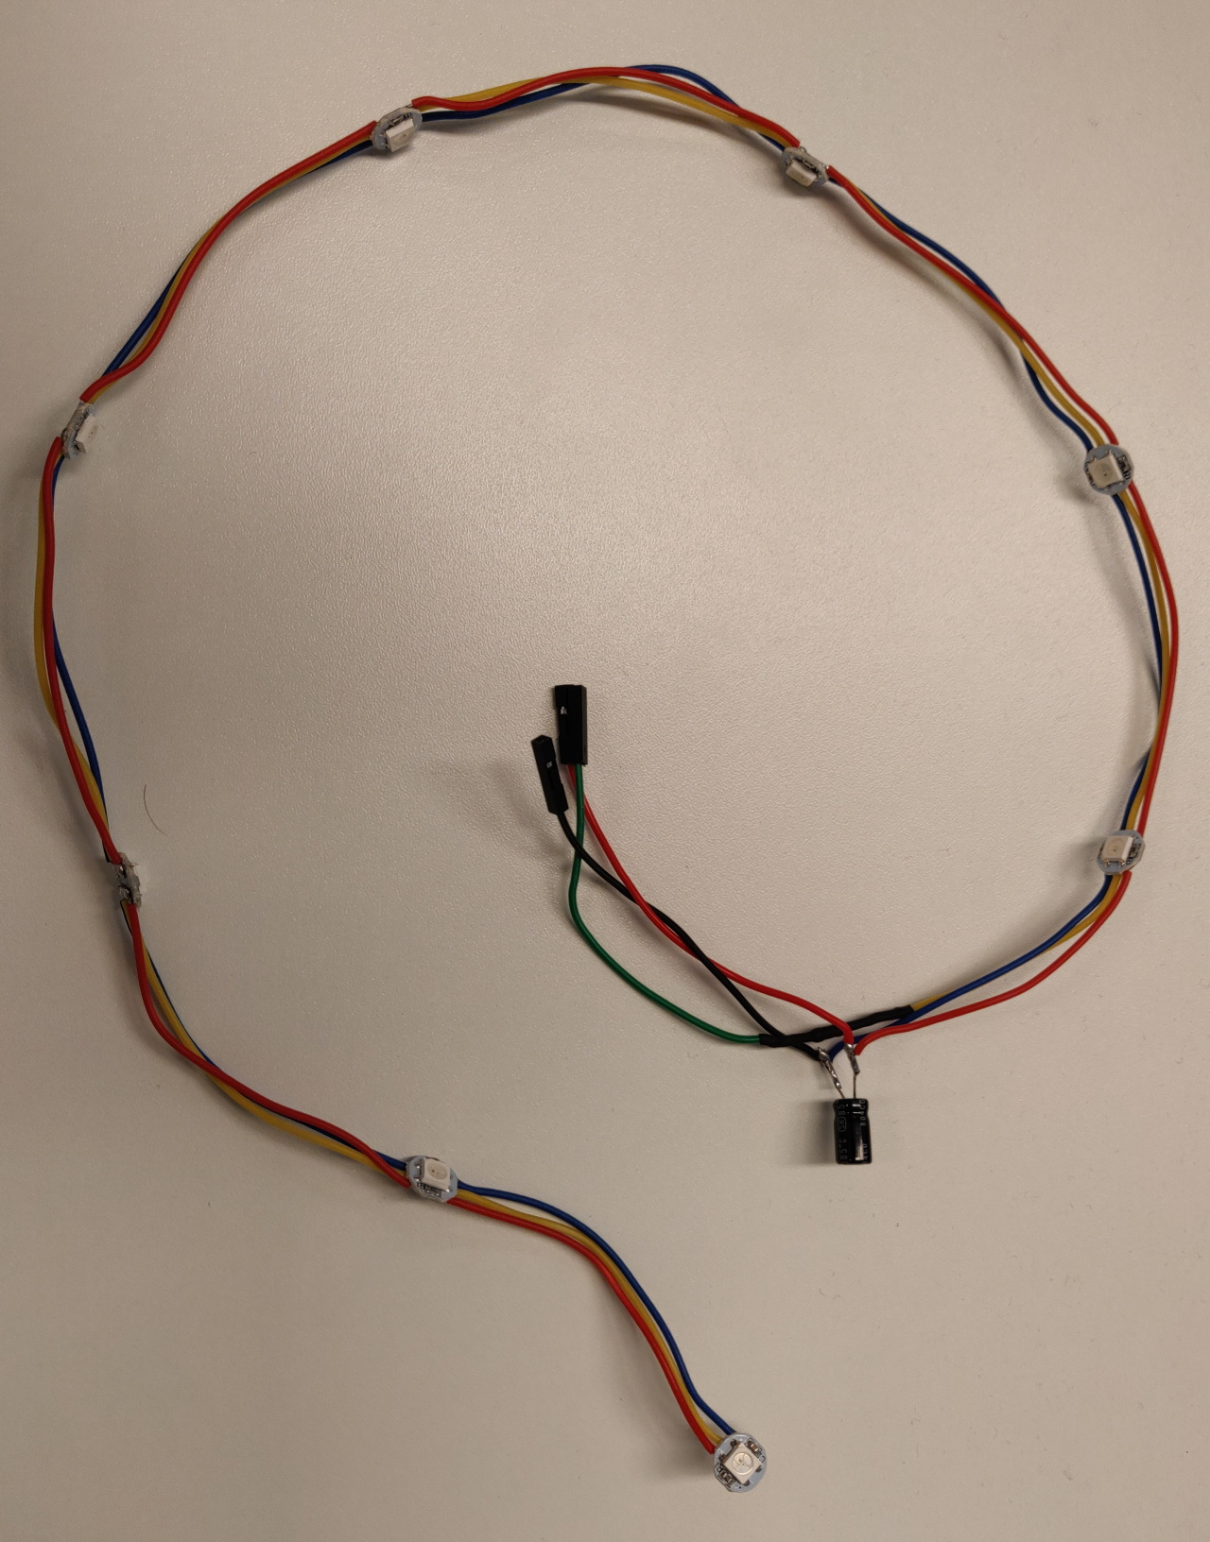

Power Circuit
pieces | details
1 | Battery Charger with charge protection  https://nl.aliexpress.com/item/32971733016.html?spm=a2g0o.productlist.0.0.4cca7c58spW1ju&s=p&algo_pvid=dabfa38b-45f1-411f-ba93-54e312cd690b&algo_expid=dabfa38b-45f1-411f-ba93-54e312cd690b-0&btsid=028f145b-4d9e-4104-bd5d-bf5fdbf62273&ws_ab_test=searchweb0_0,searchweb201602_7,searchweb201603_53
1 | Step down convertor  https://nl.aliexpress.com/item/32653810603.html?spm=a2g0o.detail.1000060.1.27705ff6Q82WkR&gps-id=pcDetailBottomMoreThisSeller&scm=1007.13339.146401.0&scm_id=1007.13339.146401.0&scm-url=1007.13339.146401.0&pvid=1edb1c1d-f0cd-46ec-8b3e-3037288c13d4
1 | Battery – LiPo – 18650 – 3400 mAh  https://nl.aliexpress.com/item/33016517000.html?spm=a2g0o.productlist.0.0.65f0d1f7bglIBc&s=p&algo_pvid=adb98d3f-064e-493e-9de7-f41c00bf5d4c&algo_expid=adb98d3f-064e-493e-9de7-f41c00bf5d4c-5&btsid=cf7c52b6-e454-426b-8957-5a8fea3eee94&ws_ab_test=searchweb0_0,searchweb201602_7,searchweb201603_53  note: should order in your native country, typically they do not pass customs
1 | Battery holder  https://nl.aliexpress.com/item/32824489601.html?spm=a2g0o.productlist.0.0.7f6b38bfQkWGdL&s=p&algo_pvid=f4945b0a-0112-498f-bf8f-3457bd99512c&algo_expid=f4945b0a-0112-498f-bf8f-3457bd99512c-4&btsid=686eff58-61dc-418e-bfbf-54a6e8c47fc6&ws_ab_test=searchweb0_0,searchweb201602_7,searchweb201603_53
1 | Switch  https://nl.aliexpress.com/item/10000003088863.html?spm=a2g0s.12269583.0.0.e27a169bdTP1A7
9 | Pin header, male  https://www.kiwi-electronics.nl/40-pin-header-strip-5-pack?search=pin%20header&description=true

Optional:
pieces | details
1 | Heat shrink tubing  https://www.kiwi-electronics.nl/krimpkousjes-assortiment?search=krimpkous&description=true  Or: some tape will do as well. The intent is to shield some of the open connections.

Final result:
Note: the switch is not (yet) assembled in the photo.

